**Ishita Hardasmalani**

**FINAL CODES FOR PRACTICAL**

1. **DFS FOR GRAPH**

def dfs(graph, start, goal, visited=None, path=None, open_list=None, closed_list=None):

if visited is None:

visited = set()

if path is None:

path = []

if open_list is None:

open_list = []

if closed_list is None:

closed_list = []

visited.add(start)

open_list.append(start)

path = path + [start]

print("Iteration", len(open_list) + len(closed_list))

print("Current Node:", start)

print("Open List:", open_list)

print("Closed List:", closed_list)

if start == goal:

return path

for neighbor in graph[start]:

if neighbor not in visited:

new_path = dfs(graph, neighbor, goal, visited, path, open_list, closed_list)

if new_path:

return new_path

open_list.remove(start)

closed_list.append(start)

return None

graph = {

'A': ['B', 'C'],

'B': ['D', 'E'],

'C': ['F'],

'D': [],

'E': ['F'],

'F': []

}

start_node = input("Enter the start node: ").strip().upper()

goal_node = input("Enter the goal node: ").strip().upper()

print("DFS Path:")

if start_node not in graph or goal_node not in graph:

print("Start node or goal node not found in the graph.")

else:

open_list = []

closed_list = []

path = dfs(graph, start_node, goal_node, open_list=open_list, closed_list=closed_list)

if path:

print("Path from", start_node, "to", goal_node, ":", ' -> '.join(path))

else:

print("Path from", start_node, "to", goal_node, "not found.")

print("Open List after DFS:", open_list)

print("Closed List after DFS:", closed_list)

GRAPH:

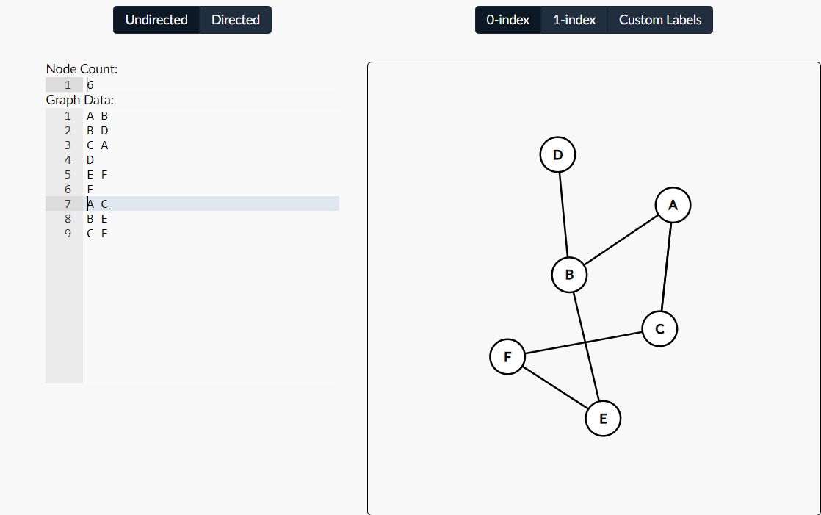

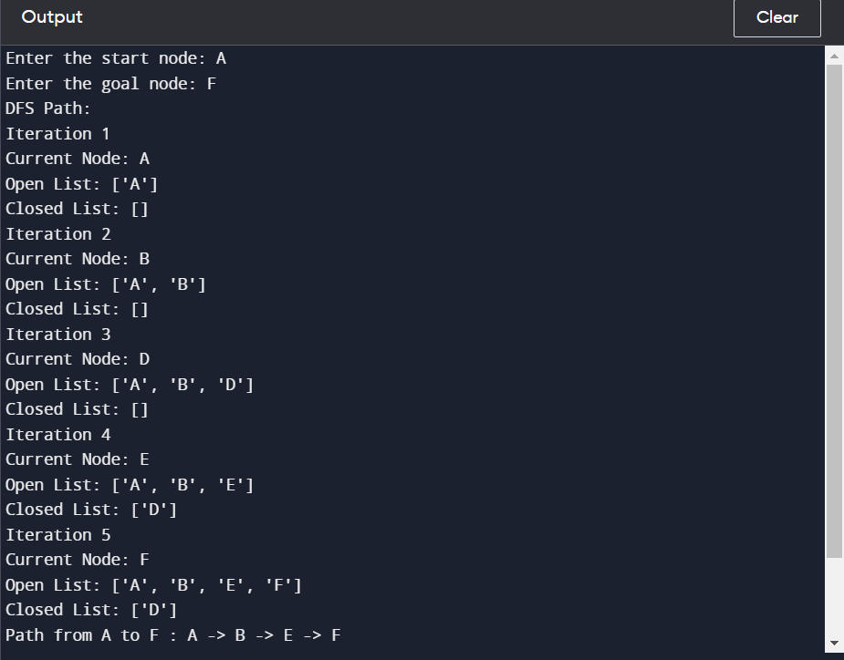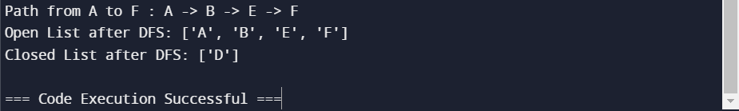

1. **DFS FOR TREE**

class TreeNode:

def __init__(self, value):

self.value = value

self.children = []

def dfs_tree(node, goal, path=None, open_list=None, closed_list=None):

if path is None:

path = []

if open_list is None:

open_list = []

if closed_list is None:

closed_list = []

open_list.append(node.value)

path.append(node.value)

print("Iteration", len(open_list) + len(closed_list))

print("Current Node:", node.value)

print("Open List:", open_list)

print("Closed List:", closed_list)

if node.value == goal:

return path

for child in node.children:

if child.value not in path:

new_path = dfs_tree(child, goal, path[:], open_list, closed_list)

if new_path:

return new_path

open_list.remove(node.value)

closed_list.append(node.value)

return None

root = TreeNode('A')

root.children = [TreeNode('B'), TreeNode('C'), TreeNode('D')]

root.children[0].children = [TreeNode('E'), TreeNode('F')]

root.children[1].children = [TreeNode('G')]

goal_node = input("Enter the goal node: ").strip().upper()

print("DFS Path in Tree:")

open_list = []

closed_list = []

path = dfs_tree(root, goal_node, open_list=open_list, closed_list=closed_list)

if path:

print("Path to", goal_node, ":", ' -> '.join(path))

else:

print("Path to", goal_node, "not found.")

TREE:

A

/|\

B C D

/ \

E G

/

F

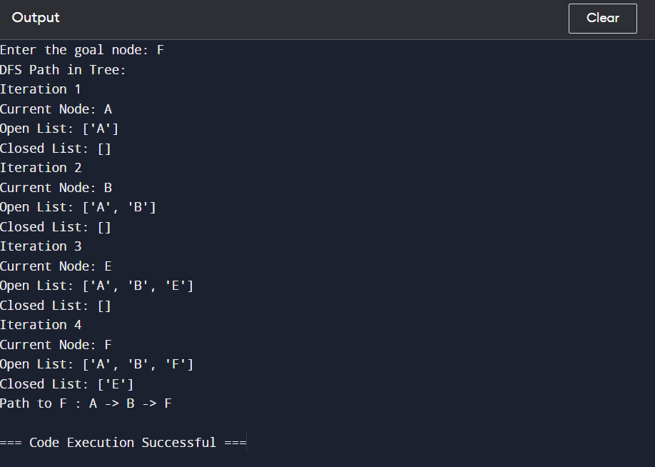

1. **DLS FOR GRAPH**

def dls(graph, start, goal, max_depth, depth=0, visited=None, path=None):

if visited is None:

visited = set()

if path is None:

path = []

visited.add(start)

path = path + [start]

if start == goal:

return path

if depth >= max_depth:

return None

for neighbor in graph[start]:

if neighbor not in visited:

new_path = dls(graph, neighbor, goal, max_depth, depth + 1, visited, path)

if new_path:

return new_path

return None

graph = {

'A': ['B', 'C'],

'B': ['D', 'E'],

'C': ['F'],

'D': [],

'E': ['F'],

'F': []

}

start_node = input("Enter the start node: ").strip().upper()

goal_node = input("Enter the goal node: ").strip().upper()

max_depth = int(input("Enter the maximum depth: ").strip())

print("DLS Path:")

if start_node not in graph or goal_node not in graph:

print("Start node or goal node not found in the graph.")

else:

path = dls(graph, start_node, goal_node, max_depth)

if path:

print("Path from", start_node, "to", goal_node, ":", ' -> '.join(path))

else:

print("Path from", start_node, "to", goal_node, "not found within the maximum depth.")

GRAPH

OUTPUT:

CASE 1

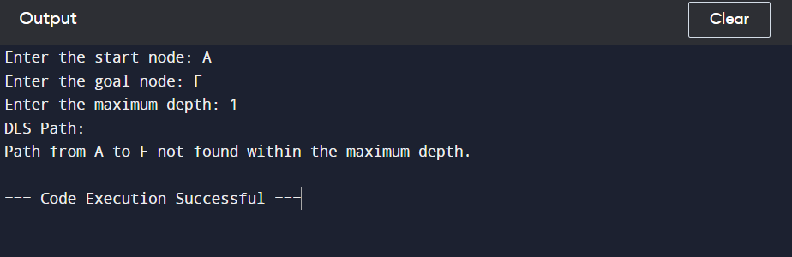

CASE 2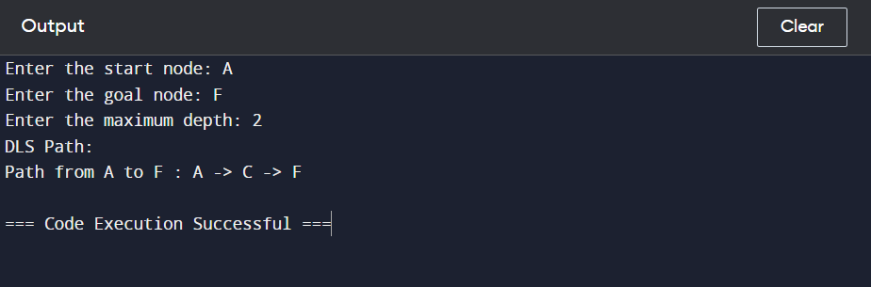

CASE 3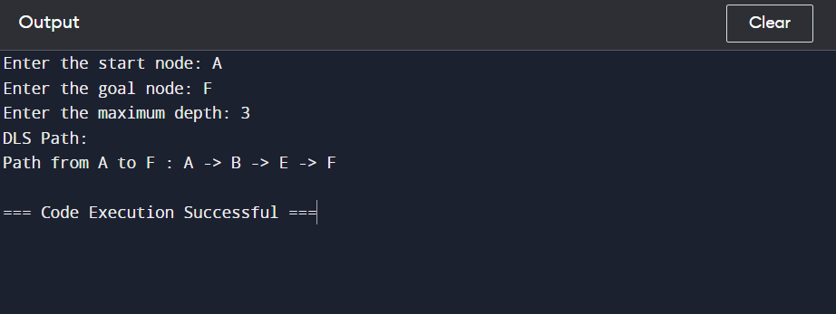

1. **DLS FOR TREE**

class TreeNode:

def __init__(self, value):

self.value = value

self.children = []

def dls_tree(node, goal, max_depth, depth=0, path=None):

if path is None:

path = []

path.append(node.value)

if node.value == goal:

return path

if depth >= max_depth:

return None

for child in node.children:

new_path = dls_tree(child, goal, max_depth, depth + 1, path[:])

if new_path:

return new_path

return None

root = TreeNode('A')

root.children = [TreeNode('B'), TreeNode('C'), TreeNode('D')]

root.children[0].children = [TreeNode('E'), TreeNode('F')]

root.children[1].children = [TreeNode('G'), TreeNode('H')]

goal_node = input("Enter the goal node: ").strip().upper()

max_depth = int(input("Enter the maximum depth: ").strip())

print("DLS Path in Tree:")

path = dls_tree(root, goal_node, max_depth)

if path:

print("Path to", goal_node, ":", ' -> '.join(path))

else:

print("Path to", goal_node, "not found within the maximum depth.")

TREE:

A



B C D



E F G H

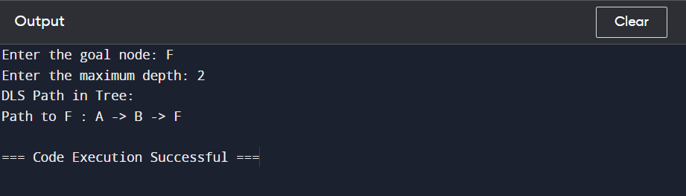

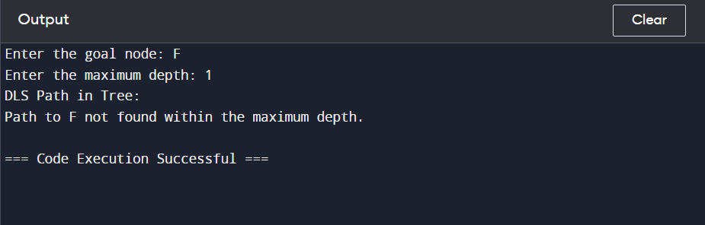

1. **DFID FOR GRAPH**

def dfs(graph, start, goal, max_depth, depth=0, visited=None, path=None):

if visited is None:

visited = set()

if path is None:

path = []

visited.add(start)

path = path + [start]

if start == goal:

return path

if depth >= max_depth:

return None

for neighbor in graph[start]:

if neighbor not in visited:

new_path = dfs(graph, neighbor, goal, max_depth, depth + 1, visited, path)

if new_path:

return new_path

return None

def dfid(graph, start, goal):

depth = 0

while True:

result = dfs(graph, start, goal, depth)

if result is not None:

return result

depth += 1

# Example graph represented as an adjacency list

graph = {

'A': ['B', 'C'],

'B': ['D', 'E'],

'C': ['F'],

'D': [],

'E': ['F'],

'F': []

}

start_node = input("Enter the start node: ").strip().upper()

goal_node = input("Enter the goal node: ").strip().upper()

print("DFID Path:")

if start_node not in graph or goal_node not in graph:

print("Start node or goal node not found in the graph.")

else:

path = dfid(graph, start_node, goal_node)

if path:

print("Path from", start_node, "to", goal_node, ":", ' -> '.join(path))

else:

print("Path from", start_node, "to", goal_node, "not found.")

In this code:

* **dfs** function performs Depth-First Search (DFS) with a depth limit.
* **dfid** function iterates over increasing depth limits and applies DFS until the goal is found or the maximum depth is reached.



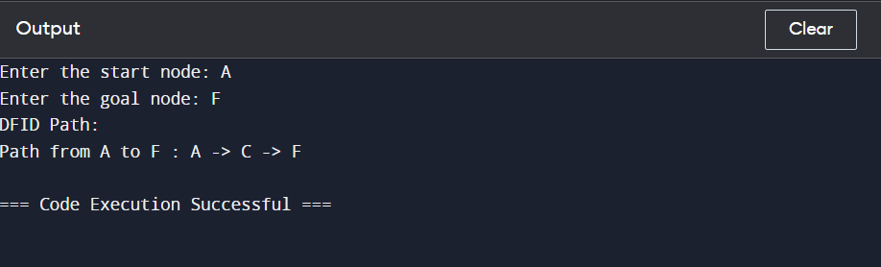

**6.DFID FOR TREE**

class TreeNode:

def __init__(self, value):

self.value = value

self.children = []

def dfs_tree(node, goal, max_depth, depth=0, path=None):

if path is None:

path = []

path.append(node.value)

if node.value == goal:

return path

if depth >= max_depth:

return None

for child in node.children:

new_path = dfs_tree(child, goal, max_depth, depth + 1, path[:])

if new_path:

return new_path

return None

def dfid_tree(root, goal):

depth = 0

while True:

result = dfs_tree(root, goal, depth)

if result is not None:

return result

depth += 1

# Example tree

root = TreeNode('A')

root.children = [TreeNode('B'), TreeNode('C'), TreeNode('D')]

root.children[0].children = [TreeNode('E'), TreeNode('F')]

root.children[1].children = [TreeNode('G'), TreeNode('H')]

goal_node = input("Enter the goal node: ").strip().upper()

print("DFID Path in Tree:")

path = dfid_tree(root, goal_node)

if path:

print("Path to", goal_node, ":", ' -> '.join(path))

else:

print("Path to", goal_node, "not found.")

TREE:

A



B C D



E F G H

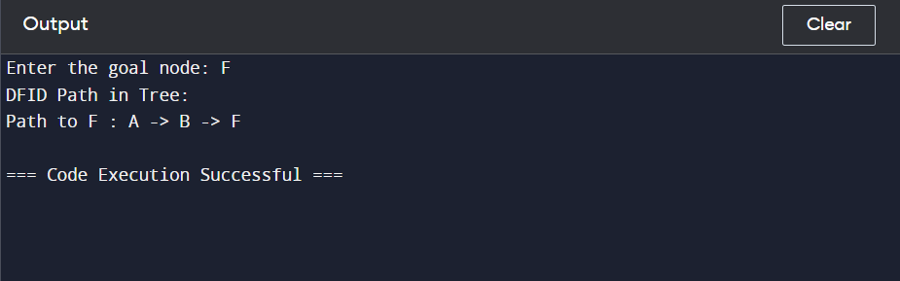

1. **Breadth First Search for Graph**

from collections import deque

def bfs(graph, start, goal):

queue = deque([start])

visited = {start: None}

while queue:

node = queue.popleft()

if node == goal:

return construct_path(visited, start, goal)

for neighbor in graph[node]:

if neighbor not in visited:

visited[neighbor] = node

queue.append(neighbor)

return None

def construct_path(visited, start, goal):

path = []

while goal is not None:

path.append(goal)

goal = visited[goal]

return list(reversed(path))

graph = {

'A': ['B', 'C'],

'B': ['D', 'E'],

'C': ['F'],

'D': [],

'E': ['F'],

'F': []

}

start_node = input("Enter the start node: ").strip().upper()

goal_node = input("Enter the goal node: ").strip().upper()

print("BFS Path:")

if start_node not in graph or goal_node not in graph:

print("Start node or goal node not found in the graph.")

else:

path = bfs(graph, start_node, goal_node)

if path:

print("Path from", start_node, "to", goal_node, ":", ' -> '.join(path))

else:

print("Path from", start_node, "to", goal_node, "not found.")

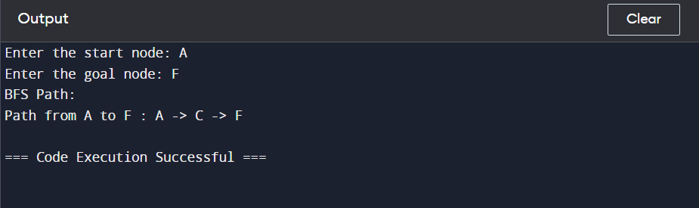

1. **Breadth First Search for Tree**

from collections import deque

class TreeNode:

def __init__(self, value):

self.value = value

self.children = []

def bfs_tree(root, goal):

queue = deque([root])

parents = {root: None}

while queue:

node = queue.popleft()

if node.value == goal:

return construct_path(parents, node)

for child in node.children:

if child not in parents:

parents[child] = node

queue.append(child)

return None

def construct_path(parents, goal):

path = []

while goal is not None:

path.append(goal.value)

goal = parents[goal]

return list(reversed(path))

root = TreeNode('A')

root.children = [TreeNode('B'), TreeNode('C'), TreeNode('D')]

root.children[0].children = [TreeNode('E'), TreeNode('F')]

root.children[1].children = [TreeNode('G'), TreeNode('H')]

goal_node = input("Enter the goal node: ").strip().upper()

print("BFS Path in Tree:")

path = bfs_tree(root, goal_node)

if path:

print("Path to", goal_node, ":", ' -> '.join(path))

else:

print("Path to", goal_node, "not found.")

TREE:

A



B C D



E F G H

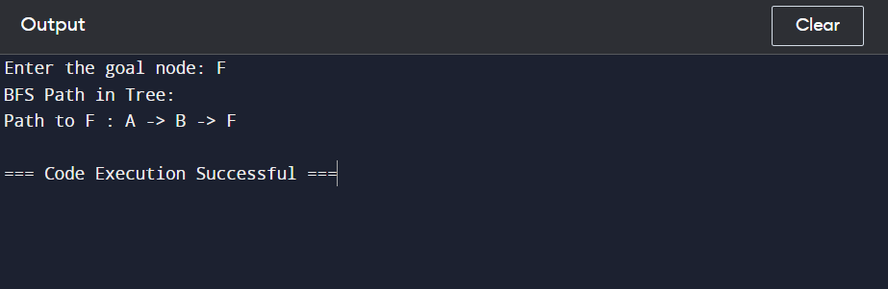

1. **Greedy Best First Search Algorithm for Graph**

import heapq

def gbfs(graph, start, goal, heuristic):

visited = set()

priority_queue = [(heuristic[start], start)]

path = {start: None}

while priority_queue:

_, current_node = heapq.heappop(priority_queue)

if current_node == goal:

return construct_path(path, start, goal)

visited.add(current_node)

for neighbor in graph[current_node]:

if neighbor not in visited:

heapq.heappush(priority_queue, (heuristic[neighbor], neighbor))

path[neighbor] = current_node

return None

def construct_path(path, start, goal):

current_node = goal

path_sequence = []

while current_node:

path_sequence.insert(0, current_node)

current_node = path[current_node]

return path_sequence if path_sequence[0] == start else None

graph = {

'A': ['S', 'T', 'Z'],

'S': ['A', 'F', 'O', 'R'],

'T': [],

'Z': [],

'F': ['S', 'B']

}

start_node = input("Enter the start node: ").strip().upper()

goal_node = input("Enter the goal node: ").strip().upper()

heuristic = {

'A': 366,

'S': 253,

'F': 176,

'T': 329,

'O': 380,

'Z': 374,

'R': 193,

'B': 0

}

gbfs_path = gbfs(graph, start_node, goal_node, heuristic)

if gbfs_path:

print('Path:', gbfs_path)

print(f"Goal '{goal_node}' found using GBFS.")

else:

print(f"Goal '{goal_node}' not found using GBFS.")

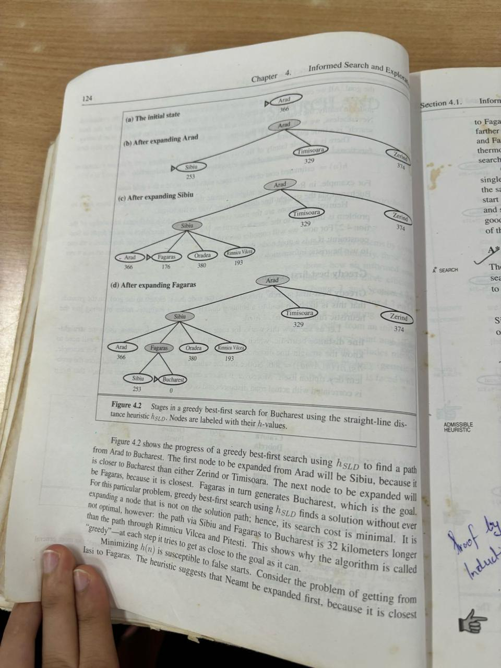

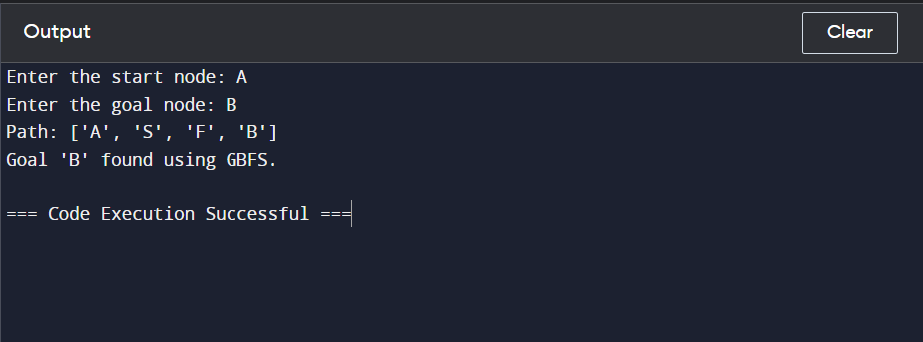

1. **Greedy Best First Search Algorithm for Tree**

import heapq

class TreeNode:

def __init__(self, value):

self.value = value

self.children = []

def gbfs_tree(root, goal, heuristic):

visited = set()

priority_queue = [(heuristic[root.value], root)]

path = {root.value: None}

while priority_queue:

_, current_node = heapq.heappop(priority_queue)

if current_node.value == goal:

return construct_path(path, root.value, goal)

visited.add(current_node.value)

for child in current_node.children:

if child.value not in visited:

heapq.heappush(priority_queue, (heuristic[child.value], child))

path[child.value] = current_node.value

return None

def construct_path(path, start, goal):

current_node = goal

path_sequence = []

while current_node:

path_sequence.insert(0, current_node)

current_node = path[current_node]

return path_sequence if path_sequence[0] == start else None

root = TreeNode('A')

root.children = [TreeNode('S'), TreeNode('T'), TreeNode('Z')]

root.children[0].children = [TreeNode('F'), TreeNode('O'), TreeNode('R')]

root.children[1].children = []

root.children[2].children = []

root.children[0].children[0].children = [TreeNode('B')]

start_node = input("Enter the start node: ").strip().upper()

goal_node = input("Enter the goal node: ").strip().upper()

heuristic = {

'A': 366,

'S': 253,

'F': 176,

'T': 329,

'O': 380,

'Z': 374,

'R': 193,

'B': 0

}

gbfs_path = gbfs_tree(root, goal_node, heuristic)

if gbfs_path:

print('Path:', gbfs_path)

print(f"Goal '{goal_node}' found using GBFS.")

else:

print(f"Goal '{goal_node}' not found using GBFS.")

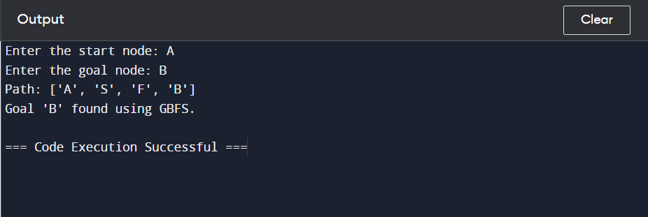

1. **A* for graph**

import heapq

def astar(graph, start, goal, heuristic, cost):

visited = set()

priority_queue = [(heuristic[start], 0, start)] # Priority queue sorted by f-value (heuristic + cost)

path_cost = {start: 0}

path = {start: None}

while priority_queue:

print("OPEN LIST:", priority_queue)

_, current_cost, current_node = heapq.heappop(priority_queue)

if current_node == goal:

return construct_path(path, start, goal)

visited.add(current_node)

for neighbor, edge_cost in graph[current_node].items():

total_cost = path_cost[current_node] + edge_cost

if neighbor not in visited or total_cost < path_cost[neighbor]:

path_cost[neighbor] = total_cost

heapq.heappush(priority_queue, (total_cost + heuristic[neighbor], total_cost, neighbor))

path[neighbor] = current_node

return None

def construct_path(path, start, goal):

current_node = goal

path_sequence = []

while current_node:

path_sequence.insert(0, current_node)

current_node = path[current_node]

return path_sequence

# Example usage

graph = {

'A': {'B': 1, 'C': 2},

'B': {'D': 3, 'E': 4},

'C': {'F': 1},

'D': {},

'E': {},

'F': {}

}

start_node = input("Enter the start node: ").upper()

goal_node = input("Enter the goal node: ").upper()

heuristic = {

'A': 3,

'B': 2,

'C': 4,

'D': 1,

'E': 1,

'F': 0

}

cost = {

'A': 0,

'B': 1,

'C': 2,

'D': 3,

'E': 4,

'F': 5

}

astar_path = astar(graph, start_node, goal_node, heuristic, cost)

print()

if astar_path:

print('Path:', astar_path)

print(f"Goal '{goal_node}' found using A*.")

else:

print(f"Goal '{goal_node}' not found using A*.")

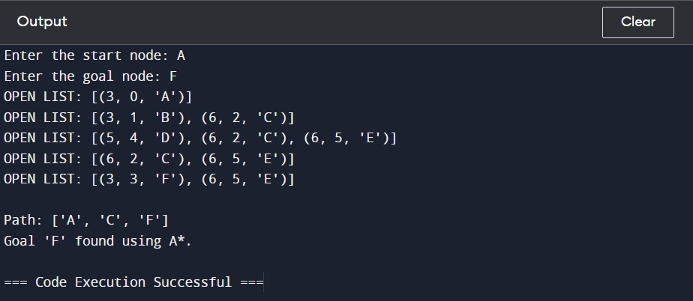

1. **A* for tree**

import heapq

class TreeNode:

def __init__(self, value, cost=None):

self.value = value

self.cost = cost

self.children = []

def __repr__(self):

return self.value

def astar_tree(root, goal, heuristic):

visited = set()

priority_queue = [(heuristic[root.value], 0, root)] # Priority queue sorted by f-value (heuristic + cost)

path_cost = {root.value: 0}

path = {root.value: None}

while priority_queue:

print("OPEN LIST:", [(f"{heuristic[node.value] + cost}, {cost}, {node}") for _, cost, node in priority_queue])

_, current_cost, current_node = heapq.heappop(priority_queue)

if current_node.value == goal:

return construct_path(path, root.value, goal)

visited.add(current_node.value)

for child, edge_cost in current_node.children:

total_cost = path_cost[current_node.value] + edge_cost

if child.value not in visited or total_cost < path_cost[child.value]:

path_cost[child.value] = total_cost

heapq.heappush(priority_queue, (total_cost + heuristic[child.value], total_cost, child))

path[child.value] = current_node.value

return None

def construct_path(path, start, goal):

current_node = goal

path_sequence = []

while current_node:

path_sequence.insert(0, current_node)

current_node = path[current_node]

return path_sequence

# Example usage

root = TreeNode('A')

root.children = [(TreeNode('B', 1), 1), (TreeNode('C', 2), 2)]

root.children[0][0].children = [(TreeNode('D', 3), 3), (TreeNode('E', 4), 4)]

root.children[1][0].children = [(TreeNode('F', 1), 1)]

start_node = input("Enter the start node: ").strip().upper()

goal_node = input("Enter the goal node: ").strip().upper()

heuristic = {

'A': 3,

'B': 2,

'C': 4,

'D': 1,

'E': 1,

'F': 0

}

astar_path = astar_tree(root, goal_node, heuristic)

print()

if astar_path:

print('Path:', astar_path)

print(f"Goal '{goal_node}' found using A*.")

else:

print(f"Goal '{goal_node}' not found using A*.")

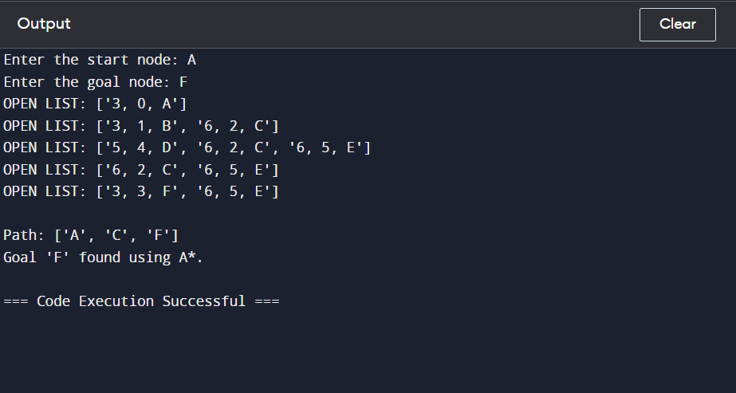

1. **Hill Climbing Algorithm**

**f(x) = -x**2**

import random

# Define the objective function

def objective_function(x):

return -x ** 2

# Generate initial solution

def generate_initial_solution():

return random.randint(-100, 100)

# Generate neighbour solutions

def generate_neighbours(solution):

neighbours = []

for delta in [-1, 1]:

neighbours.append(solution + delta)

return neighbours

# Find the best neighbour

def get_best_neighbour(neighbours):

best_neighbour = neighbours[0]

best_quality = objective_function(best_neighbour)

for neighbour in neighbours[1:]:

neighbour_quality = objective_function(neighbour)

if neighbour_quality > best_quality:

best_quality = neighbour_quality

best_neighbour = neighbour

return best_neighbour

# Hill climbing algorithm

def hill_climbing():

current_solution = generate_initial_solution()

while True:

neighbours = generate_neighbours(current_solution)

best_neighbour = get_best_neighbour(neighbours)

if objective_function(best_neighbour) <= objective_function(current_solution):

return current_solution

current_solution = best_neighbour

# Main function

def main():

best_solution = hill_climbing()

print("Best solution found:", best_solution)

print("Objective function value:", objective_function(best_solution))

# Run the main function

if __name__ == "__main__":

main()

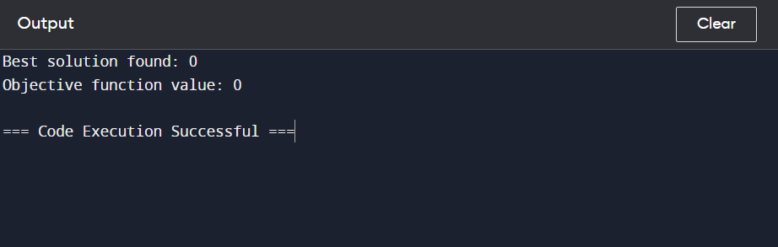

**f(x) = sinx**

import random

import math

# Define the objective function

def objective_function(x):

return math.sin(x)

# Generate initial solution

def generate_initial_solution():

return random.uniform(-math.pi, math.pi)

# Generate neighbour solutions

def generate_neighbours(solution):

neighbours = []

for delta in [-0.1, 0.1]:

neighbours.append(solution + delta)

return neighbours

# Find the best neighbour

def get_best_neighbour(neighbours):

best_neighbour = neighbours[0]

best_quality = objective_function(best_neighbour)

for neighbour in neighbours[1:]:

neighbour_quality = objective_function(neighbour)

if neighbour_quality > best_quality:

best_quality = neighbour_quality

best_neighbour = neighbour

return best_neighbour

# Hill climbing algorithm

def hill_climbing():

current_solution = generate_initial_solution()

while True:

neighbours = generate_neighbours(current_solution)

best_neighbour = get_best_neighbour(neighbours)

if objective_function(best_neighbour) <= objective_function(current_solution):

return current_solution

current_solution = best_neighbour

# Main function

def main():

best_solution = hill_climbing()

print("Best solution found:", best_solution)

print("Objective function value:", objective_function(best_solution))

# Run the main function

if __name__ == "__main__":

main()

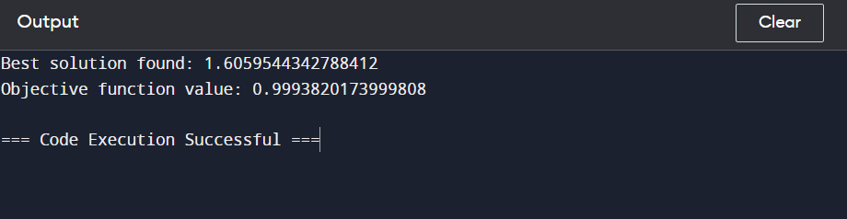

**f(x) = -5x2+3x+6**

import random

# Define the objective function

def objective_function(x):

return -(5 * x ** 2 + 3 * x + 6)

# Generate initial solution

def generate_initial_solution():

return random.uniform(-100, 100)

# Generate neighbour solutions

def generate_neighbours(solution):

neighbours = []

for delta in [-0.1, 0.1]:

neighbours.append(solution + delta)

return neighbours

# Find the best neighbour

def get_best_neighbour(neighbours):

best_neighbour = neighbours[0]

best_quality = objective_function(best_neighbour)

for neighbour in neighbours[1:]:

neighbour_quality = objective_function(neighbour)

if neighbour_quality > best_quality:

best_quality = neighbour_quality

best_neighbour = neighbour

return best_neighbour

# Hill climbing algorithm

def hill_climbing():

current_solution = generate_initial_solution()

while True:

neighbours = generate_neighbours(current_solution)

best_neighbour = get_best_neighbour(neighbours)

if objective_function(best_neighbour) <= objective_function(current_solution):

return current_solution

current_solution = best_neighbour

# Main function

def main():

best_solution = hill_climbing()

print("Best solution found:", best_solution)

print("Objective function value:", objective_function(best_solution))

# Run the main function

if __name__ == "__main__":

main()

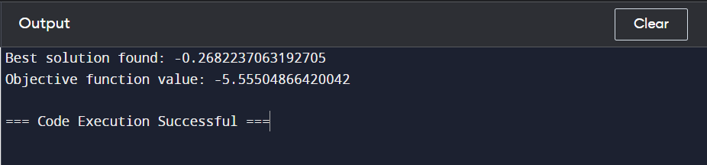

1. **Genetic Algorithm**

import random

# Step 1: Determine the number of chromosomes, generation, mutation rate, and crossover rate value

def genetic_algorithm(num_chromosomes, mutation_rate, crossover_rate, num_variables):

# Step 2: Generate chromosome population with random initialization

population = generate_population(num_chromosomes, num_variables)

i = int(1)

while True:

# Step 3: Evaluation of fitness value of chromosomes

fitness_values = [fitness_function(chromosome) for chromosome in population]

# Step 8: Solution (Best Chromosomes)

best_chromosome = population[fitness_values.index(min(fitness_values))]

# print(f"Generation {i}: solution: {best_chromosome}, Fitness: {min(fitness_values)}")

if min(fitness_values) == 0:

print(f"\nGeneration {i}: Best solution: {best_chromosome}, Fitness: {min(fitness_values)}")

print(f"Optimal Solution after {i} Generations")

break

i = i + 1

next_generation = []

# Step 5: Chromosomes selection

selected_population = selection(population, fitness_values)

for _ in range(num_chromosomes // 2):

parent1, parent2 = selected_population[random.randint(0, len(selected_population) - 1)], selected_population[random.randint(0, len(selected_population) - 1)]

# Step 6: Crossover

child1, child2 = crossover(parent1, parent2, crossover_rate)

# Step 7: Mutation

child1 = mutation(child1, mutation_rate)

child2 = mutation(child2, mutation_rate)

next_generation.extend([child1, child2])

population = next_generation

return best_chromosome

# Step 2: Generate initial population

def generate_population(size, num_variables):

population = []

for _ in range(size):

individual = [random.randint(0, 10) for _ in range(num_variables)]

population.append(individual)

return population

# Step 4: Fitness function evaluation

def fitness_function(variables):

x, y, z, w = variables

return abs((a + 2*b + 3*c + 4*d) - 30)

# Step 5: Chromosome selection using roulette wheel selection

def selection(population, fitness_values):

selected_population = []

total_fitness = sum(fitness_values)

probabilities = [fitness / total_fitness for fitness in fitness_values]

for _ in range(len(population)):

selected = random.choices(population, probabilities)[0]

selected_population.append(selected)

return selected_population

# Step 6: Crossover

def crossover(parent1, parent2, crossover_rate):

if random.random() < crossover_rate:

crossover_point = random.randint(1, len(parent1) - 1)

child1 = parent1[:crossover_point] + parent2[crossover_point:]

child2 = parent2[:crossover_point] + parent1[crossover_point:]

return child1, child2

return parent1, parent2

# Step 7: Mutation

def mutation(individual, mutation_rate):

if random.random() < mutation_rate:

index = random.randint(0, len(individual) - 1)

new_value = random.randint(0, 10)

individual[index] = new_value

return individual

def get_input():

num_chromosomes = int(input("Enter the number of chromosomes: "))

mutation_rate = float(input("Enter the mutation rate: "))

crossover_rate = float(input("Enter the crossover rate: "))

num_variables = 4 # Assuming 4 variables (a,b,c,d) for the given equation

return num_chromosomes, mutation_rate, crossover_rate, num_variables

def main():

num_chromosomes, mutation_rate, crossover_rate, num_variables = get_input()

best_chromosome = genetic_algorithm(num_chromosomes, mutation_rate, crossover_rate, num_variables)

print("Best solution:", best_chromosome)

if __name__ == "__main__":

main()

