MODULE 2

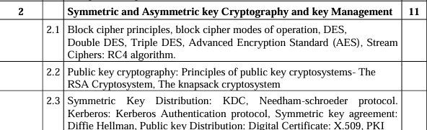

Q. Explain different modes of block cipher -IMP

Block ciphers encrypt data in fixed-size blocks, typically 64 or 128 bits, using a cryptographic key. Different modes of operation specify how these block ciphers are applied to encrypt plaintext data of arbitrary length. Each mode has its unique characteristics and is suitable for different use cases. Here are some common modes of operation for block ciphers:

1. **Electronic Codebook (ECB)**:

- **Description**: Each block of plaintext is encrypted independently using the same key.

- **Characteristics**:

- Simple and easy to implement.

- Identical plaintext blocks encrypt to identical ciphertext blocks, which can reveal patterns in the data.

- Vulnerable to known plaintext attacks and frequency analysis.

- **Use Cases**: Not recommended for most applications due to its vulnerabilities. Sometimes used for encrypting short, fixed-size messages where data patterns are not a concern.

2. **Cipher Block Chaining (CBC)**:

- **Description**: Each plaintext block is XORed with the previous ciphertext block before encryption.

- **Characteristics**:

- Provides confidentiality and requires an initialization vector (IV) to start the chain.

- Suitable for encrypting large messages and provides better security than ECB.

- Parallelization is limited due to the chaining of blocks.

- **Use Cases**: Widely used in applications requiring strong confidentiality guarantees, such as VPNs and disk encryption.

3. **Cipher Feedback (CFB)**:

- **Description**: The previous ciphertext block is encrypted and used as the keystream to encrypt the next plaintext block.

- **Characteristics**:

- Allows for streaming encryption and decryption, as it operates on a bit-by-bit basis.

- Error propagation is limited, as errors in one block affect only subsequent blocks.

- Less efficient than CBC due to the need for block-level encryption during operation.

- **Use Cases**: Suitable for applications requiring streaming encryption or where random access to encrypted data is needed.

4. **Output Feedback (OFB)**:

- **Description**: Similar to CFB, but the keystream is generated independently of the plaintext.

- **Characteristics**:

- Enables streaming encryption and decryption with minimal error propagation.

- The keystream can be precomputed independently of the plaintext, allowing for parallelization.

- The same keystream is used for both encryption and decryption.

- **Use Cases**: Suitable for applications requiring streaming encryption or random access to encrypted data, such as file storage systems.

5. **Counter (CTR)**:

- **Description**: Uses a counter value as the input to the block cipher to generate a keystream.

- **Characteristics**:

- Enables parallel encryption and decryption of blocks, as each block can be encrypted independently.

- Suitable for parallel processing and high-speed encryption, as it does not require chaining or feedback.

- The counter value must be unique for each plaintext block to maintain security.

- **Use Cases**: Widely used in applications requiring high-speed encryption, such as disk encryption and network communication protocols like TLS.

These modes can be combined with padding schemes like PKCS#5/PKCS#7 to handle plaintexts of arbitrary length. Each mode offers different trade-offs in terms of security, performance, and suitability for specific use cases. It's essential to understand these characteristics when selecting a mode for a particular application.

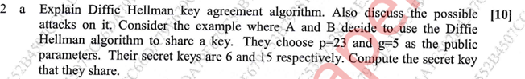



Q. Explain AES algorithm. Highlight the difference between AES and DES (10M)

**AES (Advanced Encryption Standard)**

AES (Advanced Encryption Standard) is a symmetric block cipher algorithm used to encrypt and decrypt data. It was established as a standard by the U.S. National Institute of Standards and Technology (NIST) in 2001, replacing the older DES (Data Encryption Standard) algorithm. AES operates on fixed-size blocks of 128 bits and supports key sizes of 128, 192, or 256 bits.

**Key Features of AES:**

1. **Block Size**: 128 bits (16 bytes)
2. **Key Sizes**: 128, 192, or 256 bits
3. **Rounds**: The number of rounds depends on the key size (10 rounds for 128-bit keys, 12 rounds for 192-bit keys, and 14 rounds for 256-bit keys).
4. **Substitution-Permutation Network**: AES uses a substitution-permutation network (SPN) to perform encryption and decryption operations.

**Encryption Process:**

1. **Key Expansion**: The original key is expanded into a key schedule containing round keys.
2. **Initial Round**: AddRoundKey operation XORs the plaintext with the initial round key.
3. **Rounds**: Multiple rounds of SubBytes, ShiftRows, MixColumns, and AddRoundKey operations are performed.
4. **Final Round**: The last round excludes the MixColumns operation.
5. **Output**: The final ciphertext is produced.

**Difference between AES and DES**

| **Feature** | **AES** | **DES** |
| --- | --- | --- |
| **Block Size** | 128 bits | 64 bits |
| **Key Size** | 128, 192, or 256 bits | 56 bits (with 8 bits used for parity) |
| **Rounds** | 10/12/14 rounds depending on key size | 16 rounds |
| **Key Expansion** | Key schedule generates round keys | Key is permuted and shifted for each round |
| **Substitution** | Uses S-box substitution | Uses fixed S-box substitution |
| **Permutation** | Uses permutation in MixColumns step | Uses permutation in several steps |
| **Security** | More secure due to larger key and block size | Less secure due to smaller key size and limited block size |
| **Performance** | Generally faster due to more efficient algorithms | Slower due to more complex operations |
| **Suitability** | Widely used in various applications requiring strong security | Deprecated due to its vulnerability to brute-force attacks |

**Comparison between AES and DES**

| **Aspect** | **AES** | **DES** |
| --- | --- | --- |
| **Block Size** | 128 bits | 64 bits |
| **Key Size** | 128/192/256 bits | 56 bits (with 8 bits used for parity) |
| **Rounds** | 10/12/14 rounds depending on key size | 16 rounds |
| **Key Expansion** | Key schedule generates round keys | Key permuted and shifted for each round |
| **Security** | More secure due to larger key size and block size | Less secure due to smaller key size and limited block size |
| **Performance** | Generally faster due to more efficient algorithms | Slower due to more complex operations |

**Example:**

Let's encrypt a plaintext "HELLO123" using both AES and DES algorithms with a key of 128 bits.

**AES Encryption:**

* **Plaintext**: "HELLO123"
* **Key**: 128-bit key (e.g., 0x2b7e151628aed2a6abf7158809cf4f3c)
* **Ciphertext**: e.g., 0x3925841d02dc09fbdc118597196a0b32

**DES Encryption:**

* **Plaintext**: "HELLO123"
* **Key**: 56-bit key (e.g., 0x133457799BBCDFF1)
* **Ciphertext**: e.g., 0x85e813540f0ab405

**Summary:**

AES is a more secure and efficient encryption algorithm compared to DES, offering larger key and block sizes, improved security features, and better performance. It is widely used in various applications requiring strong security guarantees. DES, on the other hand, is deprecated due to its vulnerability to brute-force attacks and limited key size.

Q. Explain Kerberos as an authentication service(10M)-IMP

Kerberos is a network authentication protocol that provides strong authentication for client/server applications by using secret-key cryptography. It was developed by MIT as part of Project Athena in the 1980s and is now widely used in many networks, including Microsoft Windows Active Directory environments.

### Key Components of Kerberos:

1. **Authentication Server (AS)**:

- The AS is responsible for authenticating users and providing initial authentication tokens called tickets.

- It verifies the identity of users based on their credentials (e.g., passwords) stored in a central database known as the Key Distribution Center (KDC) database.

2. **Ticket Granting Server (TGS)**:

- The TGS issues service tickets to users after they have been authenticated by the AS.

- Users present these tickets to access various network services.

3. **Key Distribution Center (KDC)**:

- The KDC consists of the AS and the TGS.

- It stores user credentials and secret keys for encryption and authentication.

- The KDC database stores information about users, their passwords (or password hashes), and service principal names (SPNs).

4. **Client**:

- The client is the entity seeking authentication and access to network services.

- It communicates with the AS and TGS to obtain the necessary tickets for accessing services.

5. **Service Server**:

- The service server hosts network services that clients want to access.

- It validates the tickets presented by clients to grant access to the requested services.

### Authentication Process:

1. **Authentication Phase**:

- The client authenticates itself to the AS by sending a plaintext message containing its identity (e.g., username) to request a Ticket Granting Ticket (TGT).

- The AS verifies the client's identity, retrieves the client's secret key from the KDC database, and creates a TGT encrypted with the client's secret key. The TGT is sent back to the client.

2. **Ticket Granting Phase**:

- The client presents the TGT to the TGS along with a request for a service ticket to access a specific network service.

- The TGS verifies the TGT's authenticity, extracts the client's secret key from the TGT, and generates a service ticket encrypted with the service's secret key. The service ticket is sent back to the client.

3. **Service Access Phase**:

- The client presents the service ticket to the service server along with a request to access the desired service.

- The service server validates the service ticket's authenticity and grants access to the requested service if the ticket is valid.

### Advantages of Kerberos:

- **Strong Authentication**: Kerberos uses symmetric-key cryptography to securely authenticate users and services, preventing unauthorized access.

- **Single Sign-On (SSO)**: Users only need to authenticate once to obtain tickets for accessing multiple network services, reducing the need for repeated logins.

- **Mutual Authentication**: Both clients and services authenticate each other during the ticket exchange process, enhancing security.

- **Centralized Management**: User authentication and authorization are centralized in the KDC, simplifying administration and access control.

### Limitations of Kerberos:

- **Dependence on Time Synchronization**: Kerberos relies on synchronized clocks between clients, servers, and the KDC. Clock skew can cause authentication failures.

- **Single Point of Failure**: The KDC is a critical component, and its failure can disrupt authentication services for the entire network.

- **Complexity**: Setting up and configuring Kerberos can be complex, requiring careful planning and administration.

- **Ticket Renewal Overhead**: Users need to periodically renew their tickets to maintain access, which adds overhead to the authentication process.

Despite its limitations, Kerberos remains one of the most widely used authentication protocols for securing network communications and protecting against unauthorized access.

Q. Explain ECB and CBC modes of block cipher (5M)(X2)

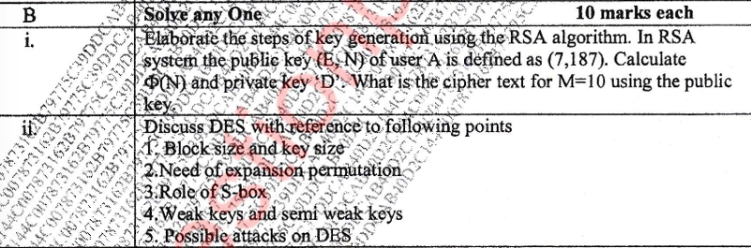



Q. Explain working of TGS in Kerberos(5M)

The Ticket Granting Service (TGS) is a crucial component in the Kerberos authentication protocol. Its primary function is to issue service tickets to clients after they have been authenticated by the Authentication Service (AS). The TGS operates as part of the Key Distribution Center (KDC), alongside the AS, and facilitates secure access to various network services.

### Working of TGS in Kerberos:

1. **Client Authentication**:

- When a client wishes to access a network service, it first authenticates itself to the AS by sending a plaintext message containing its identity (e.g., username) and a request for a Ticket Granting Ticket (TGT).

- The AS verifies the client's identity, retrieves the client's secret key from the KDC database, and creates a TGT encrypted with the client's secret key. The TGT is then sent back to the client.

2. **Obtaining Service Tickets**:

- Once the client has obtained the TGT, it can request service tickets from the TGS to access specific network services.

- The client presents the TGT to the TGS along with a request for a service ticket for the desired service.

3. **Ticket Validation**:

- The TGS verifies the authenticity of the TGT presented by the client. It decrypts the TGT using the client's secret key to retrieve the client's identity and session key.

- If the TGT is valid, the TGS generates a service ticket for the requested service. The service ticket includes the client's identity, the service's identity (Service Principal Name - SPN), and a session key encrypted with the service's secret key.

4. **Service Ticket Issuance**:

- The TGS encrypts the service ticket with the service's secret key and sends it back to the client.

- The client receives the service ticket and forwards it to the service server when requesting access to the desired service.

5. **Service Access**:

- The service server receives the service ticket from the client along with the request to access the service.

- The service server decrypts the service ticket using its secret key to validate the ticket's authenticity and retrieve the session key.

- If the service ticket is valid, the service server grants access to the requested service using the session key provided in the ticket.

### Key Points:

- The TGS acts as an intermediary between clients and network services, facilitating secure access to services after initial authentication.

- Service tickets issued by the TGS are encrypted with the service's secret key, ensuring that only the intended service can decrypt and validate the tickets.

- The TGS enforces access control policies by verifying the client's identity and ensuring that it has appropriate permissions to access the requested service.

- By issuing service tickets with session keys, the TGS enables clients and services to establish secure communication sessions without the need for further authentication.

In summary, the Ticket Granting Service (TGS) plays a vital role in the Kerberos authentication protocol by providing clients with secure access to network services through the issuance of service tickets. Its operation ensures that only authenticated and authorized clients can access the services they request.

Q. What is the purpose of S-boxes in DES? Explain the avalance effect(5M)

In the Data Encryption Standard (DES), Substitution Boxes (S-boxes) are a critical component used in the process of substitution-permutation network (SPN). The primary purpose of S-boxes is to introduce non-linearity into the encryption algorithm, enhancing its security against various cryptanalytic attacks, such as differential and linear cryptanalysis.

### Purpose of S-boxes in DES:

1. **Non-Linearity**:

- S-boxes introduce non-linearity into the encryption process by mapping input bit patterns to output bit patterns in a non-linear fashion.

- This non-linear transformation ensures that small changes in the input result in significant changes in the output, making it harder for attackers to exploit linear relationships between plaintext and ciphertext.

2. **Confusion**:

- S-boxes add confusion to the encryption process by making the relationship between the input and output of the algorithm complex and difficult to analyze.

- Each S-box performs a unique substitution based on the input bits, making it challenging for attackers to predict the output without knowledge of the S-box contents.

3. **Diffusion**:

- S-boxes contribute to the diffusion of input bits throughout the encryption process, ensuring that changes in one part of the input affect multiple parts of the output.

- This diffusion property helps spread the influence of input bits across the entire ciphertext, increasing the complexity of cryptanalysis.

### Avalanche Effect:

The avalanche effect refers to the desirable property of encryption algorithms where a small change in the input (plaintext or key) results in a significant change in the output (ciphertext). In other words, even a minor alteration in the input should cause a drastic change in the resulting ciphertext.

### How S-boxes Contribute to the Avalanche Effect:

1. **Non-Linearity**:

- S-boxes introduce non-linear transformations to the input data, ensuring that small changes in the input bits propagate through the encryption algorithm in a non-linear manner.

- This non-linearity amplifies the impact of input changes on the output ciphertext, leading to a significant alteration in the ciphertext even with minor modifications in the input.

2. **Confusion and Diffusion**:

- By adding confusion and diffusion to the encryption process, S-boxes ensure that changes in one part of the input affect multiple parts of the output ciphertext.

- This spreading of changes throughout the encryption process contributes to the avalanche effect by making the relationship between the input and output of the algorithm highly complex and unpredictable.

### Importance of Avalanche Effect:

- The avalanche effect is crucial for cryptographic algorithms as it helps prevent attackers from deducing information about the plaintext or key from the ciphertext.

- A strong avalanche effect ensures that even minor changes in the input result in significant changes in the output, making it extremely difficult for attackers to analyze or break the encryption algorithm.

In summary, S-boxes in DES play a vital role in introducing non-linearity, confusion, and diffusion into the encryption process, contributing to the avalanche effect and enhancing the security of the algorithm against various cryptanalytic attacks.

Q. Explain man in middle attack on Diffie Hellman. Explain how to overcome the same(10M)(X2)

A Man-in-the-Middle (MITM) attack on the Diffie-Hellman key exchange protocol involves an attacker intercepting and possibly altering the key exchange messages between two parties, leading to the attacker obtaining the shared secret key without the knowledge of the legitimate parties. The attacker can then use this key to decrypt and eavesdrop on the communication between the legitimate parties.

### Working of MITM Attack on Diffie-Hellman:

1. **Interception**:

- The attacker intercepts the initial public key exchange messages between Alice and Bob during the Diffie-Hellman key exchange process.

2. **Spoofing**:

- The attacker intercepts Alice's public key and replaces it with their own public key when sending it to Bob.

- Similarly, the attacker intercepts Bob's public key and replaces it with their own public key when sending it to Alice.

3. **Secret Key Derivation**:

- Since Alice and Bob are now unknowingly exchanging public keys with the attacker instead of each other, the attacker can compute a shared secret key with both Alice and Bob.

- Alice and Bob also compute a shared secret key with the attacker, believing they are communicating with each other.

4. **Eavesdropping**:

- With the shared secret key obtained from both Alice and Bob, the attacker can decrypt and eavesdrop on the communication between Alice and Bob without their knowledge.

### Mitigation Techniques:

1. **Authentication**:

- Implement mutual authentication to ensure that both parties can verify each other's identities before proceeding with the key exchange.

- Certificates issued by trusted Certificate Authorities (CAs) can be used for authentication.

2. **Key Verification**:

- After the key exchange, Alice and Bob can verify that they have derived the same shared secret key by exchanging a hash of the key or by using a secure channel to compare the keys.

3. **Digital Signatures**:

- Use digital signatures to sign the exchanged public keys and ensure their authenticity.

- Verification of digital signatures ensures that the received public key belongs to the intended party and has not been tampered with.

4. **Forward Secrecy**:

- Implement forward secrecy by regularly generating new keys for each communication session.

- Even if an attacker manages to intercept and decrypt past communications, they will not be able to decrypt future communications since each session uses a unique key.

5. **Key Exchange Protocols**:

- Use authenticated key exchange protocols, such as the Elliptic Curve Diffie-Hellman (ECDH) protocol, which integrates key exchange with authentication to prevent MITM attacks.

6. **Out-of-Band Verification**:

- Use out-of-band channels, such as phone calls or physical meetings, to exchange cryptographic information (such as public keys or key fingerprints) and verify the authenticity of the exchanged information.

By implementing these mitigation techniques, parties can reduce the risk of MITM attacks on the Diffie-Hellman key exchange protocol and ensure the security of their communication channels.

Q. Explain Kerberos in detail. (10M)(X2)

Q. What is PKI? List its components(10M)

PKI stands for Public Key Infrastructure, which is a system of hardware, software, policies, and standards used to manage digital certificates and public-private key pairs. PKI provides a framework for secure communication and authentication over insecure networks, such as the internet. It enables users and systems to securely exchange data and verify the identity of parties involved in communication.

### Components of PKI:

1. **Certificate Authority (CA)**:

- The Certificate Authority is a trusted entity responsible for issuing, revoking, and managing digital certificates.

- CAs verify the identity of certificate applicants and sign their public keys to create digital certificates.

- Trusted root CAs form the backbone of the PKI hierarchy and are pre-installed in web browsers and operating systems.

2. **Registration Authority (RA)**:

- The Registration Authority is responsible for verifying the identity of certificate applicants before forwarding their certificate requests to the CA.

- RAs act as intermediaries between users and the CA, validating identity documents and collecting necessary information for certificate issuance.

3. **Certificate Revocation Lists (CRLs)**:

- CRLs are lists maintained by CAs containing the serial numbers of revoked certificates.

- Clients can check CRLs to determine if a certificate has been revoked before trusting it for authentication or encryption.

4. **Online Certificate Status Protocol (OCSP)**:

- OCSP is a protocol used to check the revocation status of digital certificates in real-time.

- Clients send requests to OCSP responders to verify the status of certificates, receiving responses indicating whether the certificates are valid, revoked, or unknown.

5. **Certificate Policy (CP)** and Certificate Practice Statement (CPS)**:

- CP and CPS documents define the policies and procedures followed by the CA for issuing and managing digital certificates.

- CP outlines the overall policy framework, while CPS provides detailed operational practices and procedures.

6. **Certificate Templates**:

- Certificate templates define the format and contents of digital certificates issued by the CA.

- Templates specify the cryptographic algorithms, key lengths, expiration periods, and other parameters used in certificate generation.

7. **Key Management Infrastructure (KMI)**:

- KMI includes tools and processes for managing public and private key pairs, including key generation, storage, backup, and recovery.

- KMI ensures the security and integrity of cryptographic keys used in PKI operations.

8. **Public Key Cryptography Standards (PKCS)**:

- PKCS are a set of standards developed by RSA Laboratories that define formats and protocols for public key cryptography operations.

- PKCS standards cover topics such as key generation, encryption, digital signatures, and certificate management.

9. **Hardware Security Modules (HSMs)**:

- HSMs are dedicated hardware devices used to generate, store, and manage cryptographic keys securely.

- HSMs provide tamper-resistant protection for private keys, preventing unauthorized access or extraction.

10. **End Entities (Users and Devices)**:

- End entities are users, devices, or systems that utilize digital certificates for authentication, encryption, or digital signatures.

- End entities request and use digital certificates to establish secure communication channels and verify the identity of other parties.

These components work together to establish and maintain a trusted PKI infrastructure, enabling secure communication, authentication, and data protection in various applications and industries.

Q. What is digital certificate? How does it help to validate authenticity of a user. Explain X.509 certificate format.(10M)

A digital certificate, also known as a public key certificate, is a digital document that serves as an electronic credential issued by a Certificate Authority (CA). It contains information about an entity (such as an individual, organization, or device) and their corresponding public key. Digital certificates are used in Public Key Infrastructure (PKI) systems to authenticate users, encrypt data, and establish secure communication channels over insecure networks like the internet.

### Purpose of Digital Certificates:

1. **Authentication**: Digital certificates are used to verify the identity of individuals, organizations, or devices in online transactions and communications. They provide assurance that the public key associated with the certificate belongs to the entity identified in the certificate.

2. **Data Encryption**: Digital certificates are used to encrypt sensitive data exchanged between parties, ensuring confidentiality and privacy. The recipient's public key contained in the certificate is used to encrypt the data, which can only be decrypted by the corresponding private key held by the recipient.

3. **Digital Signatures**: Digital certificates are used to create digital signatures, which are cryptographic proofs of the authenticity and integrity of digital documents or messages. The sender signs the document with their private key, and the recipient can verify the signature using the sender's public key contained in the certificate.

### Validation of Authenticity:

To validate the authenticity of a user or entity using a digital certificate, the following steps are typically performed:

1. **Certificate Retrieval**: The digital certificate of the user or entity is obtained from a trusted source, such as a Certificate Authority (CA) or a public directory.

2. **Certificate Examination**: The digital certificate is examined to verify its authenticity and integrity. This involves checking the certificate's digital signature against the public key of the issuing CA to ensure that it has not been tampered with.

3. **Certificate Issuer Verification**: The identity of the CA that issued the certificate is verified to ensure that it is a trusted authority and not a rogue entity.

4. **Certificate Chain Validation**: If the certificate is not directly issued by a trusted root CA, its chain of trust is validated by checking the signatures of intermediate CAs until a trusted root CA is reached.

5. **Certificate Expiry Check**: The validity period of the certificate is checked to ensure that it has not expired and is still within its validity period.

6. **Revocation Status Check**: The revocation status of the certificate is checked against Certificate Revocation Lists (CRLs) or Online Certificate Status Protocol (OCSP) responders to ensure that it has not been revoked.

### X.509 Certificate Format:

X.509 is a widely used standard for digital certificates defined by the International Telecommunication Union (ITU) and International Organization for Standardization (ISO). An X.509 certificate consists of the following components:

1. **Version**: Indicates the version of the X.509 standard used to encode the certificate (e.g., v1, v2, v3).

2. **Serial Number**: A unique identifier assigned by the CA to the certificate.

3. **Issuer**: The distinguished name (DN) of the CA that issued the certificate.

4. **Validity Period**: The period during which the certificate is considered valid, including the start and end dates.

5. **Subject**: The DN of the entity to which the certificate is issued (e.g., individual's name, organization's name).

6. **Public Key**: The public key of the entity, used for encryption, authentication, and digital signatures.

7. **Certificate Extensions**: Optional fields containing additional information, such as key usage, subject alternative names, and certificate policies.

8. **Digital Signature**: The digital signature of the CA, created using its private key, to validate the authenticity and integrity of the certificate.

X.509 certificates are encoded using ASN.1 (Abstract Syntax Notation One) and can be stored in various formats, such as PEM (Privacy-Enhanced Mail), DER (Distinguished Encoding Rules), and PFX/P12 (Personal Information Exchange). They are widely used in SSL/TLS for securing web communication, email encryption, VPNs, and other applications requiring secure authentication and data protection.

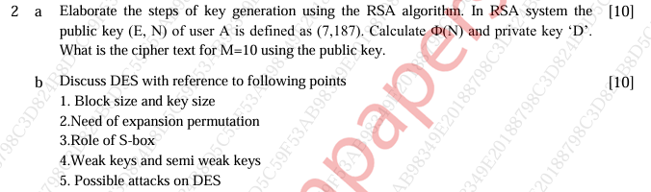



Q. Explain Kerberos. Why is it called an SSO?(10M)

Kerberos is a network authentication protocol designed to provide secure authentication for client-server applications over insecure networks, such as the internet. Developed by MIT, Kerberos operates as a trusted third-party authentication system and uses symmetric-key cryptography to authenticate clients and servers. It offers strong security features and is widely used in enterprise environments, including Microsoft Windows Active Directory.

### Key Components of Kerberos:

1. **Authentication Server (AS)**:

- The AS verifies the identity of clients and issues initial authentication tokens called Ticket Granting Tickets (TGTs).

- Clients authenticate themselves to the AS using their credentials (e.g., passwords).

2. **Ticket Granting Server (TGS)**:

- The TGS grants service tickets to clients after they authenticate with the AS.

- Clients present their TGTs to the TGS to obtain service tickets for accessing specific network services.

3. **Key Distribution Center (KDC)**:

- The KDC combines the functionalities of the AS and TGS.

- It stores user credentials, secret keys, and encryption keys used for authentication and encryption.

4. **Client**:

- The client is the entity seeking authentication and access to network services.

- It communicates with the AS and TGS to obtain tickets for accessing services.

5. **Service Server**:

- The service server hosts network services that clients want to access.

- It verifies service tickets presented by clients and grants access to the requested services.

### Why Kerberos is called Single Sign-On (SSO)?

Kerberos is often referred to as Single Sign-On (SSO) because of its ability to provide seamless authentication across multiple network services with a single login. Here's why Kerberos is considered an SSO solution:

1. **One-Time Authentication**: Users authenticate themselves to the Kerberos AS once during their login session, typically using their username and password. After successful authentication, Kerberos issues a Ticket Granting Ticket (TGT) to the user.

2. **Ticket-based Authentication**: With the TGT obtained from the AS, users can request service tickets from the TGS without needing to re-authenticate for each service they access. The TGT serves as proof of authentication and eliminates the need for repeated logins.

3. **Transparent Access to Services**: Users present their service tickets to access various network services without needing to enter their credentials again. The service tickets provided by Kerberos authenticate the users to the requested services, allowing seamless access without additional authentication steps.

4. **Centralized Authentication**: Kerberos centralizes user authentication and eliminates the need for individual services to manage user credentials. This simplifies user management and access control, enhancing security and usability.

In summary, Kerberos acts as a Single Sign-On (SSO) solution by providing users with seamless authentication and transparent access to multiple network services with a single login session. It simplifies the authentication process, improves user experience, and enhances security in enterprise environments.

Q. Compare AES and DES. Which one is bit oriented? Which one is byte oriented?(5M)

AES (Advanced Encryption Standard) and DES (Data Encryption Standard) are both symmetric block ciphers used for encryption and decryption, but they have significant differences in terms of security, key size, block size, and encryption algorithm. Let's compare them:

### AES (Advanced Encryption Standard):

1. **Security**:

- AES is considered more secure than DES due to its larger key size and block size.

- AES supports key sizes of 128, 192, or 256 bits, providing stronger encryption against brute-force attacks.

- AES has been extensively analyzed and standardized by NIST, ensuring its security and widespread adoption.

2. **Block Size**:

- AES operates on fixed-size blocks of 128 bits (16 bytes).

- Each block is processed independently during encryption and decryption.

3. **Key Size**:

- AES supports key sizes of 128, 192, or 256 bits, depending on the desired level of security.

- Longer key sizes provide stronger encryption but may impact performance.

4. **Encryption Algorithm**:

- AES uses a substitution-permutation network (SPN) to perform encryption and decryption operations.

- The encryption process consists of multiple rounds of substitution, permutation, and mixing operations.

### DES (Data Encryption Standard):

1. **Security**:

- DES is considered less secure than AES due to its smaller key size and vulnerability to brute-force attacks.

- The 56-bit key size used in DES makes it susceptible to exhaustive key search attacks.

2. **Block Size**:

- DES operates on fixed-size blocks of 64 bits (8 bytes).

- Each block is processed independently during encryption and decryption.

3. **Key Size**:

- DES supports a fixed key size of 56 bits, which is considered insufficient for modern security requirements.

- Triple DES (3DES) improves security by applying the DES algorithm three times with different keys, resulting in a key size of 168 bits.

4. **Encryption Algorithm**:

- DES uses a Feistel network structure to perform encryption and decryption operations.

- The encryption process consists of multiple rounds of permutation, substitution, and XOR operations.

### Bit-oriented vs. Byte-oriented:

- **AES**: AES is byte-oriented because it operates on fixed-size blocks of 128 bits (16 bytes). Each byte within the block is processed independently during encryption and decryption.

- **DES**: DES is bit-oriented because it operates on fixed-size blocks of 64 bits (8 bytes). Each bit within the block is processed independently during encryption and decryption.

In summary, AES is generally considered more secure and efficient than DES, primarily due to its larger key size and block size. AES operates on fixed-size blocks of 128 bits and is byte-oriented, while DES operates on fixed-size blocks of 64 bits and is bit-oriented.

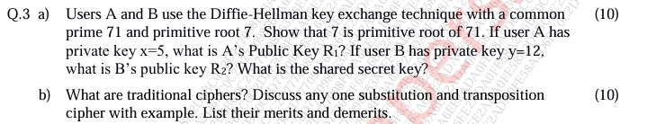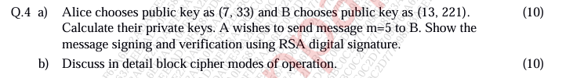



Q. Short note on: Kerberos , 3DES , X.509

### Kerberos:

Kerberos is a network authentication protocol designed to provide secure authentication between clients and servers over insecure networks. Developed by MIT, Kerberos uses symmetric-key cryptography and operates as part of a trusted third-party authentication server. Key features of Kerberos include:

- **Authentication Server (AS)**: Verifies the identity of clients and issues tickets for accessing network services.

- **Ticket Granting Server (TGS)**: Grants service tickets to clients after they authenticate with the AS, allowing access to specific network services.

- **Key Distribution Center (KDC)**: Centralizes authentication services and stores user credentials and encryption keys.

- **Mutual Authentication**: Both clients and servers authenticate each other during the ticket exchange process.

- **Single Sign-On (SSO)**: Clients only need to authenticate once to obtain tickets for accessing multiple network services.

- **Security**: Utilizes strong encryption and authentication mechanisms to prevent unauthorized access and protect communication channels.

### 3DES (Triple DES):

Triple DES (3DES) is a symmetric-key block cipher based on the Data Encryption Standard (DES). It applies the DES algorithm three times with different keys (keying option 3) to enhance security. Key features of 3DES include:

- **Key Size**: Uses a 168-bit key derived from three 56-bit DES keys, providing increased security compared to single DES.

- **Compatibility**: Maintains compatibility with existing DES implementations and infrastructure.

- **Security**: Offers improved security over single DES due to the use of multiple encryption rounds and keys.

- **Block Size**: Operates on fixed-size blocks of 64 bits, similar to DES.

- **Slow Performance**: Slower than modern encryption algorithms like AES due to its reliance on the DES algorithm and multiple encryption operations.

### X.509:

X.509 is a standard format for digital certificates used in Public Key Infrastructure (PKI) systems. It defines the structure and encoding rules for digital certificates and is widely used for authentication, encryption, and digital signatures. Key features of X.509 certificates include:

- **Format**: Specifies the format and contents of digital certificates, including fields for identifying the issuer, subject, public key, validity period, and digital signature.

- **Standardization**: Defined by the International Telecommunication Union (ITU) and International Organization for Standardization (ISO).

- **Interoperability**: Ensures interoperability between different PKI systems and implementations.

- **Security**: Enables secure authentication and communication over insecure networks by verifying the authenticity and integrity of digital certificates.

- **Extensions**: Supports extensions for additional information, such as key usage, subject alternative names, and certificate policies.

In summary, Kerberos provides secure authentication services for network communication, 3DES enhances security by applying the DES algorithm multiple times, and X.509 defines the format for digital certificates used in PKI systems. These technologies play vital roles in ensuring the security, integrity, and authenticity of digital communications in various domains.

Q. Why digital signature and digital certificates are required?(5M)

Digital signatures and digital certificates are required to ensure the authenticity, integrity, and non-repudiation of electronic documents, messages, and transactions in digital communications. Here's why they are necessary:

### Digital Signatures:

1. **Authentication**: Digital signatures authenticate the identity of the sender or signer of a digital document or message. They provide assurance that the document or message was indeed created and sent by the claimed sender.

2. **Integrity**: Digital signatures ensure the integrity of digital documents or messages by detecting any alterations or tampering. Any modification to the signed content would invalidate the digital signature, alerting the recipient to potential tampering.

3. **Non-Repudiation**: Digital signatures provide non-repudiation, meaning that the signer cannot later deny the authenticity of the signature or claim that they did not sign the document. This is crucial for legal and regulatory purposes, as it holds the signer accountable for their actions.

4. **Verification**: Recipients can verify the authenticity and integrity of digitally signed documents or messages using the signer's public key. If the signature is valid, it confirms that the document originated from the claimed sender and has not been altered since signing.

### Digital Certificates:

1. **Identity Verification**: Digital certificates verify the identity of individuals, organizations, or devices in digital communications. They provide a trusted mechanism for associating a public key with a specific entity, ensuring that the public key belongs to the claimed owner.

2. **Key Distribution**: Digital certificates facilitate the secure distribution of public keys in a Public Key Infrastructure (PKI). Instead of manually exchanging public keys, users can obtain digital certificates issued by trusted Certificate Authorities (CAs) to verify the authenticity of public keys.

3. **Trust Establishment**: Digital certificates establish trust between parties in digital communications. Users trust digital certificates issued by trusted CAs, enabling them to confidently communicate and transact with other parties over insecure networks like the internet.

4. **Encryption and Authentication**: Digital certificates are used in conjunction with public key cryptography to encrypt data, authenticate users, and establish secure communication channels. They enable secure authentication and encryption without the need for pre-shared secrets or manual key exchange.

In summary, digital signatures and digital certificates are essential components of secure digital communications, providing mechanisms for authentication, integrity, non-repudiation, and trust establishment in electronic transactions and interactions. They play a crucial role in ensuring the security and reliability of digital communications in various domains, including e-commerce, banking, government, and healthcare.

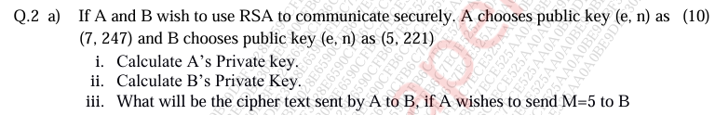



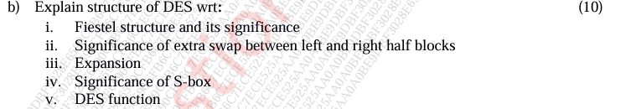

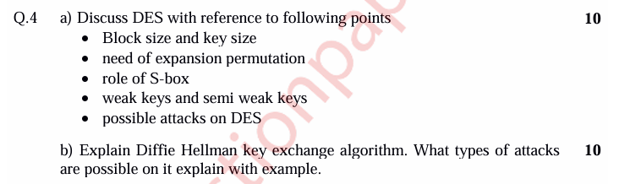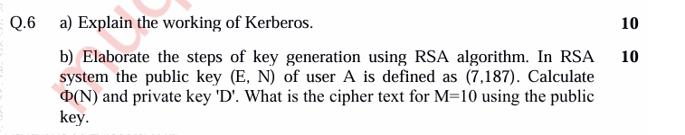



AARTI:

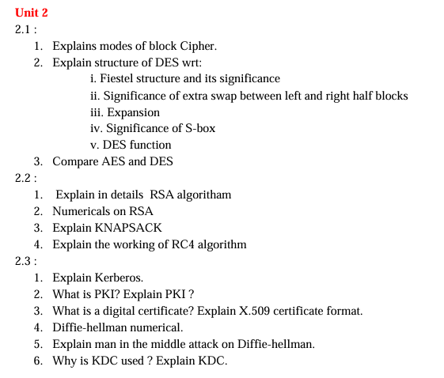

IMP:

Explain AES algorithm

Difference between AES and DES

Explain DES in detail

Explain Kerberos and working of TGS in Kerberos

Numerical on RSA or theory

Explain man in middle attack on Diffie Hellman. Explain how to overcome the same or numerical based on DH

Discuss in detail block cipher modes of operation

What is PKI? List its components

**1. Block Size and Key Size:**

* **Block Size**: DES operates on fixed-size blocks of 64 bits (8 bytes). Each block undergoes encryption or decryption independently.
* **Key Size**: DES uses a 56-bit key, but due to the parity bits, the effective key size is 64 bits. However, only 56 bits are used for encryption, and the remaining 8 bits are used for parity checks.

**2. Need of Expansion Permutation:**

* The Expansion Permutation step in DES increases the amount of data available for mixing in subsequent rounds.
* It expands the 32-bit half-block to 48 bits by duplicating some of the bits.
* This expansion helps increase the complexity of the encryption algorithm and improves its resistance against cryptanalysis.

**3. Role of S-box:**

* S-boxes (Substitution Boxes) play a crucial role in the DES algorithm by introducing non-linearity.
* Each S-box takes 6 bits as input and produces 4 bits as output, effectively reducing the block size to 32 bits.
* S-boxes provide confusion in the encryption process, making it difficult for attackers to predict the relationship between plaintext and ciphertext.

**4. Weak Keys and Semi-Weak Keys:**

* **Weak Keys**: Weak keys are specific key values that cause the encryption algorithm to behave in a predictable or undesirable manner. In DES, weak keys result in encryption being equivalent to decryption, compromising security.
* **Semi-Weak Keys**: Semi-weak keys are pairs of keys that produce the same ciphertext when encrypting plaintext. They reduce the effective key space and weaken the security of DES.

**5. Possible Attacks on DES:**

* **Brute-Force Attack**: Attempts all possible keys until the correct one is found.
* **Differential Cryptanalysis**: Analyzes how differences in input data propagate through the encryption process to reveal the key.
* **Linear Cryptanalysis**: Exploits statistical relationships between plaintext, ciphertext, and keys to recover the key.
* **Meet-in-the-Middle Attack**: Combines brute-force with known plaintext to reduce the time required to find the key.

**6. Feistel Structure and its Significance:**

* DES uses a Feistel network structure, which divides the input block into two halves that undergo multiple rounds of permutation, substitution, and mixing.
* The Feistel structure ensures that decryption is the same as encryption, simplifying implementation and reducing the risk of errors.

**7. Significance of Extra Swap Between Left and Right Half Blocks:**

* The extra swap between left and right halves after each round ensures that the same operations are applied to both halves.
* This swap ensures that the Feistel structure maintains its balanced and reversible nature, contributing to the security and effectiveness of the encryption algorithm.

**8. Expansion:**

* The Expansion step expands the 32-bit half-block to 48 bits by duplicating some of the bits.
* This expansion increases the amount of data available for mixing in subsequent rounds, enhancing the confusion and diffusion properties of the algorithm.

**9. DES Function:**

* The DES function combines the Expansion, Key Mixing, S-box substitution, and Permutation steps to transform the input half-block into the output half-block.
* This function ensures that each round of the encryption process introduces non-linearity and confusion, making it difficult for attackers to recover the plaintext from the ciphertext without the key.

**10. 2DES and 3DES:**

* **2DES**: Encrypts plaintext using two consecutive applications of the DES algorithm with different keys. While more secure than single DES, it is vulnerable to meet-in-the-middle attacks.
* **3DES**: Enhances security by applying DES three times with different keys (keying option 3). It provides a significantly larger key space and is resistant to brute-force attacks.

In summary, DES is a block cipher with a fixed block size and key size, employing S-boxes, expansion permutation, and Feistel structure for encryption. Weak and semi-weak keys pose security risks, and various attacks target DES. 2DES and 3DES are used for enhanced security, addressing vulnerabilities in single DES.