Automizing the process of including jar files – Maven
It manages the lifecycle of the project
(manually managing the jar files)

Com.xml
- Independent across IDEs
- Gives standard template to project
Gradle – Ant + Maven (powerful script and automization)
Log4j
With the help of sysout the errors we don’t get to know the severity of the problems
Logging mai severity levels dal skte hai
Log4j2 – is in use nowadays
SLF4J - it is like a façade, hides the complexities of the frameworks
Makes migration from one logging framework to anothers

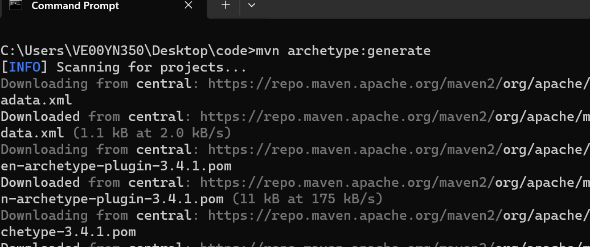

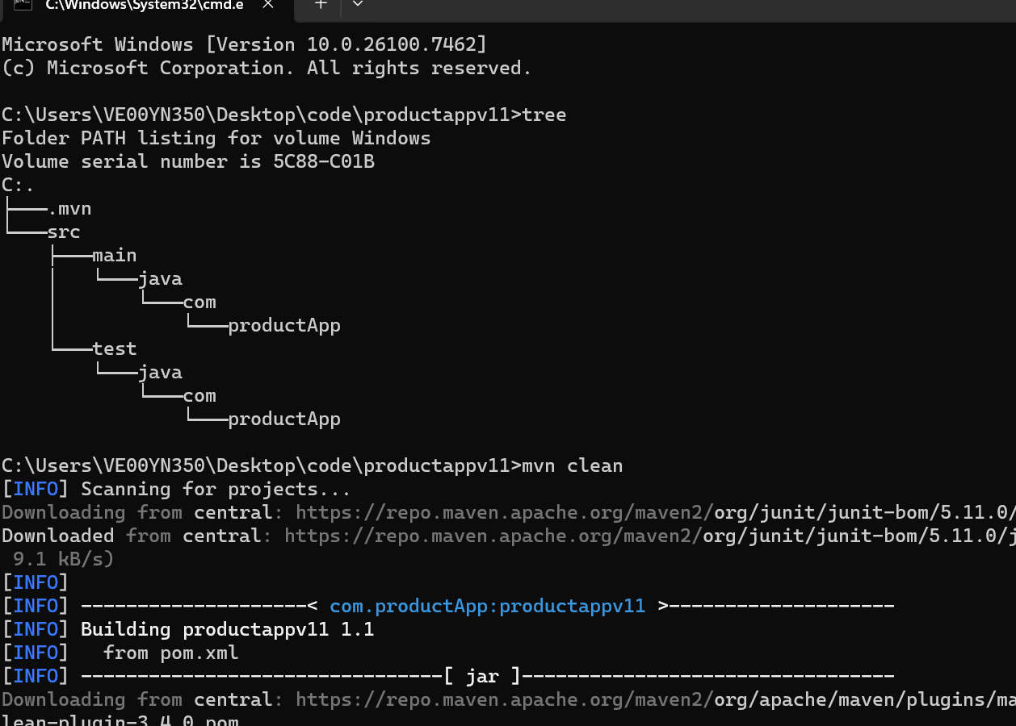

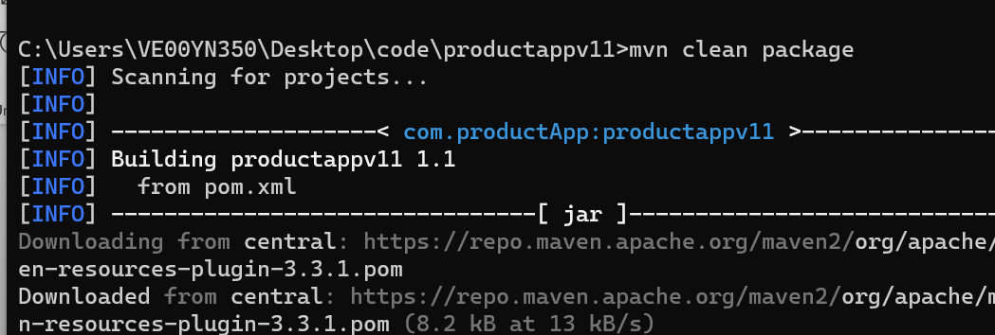

Study Maven lifecycle. TDD
Do not take make snapshot version

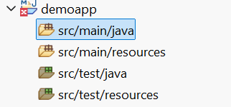

Junit and Mockito

Test Container – jo production mai actual mai use ho rha hai, we can simulate that

Java 1.4 assert keyword *
JUnit 5 (Most common today)
@BeforeEach
- Runs before every single test method
- Used to set up fresh test data
@BeforeEach
void setUp() {
calculator = new Calculator();
}

@AfterEach
- Runs after every single test method
- Used to clean up resources
@AfterEach
void tearDown() {
calculator = null;
}

@BeforeAll
- Runs once before all test methods
- Must be static (unless using @TestInstance(Lifecycle.PER_CLASS))
- Used for expensive setup (e.g., database connection)
@BeforeAll
static void initAll() {
System.out.println("Runs once before all tests");
}

@AfterAll
- Runs once after all test methods
- Must be static
- Used for global cleanup
@AfterAll
static void tearDownAll() {
System.out.println("Runs once after all tests");
}

Execution Order Example
For 2 test methods, execution order is:
@BeforeAll
@BeforeEach
test1
@AfterEach
@BeforeEach
test2
@AfterEach
@AfterAll
- Static import
Mockito uses dependency injection design pattern

