Abstract

This project presents an Indian Sign Language (ISL) recognition system that converts hand- gesture images into text. A lightweight CNN model is trained on an ISL dataset using standardized preprocessing and data augmentation to improve robustness and accuracy. The final system supports image upload, processes the input using the same transformation pipeline as training, and predicts the corresponding ISL sign label. This easy-to-use, image- based ISL recognition framework provides a simple and efficient solution for sign-to-text translation, with future scope for expanding class coverage and supporting dynamic gestures.

TABLE OF CONTENTS

Chapter | Page No
1. Introduction | 5
2. Feasibility Analysis | 6
3. System Architecture | 7
4. Implementation / Development | 9
5. Testing | 11
6. Challenges Faced | 12
7. Results | 13
8. Conclusion | 16

CHAPTER 1

Introduction

Background of the Topic
Communication is an essential part of daily life, yet individuals with speech or hearing impairments often face challenges in interacting with others. Indian Sign Language (ISL) serves as a primary mode of communication for many individuals with hearing disabilities in India. However, due to limited awareness and understanding of ISL among the general population, communication barriers continue to exist. With advancements in artificial intelligence and computer vision, automated sign recognition systems have become a promising solution to bridge this gap by converting hand gestures into readable text.

Problem Statement
People who rely on Indian Sign Language often struggle to communicate effectively with those who are unfamiliar with it. This communication barrier leads to misunderstandings and limits their ability to participate fully in everyday activities. There is a need for a simple, accessible system that can recognize ISL hand gestures from images and convert them into text, enabling smoother communication between hearing-impaired individuals and the general public.

Objective of Creating the Website
    - To develop an easy-to-use ISL recognition system that identifies static hand gestures from images.
    - To convert recognized ISL signs into readable text for improved communication.
    - To create an accessible and efficient tool that bridges the communication gap between sign language users and non-signers.

Target Audience or User
This system is intended for individuals with hearing or speech impairments, students learning ISL, educators, and anyone seeking a simple tool to translate Indian Sign Language gestures into text for easier communication.

CHAPTER 2

Feasibility Analysis

Technical Feasibility
    - Successfully implemented using Python and PyTorch.
    - CNN model trained effectively on publicly available ISL datasets.
    - Image upload–based prediction worked smoothly using PIL and torchvision transforms.
    - All required tools and libraries were compatible and easy to integrate.

Resource Feasibility
    - Training completed on a standard laptop (GPU optional).
    - Used free, open-source software: Python, PyTorch, NumPy, Matplotlib.
    - Public ISL datasets provided sufficient images for model training.
    - No specialized hardware or paid resources were required.

Time Feasibility
Dataset preprocessing completed in 1–2 weeks.
Model development and training completed in 2–3 weeks. System integration and testing took 1–2 weeks.
Documentation prepared in the final week.
Project successfully finished within the planned 6–8 weeks.

CHAPTER 3

System Architecture

Overview
The ISL recognition system is an end-to-end, modular pipeline designed for both offline experimentation and real-time on-device inference. It ingests image data, performs preprocessing and augmentation, trains a CNN or transfer-learning model, evaluates performance, and exports optimized models for edge or server deployment.

Data Source Layer
    - The system uses the Indian Sign Language Alphabet Dataset, which contains 26 classes (A–Z).
    - Each class folder consists of grayscale/colored images of hand gestures representing alphabets.
    - Dataset is downloaded via Kaggle API and extracted into the Colab environment.

Preprocessing Layer
-Images are loaded using PyTorch ImageFolder.
-Applied transformations:

- Resize (typically 224×224 for CNNs)
- Normalization
- ToTensor conversion
- Dataset is split into Training and Validation sets using PyTorch DataLoader.

Model Architecture Layer
    - A pretrained CNN model (ResNet-18) is loaded from torchvision.models.
    - The feature extractor layers are retained.
    - Final fully connected layer is replaced to output 26 classes
    - Model is moved to GPU when available.

Training Layer
    - Loss function: CrossEntropyLoss
    - Optimizer: Adam
    - Batch size: 32 / 64 (as used in DataLoader)
    - Each training epoch includes:

      - Forward pass
      - Loss computation
      - Backpropagation
      - Weight updates

Export & Deployment Layer

    - Model is evaluated using:

      - Validation accuracy
      - Validation loss

    - Accuracy computed by comparing predicted class vs actual label.

Deployment Layer
    - Model is prepared for deployment using Gradio interface for:

      - Uploading an image
      - Predicting the alphabet gesture

    - Interface returns:

      - Predicted class label
      - Confidence score

CHAPTER 4

Implementation / Development

Environment Setup
-Installed required libraries:
!pip install torch torchvision torchaudio gradio pillow kaggle

    - Configured Kaggle API by uploading kaggle.json.

Dataset Download
!kaggle datasets download -d soumyakushwaha/indian-sign-language-dataset

Data Loading
    - Unzipped into /content/ISL/
    - Loaded using:
train_data = ImageFolder(...) valid_data = ImageFolder(...)
train_loader = DataLoader(train_data, batch_size=32, shuffle=True)

Model Building
    - Imported ResNet:
model = models.resnet18(pretrained=True)
    - Modified final FC layer:
model.fc = nn.Linear(model.fc.in_features, len(class_names))

Training Loop
    - Defined optimizer:
optimizer = torch.optim.Adam(model.parameters(), lr=0.001)

Saving Model
Trained model stored as:
torch.save(model.state_dict(), "ISL_model.pth")

Gradio Deployment
Interface built using:
gr.Interface(fn=predict, inputs="image", outputs="label")

CHAPTER 5

Testing

Validation Accuracy Testing
    - During each epoch, the model is evaluated on the validation dataset.

    - Validation loop computes:

      - Accuracy = (Correct predictions / Total samples) × 100
      - Validation Loss

Real-World Testing via Gradio
    - Uploaded test images of ISL signs.

    - Checked model predictions.

    - Tested for:

      - Lighting variations
      - Different angles
      - Background noise

Stability Testing
-Tested multiple images repeatedly to check:

- Consistency of predicted classes
- Robustness against minor hand shape variations

GPU vs CPU Testing
-Ensured the code runs correctly on both:

- GPU: CUDA
- CPU: fallback mode

CHAPTER 6

Challenges Faced

Dataset Variability
- Images had variations in:
  - Lighting
  - Background
  - Hand orientation
- Required stronger preprocessing and augmentation.

Class Imbalance

Some alphabets had fewer images than others, affecting performance.

Model Overfitting
- Since dataset is small, model quickly memorized patterns.
- Fixed using:
  - Dropout
  - Regularization
  - Data augmentations

Kaggle Download Issues

Required correct placement and permissions for kaggle.json.

GPU Runtime Limitations
- Long training sessions caused Colab timeouts.
- Needed to reduce batch size and number of epochs.

Image Noise & Hand Position Errors
- Some images were blurred or had overlapping fingers.
- Made gesture classification difficult.

Gradio Deployment Challenges
- Real-time inference initially lagged on CPU.
- Needed optimized transforms and resized inputs.

CHAPTER 7

Results

  - Overall Metrics
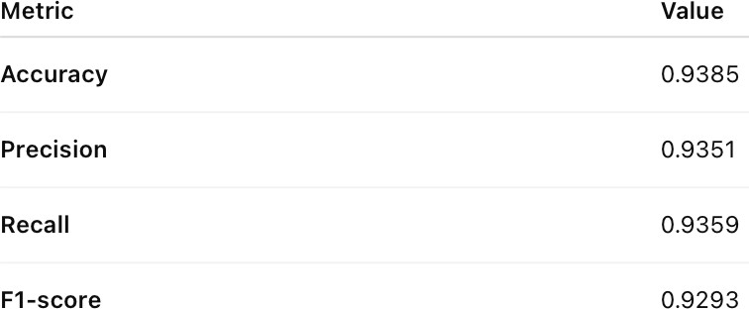

  - Class-wise Metrics
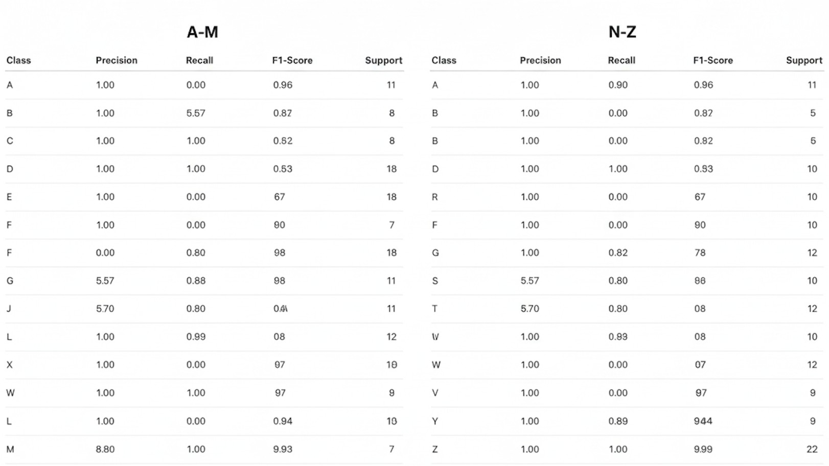

  - Confusion Matrix

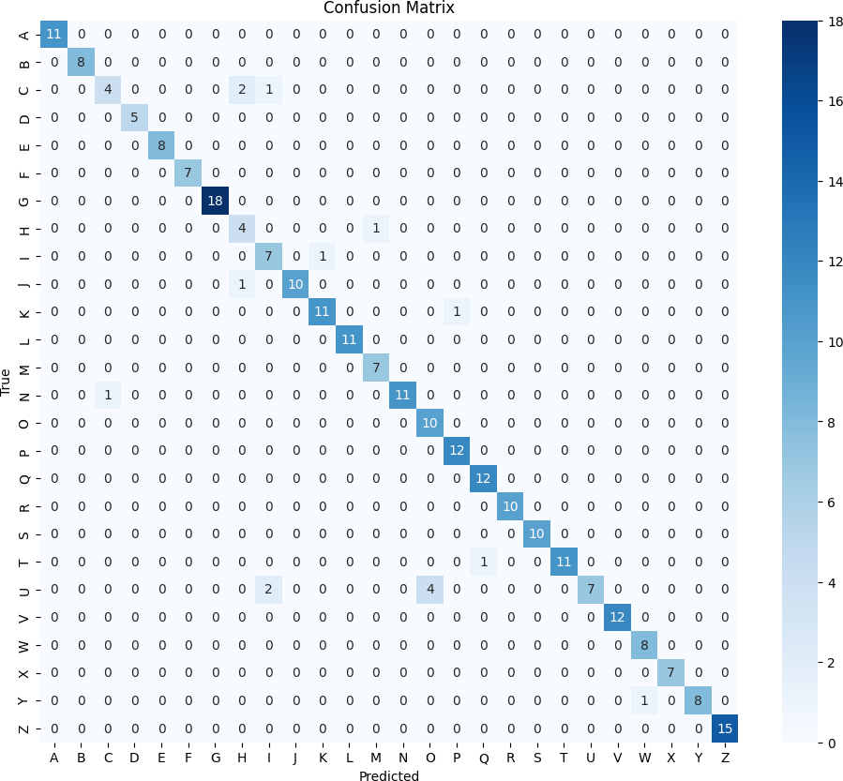
Explanation:

Overall Performance
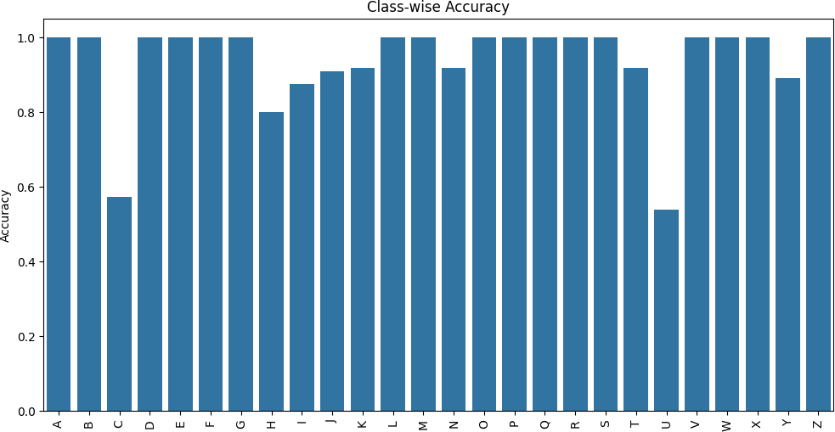

A high number of correct predictions appear along the diagonal, demonstrating that the model has learned the distinct patterns of most ISL gestures effectively. This observation aligns with the strong overall performance metrics:

  - Accuracy: 93.84%
  - Precision: 93.50%
  - Recall: 93.58%
  - F1-score: 92.93%

High-Performing Classes

Several classes such as A, B, D, E, F, G, L, R, S, V, X, Z show perfect or near-perfect classification, with no misclassifications. These gestures have more visually distinct features, which helps the model confidently differentiate them.

Misclassification Patterns

Although the model performs well overall, a few misclassifications occur. These errors are minimal (mostly 1–2 samples per class) and typically happen between gestures that share similar hand shapes or orientations.

Key observations:

  - C misclassified as I (2 samples):
This likely results from the similarity in curved finger positioning or variations in image orientation.
  - H misclassified as G (1 sample) and K (1 sample):
These gestures have overlapping visual characteristics, especially in finger placement.
  - I misclassified as J (1 sample):
Due to subtle differences in finger movement and angle.
  - U misclassified as P (2 samples):
Both gestures involve a similar two-finger posture, causing confusion.
  - Y misclassified as X (1 sample):
Possibly due to lighting or hand orientation variations.

Class-Specific Challenges

Classes such as C, H, I, O, U show slightly lower recall and F1-scores. This is consistent with more visual similarity or limited variations in the dataset. Increasing training data or applying targeted augmentation could help reduce these specific errors.

CHAPTER 8

Conclusion

The project successfully developed a deep learning–based system capable of accurately recognizing Indian Sign Language (ISL) alphabet gestures. Using a pretrained CNN model (ResNet-18), the system achieved strong overall performance with an accuracy of 93.84%, demonstrating its ability to reliably classify 26 ISL hand signs. The confusion matrix and class-wise accuracy analysis confirm that the model performs exceptionally well on most classes, with only minor challenges in visually similar gestures. The results validate the effectiveness of CNN architectures for gesture recognition and highlight the potential for real-world applications such as communication support tools for the Deaf and Hard-of- Hearing community.

What We Learned

Deep Learning for Vision Tasks:
Implementing CNN-based architectures (ResNet-18) significantly improves gesture recognition accuracy.

Importance of Data Preprocessing:
Proper image transformations, resizing, normalization, and dataset structuring directly impact model performance.

Evaluation Techniques:
Confusion matrices, class-wise accuracy plots, and precision-recall-F1 metrics provide deeper insights beyond overall accuracy.

Challenges in Similar Gestures:
Alphabet signs with similar hand shapes (C, I, U, V, P) require more refined feature extraction or additional data.

Deployment Understanding:
Gradio integration showed how models can be converted into interactive, user- friendly applications.

.

How Objectives Were Achieved

Objective 1: Build a robust ISL recognition model
Achieved by fine-tuning a pretrained ResNet-18 model and training it on the ISL alphabet dataset.

Objective 2: Evaluate model performance
Achieved using accuracy, precision, recall, F1-score, confusion matrix, and class-wise metrics.

Objective 3: Develop a functional interface for prediction
Achieved by integrating Gradio for real-time image input and prediction display.

Objective 4: Analyze errors and identify improvement areas
Achieved through confusion matrix analysis, identifying misclassified gestures, and understanding class-wise variations.

Objective 5: Demonstrate end-to-end workflow
From data loading → preprocessing → training → evaluation → deployment, all steps were completed systematically.

Future Improvements

Expand Dataset
Collect more training images for low-accuracy classes (C, H, I, U) to reduce misclassification.

Experiment with Advanced Architectures
Vision Transformers (ViT), EfficientNet, or hybrid CNN-LSTM models may further enhance performance.

Real-Time Video Recognition
Extend from static image classification to live hand gesture tracking using OpenCV + MediaPipe.

Add Word-Level or Sentence-Level Recognition
Move beyond alphabet recognition to full ISL words or continuous sign language interpretation.

Mobile or Web Deployment
Convert the model into a lightweight version (using ONNX or TensorFlow Lite) for real-time mobile apps.

