**Comprehensive Report: Homelessness and Property Sales Trend Analysis**

**Introduction**

This report combines two distinct trend analyses: one on **homelessness** and the other on **property sales**. The goal is to provide a comprehensive understanding of these trends and explore potential connections or implications between them.

**Homelessness Trend Analysis**

**Data Source**: "detailed_LA_23_total" https://www.gov.uk/government/statistical-data-sets/live-tables-on-homelessness#flows-tables

**Property Sales Trend Analysis**

**Data Source**: "ppd_data" https://www.gov.uk/search-house-prices

**Homelessness Trend Analysis**

**Initial Assessment by Area**

In the homelessness analysis, we examined the initial assessment of homelessness by geographical area. The following chart illustrates this trend:

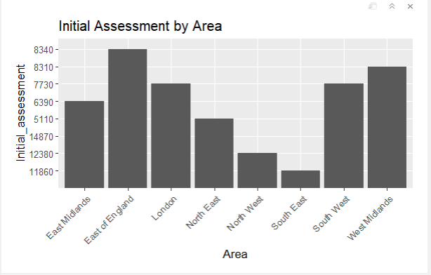

This chart allows for a comparison of homelessness rates across different regions.

**Prevention and Relief Duties by Area**

We also explored prevention and relief duties for homelessness by geographical area. The charts below provide insights into prevention and relief efforts:

* Prevention Duty by Area

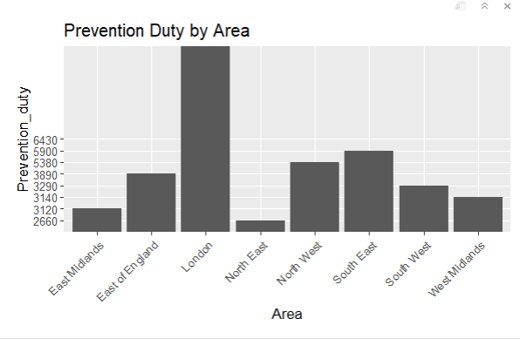

* Relief Duty by Area

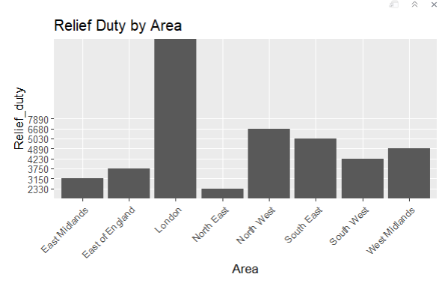

These charts highlight how regions are addressing homelessness once it has occurred and where additional prevention measures may be needed.

**Support Needs Analysis**

The analysis further examined support needs among homeless individuals. We explored:

* Households with No Support Needs by Geographical Regions

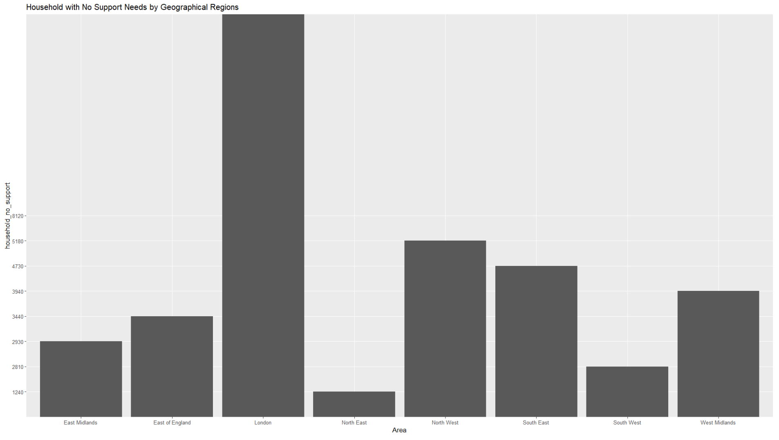

* Households with Unknown Support Needs by Geographical Regions

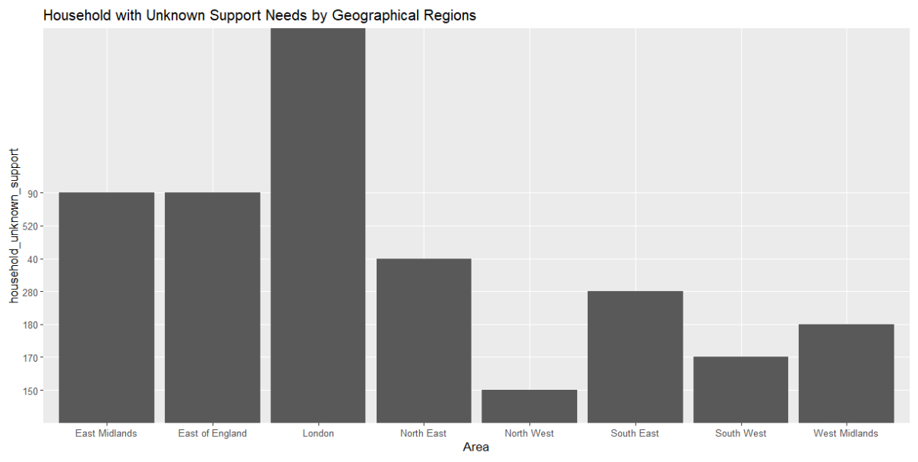

These charts shed light on the complexity of homelessness cases and the need for tailored support services.

**Age Group Analysis**

We delved into homelessness trends within different age groups:

* Homelessness for Age 18-24 by Geographical Regions

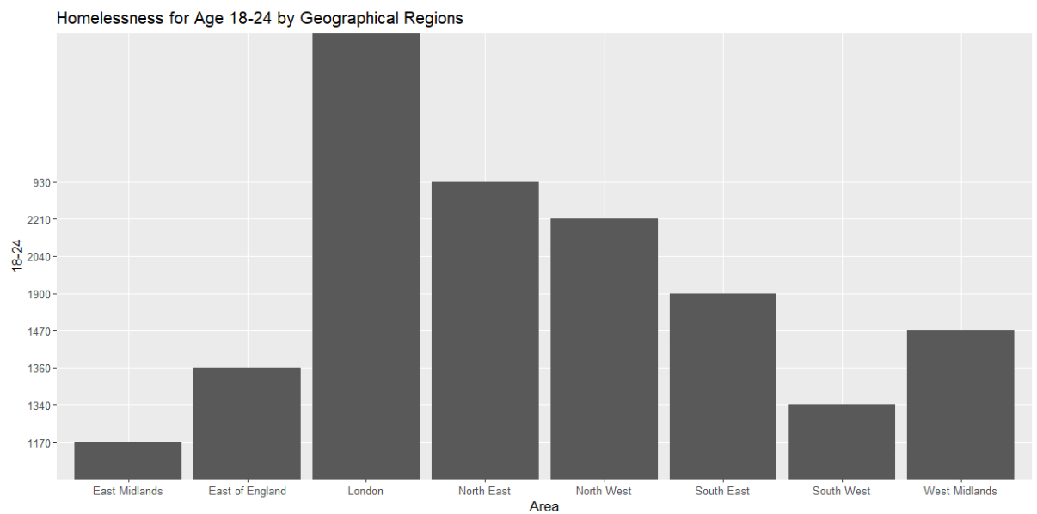

* Homelessness for Age 25-34 by Geographical Regions

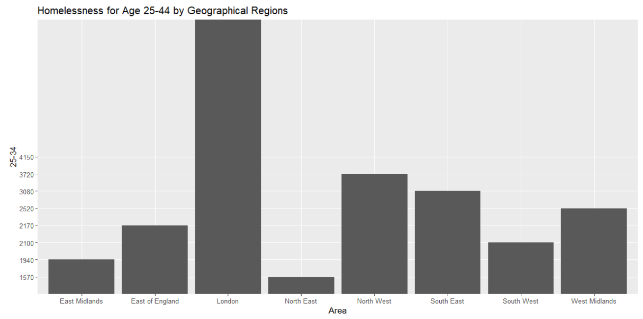

These insights guide targeted interventions and support for specific age groups.

**Referral Sources Analysis**

We analysed the sources of referrals for homelessness cases:

* Total Households Referred by Geographical Regions

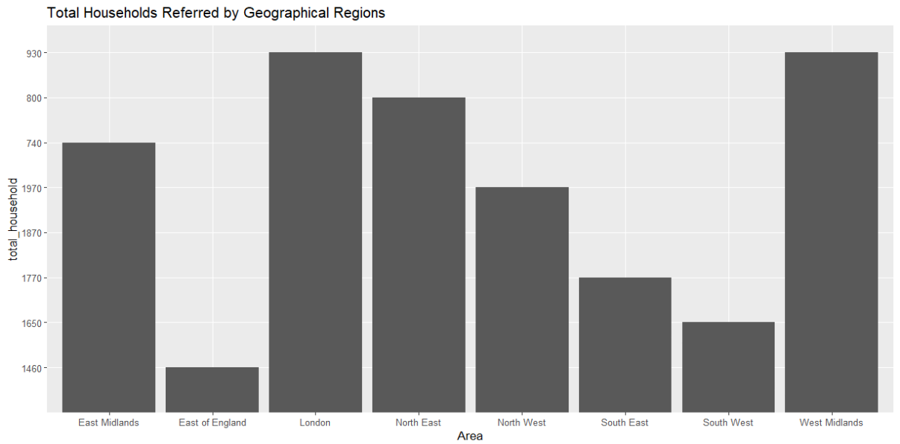

* Referrals from Adult Secure Estate (Prison) by Geographical Regions

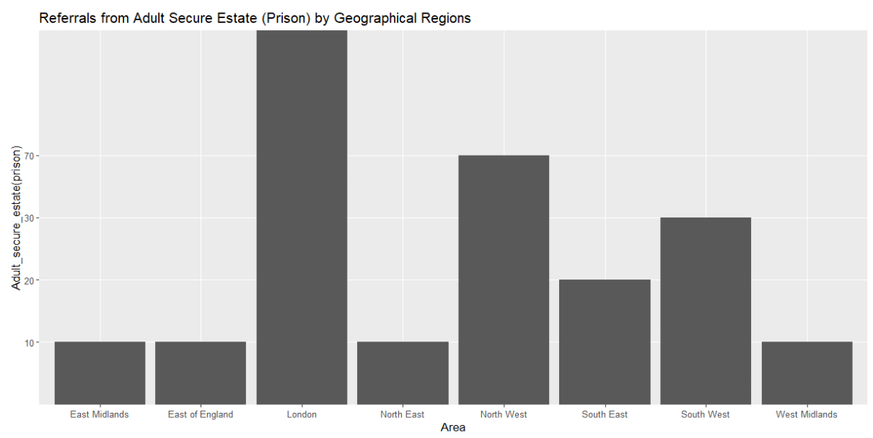

* Referrals from National Probation Service by Geographical Regions

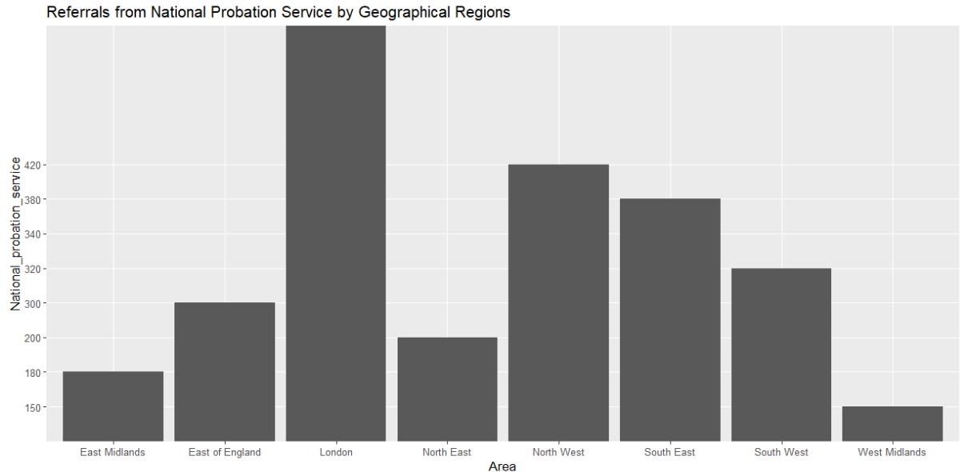

* Referrals related to Mental Health by Geographical Regions

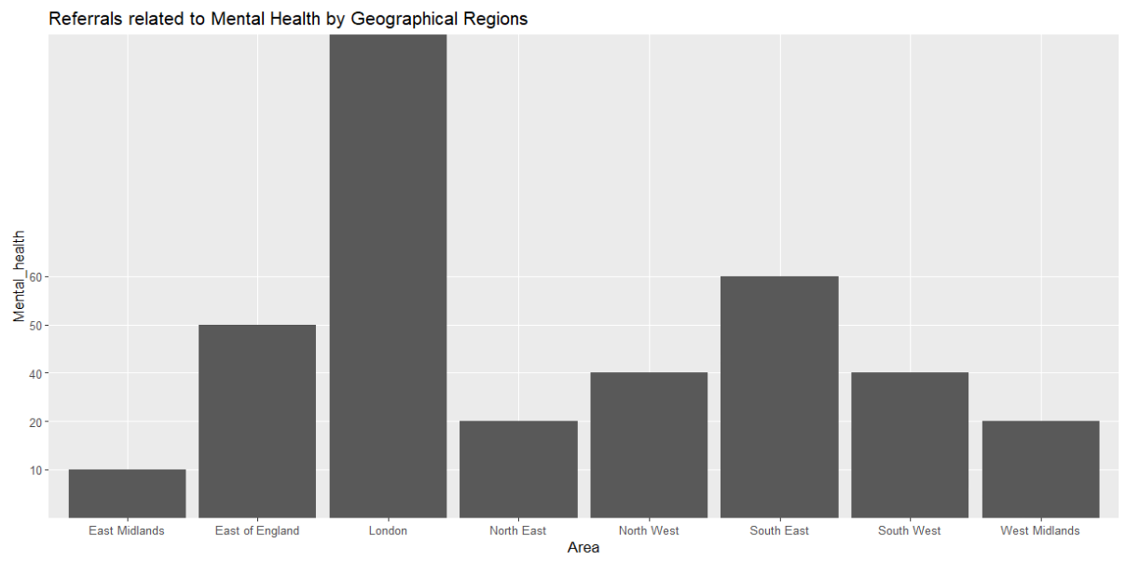

* Referrals from Jobcentre Plus by Geographical Regions

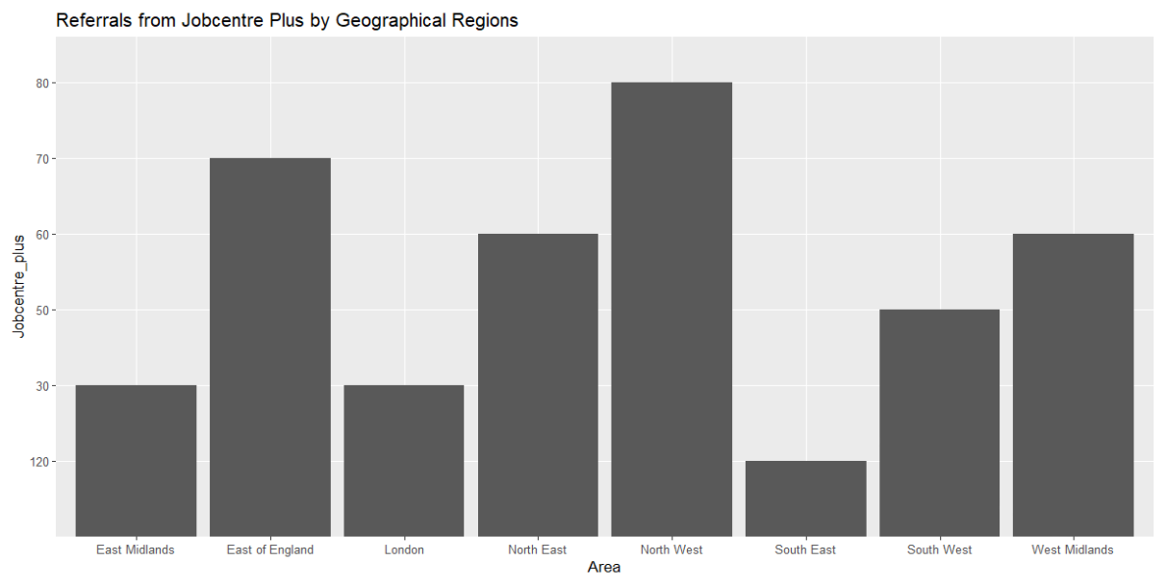

These charts identify areas where specific support services are needed to address homelessness causes effectively.

**Ethnicity Analysis**

We examined homelessness cases based on ethnicity:

* Homelessness Cases by Ethnicity in Geographical Regions

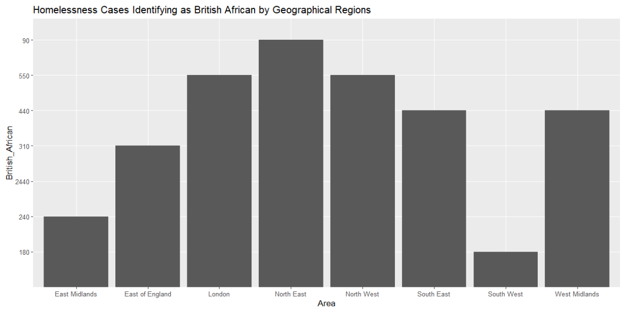

* + It shows that BRITISH AFRICAN has the highest number of homeless in almost every traditional geographical area.
* If we look at the region that has been the area with a greater number of homeless in almost ethnicity, it will be London region. It is been observed that North West region has the greatest number of British, Irish and British African homeless people.
* London has the greatest number of homeless people in total which makes the fact that there are homeless people in London of all ethnicity.
* The second highest being the North West area which has the homeless people in most of the ethnicity.

These charts provide insights into the ethnic composition of homelessness cases in various regions.

**Employment Status Analysis**

The analysis concluded with an examination of homelessness cases based on employment status:

* Total Homelessness Cases by Employment Status by Geographical Regions

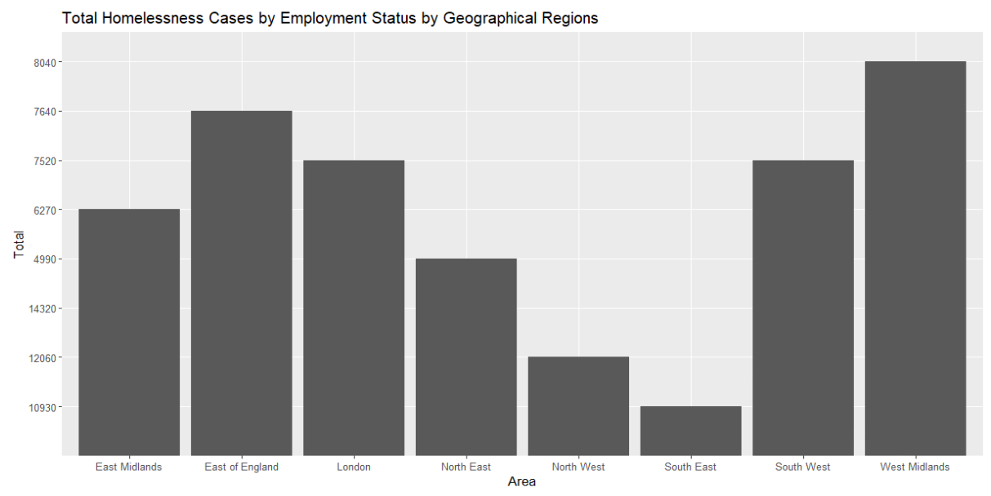

* Homelessness Cases Employed Full-time by Geographical Regions

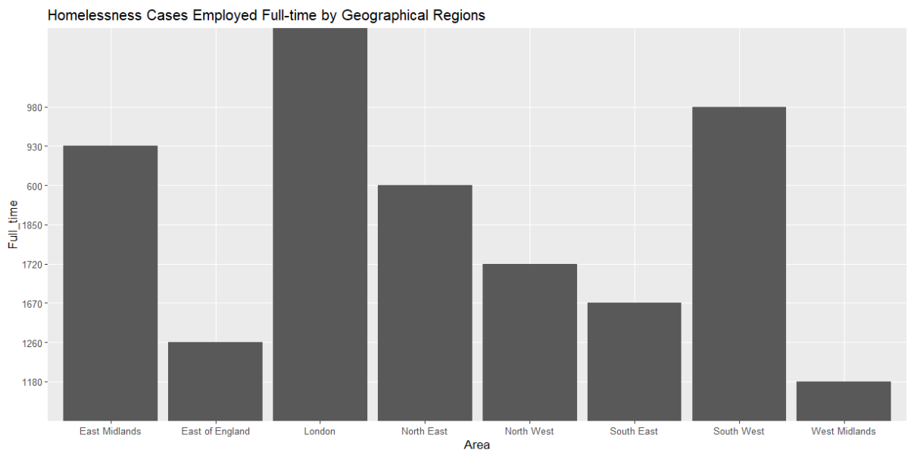

* + High numbers here could indicate a need for affordable housing or living wage initiatives.
* Homelessness Cases Employed Part-time by Geographical Regions

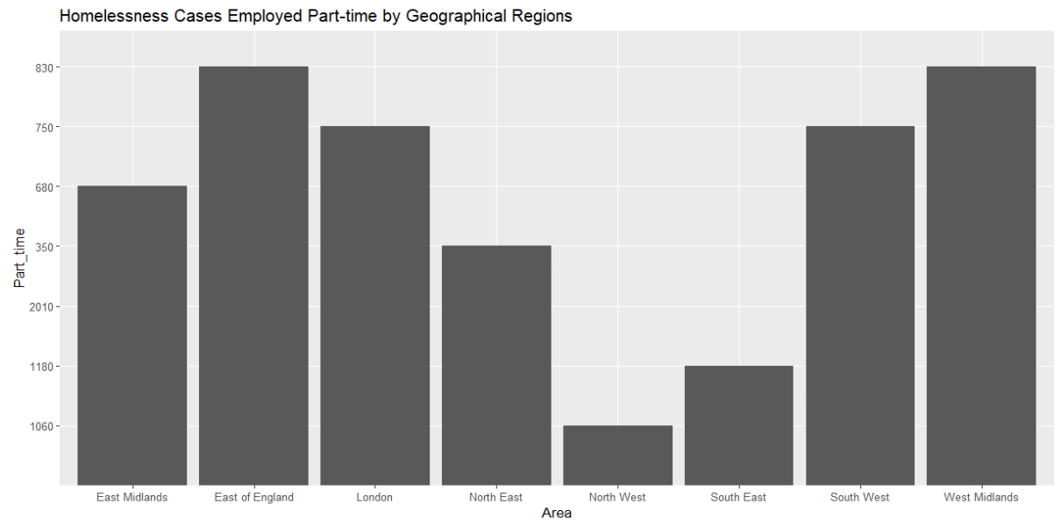

* + High numbers might indicate employment instability as a factor in homelessness.
* Homelessness Cases who are Students by Geographical Regions

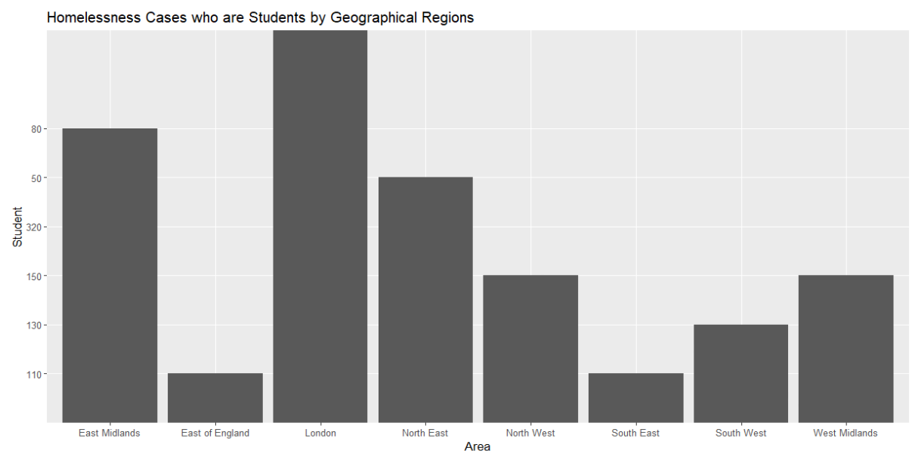

* Homelessness Cases who are Registered Unemployed by Geographical Regions

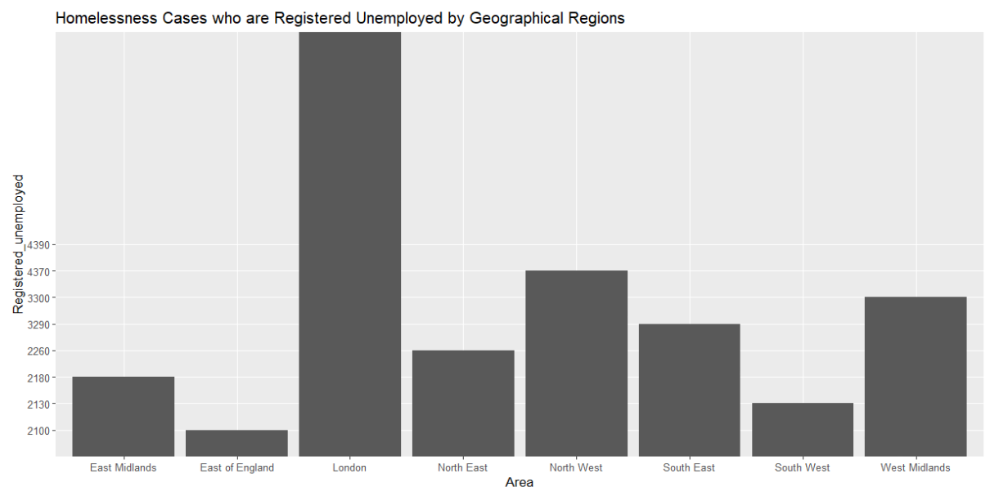

* + potentially requiring job training or employment programs.
* Homelessness Cases who are Not Seeking Employment by Geographical Regions

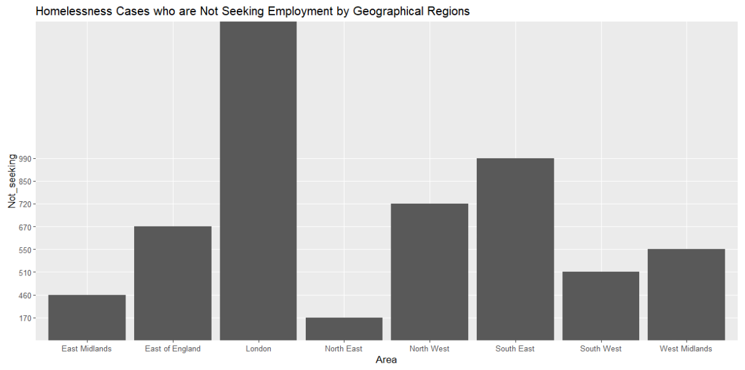

* + possibly pointing to other factors like illness or disability as the main issue.
* Homelessness Cases who are Retired by Geographical Regions

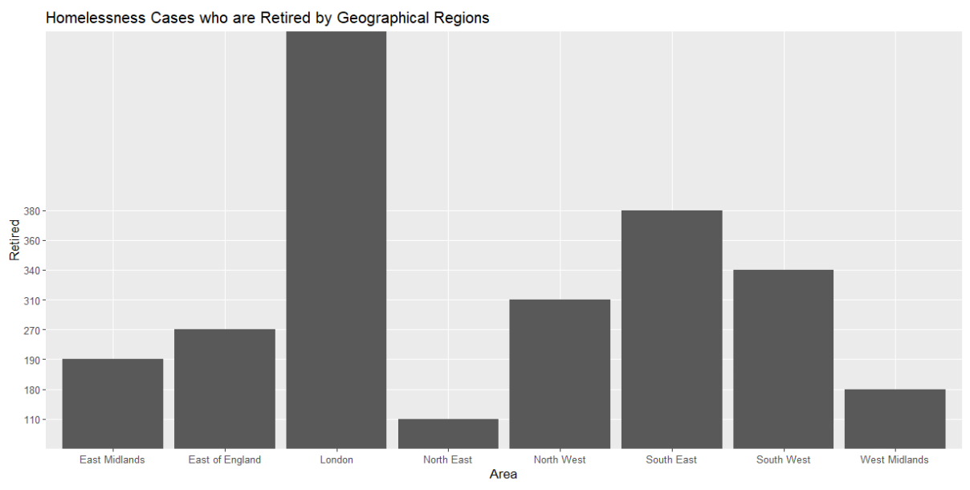

These charts offer insights into the relationship between employment status and homelessness.

**Property Sales Trend Analysis**

**Property Type Analysis**

We examined the types of properties being sold:

* Count of each property type



This analysis helps identify the most prevalent property types in the market.

**New vs. Old Build Analysis**

We analysed new and old property builds:

* Count of new build vs. old build



This data reveals trends in new construction and its impact on property sales.

**Estate Type Analysis**

We explored the estate types:

* Count of each estate type



This analysis sheds light on the distribution of properties in different estate categories.

**Property Sales Over Time**

We examined the trend of property transactions over time:

* Trend of Property Transactions Over Time

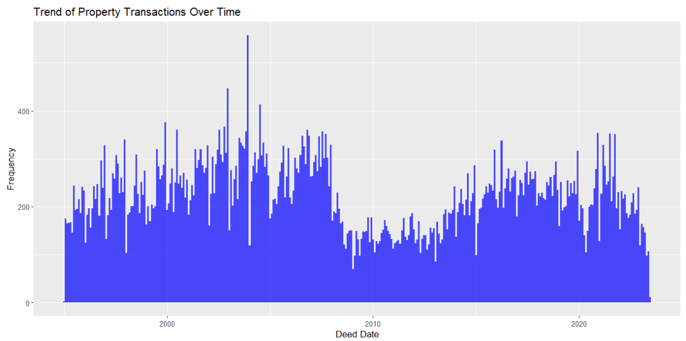

This trend analysis highlights the changes in property sales volume across years.

**Property Sales by Year**

We conducted a detailed analysis of property sales by year and postcode:

* Average Property Price by Year

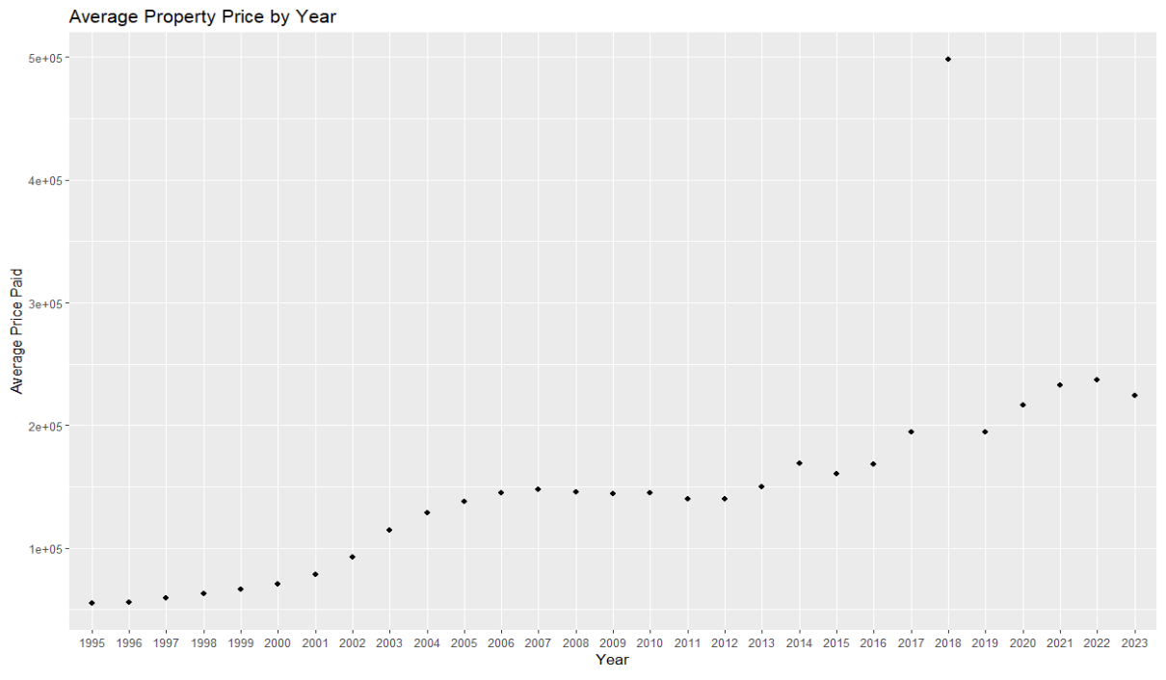

These charts provide insights into property price trends in specific areas over time.

**Relating Homelessness and Property Sales Trends**

The analysis of homelessness and property sales trends reveals several potential connections and implications:

1. **Property Affordability**: High property prices in certain areas may contribute to homelessness if individuals cannot afford housing.
2. **Property Type**: The prevalence of property types, such as apartments or single-family homes, can impact the availability of affordable housing options.
3. **New Construction**: An increase in new build properties may affect property prices and rental rates, potentially influencing homelessness rates.
4. **Employment**: Property sales trends may be linked to employment opportunities and income levels, which can impact homelessness rates.
5. **Referral Sources**: Referral sources, such as employment services and mental health services, may play a role in addressing both homelessness and employment.
6. **Geographical Patterns**: Identifying geographical patterns in property sales and homelessness can inform targeted interventions and resource allocation.

**Conclusion**

This comprehensive report combines analyses of homelessness trends and property sales trends. Understanding these trends individually and their potential interplay is crucial for policymakers, local authorities, and organizations working to address housing and homelessness challenges.

The insights provided in this report can guide evidence-based decision-making and the development of comprehensive strategies to tackle homelessness while considering the broader housing market dynamics.