**?**

**Finding Accuracy**

**Random Forest**

**K Nearest Neighbour**

**Prediction Results**

**Data Pre-processing**

**Support Vector Regression**

**Multiple Linear Regression**

**Linear Regression**

**Problem Statement**

**Exploratory Data Analysis**

**Collected Dataset**

**Price Prediction**

 

**Exploratory Data Analysis**









**Dynamic Price Problems**

**Kaggle Airfare Dataset**

**INPUT**

**Feature Engineering**

**Detect Outliers**

**Detect Missing Values**

**Distinguish Attribute**

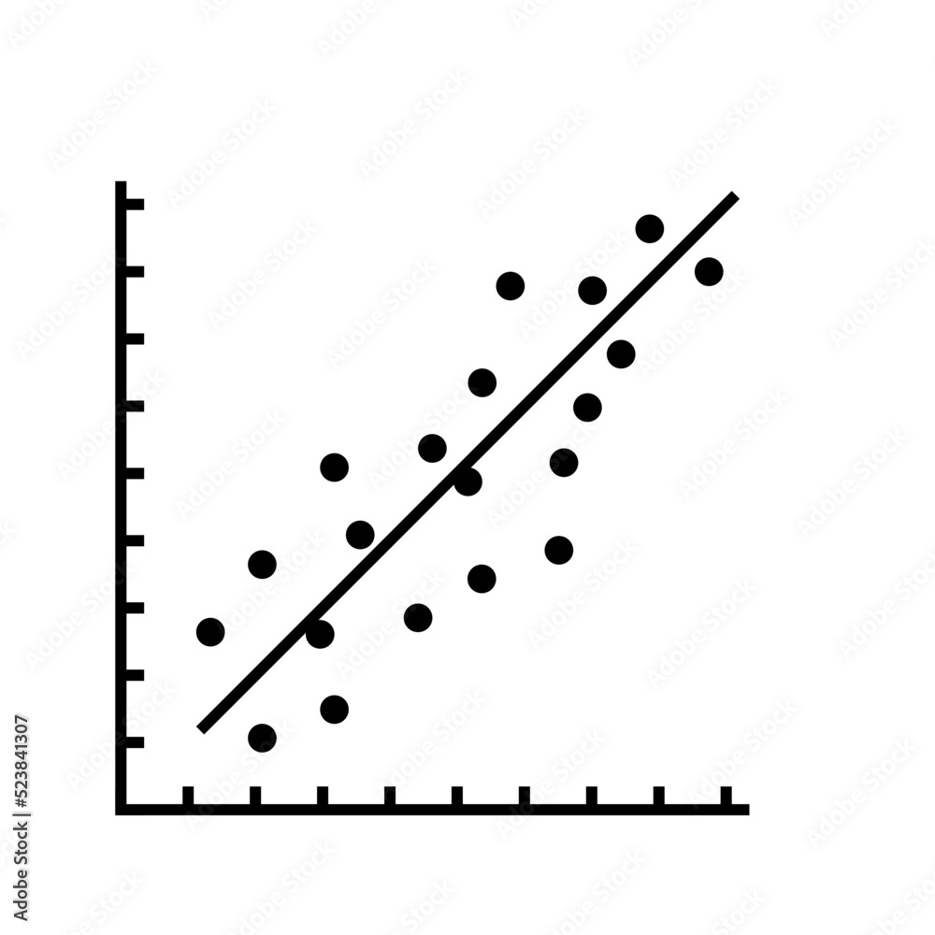





**Regression Models**

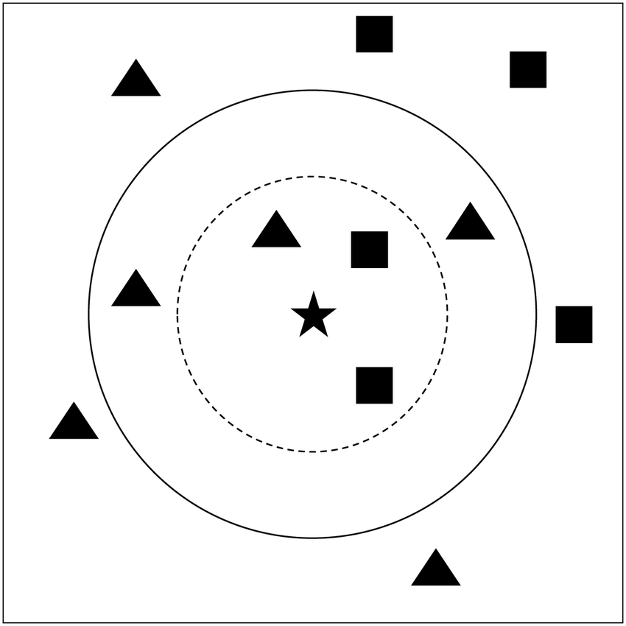

**Clean Dataset**

**Data Pre-processing**





**K Nearest Neighbor**

**Price Prediction**

**Optimal Technique (Random Forest)**

**Random Forest**



**ML Techniques**



