Table of Contents

Overview 2

Functional Requirements 2

Functional Diagram 2

System Design 2

Database Model 2

User Interface 2

Database Queries 2

Code 2

Software Requirements 2

Hardware 2

# Overview

Cruise ships are large passenger ships used mainly for vacationing. Unlike ocean liners, which are used for transport, cruise ships typically embark on round-trip voyages to various ports of call, where passengers may go on tours known as “shore excursions”. On “cruises to nowhere” or “nowhere voyage”, some cruise ships make two- to three-night round trips without visiting any ports of call.

Modern cruise ships tend to have less hull strength, speed, and agility compared to ocean liners. However, they have added amenities to cater to water tourists, with recent vessels being described as “balcony-laden floating condominiums”.

Cruise Reservation System-Lets Travel Agents and End Users to Search and Book Online Cruise Deals

# Functional Requirements

Cruise Booking a web application that searches the data from the database added by the suppliers (Cruise Operators) or from the inventory of the API will, therefore, find the best possible option available in a particular city as per the user’s search When selecting a specific Cruise, it will be routed to the payment gateway for payment or deposit account for the final booking Cruise Booking Software allows travel agents and consumers to scan and book cruises online with the best deals it can be linked to travel agents and tour operators in the form of cruise XML comprehensive inventory of cruise suppliers (such as MSC, Princess, and Carnival). The online cruise reservation system allows browsers to check the availability of online cruises, examine deck plans, cabin inventories and finally user-friendly online booking

Cruise Reservation System helps cruise companies and travel agencies manage multiple bookings, inventory levels, fare codes, taxes, and channel partners through one dashboard custom made for the cruise industry This exclusive cruise reservation system possess comprehensive cruise management and online reporting with relevant information regarding summary, sales, profit, vendors, insurance, and margins, etc With the help of our Cruise Reservation System, one can easily manage their services properly by investing a little effort The major aim of such software engines is to reduce the overhead of ticket booking, status checking, and other travel- related information. In this booking engine, we have an ample amount of cruise line, cruise descriptions, and lines which is linked with rich content and media like photos, ship images, and attire plan to help in the shopping. Cruise Reservation system also provide different screen access to your portal like mobile, desktop and tablet, etc

# Functional Diagram

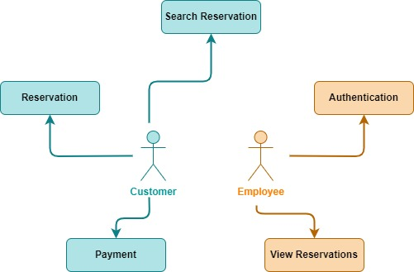

# System Design

## Database Model

## 

## User Interface

### Home

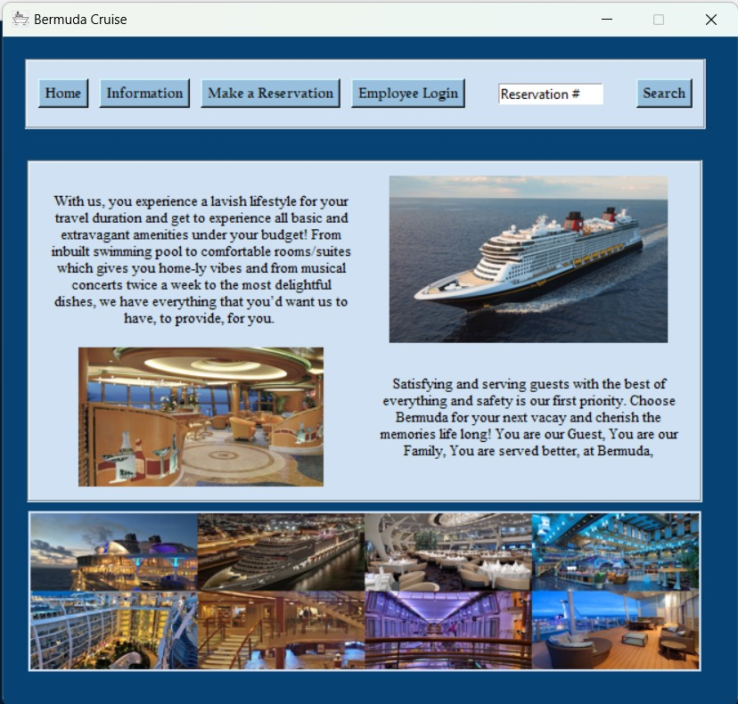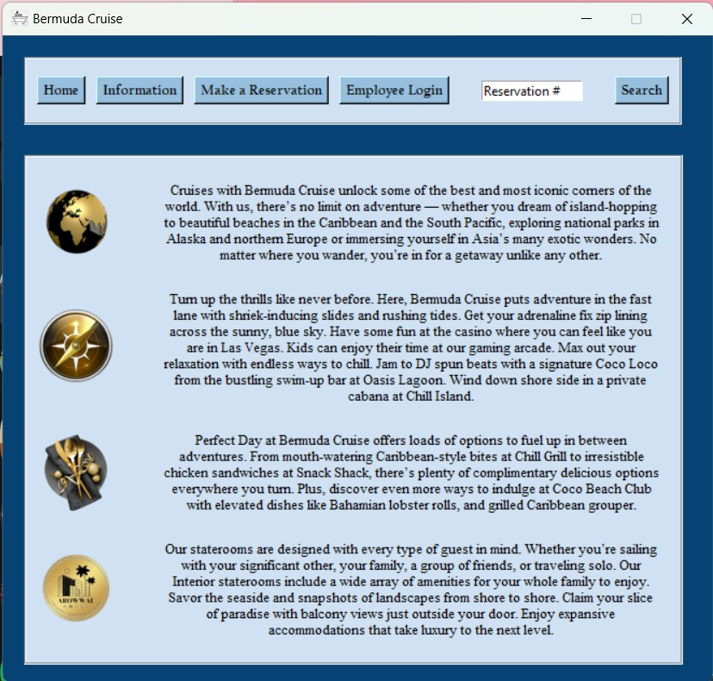

Login

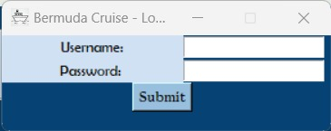

Customer Information

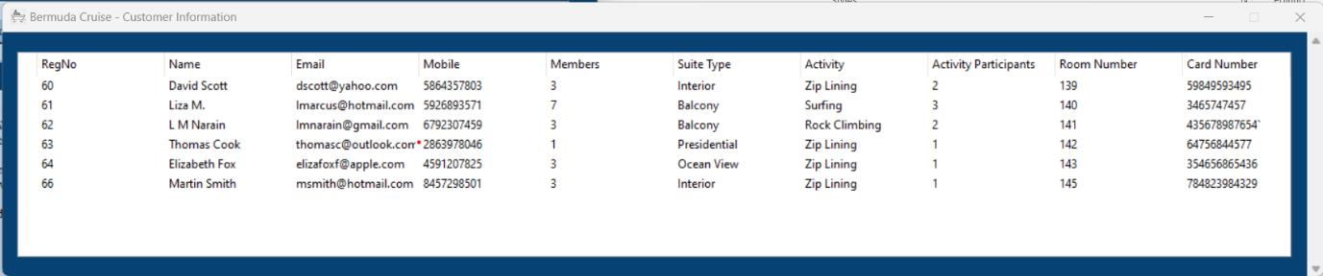

Customer Reservation Booking/Search

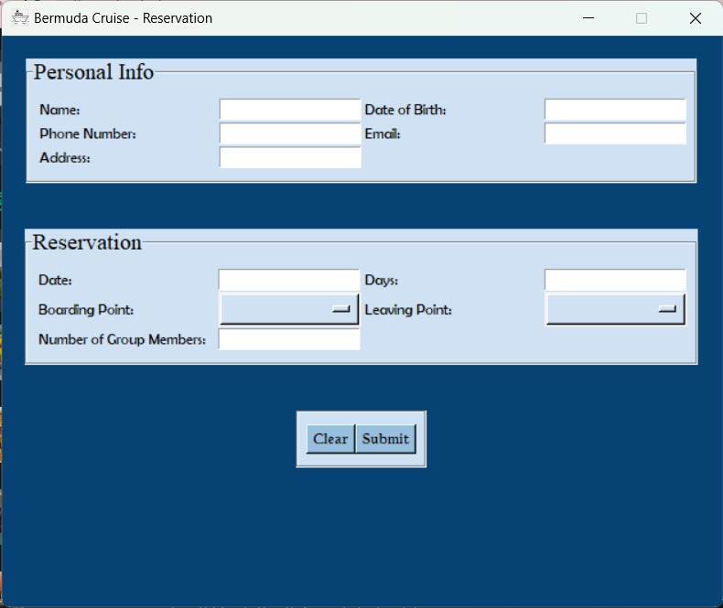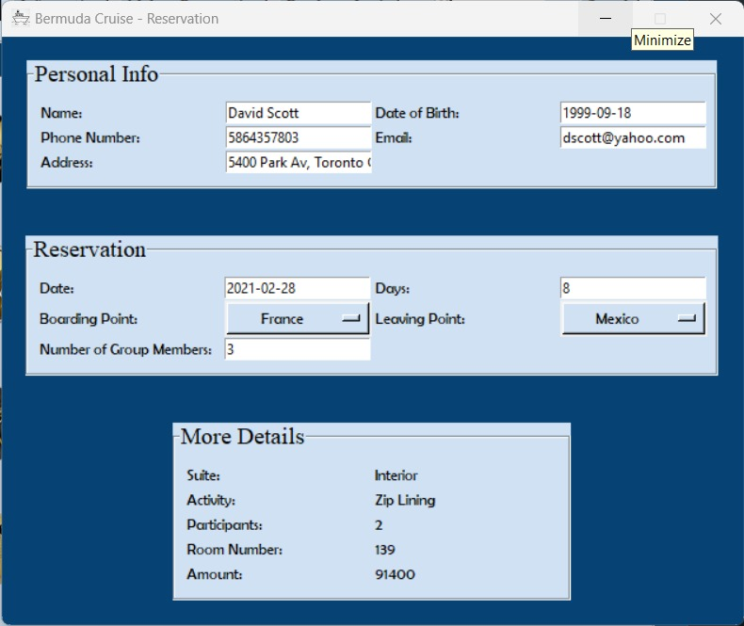

Suites and Activity

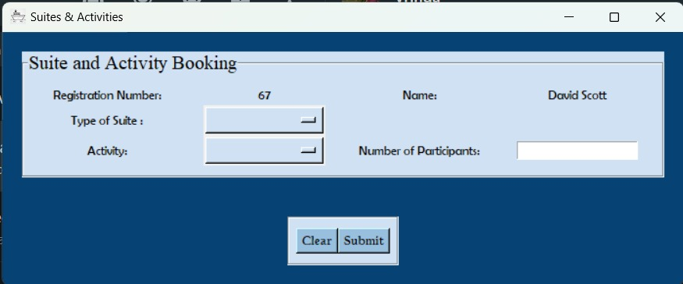

Payment

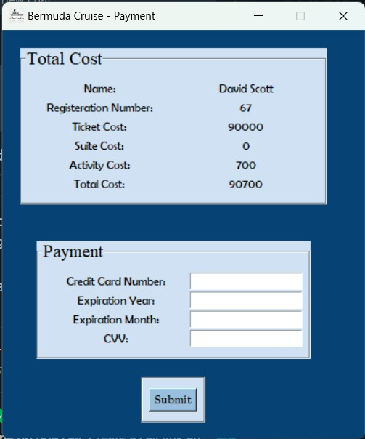

## Database Queries

### Schema

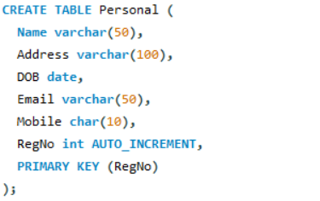

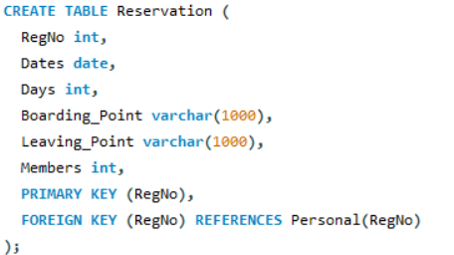

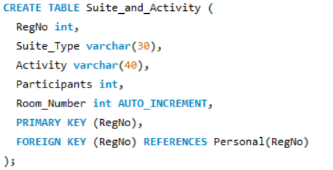

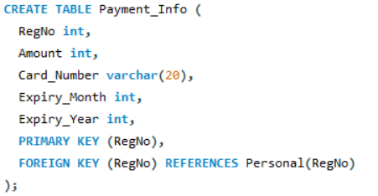

### Add Personal Details



### Add Reservation Details



### Search Reservation by RegNo

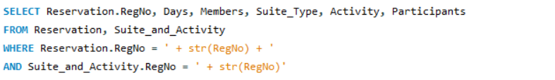

### Show Reservation Info on Payment Screen



### Allot Room Number



### Insert Payment Details

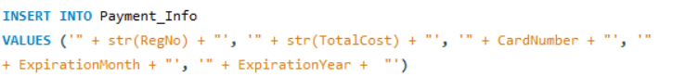

### List all Reservations

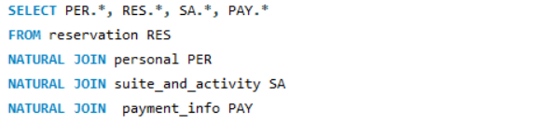

## Code

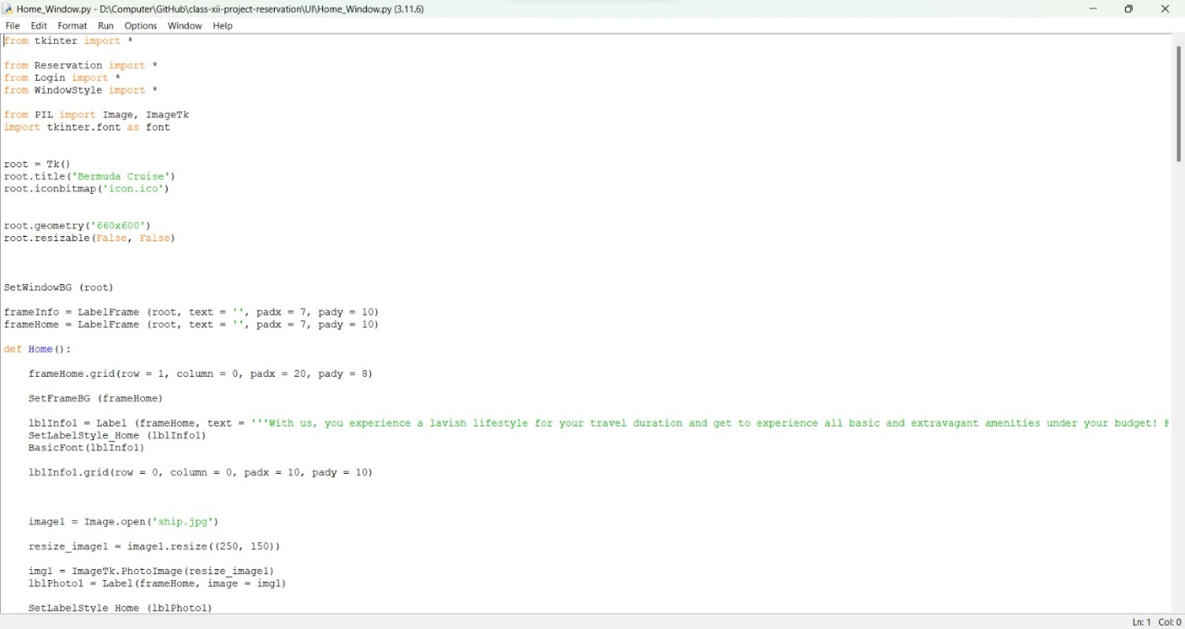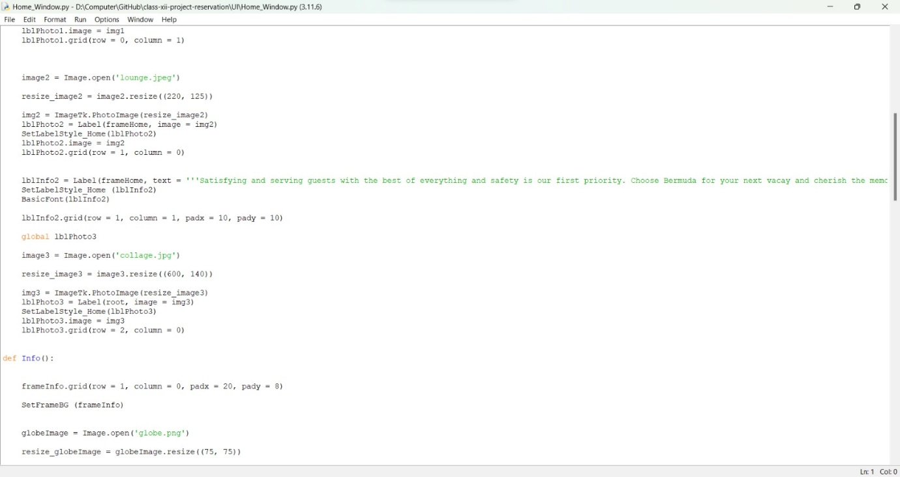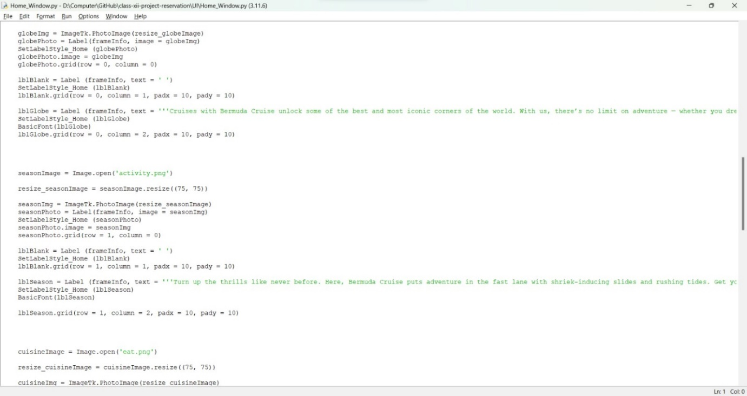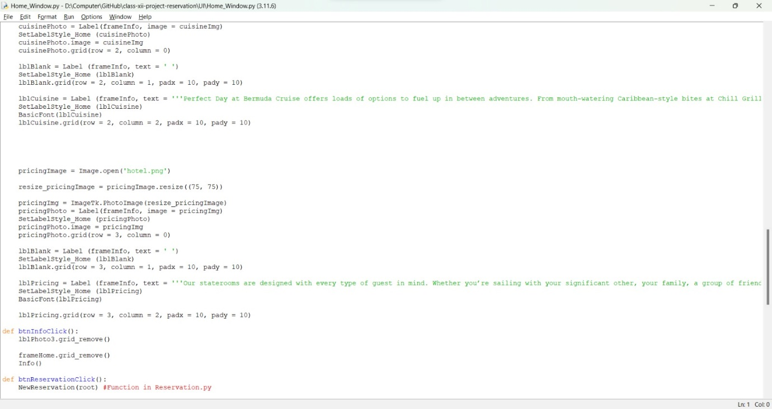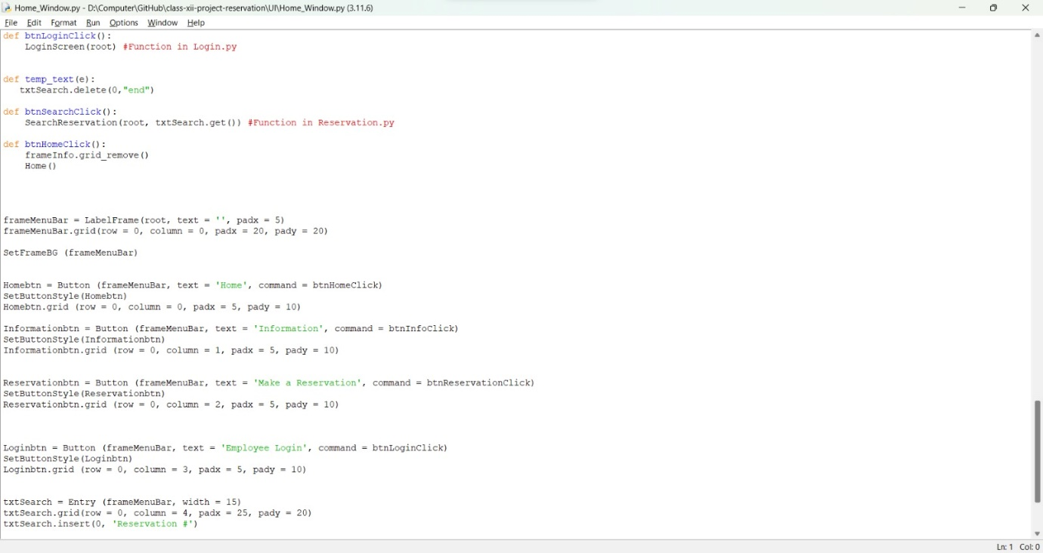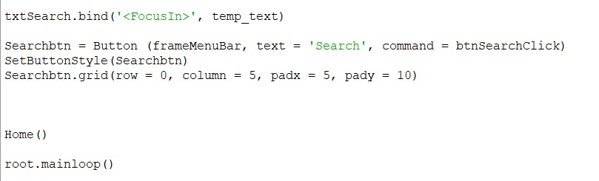

Login Screen

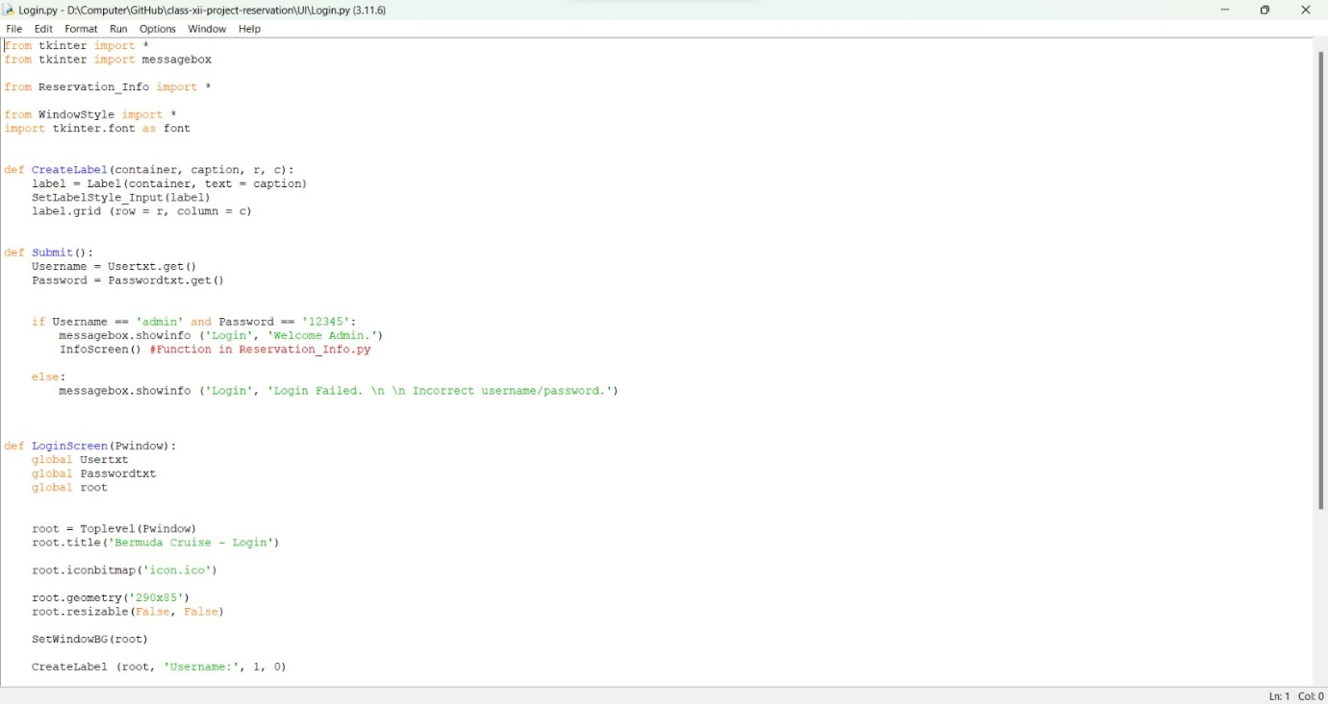

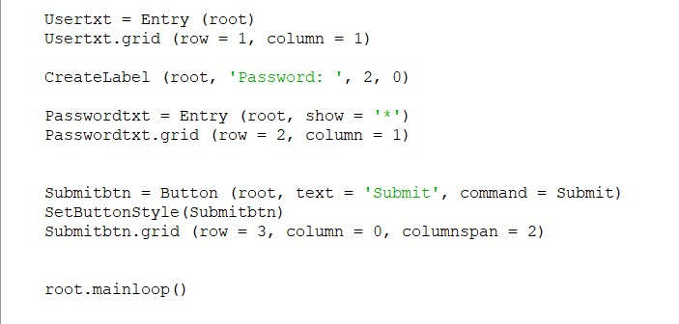

Customer Reservation Screen

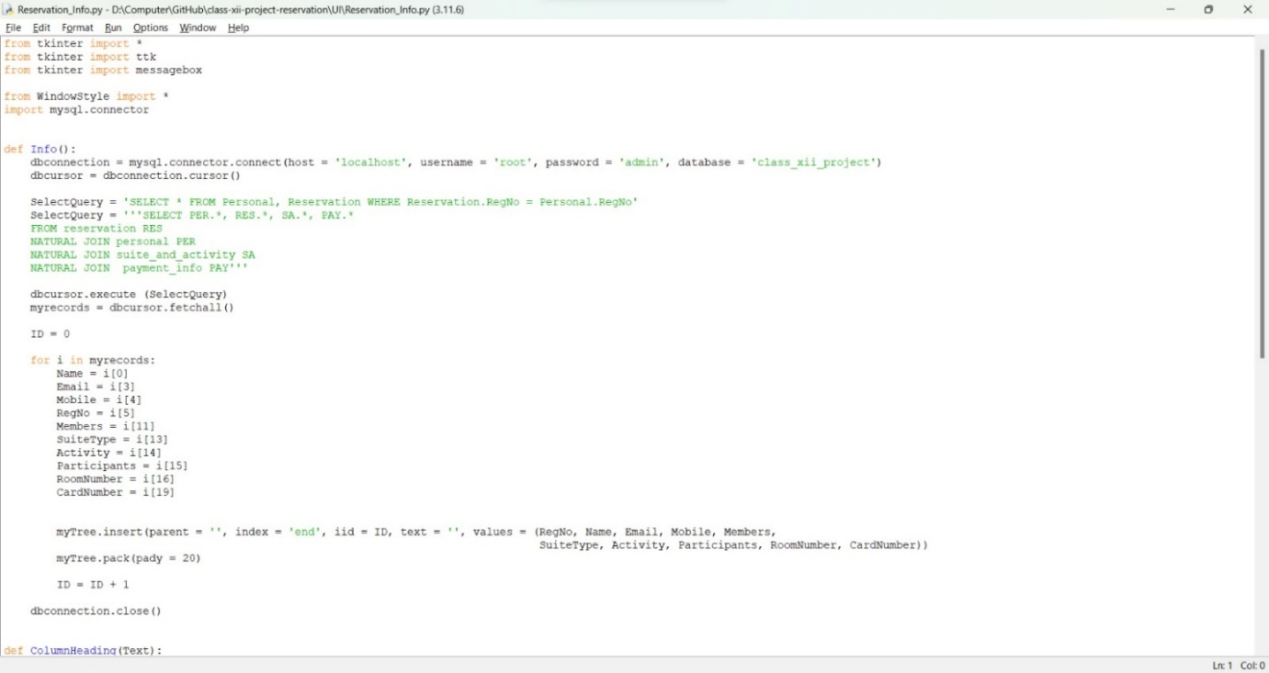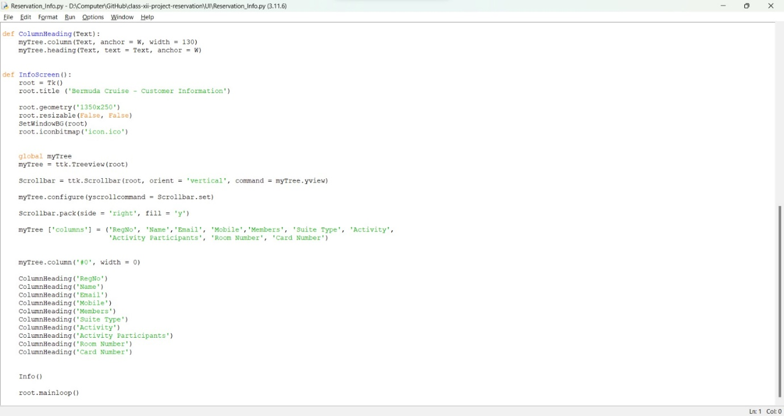

Booking Reservation Screen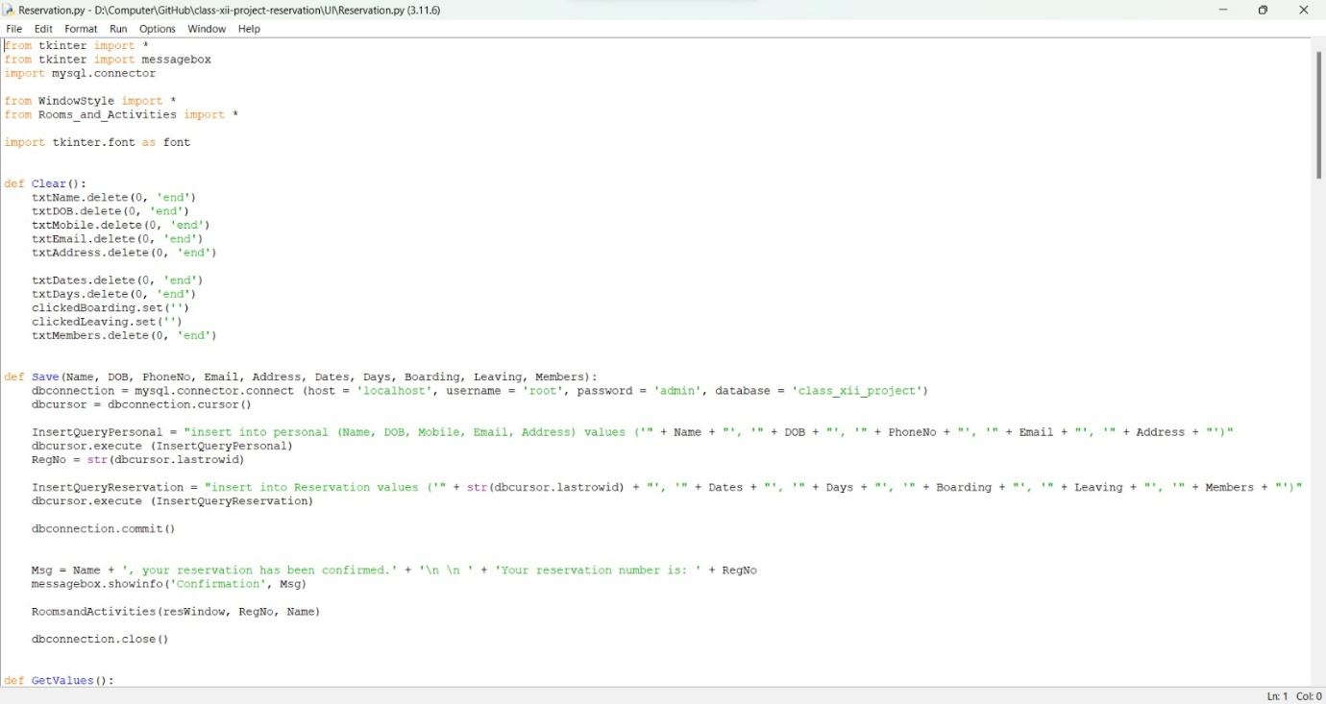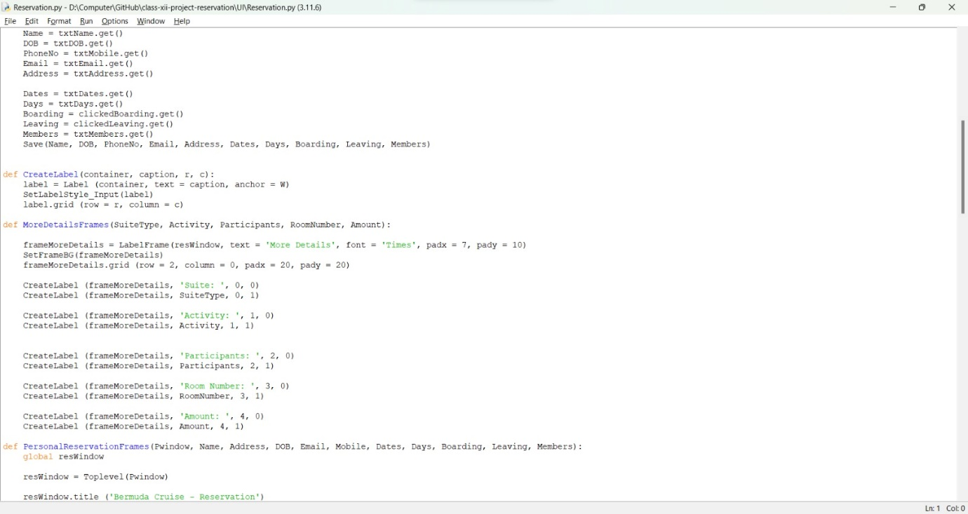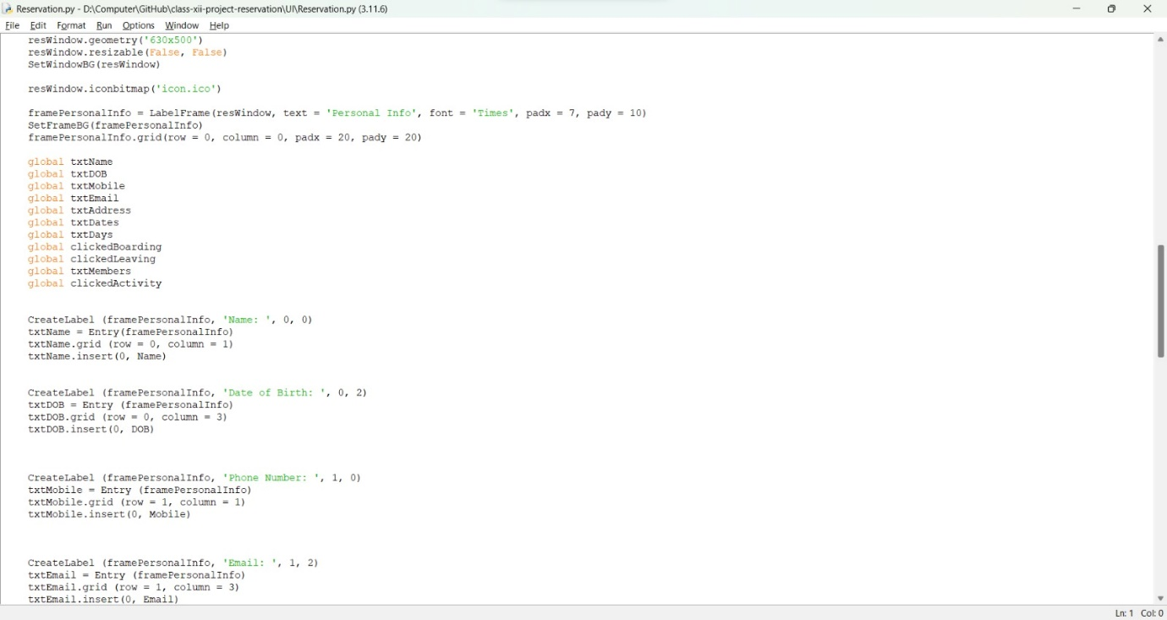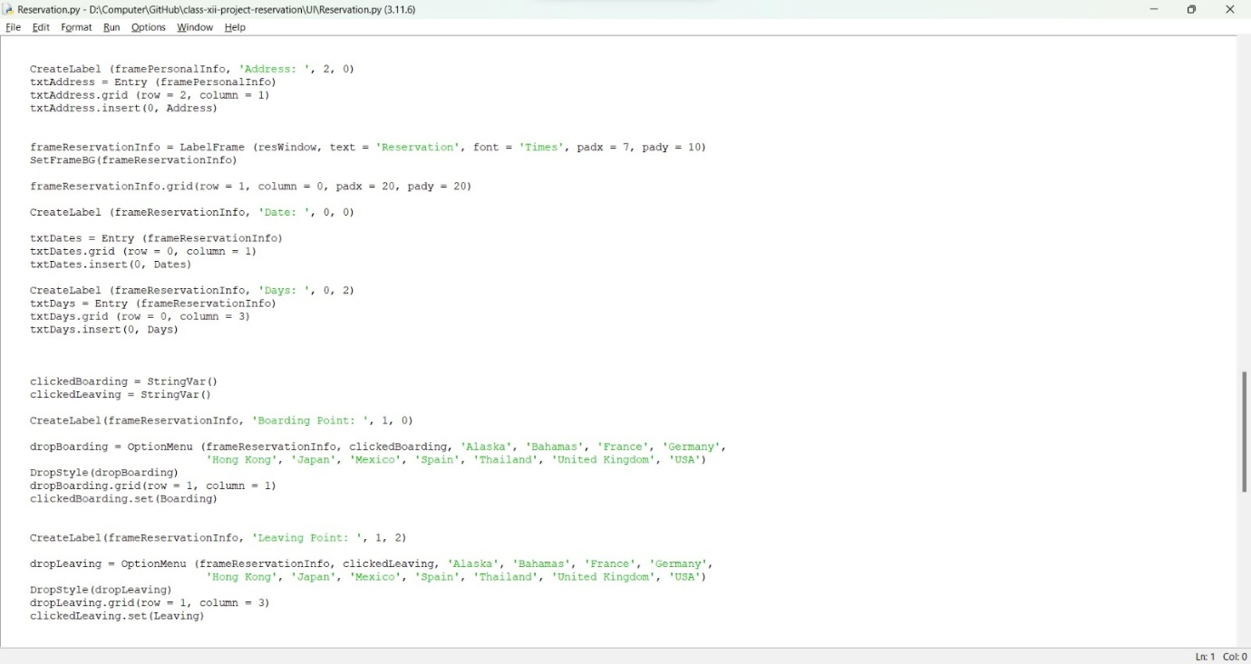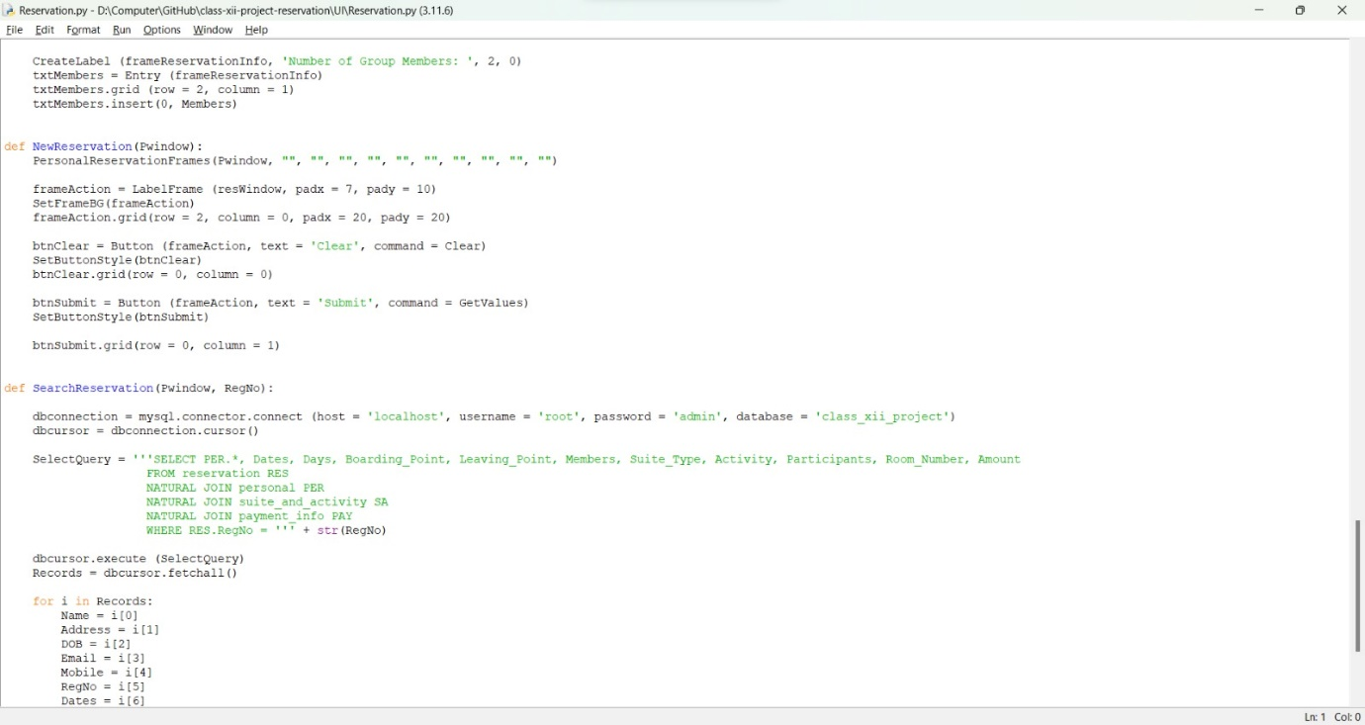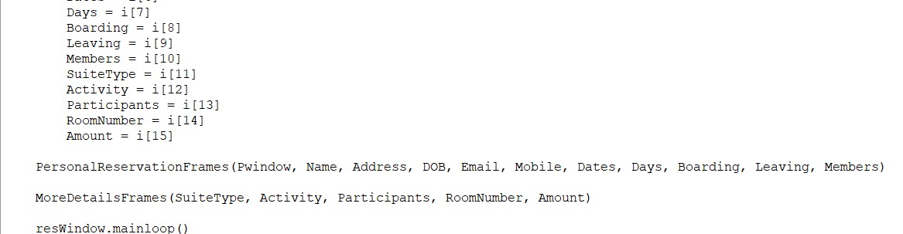

Booking suite and activity screen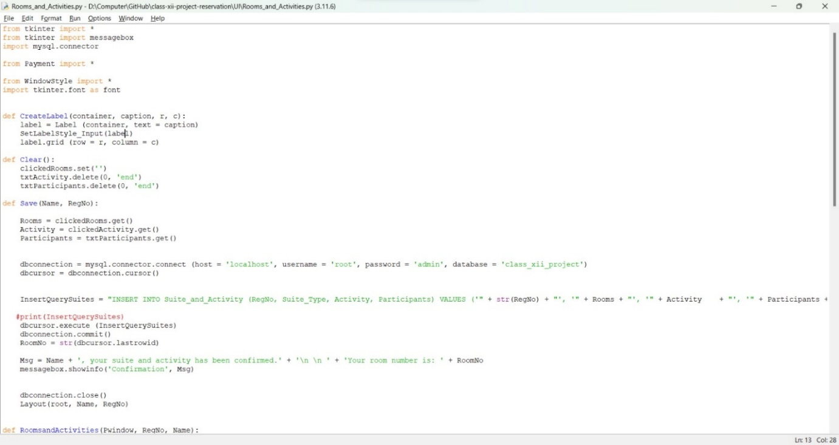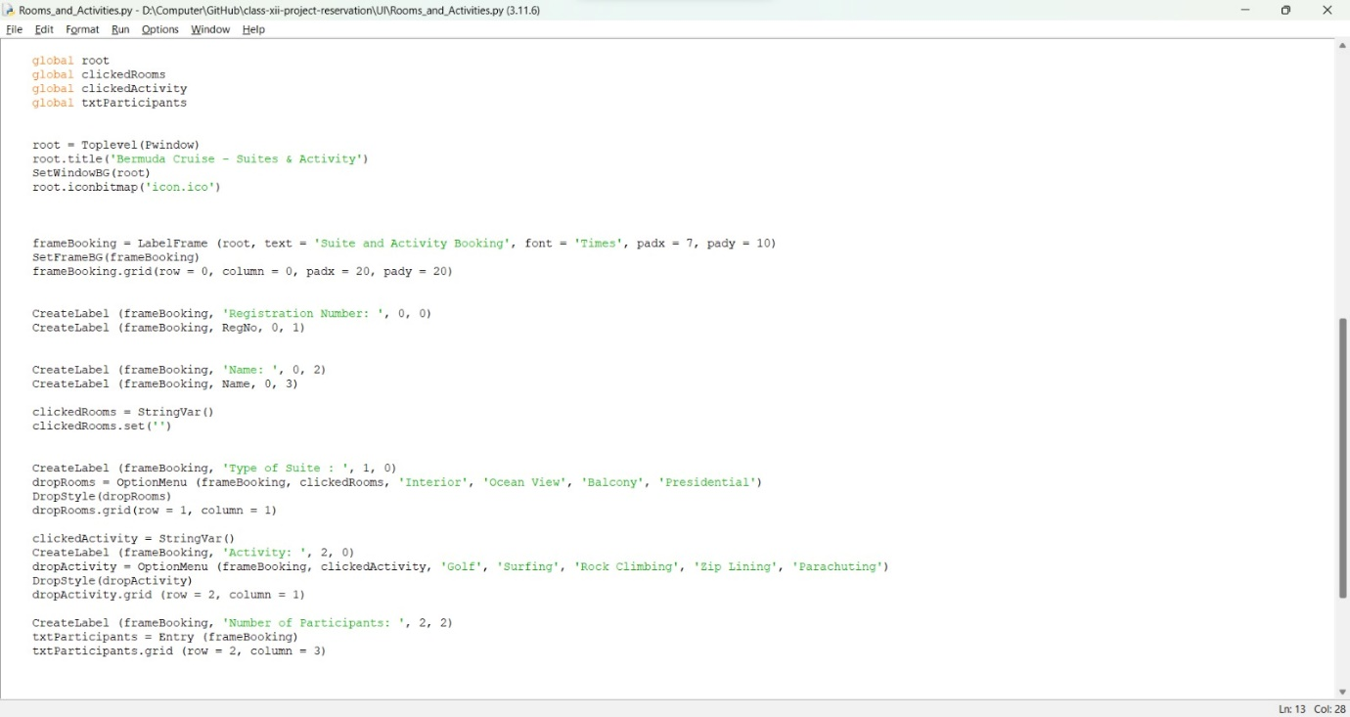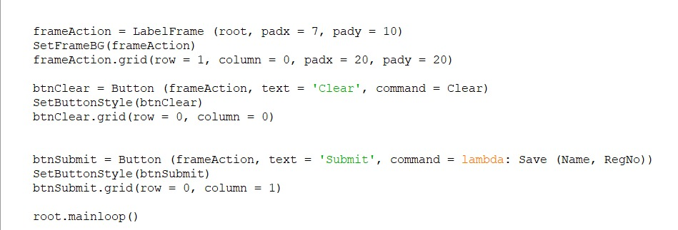

Payment Screen

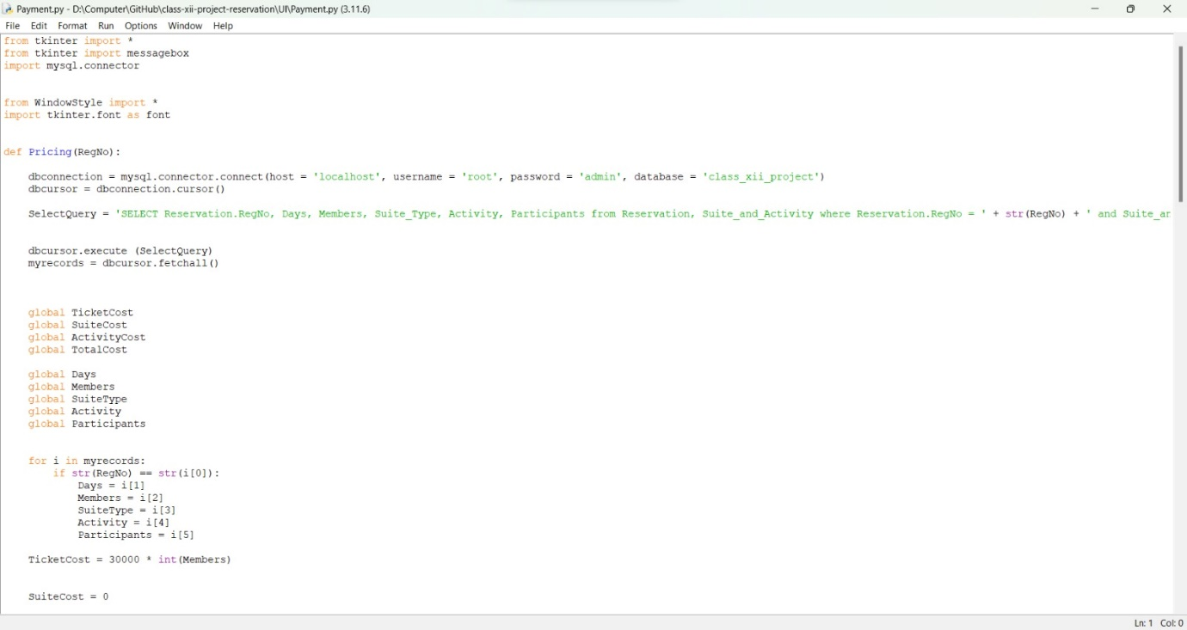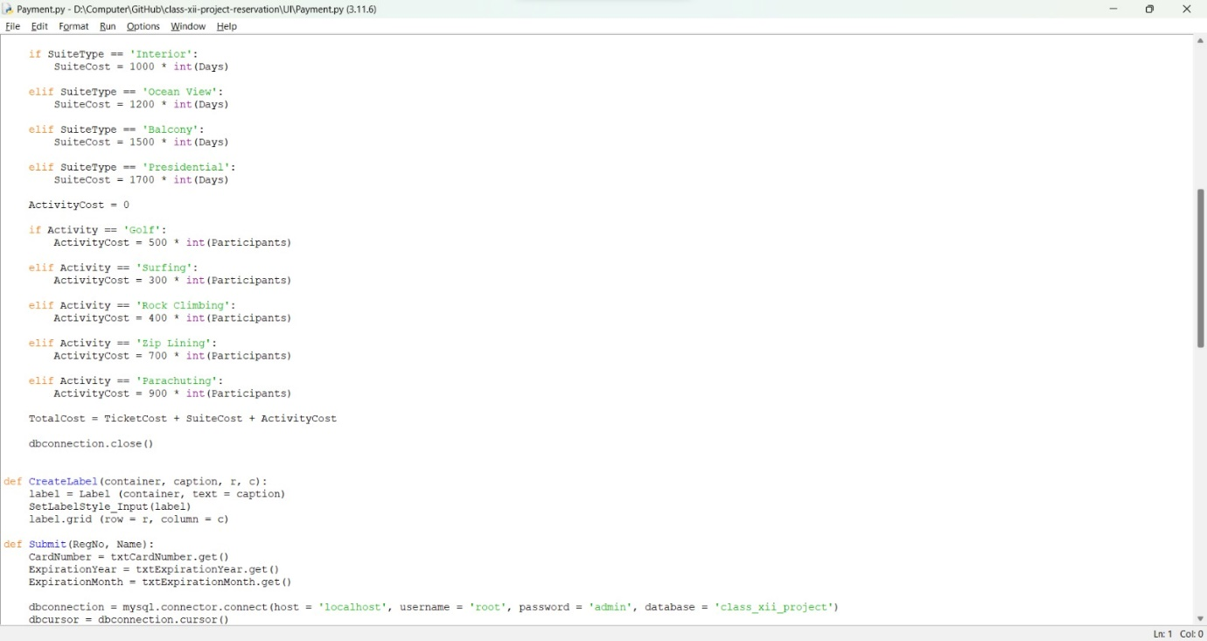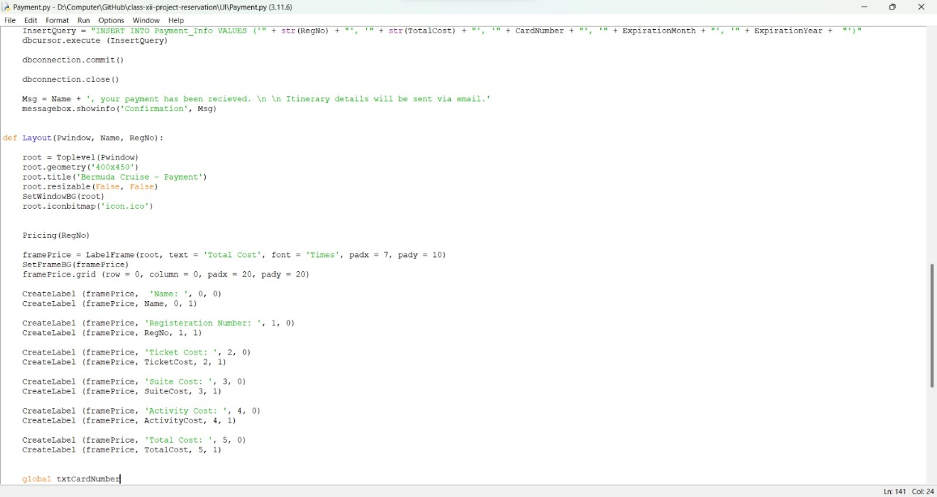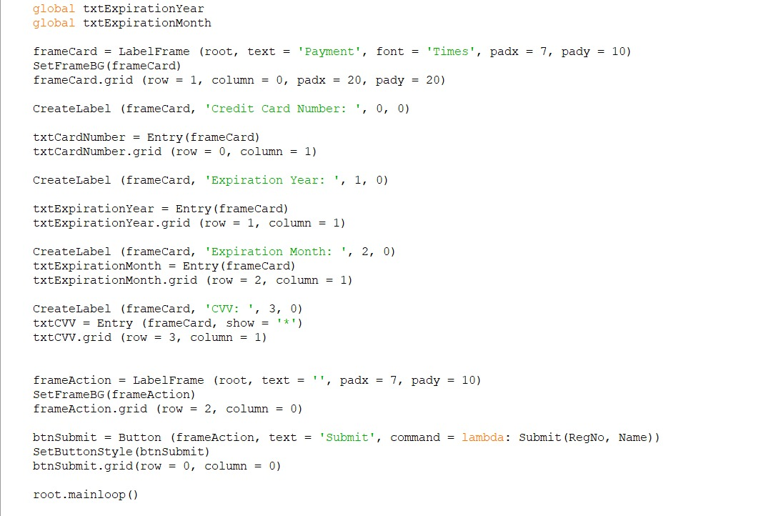

Window styling screen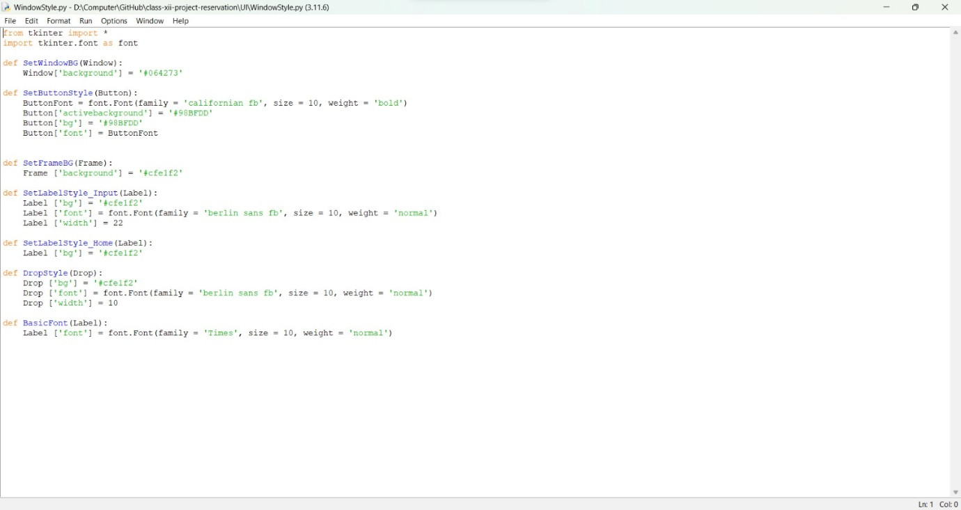

## Software Requirements

* IDLE (Python 3.11 64 bits)
* MySQL Workbench 8.0 C
* OS-Windows 11

## Modules

* Tkinter
* Pillow

## Hardware

* Dell Vostro 5620
* HP Pro book
* Dell Inspiron 15 3511