A SECURE WEB INTERFACE FOR FACE BASED IDENTIFICATION OF MISSING CHILDREN THROUGH LOGGING AND SEARCHING

Supriya Repalle
Student(UG), Department of CSE
Sathybama Institute of Science and Technology
Chennai, India
supriyarepalle07@gmail.com
A Ishita Reddy
Student(UG), Department of CSE
Sathybama Institute of Science and Technology
Chennai, India
iannreddy@gmail.com@gmail.com
Nancy Noella R S
Associate Professor, Dept of CSE
Sathybama Institute of Science and Technology
Chennai, India
nancynoella.cse@sathyabama.ac.in

Abstract— The count of the missing children is growing exponentially with each single passing day. It is implausible that a minimum count of 175 children are being missed every day. Keeping this in mind, the proposed work focuses on an end-to-end web interface for finding out the missing children through secure logging and searching of the missing child using face recognition method. Face recognition is being carried out by matching the query face image with the template image found in the database using VGG-Face algorithm from Deep Face library, using this the distance of differences between images is carried out through Euclidean loss method. This process begins with an admin module that is the police authority who has the authority to upload the missing person details with authenticated login credentials. Then, if at all a volunteer finds a child who was found, then he can click the photo of the child and put it in the web interface where the face is being compared with already present faces in the databases uploaded by the police community. If at all there is a match, then a notification would be received by the police people and to family member’s email id. So, that the child’s parents also can know with whom their child is been found. A local database is used in the project to store the details of the missing child like name, address, email id and phone number of the guardian. The total web framework is being carried out by the Streamlit for designing the web pages.
Keywords— Face Recognition, VGG-Face, Euclidean Loss, Streamlit, Web interface

Introduction
A missing person is someone who has gone missing willingly or inevitably, whether they're a sprat or a grown-up. There are multitudinous kinds of missing cases, with just 43 of missing cases having known reasons, 99 being juvenile runaways, 2500 cases being related to next of kin troubles, and roughly 600 cases being abducted by nonnatives (which include both teens and grown-ups). Women regard around58% of most instances, while men regard 48. There are no finances devoted to locating missing individualities in India," a sanctioned source revealed. A missing individual confronts several challenges, many are exposed to death (killing), sexual assault, or maltreatment. Individuals who watch the missing person, similar to blood relators, musketeers, cousins, and dear ones, are stressed and bothered since they do not know if the missing person is alive or dead. Chancing a missing person is a delicate trouble; notwithstanding the reality that we are all kept known through networking to date, it necessitates a large quantum of documentation and is a stagnant procedure. As we all know, we largely use our profiles for the identification of humans currently, and automation is perfecting day by day with regard to facial recognition and discovery. Face recognition discovery is a separate technology that has advanced fleetly in the latest times. The thing then is to produce a design to identify missing humans that will be largely handy for everyone, normal people and police departments, permitting them to find their dear ones in a short period of time. In our methodology, the picture of the missing individual handed by the custodians is saved in our database by sanctioned people like the police we use Streamlit which is the most popular frame for Deep Learning algorithms, and it includes trained models like the VGG - Face algorithm that may help with picture categorization, neural network, and Euclidean loss function is used to identify the quantum of distance among two prints.

Literature Review
First, We were inspired to develop our proposed system to identify missing people is from a journal paper written in 2021 by Shivam Mourya and his classmates from VPP College of Engineering, Maharashtra, India. The students' basic suggestion for locating the missing person using an application based on Python language refers to gathering the complaints from the relevant guardians and storing them at various stations in the firebase and matching if they find any child. In order to supplement this fundamental framework, we suggest a model of an authorized and well-maintained system in which both parties, that is, the parties attempting to file the complaint, let's say the civic force and the users, are authorized and verified respectively. The email sending component of our project, which accounts for the novelty because the missing person's parents can be notified, is also given top priority.
The Hassan Ugali and Ali Elamahmudi method of picking up on the face using deep face from incomplete data of the face paved the way for recognizing the face through dispersed and individual parts of the face. The philosophy behind their implemented model was to recognize a person's face even with the aid of imperfect data, such as when input only contains eyes and a nose, zoomed, rotated, or half of a face because frequently we tend to only get such images in the CCTV unedited prints, even then the deployed model was capable of decoding the result. For facial segmentation and perception, they have used a convolutional neural network, and for the extraction of facial features, they have used a pre-trained model called the VGG-Face algorithm and a classifier called the linear support vector machine (SVM). This inspired our project to construct the model using VGGFace
A system proposed by Rohit Satle in the year 2016, using face recognition-based system. The PCA (Principal Component Analysis) used for face recognition and SVM (Support Vector Machine) used as classifier. The issue with the system was its ability in detecting faces. Face having same expression were only detecting and the computational complexity was also very high. The major shortcomings of applying the PCA are that it takes a significant timespan and resources to complete the process, and it can only analyse faces with comparable facial expressions. The main difference between their project and ours is that our project can identify the particular person even if different facial expressions are there in both images. Our system will also detect particular person’s 2 different images, one image with moustache and another image with no moustache. We will make use of AI for recognition of images which will definitely increases our accuracy level.
In 2020, Sarthak Babbar, Navroz Dewan, Kartik Shangle and his fellow mates from Jaypee Institute of Information Technology, Noida, India team gave out a paper in which gave us very clear idea about how Amazon Web Services (AWS) Recognition works and it compares AWS recognition with other algorithms and systems like CDAC-VS, CNN Services (AWS) Recognition. As we get older, our faces change over time, but the images in our dataset don't. For the purpose of face acknowledgement across age groups, we want to investigate Residual Network's (ResNet) accuracy. On different data sets, including the cross-age known person dataset and a identification subset (CACD-VS), the performance is compared to other techniques like Amazon Web Services and cross-age reference coding (CARC). On the CACD-VS dataset, accuracy for ResNet and AWS Recognition was 98.40% and 99.45%, respectively.
Swarna Bai Arniker and K.Sita Rama Rao and his battalion from Research Institute Imarat, Hyderabad, submitted a paper in August 2014 that provides us with given facts of the Wireless Communication Integrated Missing People Identification System. In the future, this wireless scanning gear might be utilized at both police stations as well as meetups. This has procedures for locating and returning lost children, physically challenged youngsters, and elderly adults to their guardians. The radio waves label must be physically applied by the individual. As a result, it has the constraint of having a wireless communication chip that will trace the specific individual.
A system was proposed in paper by Yongsheng Gao with Maylor K.H.Leung took the advantage of a LEM (Line Edge Map) as a face recognition based system. This technique mostly used in such condition where variations in intensity of light does not change, proposed this system and 92% was it accuracy. Another face recognition using Eigen face as its method was proposed in the year of 2002.

Sayan and Ajitha proposed a model to build a face recognition system using a hybrid approach by amalgamating the outputs obtained through two distinct neural networks which are ANN, LDA in the year 2020. Numerous image processing methods and neural networks have been used by researchers to address the issue, but they have not yet been successful in achieving the desired accuracy.
In the year 2020, S. AYYAPPAN and his colleagues from IFET College of Engineering submitted a study on a similar issue description and ideal. They presented a method that employs Deep Learning-based Cosmetic Feature Birth and Matching with a stacked convolutional autoencoder (SCAE). Pictures of missing people are kept in a database. The profiles are recognized in the photos, and the characteristics are learned using a Convolutional Neural Network. These newly learned characteristics were used to train a cross-SVM classifier. They correctly identified and labeled the stripling using this approach. The key distinction between their research compared to ours is we are going to create a dataset of missing individuals with the support of those who wish to help society (NGOs). In addition, their system includes complicated algorithms that slow down the birth and bracketing processes.
The existing system for finding the lost person till date are like just enrolling the missing persons details and their family contacts along with their photograph, stored in some database, if the person is found then it says there is a match, but they do not focus on reaching that missing person to their respective families, any model did not focus on sending a notification to the family as soon as their ward was found at some particular location. Mentioning about location, in any system they have not specified methods for finding about the place where that person was found. In the earlier systems, any person can access the systems there was no authentication of users and admin that means anyone can misuse the platform to get the details of the particular person.

Proposed System
The police people and other authorized parties have to sign-up using their registered Email ID, then they have to confirm their username and password by streamlit authenticator verification method. The job of the police is to add the missing person’s details which include a photocopy, name, age, skin tone, identification marks, place and time where they were last seen, and contact details and address of the respective guardians of that particular person who has been missing. Once the details have been entered into the database, then all the details will be stored in the database with all the other records. Only the police have the authorization to add a record, update a detail, or delete the records of the missing person. To perform all the above-mentioned activities, they have to sign in again using the registered username and password which they created during the login process. As the web interface basically focuses on identifying and reporting the missing people, it has the other user login where the user has to verify the email id the difference between user and admin is they cannot make any changes to the records present in the database, to exemplify they cannot add a new record into the database, update the already presented record in the database, or delete a record present in the database. This helps us to avoid any fraudulent activity from taking place because they are forbidden from doing activities in the database. So, they have only the option of uploading the picture of the missing person, where the system checks whether the person is present in records given by the police to the database which is done through deep learning algorithm VGG-Face –
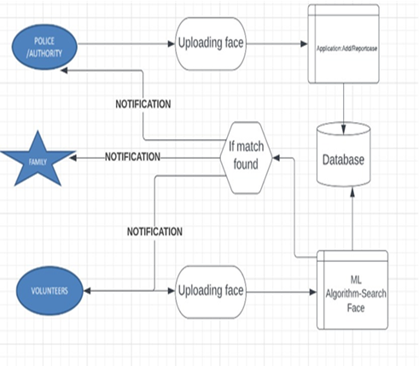
- Architecture of the system
Now, if there is a match found between the uploaded picture by the user and the given picture by the police to the records, then a page appears saying you found the saying picture is matching our records! Then a notification will be sent to the police Email Id which they gave used to sign-up and the guardian’s Email ID which the police have given while uploading the record into the database. Along with that, the location and time where the missing person was found with the details of the volunteers would be notified to the police and protector’s Email ID. The volunteer will now be displayed with the contact details of the guardian of the missing person.

Working

Initial login of the authorized admins The template is designed for, but not limited to, six authors.
- Here, only authorized persons say the police people have the authority to access in to the web interface.
- This can be obtained through hashed passwords and keys generation from the admin side
- This is done with the help of a function called generate keys which helps us to maintain and add only listed users and passwords who can have access.
- The admin has to give his correct username and password to login and report the case.
- The interface verifies the given details with that in the listed password for the app and allows only if they are present in the heap of passwords listed.

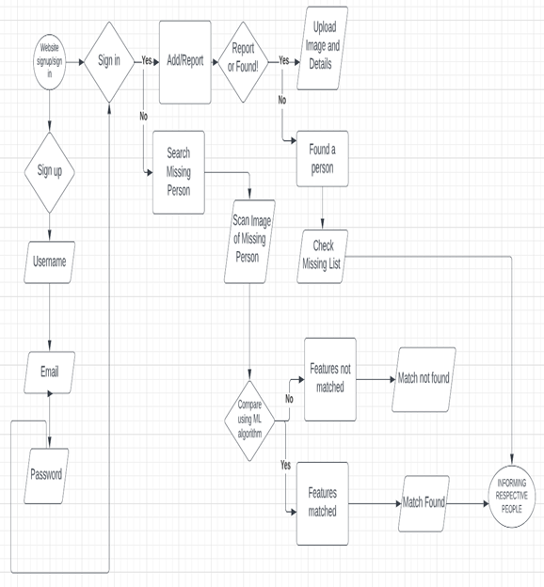
- Flow diagram of the proposed system

Registering the missing person report in the admin UI:
- The police persons or the verified admins who have successfully logged in are redirected to the reporting missing person page
- The admin UI is being created using streamlit along with the whole interface
- It has fields like name, age, emailid, contact number of the missing person, location and also a field to add and attach the photocopy of the person
- These details of the missing person are stored locally in the interface data.
- We create a data frame to store these details and add a column to return yes if the person is found along email sent column also.

User’s verification for uploading of the photo of the missing person
- The users have to give their email id and the app password which the email account’s browser creates especially for the verification of the user which the user ‘s browser creates.
- The user has to set his password in his or her’s Gmail account in the app password section.
- If he is a genuine user then only, he is allowed to upload the photo for matching.
- After uploading the photo of the person, we get a notification as we are going to receive a notification in case of the person is there in the local database.
- The user also has to give his respective phone number to contact him.

Matching the photo using Algorithm
- Here we use the VGG-Face algorithm which is used for facial recognition and is a pre-trained model of Deep Face library. It returns the distance between the cells of a matrix of two faces using Euclidean loss function.
- The basic image processing is done through the pillow library like the resizing, rotation, color improvisation.
- The threshold value for the algorithm given is 0.5 and it can be adjusted according to how accurately we want the algorithm to match the photos.

Sending the email if the person is obtained
- Email is being sent to the missed person’s family and police people that this particular person is being found in the particular location
- The email contains the contact number and details of the person who has uploaded the photo copy for matching the photos.
- The email also contains the uploaded photo by the user to check for the parents whether he is his or her child or not

Location Identification of the user
- If there is match between the uploaded photo and the photo in the database.
- Then the location of the user is being traced using his internet protocol address.
- With the location identified we can go to the particular place where the person is found.
- The user here will get the details of the missing person from the database if there is a match found.

Results
The screenshots after finishing the login and report filing are attached, the user authentication and the result after uploading the photo by the user is also attached.

- ADMIN LOGIN PAGE
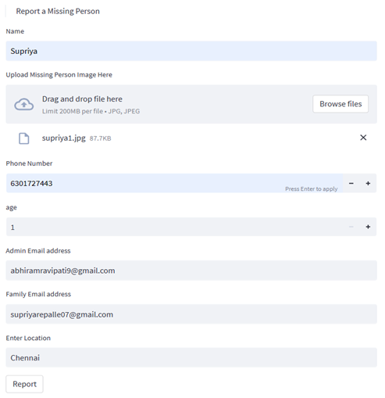
- CASE FILING AFTER SUCCESSFUL LOGIN OF THE ADMIN
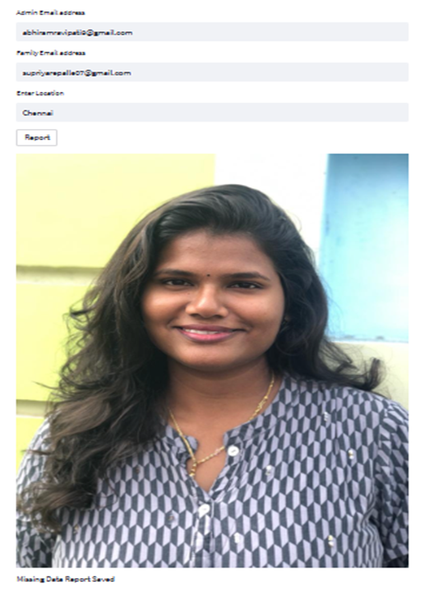
- ACKNOWLEDGING THE ADMIN AFTER SUCCESSFUL REGISTRATION OF COMPLAINT

- DATABASE ENTRY OF THE REPORT FILED
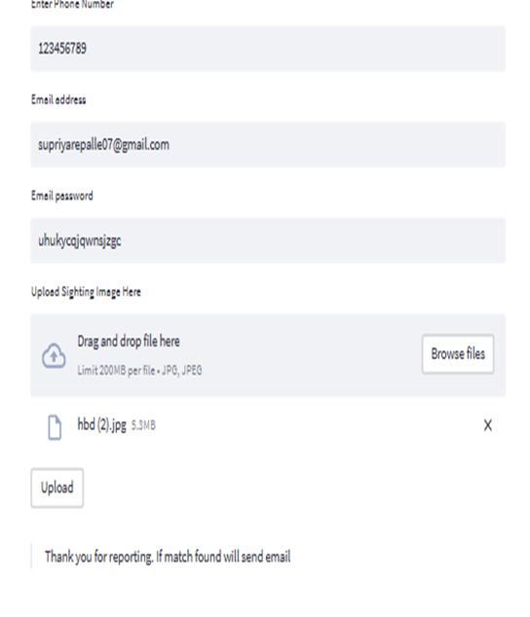
- ACKNOWLEDGING THE USER IN THE USER UI

- VERIFYING THE EMAIL OF THE USER IN THE USER UI
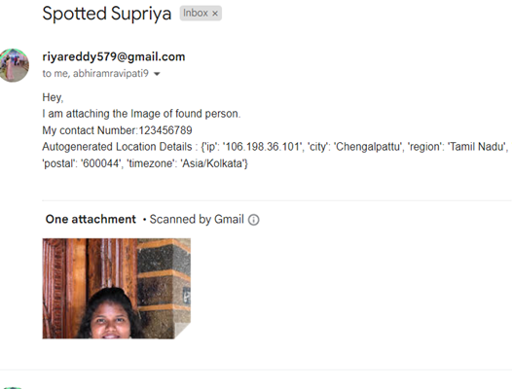
- A MAIL WILL BE SENT TO THE MISSING PERSON’S GUARDIANS THAT THEIR CHILD IS FOUND WITH PARTICULAR USER
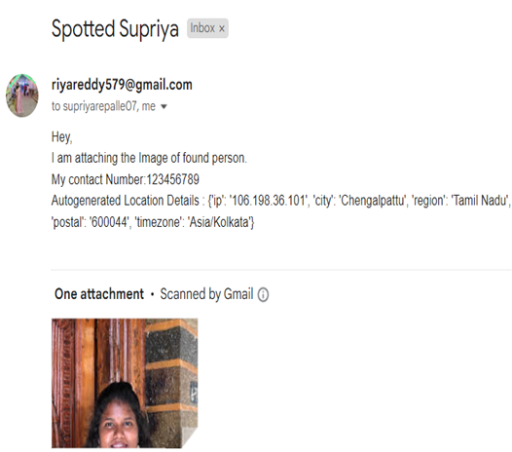
- THE EMAIL WILL BE SENT TO THE ADMIN’S EMAIL ACCOUNT ALSO IN THE SAME MANNER.
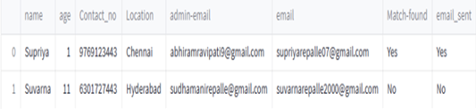
- THE DETAILS IN THE DATABASE GETS UPDATED AS SOON AS THERE IS A MATCH.

Conclusion
This way, if a volunteer discovers the missing person, they can safely hand them over through our secure web interface with a quick notification that includes their location and their phone number. This system can be made even better by turning on the hotspot within 10 km of the location of the missing child, which we collect at the time of case reporting from the administrative side. This suggested methodology can be applied to CCTVs and surveillance cameras to get quick and precise results. Therefore, facial recognition in practice offers us beneficial examples.

References
The template will number citations consecutively within brackets [1]. The sentence punctuation follows the bracket [2]. Refer simply to the reference number, as in [3]—do not use “Ref. [3]” or “reference [3]” except at the beginning of a sentence: “Reference [3] was the first ...”
Number footnotes separately in superscripts. Place the actual footnote at the bottom of the column in which it was cited. Do not put footnotes in the abstract or reference list. Use letters for table footnotes.
Unless there are six authors or more give all authors’ names; do not use “et al.”. Papers that have not been published, even if they have been submitted for publication, should be cited as “unpublished” [4]. Papers that have been accepted for publication should be cited as “in press” [5]. Capitalize only the first word in a paper title, except for proper nouns and element symbols.
For papers published in translation journals, please give the English citation first, followed by the original foreign-language citation [6].

- Neha Gholape, Ashish Gour, Shivam Mourya,” Finding missing person Using ML, AI”, International Research Journal of Modernization in Engineering Technology and Science, e-ISSN: 2582-5208, Volume:03/Issue:04/April-2021.
- Puja S. Prasad, Rashmi Pathak, Vinit Kumar Gunjan, H. V. Ramana Rao,” Deep Learning Based Representation for Face Recognition”, ICCCE 2019, 2020, Volume 570, ISBN : 978-981-13-8714-2
- Shilpa Wakode, Rohit Satle, Vishnuprasad Poojary, John Abraham, “Missing Child Identification Using Face Recognition System,” Electronics Department, Lokmanya Tilak College of Engineering, Mumbai University, Mumbai, India, 2016.
- S. Babbar, N. Dewan, K. Shangle, S. Kulshrestha, and S. Patel, "Cross-Age Face Recognition using Deep Residual Networks," 2019 Fifth International Conference on Image Information Processing (ICIIP), Shimla, India, 2019, pp. 257-262, doi: 10.1109/ICIIP47207.2019.8985765.
- Swarna Bai Arnikar, G. Kalyani, D. Meena, M. Lalitha, K. Shirisha, Seetasaikiran, “RFID based missing person identification system”, IEEE 2014 International Conference on Informatics, Electronics & Vision (ICIEV).
- Gao, Yongsheng & Leung, Karhang & Hui, Siu & Tananda, M.W.. (2003). “Facial Expression Recognition from Line-Based Caricatures. Systems, Man and Cybernetics, Part A: Systems and Humans”, IEEE Transactions on. 33(3). 407 - 412. 10.1109/TSMCA.2003.817057.
- Nancy Noella, R.S., Priyadarshini, J. (2019). “Efficient Computer-Aided Diagnosis of Alzheimer’s Disease and Parkinson’s Disease—A Survey. “In: Nath, V., Mandal, J. (eds) Nanoelectronics, Circuits and Communication Systems . Lecture Notes in Electrical Engineering, vol 511. Springer, Singapore. https://doi.org/10.1007/978-981-13-0776-8_5.
- Noella, R.S.N., Priyadarshini, J. RETRACTED ARTICLE: Diagnosis of Dementia Using a Generative Deep Convolution Neural Network. Arab J Sci Eng (2021). https://doi.org/10.1007/s13369-021-05982-0.
- Nancy Noella R S,Priyadarshini J,”Machine Learning Algorithms for Alzheimer’s and Parkinson’s Disease”Int J Adv Trends Comput Science Eng,Volume 9,Isuue 4,2020.
- K. M. A. Solaiman, T. Sun, A. Nesen, B. Bhargava and M. Stonebraker, "Applying Machine Learning and Data Fusion to the “Missing Person” Problem," in Computer, vol. 55, no. 6, pp. 40-55, June 2022.
- S. Alagarsamy, K. V. Sudheer Kumar, P. Vamsi, D. Bhargava and B. D. Hemanth, "Identifying the Missing People using Deep Learning Method," 2022 7th International Conference on Communication and Electronics Systems (ICCES), 2022.
- A. Nadeem, K. Rizwan, A. Mehmood, N. Qadeer, F. Noor and A. AlZahrani, "A Smart City Application Design for Efficiently Tracking Missing Person in Large Gatherings in Madinah Using Emerging IoT Technologies," 2021 Mohammad Ali Jinnah University International Conference on Computing (MAJICC), 2021.
- B. Vinavatani, M. R. Panna, P. H. Singha, and G. J. W. Kathrine, "AI for Detection of Missing Person," 2022 International Conference on Applied Artificial Intelligence and Computing (ICAAIC), Salem, India, 2022, pp. 66-73, doi: 10.1109/ICAAIC53929.2022.9792672.
- S. M. R., K. Chaudhary, S. R and P. Panjiyar, "AI-Assisted Search for Missing Children," 2022 IEEE 2nd Mysore Sub Section International Conference (MysuruCon), Mysuru, India, 2022, pp. 1-6, doi: 10.1109/MysuruCon55714.2022.9972347.
- B. Vinavatani, M. R. Panna, P. H. Singha, and G. J. W. Kathrine, "AI for Detection of Missing Person," 2022 International Conference on Applied Artificial Intelligence and Computing (ICAAIC), Salem, India, 2022, pp. 66-73, doi: 10.1109/ICAAIC53929.2022.9792672.
- Shefali Patil, Pratiksha Gaikar, Divya Kare, and Sanjay Pawar, “Finding Missing Person Using AI,” IJPRSE, vol. 2, no. 6, pp. 101–104, Jun. 2021.
- D. J. Samatha Naidu, R. Lokesh, "Missing Child Identification System using Deep Learning with VGG-FACE Recognition Technique," SSRG International Journal of Computer Science and Engineering, vol. 9, no. 9, pp. 1-11, 2022. Crossref.
- Bharath Darshan Balar, D S kavya, Chandana M, Anush E, Vishwanath R Hullipalled, “Efficient Face recognition system for identifying lost people”, International Journal of engineering and standard technology (IJEAT), ISSN:2249-8958, Volume-8, Issue-5 S, May 2019.
- Sayan Deb Sarkar and Ajitha Shenoy, “Face Recognition using Artificial Neural Network and Feature Extraction”, IEEE 2020 IEEE 7th International Conference on Signal Processing and Integrated Networks.
- Birari Hetal, Sanyashiv Rakesh, Porje Rohan, Salwe Harish, “Android Based Application-Missing Person Finder”, IRE Journals, Volume1 Issue 12, ISSN: 2456- 8880
- Kumar, Mithilesh; Singh, Shikar; Dipesh L I Harish Raju; S Sasidhar Babu.“Locating Missing Persons Using Artificial Intelligence”, International Journal of Advanced Research in Computer Science; Udaipur Vol. 11, Iss. Special Issue 1, May 2020: 43-46.
- Ahonen, Timo, Abdenour Hadid, and Matti Pietikainen. “Face description with local binary patterns: Application to face recognition”, IEEE transactions on pattern analysis and machine intelligence 28.12 (2006): 2037–2041.

IEEE conference templates contain guidance text for composing and formatting conference papers. Please ensure that all template text is removed from your conference paper prior to submission to the conference. Failure to remove template text from your paper may result in your paper not being published.

