**Practical No 5**

**Aim:**

Steps –

* **Go to file menu and click on capture history**

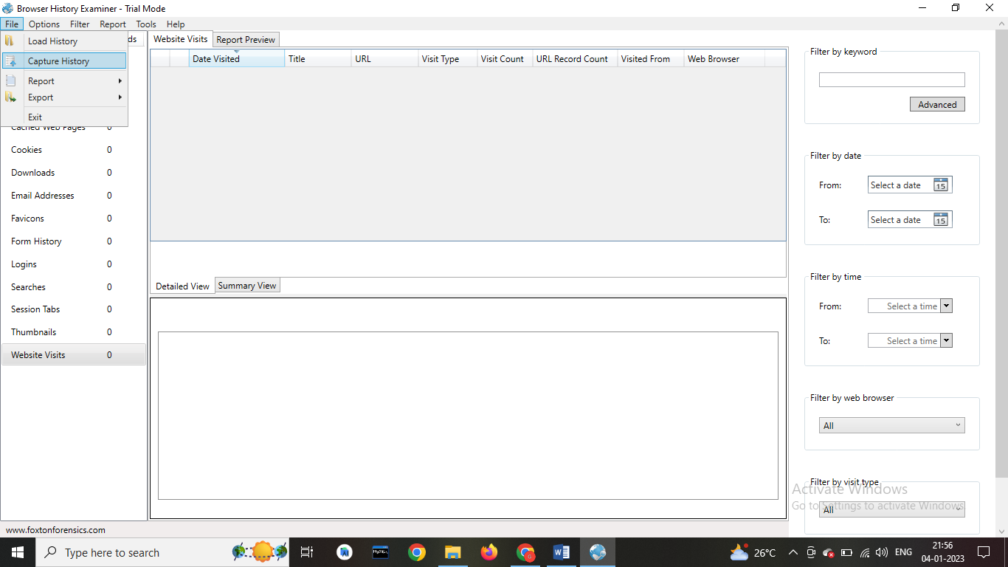

* **Select capture history from this computer then click on next**

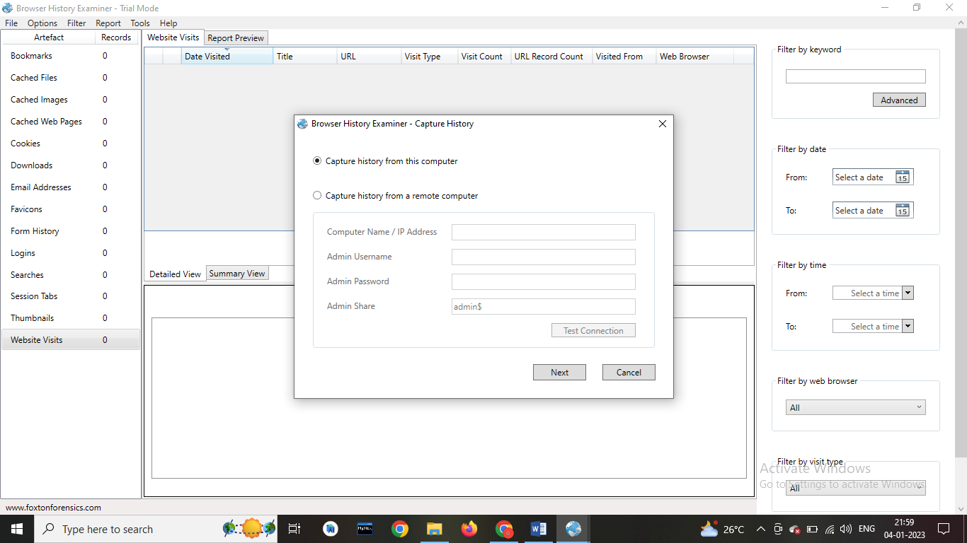

* **Select the browsers that you examine and data what you see and set the destination And click on Capture button**

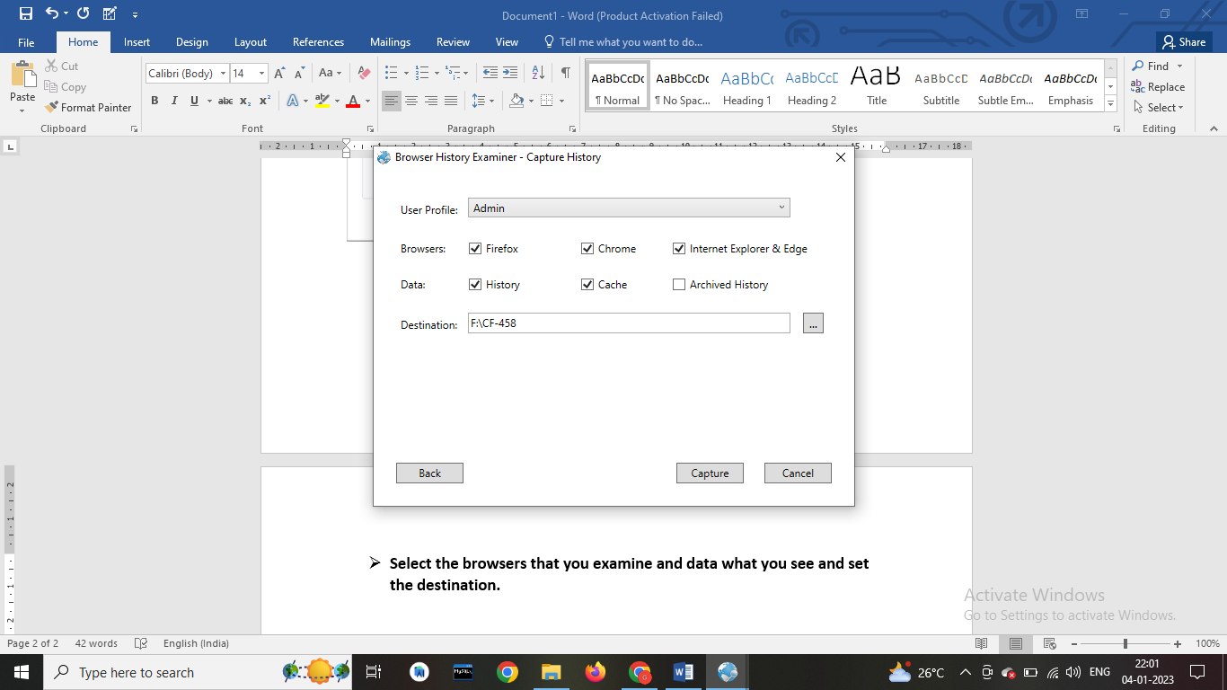

* **The History is been extracting.**

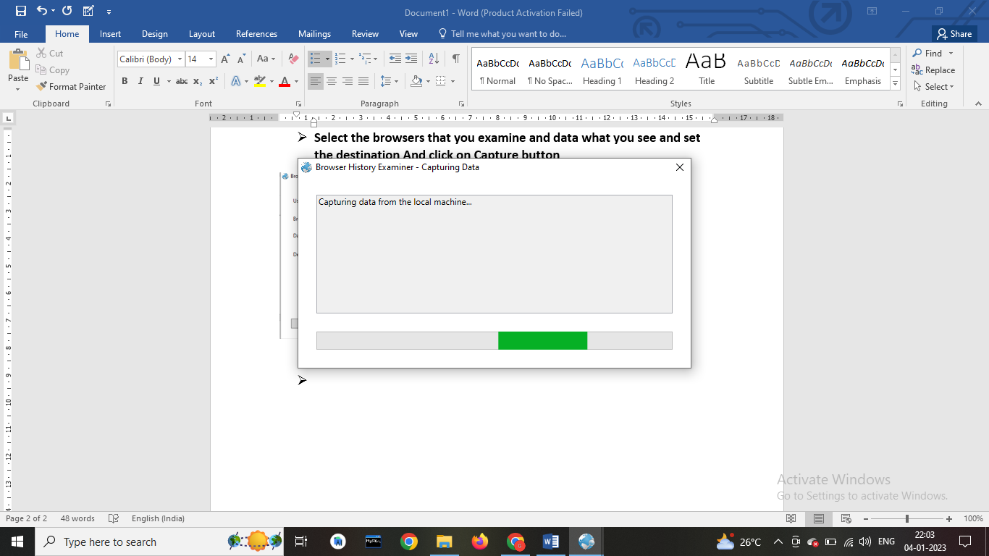

* **The data has been retrieved.**

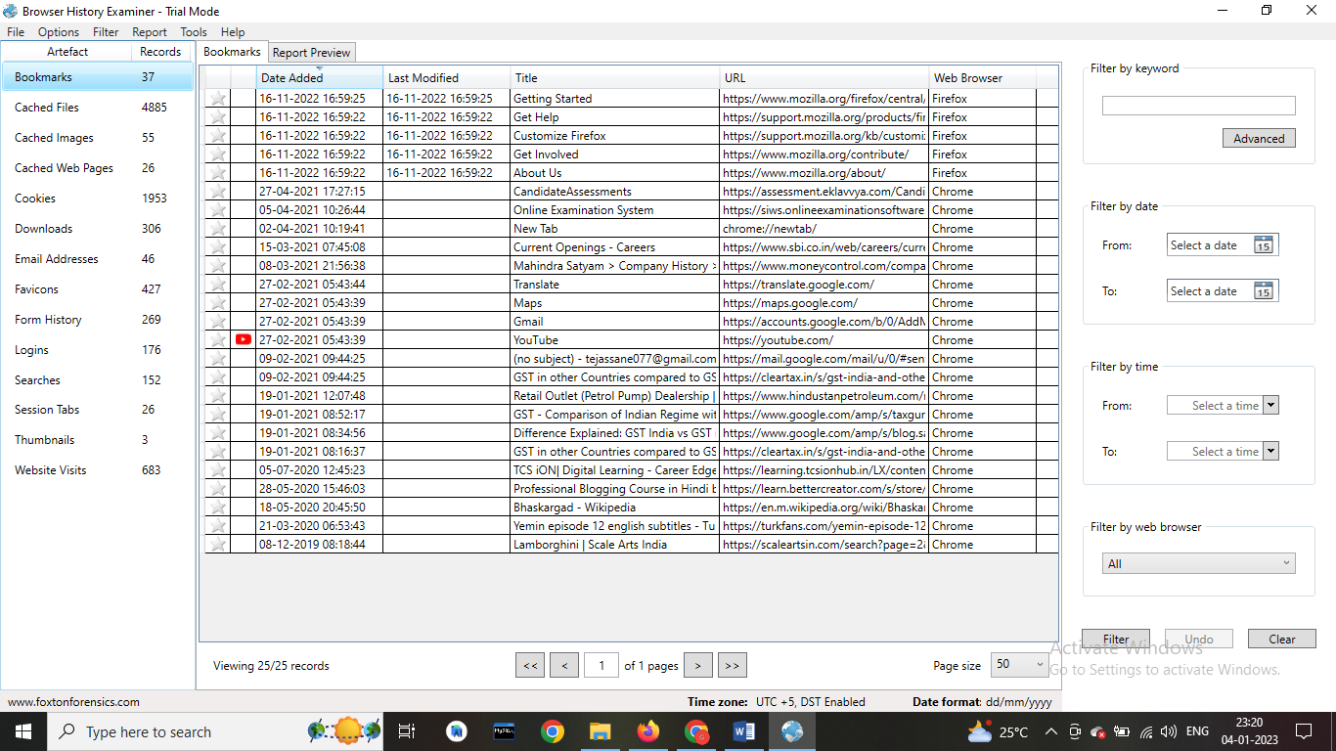

* **On the left panel click on bookmarks.**



* **On the left panel click on cached files.**

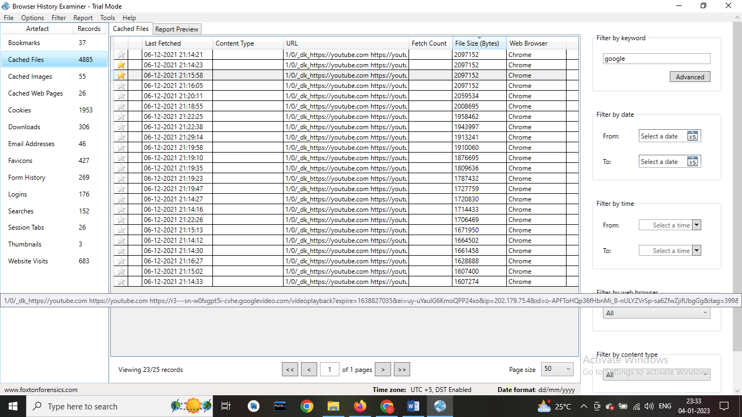

* **On the left panel click on cached images**

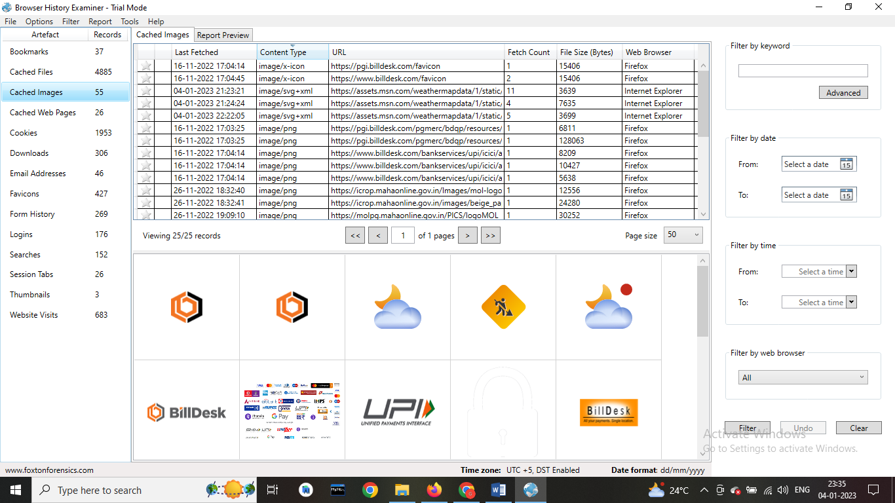

* **On the left panel click on cookies.**

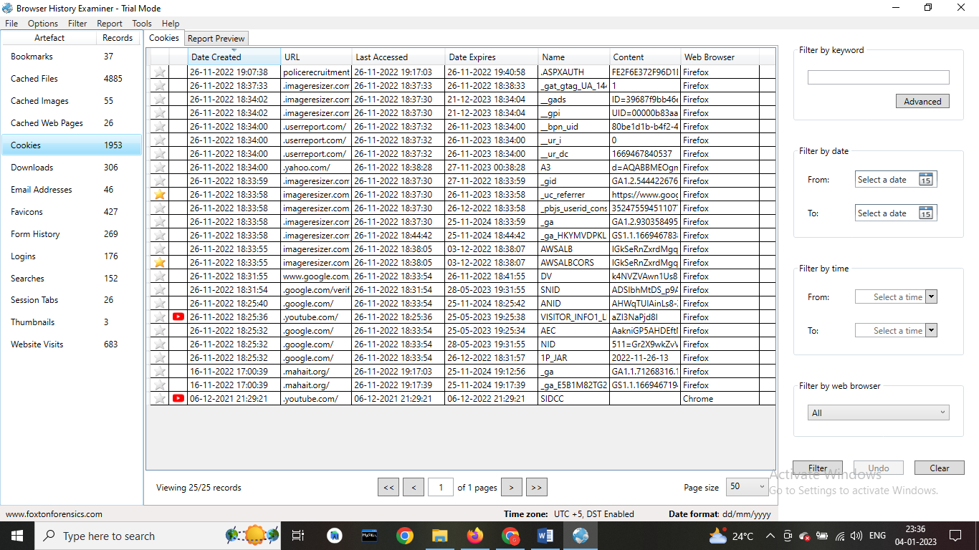

* **To Create Reports. Click on file > Report and save the report as pdf or html page.**

