We are tracking single underlying asset – AAPL, with a deep option chain.
Spot Price: ~ 256 $
Alternative 1: Using Implied Volatility
In the real market, we don’t know the true volatility. We only know the market Price.
We take the observed market price and "back-calculate" the volatility that makes the Black-Scholes formula equal that price. IV represents the market's collective expectation of future risk. By using IV, our Greeks (Delta, Vega) are anchored to what the market is actually pricing right now.
In theory, every option on the same stock should have the same IV. In reality, they don't. Options with different strikes and expirations trade at different IVs.
Dividend Adjusted Price of the stock
Before Calculating the Greeks (Delta and Vega), we must adjust the Spot price to the Forward Price.
F = Se^((r-q))T
We don’t use the price on the screen; we use the price adjusted for interest and dividends.
Marking The Surface of Implied Volatility
We calculate the “Mid” prices (Average of Bid and Ask) for the entire AAPL option chain.
We solve the Black Scholes formula to get the volatility using the risk and dividend adjusted Forward Price.
We find the volatility of every single strike. This volatility surface tells us the exact IV for any strike or expiration.
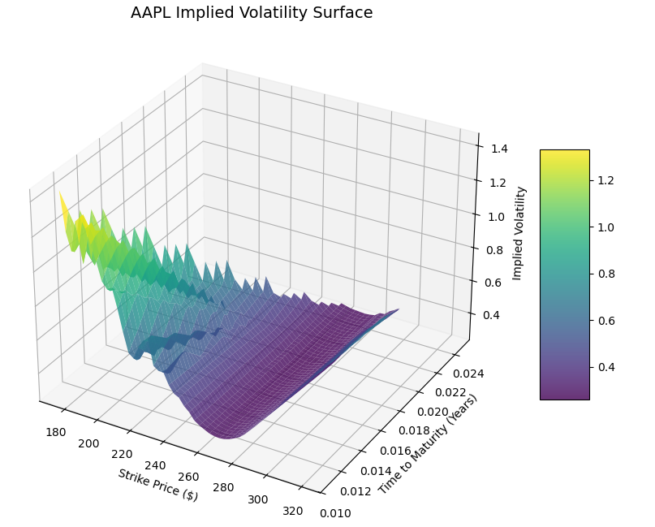
Finding how much “in the money” an option is, adjusted for time and volatility.

Using the d1, Find the Delta and vega
Delta – Directional Risk
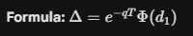
For an AAPL 260 Call, the model calculates a based on the surface IV is 25 %. If delta = 0.52, then holding 1 option contract (example - 100 shares) gives you the same directional exposure as owning 52 shares of AAPL stock.
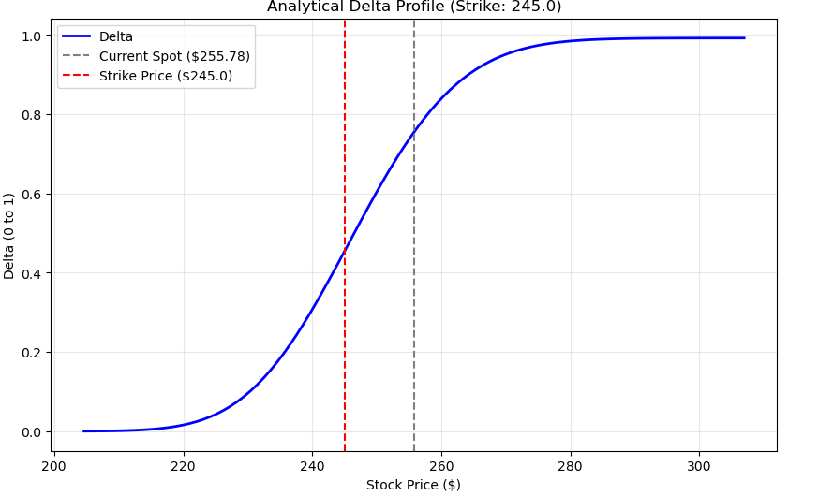
Vega – Volatility Risk
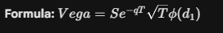
If AAPL Vega = 0.20$, and a news event causes the IV Surface to "lift" by 1%, the option value increases by 0.20 $

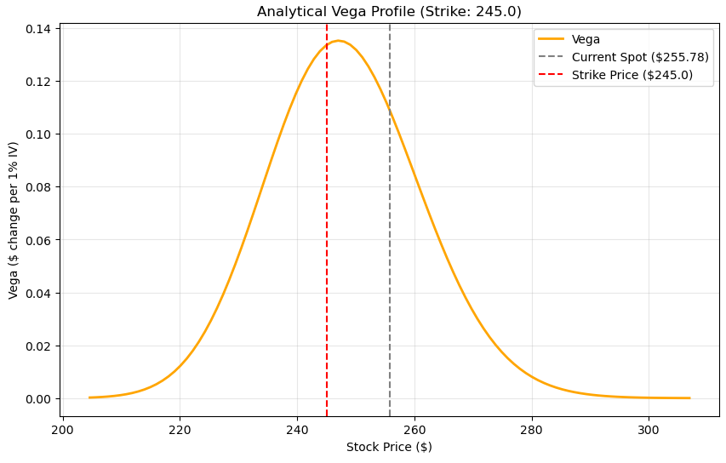
Alternate 2: Taylor Series Approximation
We take an initial Snap of the market state at t0. And calculate the price by adding the Linear Impact and Convexity Impact.
For example:
Stock Price ($): $256.00
Option Price (P): $4.50
Delta: 0.50$
Gamma: 0.06$
Let us say, after a millisecond later, the AAPL stock price moves UP by 0.50 $
Old Stock: $256.0 New Stock: 256.50$
Change (dS): 05 $

New Price Value approx. Equals = Old Value + (Sensitivity * Change in Market)

New Delta:

New Delta: 0.50 + (0.06 * 0.5) = 0.53

Limitations:
The Taylor Series is an approximation. Over time, or after very large moves(example AAPL jumps 5 $ instantly), the approximation accumulates error.
As we are assuming Gamma as constant for that period of time. But Gamma changes slowly.
We might have to re-calculate the whole model at every X seconds, lets say 30 seconds. And meanwhile use the approximation.
