How would you apply Monte Carlo to AAPL options, and how do you ensure the price values remain positive?

To model AAPL's risk, I would use a Monte Carlo simulation based on Geometric Brownian Motion (GBM). The reason we use GBM specifically is to solve the 'positive value' problem.

In a simple random walk, prices could theoretically drop below zero, which is physically impossible for a stock. In GBM, we model the logarithm of the price. We treat the stock return as a combination of a deterministic 'drift' (the average expected return) and a stochastic 'shock' (market volatility).
Mathematically, we use the equation
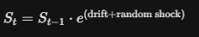
OR
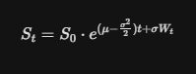
The range of the function f(x) = e^x is (0, infinity)
The exponential function e^x is always greater than zero, our simulated AAPL price will stay positive regardless of how large the negative market shock is.

