MAMA – THE MOTHER OF ADAPTIVE MOVING AVERAGES
By
John Ehlers

The MESA Adaptive Moving Average (MAMA) adapts to price movement in an entirely new and unique way. The adapation is based on the rate change of phase as measured by the Hilbert Transform Discriminator I have previously described. The advantage of this method of adaptation is that it features a fast attack average and a slow decay average so that composite average rapidly ratchets behind price changes and holds the average value until the next ratchet occurs. The action of MAMA is shown in Figure 1. Since the average fallback is slow I can build trading systems that are virtually free of whipsaw trades.

Figure 1. MAMA Rapidly Ratchets to Follow Price
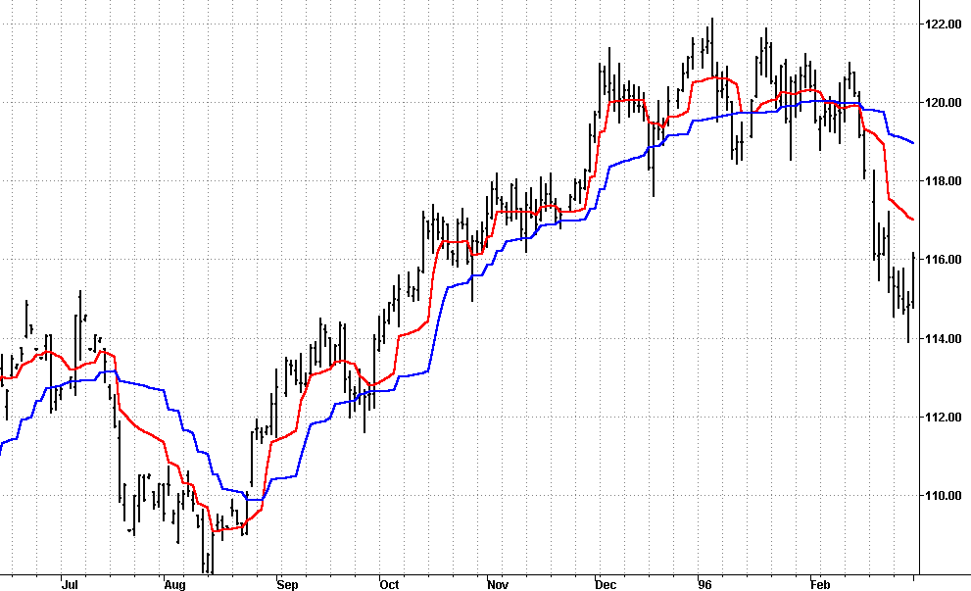

The starting point for MAMA is a conventional Exponential Moving Average (EMA). The equation for an EMA is written as:
EMA = α*Price + (1 – α)*EMA[1]
Where α is less than 1
In English, this equation says that the EMA is comprised of taking a fraction of the current price and adding one minus that fraction times the previous value of the EMA. The larger the value of α, the more responsive the EMA becomes to the current price. Conversely, if α becomes smaller, the EMA is more dependent on previous values of the average rather than the current price. Therefore, a way to make an EMA adaptive is to vary the value of α according to some independent parameter. The Kaufman Adaptive Moving Average (KAMA) and the Variable Index Dynamic Average (VIDYA) use the variation in prices, or volatility, as the basis of their adaptations.
The concept of MAMA is to relate the phase rate of change to the EMA alpha, thus making the EMA adaptive. As shown in Figure 2, the cycle phase goes from 0 through 360 degrees in each cycle. The phase is continuous, but is usually drawn a snap back at the beginning of each cycle. Thus the phase rate of change is 360 degrees per cycle. The shorter the cycle, the faster the phase rate of change. For example, a 36 bar cycle has a phase rate of change of 10 degrees per bar, while a 10 bar cycle has a rate of change of 36 degrees per bar. The cycle periods tend to be longer when the market is in a Trend Mode.

Figure 2. Phase increases 360 degrees per cycle. The ArcTangent(Q/I) snaps back every half cycle.
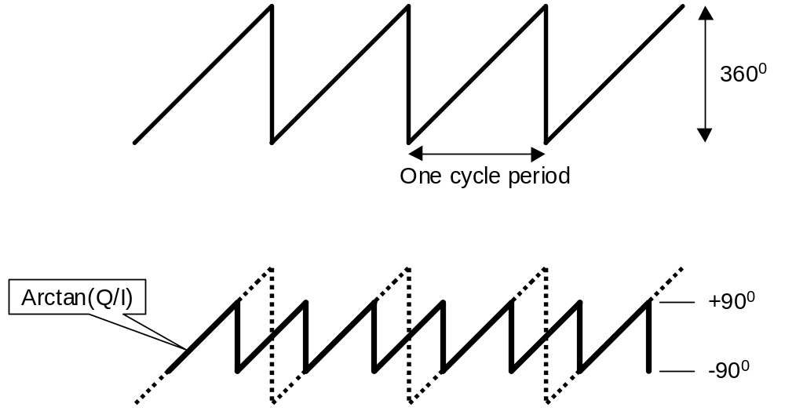

The cycle phase is computed from the arctangent of the ratio of the Quadrature component to the InPhase component. I obtain the phase rate of change values by taking the difference of successive phase measurements. The arctangent function only measures phase over a half cycle, from –90 degrees to +90 degrees. Since the phase measurement snaps back every half cycle, a huge negative rate change of phase every half cycle results from the computation of the rate change of phase. Measured negative rate changes of phase can also occur when the market is in a trend mode. Any negative rate change of phase is theoretically impossible because phase must advance as time increases. I therefore limit all rate change of phase to be no less than unity.
The alpha in MAMA is allowed to range between a maximum and minimum value, these values being established as inputs. The suggested maximum value is FastLimit = 0.5 and the suggested minimum is SlowLimit = 0.05. The variable alpha is computed as the FastLimit divided by the phase rate of change. Any time there is a negative phase rate of change the value of alpha is set to the FastLimit because the phase rate of change can be no less than 1. If the phase rate of change is large, the variable alpha is bounded at the SlowLimit. This keeps MAMA from reacting to the shorter market cycles.
The arctangent function produces a phase response between -90 degrees and +90 degrees, with a phase wrap back to -90 degrees. There is a huge negative rate change of phase across this phase wrap boundary. By limiting this negative rate change of phase to +1, the alpha used in the EMA is set to the FastLimit. The phase wrap boundary occurs at zero degrees and 180 degrees of a theoretical sinewave due to the 90 degree lag of the Hilbert transform.
The variable alpha is guaranteed to be set to the FastLimit every half cycle due to the measured phase snap back. This relatively large value of alpha causes MAMA to rapidly approach the price. After the phase snaps back, the alpha returns to a typically small value. The small value of alpha causes MAMA to hold nearly the value it achieved when alpha was at the FastLimit. This switching between the relatively large and relatively small values of alpha produce the ratcheting action that you observe in the waveform. The ratcheting occurs less often when the market is in the Trend Mode because the cycle period is longer in these cases.
An interesting set of indicators result if the MAMA is applied to the first MAMA line to produce a Following Adaptive Moving Average (FAMA). By using an alpha in FAMA that is half the value of the alpha in MAMA, the FAMA has steps in time synchronization with MAMA, but the vertical movement is not as great. As a result, MAMA and FAMA do not cross unless there has been a major change in market direction. This suggests an adaptive moving average crossover system that is virtually free of whipsaw trades.
The MAMA code is shown in Figure 3. This code is nearly the same as the one that computes the Hilbert Transform Homodyne Discriminator cycle measurement, with the additional code to compute phase rate of change, the nonlinear alpha, and the MAMA and FAMA lines. Your superheterodyne radios and TVs are tuned by multiplying the incoming RF signal with a variable frequency local oscillator to produce a fixed frequency Intermediate Frequency (IF). Homodyne means we multiply the signal by itself (delayed by one bar) to produce a zero frequency beat note. The phase information is carried in the value of the beat note. The code in Figure 3 performs the complex multiplication and filtering to produce the measured phase angle.
The unique character of MAMA is shown in Figure 1. The red MAMA line ratchets closely behind the price. The blue Following Adaptive Moving Average (FAMA) line steps in time sequence with MAMA, but the movement is not as dramatic because its alpha is at half value. From Figure 1 it is clear that the two adaptive moving average lines only cross at major market reversals. Their action enables the creation of a trading system that is virtually free of whipsaw trades. As an example, I tested the MAMA crossover system on 100 stocks from 1/2/1998 to 1/2/2001, taking long side trades only and trading one share per stock. This period is comprises a good system test because it encompasses both the 1999 bull market and the 2000 bear market. The gross profit of this test was $6,403 on 1317 trades. 37.5% of all the trades were profitable, with the average profit per trade being $4.86 per share. Typical transaction cost is about $.30 per share, showing that the system turns in a substantial net profit on the average. MAMA trades about 4.4 times a year per stock, trading only on the long side. The relatively large number of trades in this test demonstrate that the MAMA system was not curve-fitted to the sample data.
I hope your MAMA will do as good for you in your trading.

John Ehlers is president of MESA Software and a frequent contributor to STOCKS & COMMODITIES. John pioneered the MESA algorithm for measuring market cycles. This article was adapted from Rocket Science for Traders, published by John Wiley and Sons. He may be reached via his website at www.mesasoftware.com.

MAMA EasyLanguage Code
Inputs: Price((H+L)/2),
FastLimit(.5),
SlowLimit(.05);

Vars: Smooth(0),
Detrender(0),
I1(0),
Q1(0),
jI(0),
jQ(0),
I2(0),
Q2(0),
Re(0),
Im(0),
Period(0),
SmoothPeriod(0),
Phase(0),
DeltaPhase(0),
alpha(0),
MAMA(0),
FAMA(0);

If CurrentBar > 5 then begin
Smooth = (4*Price + 3*Price[1] + 2*Price[2] + Price[3]) / 10;
Detrender = (.0962*Smooth + .5769*Smooth[2] - .5769*Smooth[4] - .0962*Smooth[6])*(.075*Period[1] + .54);

{Compute InPhase and Quadrature components}
Q1 = (.0962*Detrender + .5769*Detrender[2] - .5769*Detrender[4] - .0962*Detrender[6])*(.075*Period[1] + .54);
I1 = Detrender[3];

{Advance the phase of I1 and Q1 by 90 degrees}
jI = (.0962*I1 + .5769*I1[2] - .5769*I1[4] - .0962*I1[6])*(.075*Period[1] + .54);
jQ = (.0962*Q1 + .5769*Q1[2] - .5769*Q1[4] - .0962*Q1[6])*(.075*Period[1] + .54);

{Phasor addition for 3 bar averaging)}
I2 = I1 - jQ;
Q2 = Q1 + jI;

{Smooth the I and Q components before applying the discriminator}
I2 = .2*I2 + .8*I2[1];
Q2 = .2*Q2 + .8*Q2[1];

{Homodyne Discriminator}
Re = I2*I2[1] + Q2*Q2[1];
Im = I2*Q2[1] - Q2*I2[1];
Re = .2*Re + .8*Re[1];
Im = .2*Im + .8*Im[1];
If Im <> 0 and Re <> 0 then Period = 360/ArcTangent(Im/Re);
If Period > 1.5*Period[1] then Period = 1.5*Period[1];
If Period < .67*Period[1] then Period = .67*Period[1];
If Period < 6 then Period = 6;
If Period > 50 then Period = 50;
Period = .2*Period + .8*Period[1];
SmoothPeriod = .33*Period + .67*SmoothPeriod[1];

If I1 <> 0 then Phase = (ArcTangent(Q1 / I1));
DeltaPhase = Phase[1] - Phase;
If DeltaPhase < 1 then DeltaPhase = 1;
alpha = FastLimit / DeltaPhase;
If alpha < SlowLimit then alpha = SlowLimit;
MAMA = alpha*Price + (1 - alpha)*MAMA[1];
FAMA = .5*alpha*MAMA + (1 - .5*alpha)*FAMA[1];

Plot1(MAMA, “MAMA”);
Plot2(FAMA, “FAMA”);

End;

John Ehlers, “Phasor Displays”, Stocks & Commodities, Dec 2000, pp 19
Perry J. Kaufman, “Trading Systems and Methods, Third Edition”, John Wiley & Sons, pp 436-438
Tushar S. Chande and Stanley Kroll, “The New Technical Trader”, John Wiley & Sons, New York, 1994

