RELATIVE VIGOR INDEX (RVI)
By
John Ehlers

INTRODUCTION
Congratulations to Stocks & Commodities on their 20th anniversary! This article describing the Relative Vigor Index (RVI) is appropriate for the occasion because it uses concepts dating back to the beginning of the magazine and also uses modern filter and digital signal processing theory to realize those concepts as a practical and useful indicator. Just like the magazine, the RVI merges the old concepts with the new technologies.
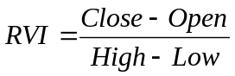 The basic idea of the RVI is that the prices tend to close higher than they open in up markets and tend to close lower than they open in down markets. The vigor of the move is thus established by where the prices reside at the end of the day. To make the index normalized to the daily trading range, the change of price is divided by the maximum range of prices for the day. Thus, the basic equation for the RVI is:

HISTORICAL PERSPECTIVE
In 1972, Jim Waters and Larry Williams published a description of their A/D Oscillator. In this case, A/D means accumulation/distribution rather than the usual advance/decline. They defined Buying Power (BP) and Selling Power (SP) as:
BP = High – Open
SP = Close – Low
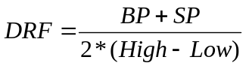Where the prices were the open, high, low, and closing prices for the day. The two values, BP and SP, show the additional buying strength relative to the open and the selling strength relative to the close to obtain an implied measure of the day’s trading. They combined the measurement as the Daily Raw Figure (DRF). DRF is calculated as:

The maximum value of 1 is reached when a market opens trading at the low and closes at the high. Conversely, the minimum value of zero is reached when the market opens trading at the high and closes at the low. The day-to-day evaluation causes the DRF to vary radically, and requires smoothing to make it useable.
We can expand the equation for DRF as:

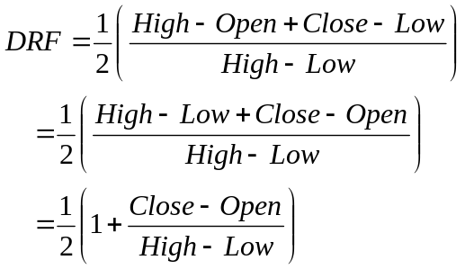
Clearly, the equation for DRF is identical with the daily RVI expression except for the additive and multiplicative constants. It seems there are no new ideas in technical analysis. However, smoothing must be done to make the indicator practical. This is where modern filter theory contributes to the successful implementation of the RVI.

SMOOTHING
The RVI is an oscillator, and we are therefore only concerned with the cycle modes of the market in its use. The sharpest rate of change for a cycle is at its midpoint. Therefore, in the ascending part of the cycle we would expect the difference between the Close and Open to be at a maximum. We would prefer to have the indicator be exactly in phase with the cyclical component of the price action. We know from calculus that if we integrate a sinewave over a half cycle period that the resultant is another sinewave delayed by a quarter cycle. Summing over a half cycle is basically the same as mathematically integrating, with the result that the waveshape of the sum is delayed by a quarter wavelength relative to the input. This is exactly the delay we require to produce an oscillator output to be in phase with the cycle component of the prices. You can measure the cycle period using a Hilbert Discriminator or a MESA software package. The RVI would then be smoothed over half the length of the measured dominant cycle.
If a cycle measurement is not available, you can sum the RVI components over a fixed default period. A nominal value of 10 is suggested because this is approximately half the period of most cycles of interest. The smoothing that is realized by summing over ten bars is shown in Figure 1. The amplitude of the smoothed output is measured in decibels, showing that the higher frequencies are attenuated. The period of the cyclic components can be computed as 2/(normalized frequency). For example, the highest possible normalized frequency is 1, which corresponds to a 2 bar cycle. This is because the Nyquist criteria requires at least 2 samples per cycle. In the case of a 10 bar sum the day-to-day 2 bar cycle is completely eliminated. This is very desirable for smoothing. However, if we choose to sum over 9 bars rather than the original 10 bars, we realize the frequency response shown in Figure 2. In this case, the 2 bar cycle is attenuated only by about 20 dB. In general, the 2 bar cycle is completely eliminated in the summing process only when the summing length is an even number.

Figure 1. Frequency Response of a 10 bar sum shows the 2 bar cycle is eliminated.
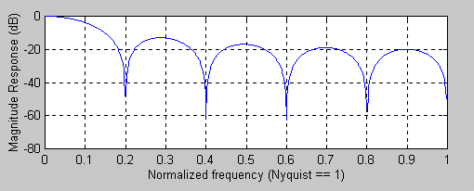

Figure 2. Frequency Response of a 9 bar sum shows the 2 bar cycle is not eliminated.
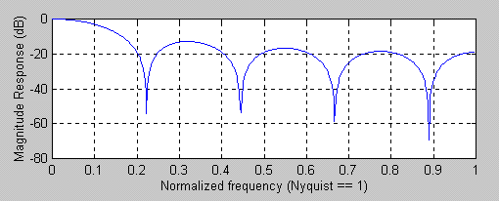

If you are using a dominant cycle measurement to determine the summing length, then you have little control over whether that length is even or odd. It is therefore advisable to use a symmetrically weighted FIR filter that is guaranteed to eliminate both the 2 bar and 3 bar cycle components. Such a filter has the coefficients as:
C=[1 2 2 1]/6
In the concise MatLab notation, or in EasyLanguage notation (where [1] denotes the value 1 bar ago) is:
Output = (input + 2*input[1] + 2*input[2] + input[3])/6
The frequency response of the symmetrically weighted FIR filter, shown in Figure 3, demonstrates that both the 2 bar cycle and 3 bar cycle components are completely rejected.

Figure 3. A Symmetrically Weighted 4 Bar SMA eliminates both the 2 bar and 3 bar cyclic components
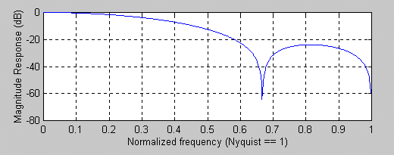

COMPUTING THE RVI
Calculating the RVI is straightforward. The numerator, consisting of the Close – Open, is filtered in the 4 bar weighted SMA. The denominator, consisting of the High – Low, is independently filtered in a 4 bar weighted SMA. The numerator and denominator are then independently summed over an approximate half dominant cycle period. A summation length of 10 bars can be used as a default if the cycle measurements are not available. The RVI is then computed as the ratio of the numerator to the denominator.
The rules for the use of the RVI are flexible. Just remember that it is an oscillator that is basically in phase with the cyclic component of the market prices. I prefer crossing line indicators because they are unambiguous in their signals. Since the lag of an N bar SMA is (N-1)/2, if we take a 4 bar symmetrically weighted average of the RVI we create a trailing trigger signal that trails by only 1.5 bars.
An example of the RVI is shown in Figure 4. The responsiveness and clarity of the signals are self explanatory. The EasyLanguage code to compute the RVI is shown in Figure 5.

Figure 4. The RVI give crisp indications of the cyclic turning points.
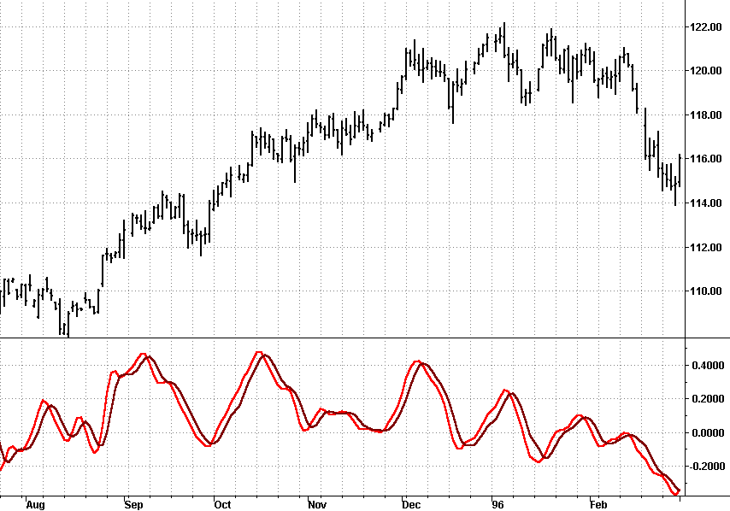

Figure 5. EasyLanguage Code to Compute the RVI
{****************************************************
Relative Vigor Index (RVI)
Copyright (c) 2001 MESA Software
*****************************************************}
Inputs: Length(10);

Vars: Num(0),
Denom(0),
count(0),
RVI(0),
RVISig(0);

Value1 = ((Close - Open) + 2*(Close[1] - Open[1]) + 2*(Close[2] - Open[2]) + (Close[3] - Open[3]))/6;
Value2 = ((High - Low) + 2*(High[1] - Low[1]) + 2*(High[2] - Low[2]) + (High[3] - Low[3]))/6;
Num = 0;
Denom = 0;
For count = 0 to Length -1 begin
Num = Num + Value1[count];
Denom = Denom + Value2[count];
End;
If Denom <> 0 then RVI = Num / Denom;

RVISig = (RVI + 2*RVI[1] + 2*RVI[2] + RVI[3])/6;

Plot1(RVI, "RVI");
Plot2(RVISig, "Sig");

John Ehlers , “Rocket Science for Traders”, John Wiley & Sons
www.mesasoftware.com

