http://meyersanalytics.com/papers.html

http://hk-lisse.over-blog.com/tag/les%20cycles/

[Goertzel algorithm: Amplitude, Period and Phase](http://hk-lisse.over-blog.com/article-31426339.html)

Goertzel algorithm: Research amplitude, period and phase of the cycle.  
  
In the last article on the Goertzel algorithm, the program allowed to recover the 2 periods of cycles that had the best answer. I complèté and corrected to also ensure the correct amplitude of the cycle and phase. This in order to redraw the curve   
In the example below, the signal (black) is a sinusoid 11 period added to a sine wave period 19 (amplitude 2) with a phase shift (90), all with a pinch of noise .. the two curves (red and blue) are reconstructed by the program, it remains to overlay for the signal without noise.

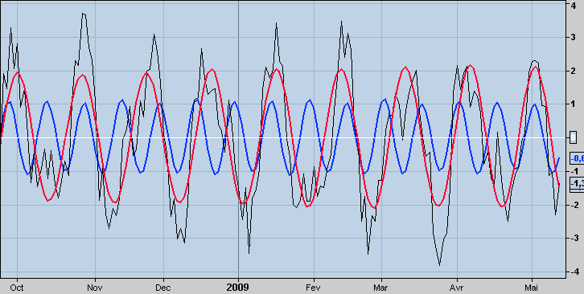

the code for ProRealTime (k variable is the frequency already found):

////////////////// sous prgm goertzel  biss ////////////  
a=barindex  
sig=sin(360*a/11)+2*sin(360*a/19+90)  
b=SQRT(barindex*(b+1))  
b=abs((b-ROUND(b))*4)  
c=b-1  
sig=sig+c  
n=200  
pr=sig  
alpha=2*cos(360*1/k)  
q1=0  
q2=0  
for i=n downto 0//fenêtre de 200 barres  
    q3=pr[i]+alpha*q1-q2  
    q2=q1  
    q1=q3  
next  
amp=sqrt(square(q1)+square(q2)-alpha*q1*q2)  
real=q1-(alpha*q2)/2  
imag=q2*sin(360*1/k)  
phas=atan(imag/real)  
if real<0 then  
    phas=phas+180  
elsif real>=0 and imag<0 then  
    phas=phas+360  
endif

[**Goertzel algorithm and Signal Analysis**](http://hk-lisse.over-blog.com/article-23944329.html)

in a paper (MESA vs Goertzel), Dennis Meyers compares the use of the Goertzel algorithm with the method of Ehlers for signal analysis: finding the dominant cycle.

return (2*amp/n)*sin(360/k+phas[1]+90),sig

In the following article, I rely on the publication of Meyers to test, as he did, the two methods.

This has also been useful to see if the codes programmed PRT gave correct results.

So I created as Meyers, a dummy signal: 1 sine period 11 added to a sine wave period 19 with a phase shift , all with a pinch of noise.

Here is what happens in one window, the noiseless signal (2 sine waves mixed) in window 2, the noise (ranging from -1 to +1) and window 3, the signal with noise.

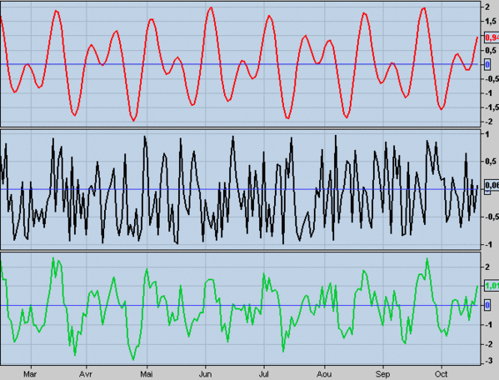

 On this signal I apply the Goertzel algorithm and Ehlers program to try to find the dominant cycles or periods 11 and 19. below the result with the algo Goertzel.

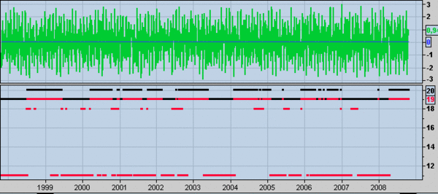

There are many detection of the period of Cycle 11, but it is not continuous.

For the period of Cycle 19, the display is continuous but varies from 19 to 20.

The program returns the two frequencies that have the best answer.

Here is a view of Elhers program "raw" (only one frequency is displayed), the detection periods 11 and 19 is less obvious:

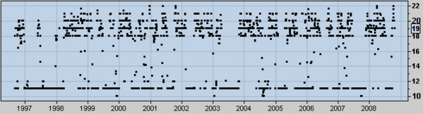

and another view with the hacked code 2 for output frequencies:

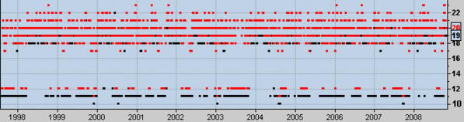

the same, expanding 50 to 100 bars of analysis window:

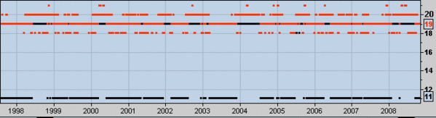

Conclusions:

- the codes look correct, the rings 11 and 19 appear.

- the accuracy of detection depends for 2 programs, the length of the calculation window.

The longer it is, the longer the calculation time, and it is accurate.

Meyers recommends 3 times the length of the estimated cycle, but 5 or 6 times seems essential to post-test.

- For the 2 methods, there are times when the cycle 11 is not detected.

For cons, the cycle 19 is always present with more or less precision.

- The program structure is similar, with a subroutine, and so it's quite heavy to rotate.

- It remains to apply the detection on the course previously "detrented" for a future article.

 Here are the different codes for ProRealTime used in the article:

/////////// signal sans bruit ////////////  
b=barindex  
sig=sin(360*b/11)+sin(360*b/19+90)  
return sig,0  
  
/////////////// bruit //////////////////  
b=SQRT(barindex*(b+1))  
b=abs((b-ROUND(b))*4)  
c=b-1  
return c,0  
  
////////////////// sous prgm goertzel ////////////  
a=barindex  
sig=sin(360*a/11)+sin(360*a/19+90)  
b=SQRT(barindex*(b+1))  
b=abs((b-ROUND(b))*4)  
c=b-1  
sig=sig+c  
  
pr=sig  
alpha=2*cos(360*1/k)  
q1=0  
q2=0  
for i=200 downto 0//fenêtre de 200 barres  
    q3=pr[i]+alpha*q1-q2  
    q2=q1  
    q1=q3  
next  
amp=sqrt(square(q1)+square(q2)-alpha*q1*q2)  
return amp

/////////////////// prgm goertzel ///////////////////  
l=0  
maxi=l  
maxo=0  
for p=5 to 25//détection de cycle de période de 5 à 25  
    my = CALL "goertzel sous"[p]  
    if my>maxi then  
        per=p  
        maxi=my  
    endif  
    if my>maxo and my<maxi then  
        peri=p  
        maxo=my  
    endif  
next  
return max(per,peri),min(per,peri)  
  
////////////// sous prgm ehlers ////////////////  
a=barindex  
sig=sin(360*a/11)+sin(360*a/19+90)  
b=SQRT(barindex*(b+1))  
b=abs((b-ROUND(b))*4)  
c=b-1  
sig=sig+c  
cl=sig  
  
cospart=0  
sinpart=0  
for n=0 to 99// fenetre de 100 barres  
    cycper=(360*n)/peri  
    cospart=cospart+cl[n]*cos(cycper)  
    sinpart=sinpart+cl[n]*sin(cycper)  
next  
pwr=square(cospart)+square(sinpart)  
return pwr

/////////////// prgm ehlers ///////////////  
mix=0  
maxpwr = CALL "sousprog dft"[8]  
pero=8  
  
for ki=9 to 30//détection de cycle de période de 9 à 30  
    mys=call "sousprog dft"[ki]  
    if mys>maxpwr then  
        maxpwr=mys  
        pero=ki  
    endif  
    if mys>mix and mys<maxpwr then  
        mix=mys  
        por=ki  
    endif  
next  
return pero,por

[Fourier Transform For Traders By John Ehlers](http://hk-lisse.over-blog.com/article-16644271.html)

In the January 2007 issue of S & C include a last section of John Ehlers on how to use the cycles for trading.

It proposes to use the "Discrete Fourier Transform" (DFT) for tuning indicators.

It takes an example where the RSI period is based on the dominant cycle calculated by the DFT.

I'm not a fan of the RSI, I took the adaptive period in a moving average system (eg proposed by the developer of WEALTH-LAB).

The signals are given by the intersection of linear regression curve (period = 1/4 cycle) with the simple moving average (period = 1/2 cycle).

Here is a view of KO with averages 2 and the bottom window, the flag that returns the dominant cycle.

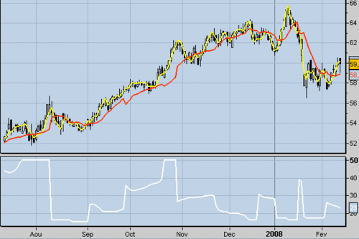

Several remarks:

 - I'm not sure of the accuracy of calculations, after a quick comparison with the graph of IBM presented in the article.

 I will publish the program as needed (you can always leave a comment in the queue dedicated if you find a bug).

 - The ProRealTime software once again shows all its limits with the inability to include loops in loops loop ......... Message endless!

After floored for over a week, I give you the result although as I mentioned earlier, I am not sure of it.

 - The rowing program, it takes almost 40 minutes to display a 150 bar graph!

It is therefore unusable in its current form, I guess the time to a screener or a backtest!

 - Next steps: try to make the program faster and compare it with the method proposed by Dennis Meyers ( [Mesa Vs Goertzel DFT](http://www.meyersanalytics.com/publications/MesaVsGDFT.pdf) ).

Here is the code for ProRealTime the dominant cycle indicator:

maxpwr = CALL "sousprog dft"[8]  
for kk=9 to 50  
    mys=call "sousprog dft"[kk]  
    if mys>maxpwr then  
        maxpwr=mys  
    endif  
next  
if barindex <60 then  
    maxpwr=undefined  
endif  
num=0  
denom=0  
for kk=8 to 50  
    mys=call"sousprog dft"[kk]  
    db=-10*log(0.01/(1-0.99*mys/maxpwr))/log(10)  
    if db>20 then  
        db=20  
    endif  
    if db<3 then  
        thre=3-db  
        num=num+kk*thre  
        denom=denom+thre  
    endif  
next  
if barindex>60 then  
    cyc=num/denom  
else  
    cyc=undefined  
endif  
  
return cyc

As the sub-program code used to circumvent the weaknesses of the software must be introduced in the variable period (peri)

pr=medianprice  
if barindex<=5 then  
    hp=pr  
    cl=pr  
else  
    per=360/40  
    cosper=cos(per)  
    alph=(1-sin(per))/cosper  
    hp=0.5*(1+alph)*(pr-pr[1])+alph*hp[1]  
    cl=(hp+2*hp[1]+3*hp[2]+3*hp[3]+2*hp[4]+hp[5])/12  
endif  
cospart=0  
sinpart=0  
for n=0 to 49  
    cycper=(360*n)/peri  
    cospart=cospart+cl[n]*cos(cycper)  
    sinpart=sinpart+cl[n]*sin(cycper)  
next  
pwr=square(cospart)+square(sinpart)  
  
return pwr

[Watch The Length And The Magnitude Of Cycle](http://hk-lisse.over-blog.com/article-16642213.html)

First, a small graph to illustrate the changing nature of the plot of the curves drawn for the moment with the program.

In the last article, I posted a chart of INTC betting on a rebound up the purple channel.

On the new graph, we see that the prognosis was very correct, but **mostly** I was helped by moving the curves!

Indeed, if you compare the two views (it's a little game of 7 errors), you will find that the curves have changed.

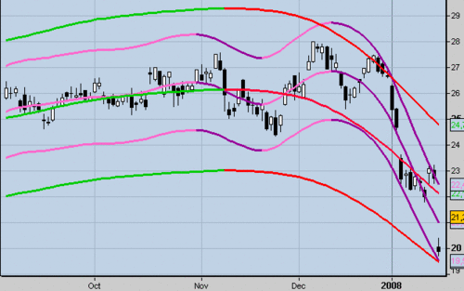

In the last post, I said also seek to automate the lengths and widths of Hurst envelopes.

While Bressert claimed there was a cycle and identified the latter averaging 20 centered, Hurst advance the fact that there are several cycles superimposed.

Therefore my program "Detrend20" presented the 21/10 based on the theory of Bressert not enough anymore.

BJ Millard in his book "Channels & Cycles - A Tribute to JM Hurst" describes a way to identify the different cycles.

Subtracts an average centered length equal to the cycle to be isolated, a second mean centered length equal to half the first.

I found a "Amibroker" version of the indicator, I adapted.Here is a view of HG with the indicator in window 1 and the current window 2.

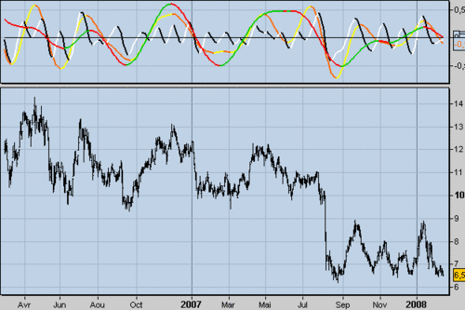

On the one hand, the indicator is much cleaner, and secondly, it allows to view several cycles.

I try a little analysis, here is a view of the Dow Jones with the cycle indicator:

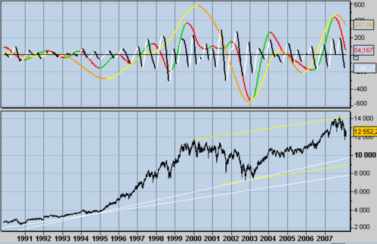

We can see that the cycle at 6 months (black / white) is always present and that its amplitude has increased since 1996, the 2-year cycle was defined until 1999 and that would have a 3-year cycle that drawing since 2003. This week (14/02/08), the cycle would turn to 6 months but going against the longer cycles.

It remains to find, as the RSI3M3, an indicator that sticks in real time to allow me a suitable extrapolation.

[Cycles: The Point On The Envelopes](http://hk-lisse.over-blog.com/article-16641382.html)

As I see that some are eager to read more articles on the cycles, I post this little report that shows you where I am.

Here is the graph of INTC.

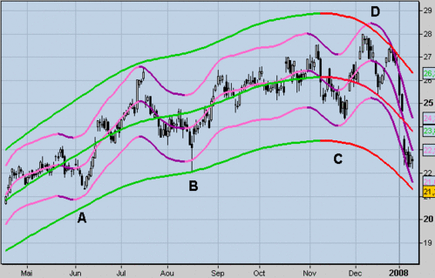

For now, I can trace the envelopes described by Hurst and Millard.

I still have some adjustments problems: A, B, and C, the lower long-term curve should shift upwards by against D is the upper curve is too low. The curves are plotted by trial and error, I try to automate the length and width thereof.

If the analysis of cycles is correct, we should have a bounce INTC up the purple channel.

Do always remember that curves are plotted with future data known and they change!

[Cycles: Start For The Start With JM Hurst](http://hk-lisse.over-blog.com/article-16640484.html)

JM Hurst is the author of "The Profit Magic Of Stock Transaction Timing ', written in the late 60s This book was the first to speak of cyclicality of financial markets.

W.Bressert, J. Tillman, P. Eliades, R. Zukowski ... continue on this path and used the work of Hurst.

For example, much of what J. Ehlers published, is already in the book of Hurst.

In the first chapters of his book, Hurst built envelopes constant widths around courtyards.

he uses it to illustrate a part of his theory on the importance of timing in trading.

A graphic example of using the strips, is [here](http://www.sr-analyst.com/cyclePackHelp/hs460.htm) .

Here for now what I get with ProRealTime it based on a Metastock code (Chart AAPL):

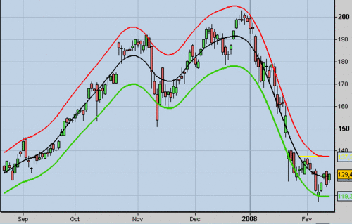

You should know that this kind of representation can not be used for trading since it uses the data of the future.

Thus, curves that appear along the yellow line may change.

There are two challenges: first, to have a correct envelopes and curve data for "established" and then try to find a way to extrapolate the curves of the most accurate way possible.

Here is another view to illustrate the principle (SNDK)

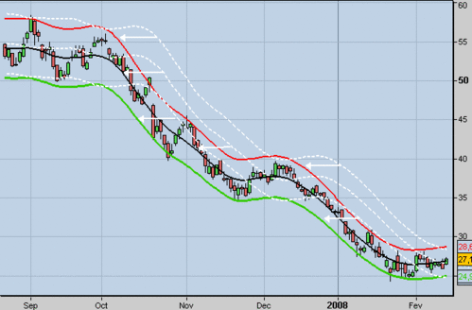

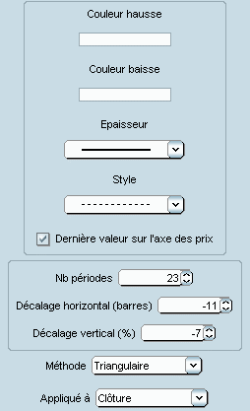

We see that the program takes a triangular moving average, added 2 envelopes +/- 7% and refocuses all 11 bars back.

The coefficients depend on cycles and are therefore specific to each graph.

Bands can also be constructed with a fixed amount (eg $ 2) or a multiple of the ATR.

Comic channels from the bar -11 are inherently pure fiction! I continue exploring .....

[Cycles: The Bandpass Filter](http://hk-lisse.over-blog.com/article-16638635.html)

In its latest file (February 2007), J. Ehlers present the Bandpass Filter and advice for its use.

Should vary the filter settings (spacing and width) in order to constitute a sample.

Out of these results, it takes the filter that has the largest amplitude output, it gives us the cycle currently dominant classes.Just then introduce this data in our favorite indicators for indicators adapted to market conditions.

For example: RSI = 0.5 * cycle, STOCHASTIC = 0.5 * cycle, cycle = CCI, MACD 0.5 * 1 * cycle and cycle.

Here is a view of the Bandpass Filter with ES and the various parameters: 10,12,14,16,18,20.

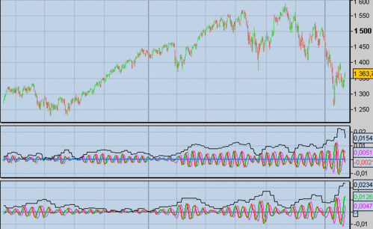

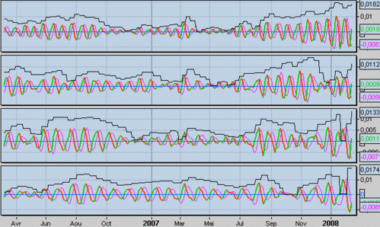

It is well noted the changing amplitudes according to market conditions, but how to use it for trading?

Here is the code for the filter ProRealTime must be introduced in the variable period (period from 8 to ....) and Delta (0.05, 0.10, 0.25, ......), the program also returns the last amplitude (for possible comparisons):

pr=(high+low)/2  
if barindex>1 then  
    beta=cos(360/period)  
    gama=1/cos(720*delta/period)  
    alpha=gama-sqrt(gama*gama-1)  
    bp=0.5*(1-alpha)*(pr-pr[2])+beta*(1+alpha)*bp[1]-alpha*bp[2]  
    lead=(period/6.28318)*(bp-bp[1])  
endif  
if bp>bp[1] and bp[1]<bp[2] then  
    rep1=rep  
    rep=bp[1]  
endif  
if bp<bp[1] and bp[1]>bp[2] then  
    rep1=rep  
    rep=bp[1]  
endif  
ecart=abs(rep-rep1)  
return bp,lead,0,ecart

[Cycles: Publications From J. Ehlers (3)](http://hk-lisse.over-blog.com/article-16636976.html)

In the August 2006 issue of S & C, one can read an article by J. Ehlers: "Modeling The Market = Building Trading Strategies".

He presents three indicators and 3 strategies.

A view of the Bund with the indicators: 1 window, the course with Instantaneous Trendline (in white) and Modeling The Market (yellow) in window 2, the indicator window and Cyclic Component 3, the transformation StochasticRSI applied to the Model.

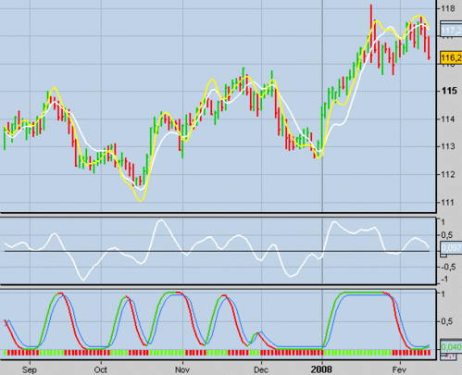

Here are the codes for ProRealTime, you can vary the reference price (MedianPrice default), the length of the average (20 by default) and the parameters of StochasticRSI:

pr=(high+low)/2  
len=20  
sma=average[len](pr)  
sl=pr-pr[len-1]  
ssl=(sl+2*sl[1]+2*sl[2]+sl[3])/6  
itrend=sma+0.5*ssl  
  
a=(1-SIN(360/len))/cos(360/len)  
if barindex<50 then  
     
    hp=exponentialaverage[2*len+1]((1+a)*(pr-pr[1]))  
else  
     
    hp=(0.5*(1+a)*(pr-pr[1]))+(a*hp[1])  
endif  
  
shp=(hp+2*hp[1]+2*hp[2]+hp[3])/6  
model=itrend+shp  
  
return itrend,model

----------------------------------------

pr=(high+low)/2  
len=20  
a=(1-SIN(360/len))/cos(360/len)  
if barindex<50 then  
    hp=exponentialaverage[2*len+1]((1+a)*(pr-pr[1]))  
else  
    hp=(0.5*(1+a)*(pr-pr[1]))+(a*hp[1])  
endif  
shp=(hp+2*hp[1]+2*hp[2]+hp[3])/6  
  
return shp,0

-----------------------------------

pr=(high+low)/2  
len=20  
rlen=8  
stolen=8  
wlen=5  
sma=average[len](pr)  
sl=pr-pr[len-1]  
ssl=(sl+2*sl[1]+2*sl[2]+sl[3])/6  
itrend=sma+0.5*ssl  
  
a=(1-SIN(360/len))/cos(360/len)  
if barindex<50 then  
    hp=exponentialaverage[2*len+1]((1+a)*(pr-pr[1]))  
else  
    hp=(0.5*(1+a)*(pr-pr[1]))+(a*hp[1])  
endif  
shp=(hp+2*hp[1]+2*hp[2]+hp[3])/6  
model=itrend+shp

cu=0  
cd=0  
cu=max(0,model-model[1])  
cd=max(0,model[1]-model)  
cu1=average[rlen](cu)  
cd1=average[rlen](cd)  
if cuave<>-cdave then  
    rsio=cuave/(cuave+cdave)  
endif  
if barindex >60 then  
    cuave=(cuave[1]*(rlen-1)+cu1)/rlen  
    cdave=(cdave[1]*(rlen-1)+cd1)/rlen  
endif  
if cuave<>-cdave then  
    rsio=cuave/(cuave+cdave)  
endif  
mrs=rsio  
hir=highest[stolen](mrs)  
lor=lowest[stolen](mrs)  
stor=(mrs-lor)/(hir-lor)  
stari=0  
div=0  
for i=0 to wlen-1  
    stari=stari+(wlen-i)*stor[i]  
    div=div+i+1  
next  
stori=stari/div  
trig=0.05+0.9*stori[1]  
if stori>trig then  
    flag=-.1  
else  
    flag=0  
endif  
if stori<trig then  
    flagb=-.1  
else  
    flagb=0  
endif  
  
return stori,trig,flag,flagb

-----------------------------------

The first strategy uses only Instantaneous Trendline.

We go to buy when the stock crosses upward the lagging indicator of 2 periods.

The conditions of sale are reversed, we have a SAR system.

On the next shot, I optimized the period average and the number of late bars.

Here the EC with len = 27 and delay = 3 (no slippage, fees of 4 eur / R per contract):

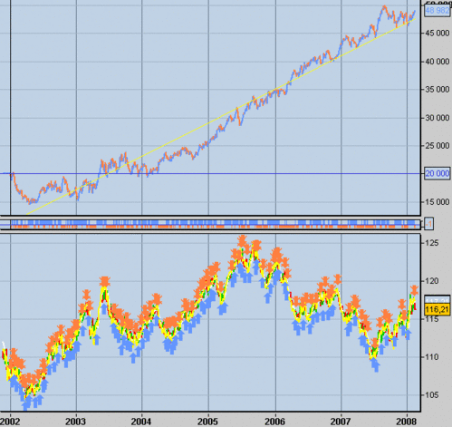

And now the backtest code for ProRealTime:

pr=(high+low)/2  
len=a  
rem b=delay  
sma=average[len](pr)  
sl=pr-pr[len-1]  
ssl=(sl+2*sl[1]+2*sl[2]+sl[3])/6  
itrend=sma+0.5*ssl  
REM Achat  
c1 = (itrend CROSSES OVER itrend[b])  
IF c1 THEN  
    BUY 1 SHARES AT MARKET THISBARONCLOSE  
ENDIF  
REM Vente  
c2 = (itrend CROSSES UNDER itrend[b])  
IF c2 THEN  
    SELL  AT MARKET THISBARONCLOSE  
ENDIF  
REM Vente à découvert  
c3 = (itrend CROSSES UNDER itrend[b])  
IF c3 THEN  
    SELLSHORT 1 SHARES AT MARKET THISBARONCLOSE  
ENDIF  
REM Rachat  
c4 = (itrend CROSSES OVER itrend[b])  
IF c4 THEN  
    EXITSHORT  AT MARKET THISBARONCLOSE  
ENDIF

The second strategy is to take position at the crossroads of StochasticRSI with its signal, it is also a SAR system.

Here is a view of the EC with optimized parameters, len = 19 = 16 RLEN, stolen = 19 = 7 Wlen (no slippage and 4 eur charge A / R per contract):

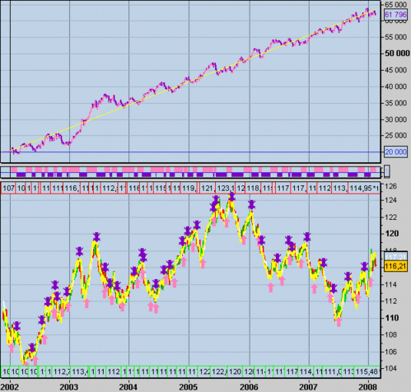

And backtest ProRealTime code:

pr=(high+low)/2  
len=aa  
rlen=bb  
stolen=cc  
wlen=dd  
sma=average[len](pr)  
sl=pr-pr[len-1]  
ssl=(sl+2*sl[1]+2*sl[2]+sl[3])/6  
itrend=sma+0.5*ssl  
  
a=(1-SIN(360/len))/cos(360/len)  
if barindex<50 then  
    hp=exponentialaverage[2*len+1]((1+a)*(pr-pr[1]))  
else  
    hp=(0.5*(1+a)*(pr-pr[1]))+(a*hp[1])  
endif  
shp=(hp+2*hp[1]+2*hp[2]+hp[3])/6  
model=itrend+shp  
  
cu=0  
cd=0  
cu=max(0,model-model[1])  
cd=max(0,model[1]-model)  
cu1=average[rlen](cu)  
cd1=average[rlen](cd)  
if cuave<>-cdave then  
    rsio=cuave/(cuave+cdave)  
endif  
if barindex >60 then  
    cuave=(cuave[1]*(rlen-1)+cu1)/rlen  
    cdave=(cdave[1]*(rlen-1)+cd1)/rlen  
endif  
if cuave<>-cdave then  
    rsio=cuave/(cuave+cdave)  
endif

mrs=rsio  
hir=highest[stolen](mrs)  
lor=lowest[stolen](mrs)  
stor=(mrs-lor)/(hir-lor)  
stari=0  
div=0  
for i=0 to wlen-1  
    stari=stari+(wlen-i)*stor[i]  
    div=div+i+1  
next  
stori=stari/div  
trig=0.05+0.9*stori[1]  
  
REM Achat  
c1 = (stori CROSSES OVER trig)  
IF c1 THEN  
    BUY 1 SHARES AT MARKET THISBARONCLOSE  
ENDIF  
REM Vente  
c2 = (stori CROSSES UNDER trig)  
IF c2 THEN  
    SELL  AT MARKET THISBARONCLOSE  
ENDIF  
REM Vente à découvert  
c3 = (stori CROSSES UNDER trig)  
IF c3 THEN  
    SELLSHORT 1 SHARES AT MARKET THISBARONCLOSE  
ENDIF  
REM Rachat  
c4 = (stori CROSSES OVER trig)  
IF c4 THEN  
    EXITSHORT  AT MARKET THISBARONCLOSE  
ENDIF

[Cycles: Publications From J. Ehlers (2)](http://hk-lisse.over-blog.com/article-16636404.html)

Here is a second system presented in the "TAG22 Rocket Science" file.

The codes always come in Arnaudbzh dakoté.

I found relatively little information about its use.

As for system 1, there is a trendline and a filter but the code is different.

Similarly, the calculation of the period and the signal / noise ratio is different.

Finally, areas of cycle and trend are not common to the two systems.

The Awesome indicator is done to confirm the signal on the sinewave.

The value of the signal / noise ratio negative seems bizarre.

I corrected the function ROUND in INTEGER, and in the file that I have, there is no mention of the noise condition> 6 dB encoded by Arnaudbzh for Mode.

Here is a view of ACC with the indicators: 1 window, the price with the TRENDLINE and filter, window 2, the release MODE Arnaudbzh, window 3, the release MODE hk, window 4, CORE indicator in window 5, the PHASE indicator window 6, the SNR indicator window 7, the SINEWAVE and window 8, the AWESOME indicator.

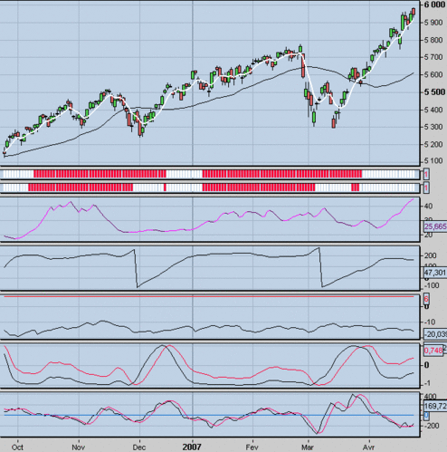

Now the codes:

REM CORE CODE - CYCLE PERIOD CODE  
REM Indicateur "CORE"  
  
Price = (High+Low)/2  
  
IF Barindex > 5 THEN  
     
    REM Compensating Hilbert Transforms  
    Smoother = (4*Price + 3*Price[1] + 2*Price[2] + Price[3]) / 10  
    Detrender = (0.25*Smoother + 0.75*Smoother[2] - 0.75*Smoother[4] - 0.25*Smoother[6]) * (0.046*Period [1] + 0.332)  
     
    REM Compute InPhase and Quadrature components  
    Q1 = (0.25*Detrender + 0.75*Detrender[2] - 0.75*Detrender[4] - 0.25*Detrender[6]) * (0.046*Period[1] + 0.332)  
    I1 = Detrender[3]  
     
    REM advance the phase of I1 and Q1 by 90 degrees  
    JI = 0.25*I1 + 0.75*I1[2] - 0.75*I1[4] - 0.25*I1[6]  
    JQ = 0.25*Q1 + 0.75*Q1[2] - 0.75*Q1[4] - 0.25*Q1[6]  
     
    REM Phasor addition to equalize amplitude due to quadrature calculations (and 3 bar averaging)  
    I2 = I1 - JQ  
    Q2 = Q1 + JI  
     
    REM Smooth the I and Q components before applying the discriminator  
    I2 = 0.15*I2 + 0.85*I2[1]  
    Q2 = 0.15*Q2 + 0.85*Q2[1]  
     
    REM Homodyne Discriminator  
    REM Complex Conjugate Multiply  
    X1 = I2*I2[1]  
    X2 = I2*Q2[1]  
    Y1 = Q2*Q2[1]  
    Y2 = Q2*I2[1]  
    Re = X1 + Y1  
    Im = X2 - Y2  
     
    REM Smooth to remove undesired cross products  
    Re = 0.2*Re + 0.8*Re[1]  
    Im = 0.2*Im + 0.8*Im[1]

    REM Compute cycle period  
    IF Im <> 0 and Re <> 0 THEN  
        Period = 360/ATAN(Im/Re)  
    ENDIF  
     
    IF Period > 1.5*Period[1] THEN  
        Period = 1.5*Period[1]  
    ENDIF  
     
    IF Period < 0.67*Period[1] THEN  
        Period = 0.67*Period[1]  
    ENDIF  
     
    IF Period < 6 THEN  
        Period = 6  
    ENDIF  
     
    IF Period > 50 THEN  
        Period = 50  
    ENDIF  
     
    Period = 0.2*Period + 0.8*Period[1]  
     
ENDIF  
  
RETURN Period as "PERIOD" , Q1 as "Q1" , I1 as "I1"

-------------------------------------------------------------------

REM Measuring Phase  
REM Indicateur "CORE PHASE2"  
  
  
Price = (High + Low)/2  
myPERIOD, myQ1,myI1 = CALL "CORE"  
  
IF Barindex > 50 THEN  
    p1=myperiod/10 MOD 10  
    p2=myperiod mod 10  
    int=p1*10+p2

    value5 =int  
    RealPart = 0  
    ImagPart = 0  
     
    IF Value5 > 6 THEN  
        For count = 0 To Value5 - 1  
            RealPart = RealPart + Sin(360 * count / Value5) * (Price[count])  
            ImagPart = ImagPart + Cos(360 * count / Value5) * (Price[count])  
        NEXT  
    ENDIF  
     
    RealPart = 0.33*RealPart + 0.67*RealPart[1]  
    ImagPart = 0.33*ImagPart + 0.67*ImagPart[1]  
     
    IF ABS(ImagPart) > 0.001 THEN  
        DCPhase = ATAN(RealPart / ImagPart)  
    ENDIF  
     
    If ABS(ImagPart) <= 0.001 THEN  
        DCPhase = 90 *SGN(RealPart)  
         
    ENDIF  
     
    REM Compensate phase for smoothing lag prior to taking the arctangent  
    DCPhase = DCPhase + 720 / myPERIOD  
    DCPhase = DCPhase + 90  
     
    IF ImagPart < 0 and myQ1 <> 500 and myI1 <> 500 THEN  
        DCPhase = DCPhase + 180  
    ENDIF  
     
    IF DCPhase > 270 THEN  
        DCPhase = DCPhase - 360  
    ENDIF  
     
ENDIF  
  
RETURN DCPhase as "DCPhase"

----------------------------------------------------

REM Signal-to-Noise Indicator Code  
REM Indicateur "CORE SNR"  
REM Ajout ligne horizontale = 6

ignored, my1,my12 = CALL "CORE"  
  
IF Barindex > 50 THEN  
     
     
     
    REM Signal Amplitude Squared comes directly from the discriminator  
    Signal = SQRT(my12*my12 + my1*my1)  
     
    REM Noise is a 20 bar EMA of ranges squared  
    Noise = 0.1*(High - Low)*(High - Low) + 0.9*Noise[1]  
     
    REM Convert to dB and smooth with EMA  
    IF Noise <> 0 and Signal <> 0  THEN  
        SNR = 0.33*(10*Log(Signal/Noise)/Log(10)) + 0.67*SNR[1]  
    ENDIF  
     
ENDIF  
  
RETURN SNR as "SNR",6

-----------------------------------------------------------

REM The Sinewave Indicator  
REM Indicateur "CORE SINEWAVE"  
REM Calcul du SINE et du LEAD_SINE  
REM Sinus de la phase et ce même sinus avancé de 45°  
  
myDCPhase = CALL "CORE PHASE2"  
  
IF Barindex > 5 THEN  
    SINE = SIN(myDCPhase)  
    LEADSINE = SIN(myDCPhase + 45)  
ENDIF  
  
  
RETURN SINE as "SINE" , LEADSINE as "LEAD SINE"

----------------------------------------------------------------------

REM The Awesome Oscillator  
REM Indicateur "CORE AWESOME"  
  
Price = (High+Low)/2  
  
IF Barindex > 12 THEN  
     
    Value1 = (4*Price + 3*Price[1] + 2*Price[3] + Price[4])/10  
    Value2 = Value1 + 0.088*Value2[6]  
    Value3 = Value2 - Value2[6] + 1.2*Value3[6] - 0.7*Value3[12]  
     
    Detrend = Value3[12] - 2*Value3[6] + Value3  
    Smooth = 0.13785*(2*Detrend - Detrend[1]) + 0.0007*(2*Detrend[1] - Detrend[2])+ 0.13785*(2*Detrend[2] - Detrend[3]) + 1.2103*Smooth[1] - 0.4687*Smooth[2]  
     
ENDIF  
  
RETURN Detrend as "Detrend" , Smooth as "Smooth",0

------------------------------------------------------------------------------

REM Instantaneous Trendline Code  
REM Indicateur "CORE TRENDLINE"  
  
Price = (High + Low)/2  
myPERIOD, ignored,ignored = CALL "CORE"  
  
IF Barindex <= 50 tHEN  
    aa = Close  
ENDIF  
  
IF Barindex > 50 THEN  
    p1=myperiod/10 MOD 10  
    p2=myperiod mod 10  
    int=p1*10+p2  
     
    value5 =int  
     
    aa = 0  
endif  
  
FOR count = 0 TO Value5 - 1  
    aa = aa + Price[count]  
NEXT  
  
IF Value5 <> 0 THEN  
    aa = aa / Value5  
     
    bb = 0.25*aa + 0.75*bb[1]  
    Smooth = (7*Price + 6*Price[1] + 5*Price[2] + 4*Price[3] + 3*Price[4] + 2*Price[5] + Price[6])/28  
     
ENDIF  
  
return bb as "Trend", Smooth as "Smooth"

---------------------------------------------------------------

REM Market Mode Detector  
REM Indicateur "CORE MODE2"  
  
myDCPhase = CALL "CORE PHASE2"  
myPERIOD, myQ1,myI1 = CALL "CORE"  
//mySNR,ignored = CALL "core snr"  
  
p1=myperiod/10 MOD 10  
p2=myperiod mod 10  
int=p1*10+p2  
  
value5 =int  
  
REM Rule 1: Sinewave Indicator Crossing initializes half cycle crossing timing when SNR > 6 dB  
IF Sin(myDCPhase) Crosses Over Sin(myDCPhase + 45) OR Sin(myDCPhase) Crosses Under Sin(myDCPhase + 45) then//and mySNR > 6 THEN  
    DaysInTrend = 0  
    Trend = 0  
    Cycles = 1  
ENDIF  
  
DaysInTrend = DaysInTrend + 1  
  
REM Rule2: Phase rate of change must be within 50% of dominant cycle phase rate of change  
IF Value5 <> 0 and myDCPhase - myDCPhase[1] > 0.67*360/Value5 and myDCPhase - myDCPhase[1] < 1.5*360/Value5 THEN  
    Trend = 0  
    Cycles = 1  
ENDIF  
  
IF DaysInTrend > 0.5*myPERIOD and myQ1 <> 500 and myI1 <> 500 THEN  
    Trend = 1  
    Cycles = 0  
ENDIF  
  
RETURN Trend as "Trend" , Cycles as "Cycles"

[Cycles: Publications From J. Ehlers (1)](http://hk-lisse.over-blog.com/article-16635860.html)

J. Ehlers publishes on its website ( [mesasoftware.com](http://www.mesasoftware.com/seminars.htm) ) a series of papers, indicators and trading systems on the base cycles.

I return here for a first system, the codes written by Arnaudbzh for ProRealTime in dakoté and explanations of Smallcaps90 its operation.

I am not convinced of the effectiveness of key system in hand, but the way Ehlers addresses the problem of cycles should be included in this file.

This system is described in the "OWorld2000RocketScience" file.

A view of ACC with different indicators.

Window 1, the ProRealTime cycle for comparison.

Window 2, the CAC with TRENDLINE indicator (magenta) and the Kalman filter (white).

In window 3, the indicator PERIOD.

Window 4, the PHASE indicator.

Window 5 Indicator SIGNAL / NOISE (SNR).Window 6, the SINEWAVE indicator and window 7, the MODE indicator CYCLE / TREND.

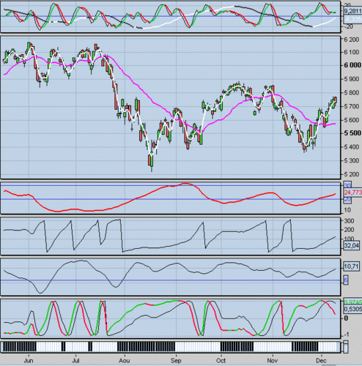

Comments Smallcaps90:

"The program searches the dominant cycle this by calculating its period, its phase and the signal / noise ratio in dB It determines the mode in which the courses are:.. Cycle or trend The method is based on the Hilbert transform and the work of JP Burg on the "maximum entropy" to extract a signal its dominant sinusoidal component.

When the Kalman filter crosses Trendline, calculating the period. If the curve does not recrosses Kalman Trendline before a half cycle, then it is in trend mode. If we go at this time, the output signal is the next crossing Kalman with the Trendline where we leave the fashion trend for the cycle mode.

Mode cycle, we take position at the crossroads of the Lead-Sinewave Sinewave curve. On the next crossing spring. A signal / noise ratio> 6 dB the hypothesis dominant cycle mode. Ehlers proposes the following test for the input: the ratio of the distance peak to trough (or vice versa) on the Kalman filter by average lengths over the bars on the previous part of curve between previous crossovers Sinewave and its signal. If this ratio is at least 2, a stance is possible (actually a filter on the volatility and the amplitude of the cycle) and amplitude of the expected future movement would be sufficient.

The rules governing one to the other mode are:

-A Cross Sinewave / Lead-Sinewave passed in cycle mode if the signal / noise ratio is> 6 dB, and the phase of the cycle is almost linear over a full period of this cycle (Smallcaps90 uses a rate of change of the phase 0.3).

-When A cross between the Trendline and the Kalman filter appears, it activates a counter that is incremented at each bar. If the mode is trend, confirmation of it only after a number of bars equal to half the period of the cycle. "

The codes of Arnaudbzh indicators for ProRealTime:

REM TRENDLINE DE J. EHLERS  
REM Indicateur "MESA PERIODE"  
REM Calcul de la période du cycle dominant  
  
PRIX = (high + low) / 2  
  
IF Barindex <= 5 THEN  
    PERIODE = 0  
    V5 = 0  
ENDIf  
  
IF Barindex > 5 THEn  
    REM Détermination de la phase de chaque tic  
    V1 = PRIX - PRIX[6]  
    V2 = V1[3]  
    V3 = 0.75*(V1-V1[6])+0.25*(V1[2]-v1[4])  
    ENPHASE = 0.33*V2+0.67*ENPHASE[1]  
    ENQUADRATURE = 0.2*V3 + 0.8*ENQUADRATURE[1]  
    IF ABS(ENPHASE + ENPHASE[1]) > 0 THEN  
        A = ABS((ENQUADRATURE + ENQUADRATURE[1]) / (ENPHASE+ENPHASE[1]))  
        PHASEDEG = ATAN(A)  
    endif  
     
    REM Correction si autres quadrants  
    IF ENPHASE < 0 AND ENQUADRATURE > 0 THEN  
        PHASEDEG = 180 - PHAsedeg  
    endif  
     
    IF ENPHASE < 0 AND ENQUADRATURE < 0 THEN  
        PHASEDEG = 180 + PHASEDeg  
    endif  
     
    IF ENPHASE > 0 AND ENQUADRATURE < 0 THEN  
        PHASEDEG = 360 - PHASedeg  
    endif  
     
    REM Phase différentielle et corrections éventuelles  
    DELTAPHASE = PHASEDEg[1]-phasedeg  
    IF PHASEDEG[1] < 90 AND PHASEDEG > 270 THEN  
        DELTAPHASE = 360 + DELTaphase  
    endif  
     
    IF DELTAPHASE < 1 THEN  
        DELTAPhase=1  
    endif  
     
    IF DELTAPHASE > 60 THEN  
        DELTAphase=60  
    endif  
     
    REM Calcul de la période instantanée du cycle actuel  
    REM et correction éventuelle  
    PERIODEINSTANT = 0  
    V4 = 0  
    J = 0  
    WHILE J<41  
        V4 = V4 + DELTAPHASE[J]  
        IF V4>360 AND PERIODEINSTANT=0 THEN  
            PERIODEINSTANT =J  
        ENDIF  
        J=J+1  
    WEND  
     
    IF PERIODEINSTANT=0 THEN  
        PERIODEINSTANT = PERIODEINSTANT[1]  
    ENDIF  
     
    REM Calcul de la PERIODE  
    V5 = 0.25 * PERIODEINSTANT +0.75*V5[1]  
    periode=v5  
ENDIF  
  
RETURN PERIODE as "PERIODE" , DELTAPHASE as "deltaphase"

-------------------------------------------------------------------------------

REM TRENDLINE DE J. EHLERS  
REM Indicateur "MESA PHASE"  
REM Calcul de la phase du cycle dominant  
  
IF Barindex > 5 THEN  
     
    PRIX = (high + low) / 2  
    myPERIODE, myDELTAPHASE = CALL "MESA PERIODE"  
     
    PERIODE = ROUND(myPERIODE)  
     
    PARTIEREELLE = 0  
    PARTIEIMAGINAIRE = 0  
     
    K = 0  
    REM Calcul en degrés  
    WHILE K < PERIODE  
        PARTIEREELLE = PARTIEREELLE + SIN(360*K/PERIODE)*PRIX[K]  
        PARTIEIMAGINAIRE = PARTIEIMAGINAIRE + COS(360*K/PERIODE)*PRIX[K]  
        K = K+1  
    WEND  
     
    IF ABS(PARTIEIMAGINAIRE) > 0.001 THEN  
        DCPHASEDEG = ATAN(PARTIEREELLE/PARTIEIMAGINAIRE)  
    ENDIF  
     
    IF ABS(PARTIEIMAGINAIRE) <= 0.001 THEN  
        IF PARTIEREELLE >= 0 THEN  
            SIGNEPARTIEREELLE=1  
        ELSE  
            SIGNEPARTIEREELLE=-1  
        ENDIF  
        DCPHASEDEG = 90*SIGNEPARTIEREELLE  
    ENDIF  
     
    DCPHASEDEG = DCPHASEDEG + 90  
     
    IF PARTIEIMAGINAIRE<0 THEN  
        DCPHASEDEG = DCPHASEDEG + 180  
    ENDIF  
     
    IF DCPHASEDEG>315 AND DCPHASEDEG<=360 and myDELTAPHASE <> 500 THEN  
        DCPHASEDEG = DCPHASEDEG - 360  
    ENDIF  
     
    PHASE = DCPHASEDEG  
         
ENDIF  
  
RETURN PHASE as "PHASE"

-------------------------------------------------------------------------------------------

REM Indicateur "MESA RSB"  
REM Calcul du rapport signal / bruit (RSB en dB)  
REM Ajout ligne horizontale = 6  
  
  
IF Barindex <= 8 THEN  
    RSB = 0  
    RANGERSB = 0  
    ENPHASE = 0  
    ENQUADRATURE = 0  
ENdif  
  
IF Barindex > 8 THEn  
    PRIX = (high + low) /2  
    REM Détermination des composantes en phase et en quadrature  
    REM Transformation de Hilbert  
    RANGERSB = 0.2*(high - low) + 0.8*RANGERSB[1]  
    V1 = PRIX-PRIX[6]  
    V2 = V1[3]  
    V3 = 0.75*(V1-V1[6]) + 0.25*(V1[2]-V1[4])  
    ENPHASE = 0.33*V2 + 0.67*ENPHASE[1]  
    ENQUADRATURE = 0.2*V3 + 0.8*Enquadrature[1]  
    REM Lissage du rapport signal/bruit  
    V2 = 0.2*(square(ENPHASE) + square(ENQUADRATURE)) + 0.8*V2[1]  
    REM Calcul du rapport signal/bruit lissé  
    IF V2<0.001 THEN  
        V2=0.001  
    endif  
     
    IF RANGE>0 THEN  
        RSB = 0.25*(10* LOG(V2 / square(RANGERSB)) / LOG(10)+4.7) + 0.75*RSB[1]  
    ENDif  
endif  
  
RETURN RSB as "Rapport Signal-Bruit"

---------------------------------------------------------------------------------------

REM TRENDLINE DE J. EHLERS  
REM Indicateur "MESA SINEWAVE"  
REM Calcul du SINEWAVE et du LEAD_SINEWAVE  
REM Sinus de la phase et ce même sinus avancé de 45°  
  
myPHASE = CALL "MESA PHASE"  
  
IF Barindex > 5 THEN  
    PHASE = myPHASE  
    SINEWAVE = SIN(PHASE)  
    LEADSINEWAVE = SIN(PHASE + 45)  
ENDif  
  
RETURN SINEWAVE as "SINEWAVE" , LEADSINEWAVE as "LEAD SINEWAVE"  
------------------------------------------------------------------------------------------------

REM TRENDLINE DE J. EHLERS  
REM Indicateur "MESA TRENDLINE"  
REM Calcul de la TRENDLINE et du FILTRE DE KALMAN  
REM Utilisés comme 2 moyennes mobiles adaptatives en mode Tendance  
  
IF Barindex > 5 THEN  
     
    PRIX = (high + low) /2  
    myPERIODE, myDELTAPHASE = CALL "MESA PERIODE"  
     
    PERIODE = ROUND(myPERIODE)  
    TRENDLINE = 0  
    J =0  
    WHILE J < PERIODE+2  
        TRENDLINE = TRENDLINE + PRIX[J]  
        J = J+1  
    wend  
     
    IF PERIODE>0 THEN  
        TRENDLINE = TRENDLINE / (PERIODE+2)  
    endif  
     
    REM Filtre de Kalman zero lag  
    KALMAN = 0.33*(PRIX + 0.5*(PRIX - PRIX[3])) + 0.67*Kalman[1]  
    IF Barindex<26 and myDELTAPHASE <> 500 THEN  
        TRENDLINE = PRIX  
        KALMAN =prix  
    ENDIf  
endif  
  
RETURN TRENDLINE as "TRENDLINE" , KALMAN as "KALMan"  
----------------------------------------------------------------------------------------

REM TRENDLINE DE J. EHLERS  
REM Indicateur "MESA CYCLE TENDANCE"  
REM Essai de détermination du mode cycle ou tendance  
REM Variable P1 = 0.3  
  
myPERIODE, myDELTAPHASE = CALL "MESA PERIODE"  
mySINEWAVE, myLEADSINEWAVE = CALL "MESA SINEWAVE"  
myTRENDLINE, myKALMAN = CALL "MESA TRENDLINE"  
myRapportSignalBruit = CALL "MESA RSB"  
  
P = myPERIODE  
DEL = myDELTAPHASE  
S = mySINEWAVE  
LS = myLEADSINEWAVE  
TL = myTRENDLINE  
K = myKALMAN  
RSB = myRapportSignalBruit  
  
TENDANCE=1  
CYCLES=0  
  
REM Détecter un croisement LS/S et initialiser le mode cycle si RSB suffisant  
IF LS crosses over S OR LS crosses under S AND RSB>6 THEN  
    TENDANCE=0  
    CYCLES=1  
ENDIf  
  
REM Vérifier progressivité de la variation de la phase  
IF P<>0 AND DEL>(1-P1)*360 / P AND DEL<(1+P1)*360 / P THEN  
    TENDANCE=0  
    CYCLES=1  
endif  
  
REM Détecter un croisement K/TL et initialiser le compteur de jours  
IF K crosses over TL OR K crosses under TL THEN  
    NB=0  
endif  
REM Incrémenter compteur de jours  
NB=nb+1  
REM Confirmer mode cycle si compteur < une demi-période, sinon tendance  
IF NB<P/2 THEN  
    CYCLES=1  
    TENDANCE=0  
ELSE  
    CYCLEs=0  
    tendance=1  
endif  
  
RETURN CYCLES as "CYCLES", TENDANCE as "TENDANCE"

[Cycles: The Relative Strength Spread](http://hk-lisse.over-blog.com/article-16633465.html)

In the 10/06 edition of S & C, Ian Copsey presents the spread relative strenght (RSS) to identify cycles. It applies the RSI of Wilder to the difference (spread) between two moving averages. The differences between the peaks / troughs of course and peaks / hollows of RSS can be exploited for trading.

I apply the same technique to create a "spread stochastic".

A view of ACC with the comparison below, the Detrend20 and superimposed stochastic spread, the RSS, the stochastic spread with SMA3 of it for visibility, and finally the ProRealTime cycle.

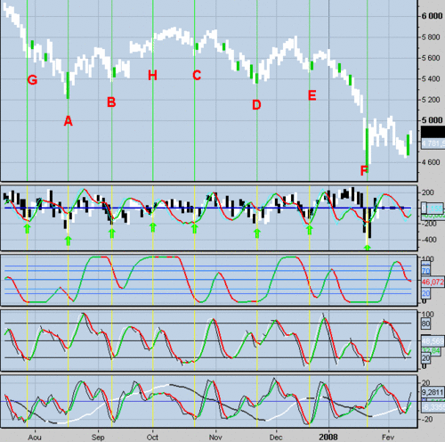

z1=0  
y1=0  
m10=exponentialaverage[10](close)  
m40=exponentialaverage[40](close)  
spr1=m10-m40  
chang1=spr1-spr1[1]  
for i=0 to 4  
    if chang1[i]>0 then  
        z1=z1+chang1[i]  
    endif  
    if chang1[i]<0 then  
        y1=y1-chang1[i]  
    endif  
next  
if y1=0 then  
    y1=.00001  
endif  
rs21=z1/y1  
srsi21=average[5](100-(100/(1+rs21)))  
return srsi21,20,30,50,70,80

Le code du "spread stochastic" :

ema1=exponentialaverage[10](close)  
ema2=exponentialaverage[40](close)  
spread=ema1-ema2  
spr=spread-spread[1]  
ll=lowest[5](spr)  
hh=highest[5](spr)  
stoc1=100*(spr-ll)/(hh-ll)  
return average[5](stoc1),20,80,50

[Cycles: The Double Stochastic](http://hk-lisse.over-blog.com/article-16632224.html)

Walter Bressert also provides another technique for generating the cycles based trading signals. It uses double stochastic, the stochastic a stochastic. He named DBS October 1 dual 10/3 stochastic exponential.

At purchase, the signal is determined by a reversal of the indicator under 40. The bar is marked. If the current exceeds the high of the bar, the signal is triggered. Stop below the low point of the cycle.

The sale, the signal is determined by a reversal above 70 ........ then reverse procedure of purchase.

Here is a view of ACC with in order: the ProRealTime cycle, ACC marked with bars, Detrend20 superimposed with the DBS10 and finally DBS10 with yellow / green signals.

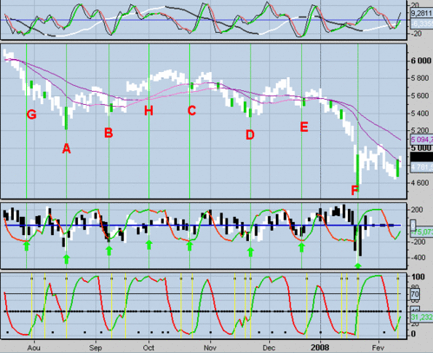

The signals are more frequent than with RSI3M3 and therefore require a filter in my opinion. Bressert also uses a DBS5, double stochastic 5/3, even more signals (signal above 90 and below 10). He advocates the simultaneous signals or confirmation to increase the chances of success.

I put the backtest of RSI3M3 and DBS10 in the to-do list.

Found on the net, another indicator for using the stochastic cycle compared with the ProRealTime cycle.

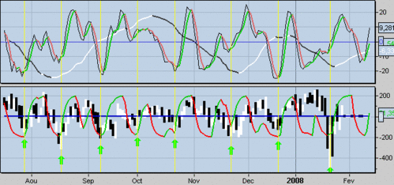

A dig by varying the moving average values ​​may be. Here's the code:

slw=3  
pds=7  
ratio=ExponentialAverage[3](close)/ExponentialAverage[7](close)  
divi=highest[pds](ratio)-lowest[pds](ratio)  
a=exponentialaverage[slw]((ratio-lowest[pds](ratio))/divi)*100  
divi2=highest[pds](a)-lowest[pds](a)  
dss=exponentialaverage[slw]((a-lowest[pds](a))/divi2)*100  
return dss,10,90

[Cycles: The Vision Of Walter Bressert](http://hk-lisse.over-blog.com/article-16628183.html)

Walter Bressert has developed a theory of the cycle-based trading. To you to get an idea, his website:[www.walterbressert.com/](http://www.walterbressert.com/)

He said the markets have a dominant cycle between 14 and 25 bars and most between 18 and 22 bars, an average of 20 bars. The cycles are measured from trough to trough. To identify the cycles, it uses a moving average of the same length as the probable cycle (we fumbled a bit, but in general it takes 20 to start). Bressert then shifts the average mid-cycle backwards to the (period / 2) bars, so for an average of 20, it was down 10 bars. It then displays the price variation with offset this average.The DPO indicator (Detrended Price Oscillator) is designed for this use. An example of the CAC:

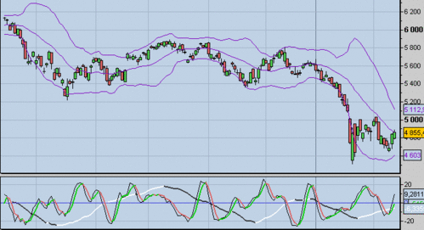

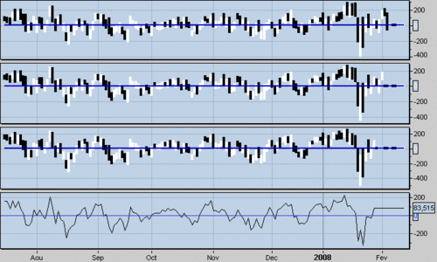

With, in order, the ProRealTime cycle, the Detrend10 (an indicator to my sauce), the Detrend14, the Detrend20 and finally the DPO20Close ProRealTime. We can visualize the cycles of the past, unfortunately, because of its construction, the indicator will stop x bars before the current bar: do not exactly educating us on the current phase. It only remains to find an oscillator that provides information on the real-time cycle and not only those of the past.

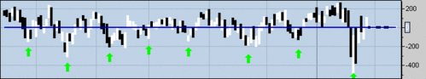

Here we see that the gap between the hollows, varies from 15 to 22 bars. previous cycles we can deduce.

Bressert recommends using the oscillator RSI3M3 as to identify the cycle. To build it, it applies to a average3 RSI3. It also constructs a Detrended IHR is the difference between the RSI3M3 and average.5 thereof.

Here is a comparison of the different superimposed oscillators Detrend20: 1 in the Detrended RSI, 2, and 3 the RSI3M3 the ProRealTime cycle.

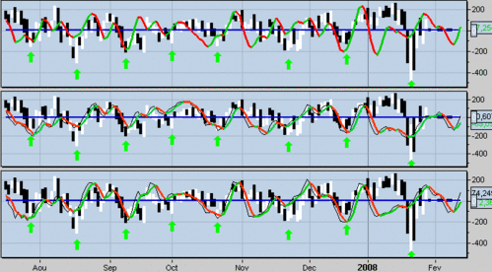

Always the same problems: periods of range or trend and intervention against trend.

Walter Bressert automatically generates trading signals with the following setup (for purchase):

- The RSI3M3 is under level 30.

- RSI3M3 the turns and the bar that causes this reversal is marked.

- A stop order to buy is entered above the high of the bar marked.

- Once purchased, a stop order is placed below the lowest price of the trough of the cycle.

An example of the CAC:

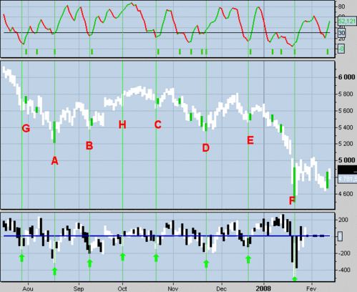

Above, the RSI3M3 with the signal, and down, the Detrend20 with hollow cycles. Signals has , b , c ,d , e , and f occur near a bottom of the cycle. The signal g is not triggered (high not exceeded), 5 of 6 triggered signals can be winners. The system gives no signal when the trend is strong (eg h ). In these cases Bressert recommends the use of DetrentedRSI, still need to identify strong trends. Also, I find that the lag is more important and the number of signals.  According Bressert, it is more efficient (I doubt not) to intervene in the direction of the trend. To determine this, it displays two EMA's (eg 25 and 50) or he takes the cycle of higher UT (primary school).

I will return to the system developed by Bressert with slicked stochastics.

[The Cycle Indicator ProRealTime](http://hk-lisse.over-blog.com/article-16580298.html)

The ProRealTime contains a cycle indicator, the latter comes Eric Lefort. The formula is based on a combination of stochastics with calculating a first STPMT indicator. Unlike STPMT this indicator with a simple average 9 gives the cycle indicator.

STPMT = (4.1 * sto (5.3) + 2.5 * sto (14.3) + sto (45.14) + 4 * sto (75.20)) / 11.6

CYCLE = STPMT average single-9 (STPMT)

A view of the CAC:

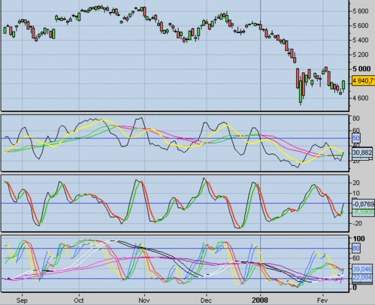

The second window displays the STPMT with the M9 yellow and green / red the M20.

The third window shows the cycle, I added an average of 3 simple for the visibility.

The last window displays the various component STPMT stochastics. It can be seen that in the end the cycle acts as a 5/3/3 stochastic.

From mid-March to mid-May, the CAC evolves upward trend and the cycle diverges, it takes the intersection of zéroligne. From mid-May to mid-July, the index remains in range, you can use the cycle turns. As a stochastic, so it is important to detect periods of range and trend to fully use this indicator. The STPMT display with the average 20 can provide information. Another solution is to display the cycle of higher UT.

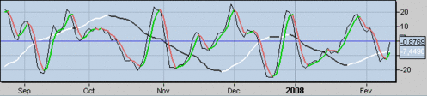

-------------------------------------------------------------------

http://www.money99.in/2014/12/most-popular-moving-averages.html

Moving averages are one of the key tools used to analyse financial time series. In a

nutshell, moving average is simple weighted sum (mean) calculated over selected historical price range.

Most popular moving averages (simple, exponential, weighted, sinus weighted, Spencers, median, Tilson, Hull, double exponential, TRIX/triple exponential, Ehlers, zero lag, Butterworth, Mesa, Savitzky-Golay, Kaufman, geometric, quadratic and harmonic moving average).

**Simple moving average (SMA)** is well known and widespread. It gives equal weights to all past prices and by definition is just average of them. Although very simple, it can solve serious problems. It will be used as a benchmark to compare against other averages.

**Exponential moving average (EMA)** gives exponentially diminishing weights to all past prices. This moving average is very well known and used, therefore formula is not included.

**Weighted moving average (WMA)** gives arithmetically diminishing weights for past prices, depending on length of the average.

**Sinus weighted moving average (SWMA)** is a weighted average, based on motivation, that price fluctuates following some unknown wave. As model, Sine wave is used to adjust price weights. SWMA is calculated using formula:

[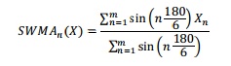](http://3.bp.blogspot.com/-QzDF-B_t-2I/VIPRGPalOkI/AAAAAAAABjY/25kE1Wt6PzU/s1600/sinus.png)

[](http://pinterest.com/pin/create/button/?url=http://www.money99.in/2014/12/most-popular-moving-averages.html&media=http://3.bp.blogspot.com/-QzDF-B_t-2I/VIPRGPalOkI/AAAAAAAABjY/25kE1Wt6PzU/s1600/sinus.png&description=Most%20popular%20moving%20averages)

Where m is period of moving average, X is list of prices with X0 the most recent one.

**Spencers 15 point moving average (SpMA)** is another version of WMA used by

actuaries. It is fixed 15 position mean with weights 3, -6, -5, 3, 21, 46, 67, 74, 67, 46,

21, 3, -5, -6, -3. The problem with this average is high lag.

**Double exponential moving average (DEMA)**is whole different from described above. It is composite moving average and uses other moving averages to get the result [11]. In case of DEMA, the EMA is used. Also, DEMA is adaptive - it employs some mechanism to adapt to price swings dynamically. DEMA uses trick to get better smoothness by running moving average on itself. But this operation increases lag, so to counter this technique called twicing is used. It takes difference between price and moving average to adjust itself, making DEMA adaptive. Formula:

[http://2.bp.blogspot.com/-DwVGi2ntXLc/VIPR441EblI/AAAAAAAABjs/OG-U1tYvcIo/s1600/dema.png](http://2.bp.blogspot.com/-DwVGi2ntXLc/VIPR441EblI/AAAAAAAABjs/OG-U1tYvcIo/s1600/dema.png)

[](http://pinterest.com/pin/create/button/?url=http://www.money99.in/2014/12/most-popular-moving-averages.html&media=http://2.bp.blogspot.com/-DwVGi2ntXLc/VIPR441EblI/AAAAAAAABjs/OG-U1tYvcIo/s1600/dema.png&description=Most%20popular%20moving%20averages)

where n is length of moving average and X is the prices.

**Triple exponential moving average (TRIX)** is similar to DEMA but uses exponential

moving average three times:

[http://4.bp.blogspot.com/-9bauRAWfeGY/VIPR4cIZmwI/AAAAAAAABjg/umKLB7RjGhU/s1600/triple%2Bmov.png](http://4.bp.blogspot.com/-9bauRAWfeGY/VIPR4cIZmwI/AAAAAAAABjg/umKLB7RjGhU/s1600/triple%2Bmov.png)

**Zero lag moving average (ZMA)** sounds like a perfect moving average [9]. But the only thing without lag is the price, which this adaptive and composite moving average uses to correct itself. In a nutshell, ZMA ads portion of price to EMA to counter lag, while giving up some smoothness. Formula (n – period, X – prices

[http://2.bp.blogspot.com/-MRYr4zj69jI/VIPR4uWFYOI/AAAAAAAABjk/0h33AsiN4IA/s1600/zero%2Blag.png](http://2.bp.blogspot.com/-MRYr4zj69jI/VIPR4uWFYOI/AAAAAAAABjk/0h33AsiN4IA/s1600/zero%2Blag.png)

**Tilson moving average (TMA)**is also known as T3. It is both composite and adaptive. It is build using EMA [11]. To make notion more readable, formula is decomposed. First one describes generalized DEMA average introducing parameters n and v. For Tilson moving average, v is 0,7. If v would be 1, then GD would be DEMA. To improve smoothness of TMA, moving average is applied over again.

[http://2.bp.blogspot.com/-g4QpFX1_Uak/VIPWCf0tDiI/AAAAAAAABkU/U56_ag7EsBE/s1600/tilson.png](http://2.bp.blogspot.com/-g4QpFX1_Uak/VIPWCf0tDiI/AAAAAAAABkU/U56_ag7EsBE/s1600/tilson.png)

Hull moving average (HMA) is composite moving average made from composing WMA of various period lengths [12]. Formula:

[http://4.bp.blogspot.com/-giI7C79Eozg/VIPWBXa-uHI/AAAAAAAABkA/-BPCZDIhDjA/s1600/hull.png](http://4.bp.blogspot.com/-giI7C79Eozg/VIPWBXa-uHI/AAAAAAAABkA/-BPCZDIhDjA/s1600/hull.png)

Exponential Hull moving average (EHMA) is exactly the same as Hull MA but Exponential MA is used instead of Weighted MA:

[http://3.bp.blogspot.com/-AeNKv7oPw6Y/VIPWBXU9SNI/AAAAAAAABkE/a0EodlTCWZg/s1600/expontnl.png](http://3.bp.blogspot.com/-AeNKv7oPw6Y/VIPWBXU9SNI/AAAAAAAABkE/a0EodlTCWZg/s1600/expontnl.png)

Ehlers moving average (EhMA) is another adaptive moving average [8]. To use it, data must be first detrended subtracting SMA (of the same period as EhMA) from the price. Then EhMA coefficients are recalculated for each position, based on quadratic distance. This makes EhMA computational expensive with large periods over bigger datasets. Formula (X – detrended prices, n – period of EhMA) is gives for detrended prices, after applying EhMA result is obtained adding SMA back to it:

[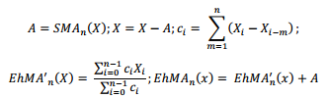](http://4.bp.blogspot.com/-doOx2lA77fA/VIPWBP6z3cI/AAAAAAAABj8/RHyh4Jzgz5Y/s1600/ethleres.png)

Butterworth moving average (BMA) came from analogue circuits’ era [8]. Very well known there, works for trading as well. Formula (n – period, X - prices, i – current bar) to calculate current bar BMA(i):

[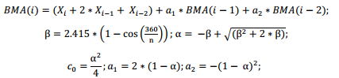](http://2.bp.blogspot.com/-DA9cRmURr-s/VIPXTr8BJcI/AAAAAAAABkg/ekAfRrvQzDY/s1600/butter.png)

**Mesa moving average (MAMA)** uses Hilbert transform to make EMA adaptive. Because of Hilbert transform this moving average has complex formula, only main parts will be given. By definition MAMA is EMA with variable alpha: MAMA(i) = alpha * Price + (1 – alpha) * MAMA(i-1), where alpha = FastLimit/DeltaPhase. FastLimit is the upper bound of a and DeltaPhase is the rate of change of the Hilbert

Transform homodyne discriminator. The alpha value is kept within the range of FastLimit and SlowLimit.

**Savitzky-Golay moving average (SGMA**) is polynomial smoother [15]. Given last n prices, i tries to fit k level polynomial over them using MSE. Then polynomial value is used as filtered value. SGMA has two parameters: n – period, and k –level of

polynomial to fit.

**Kaufman moving average (KAMA)** is adaptive one, which alters alpha of EMA using smoothing constant C to achieve addictiveness [3 p.731]. Formula (n –period, X – prices, Xi – past price i bars back):

[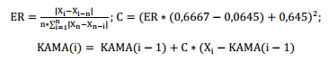](http://2.bp.blogspot.com/-k_IRhmxYY80/VIPaVMy9vJI/AAAAAAAABks/P4x3HAvXEcc/s1600/kama.png)

KAMA adjust alpha using efficiency ratio of the market. It is ratio between direction and volatility. Constants 0,6667 and 0,0645 represent adaptivness range from 2 to 30 bars of EMA alpha value. These constants are suggested by author, so we will keep them.

**Chande’s variable index dynamic average (VIDYA)** follows same concept as KAMA. VIDYA, however, uses relative volatility to adjust smoothing constant  Formula (s – constant, representing 9 bar EMA smoothing constant, C – closing prices, i – current time, Cn – prices of recent n bars, Cm – prices of longer historic period m>n):

[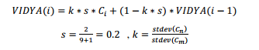](http://4.bp.blogspot.com/-z8nrPIpTSMU/VIPaVLTF3EI/AAAAAAAABk0/GwXwmUG0gHw/s1600/chande.png)

Other types of moving averages

[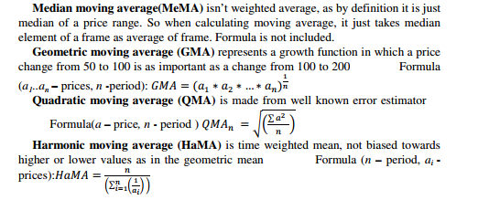](http://1.bp.blogspot.com/-c5TvRL596Js/VIPaVI2EYZI/AAAAAAAABkw/FEXrvZpXJP0/s1600/pn1.png)

------------------------------------------------------------

http://www.smartquant.com/forums/viewtopic.php?f=34&t=2368

The Hilbert Period provides a means of calculating a dynamic lookback period to use instead of static time periods with other indicators. Does anyone have suggestions on how to convert this EasyLanguage code to C#?   
  
[code]Inputs: Price(close);//(numeric);   
  
Vars: Smoother(0), Detrender(0), I1(0), Q1(0), jI(0), jQ(0), I2(0),Q2(0),   
X1(0), X2(0), Y1(0), Y2(0), Re(0), Im(0), Period(0);   
  
If CurrentBar >5 then begin   
Smoother = (4*Price + 3*Price[1] + 2*Price[2] + Price[3])/10;   
Detrender = (.25*Smoother + .75*Smoother[2] - .75*Smoother[4] - .25*Smoother[6])*(.046*Period[1] + .332);   
  
{Compute InPhase and Quadrature components}   
Q1 = (.25*Detrender + .75*Detrender[2] - .75*Detrender[4] - .25*Detrender[6])*(.046*Period[1] + .332);   
I1 = Detrender[3];   
  
{advance the phase of I1 and Q1 by 90 degrees}   
jI = .25*I1 + .75*I1[2] - .75*I1[4] - .25*I1[6];   
jQ = .25*Q1 + .75*Q1[2] - .75*Q1[4] - .25*Q1[6];   
{Phasor addition to equalize amplitude due to quadrature calculations (and =   
3 bar averaging)}   
I2 = I1 - jQ;   
Q2 = Q1 + jI;   
  
{Smooth the I and Q components before applying the discriminator}   
I2 = .15*I2 + .85*I2[1];   
Q2 = .15*Q2 + .85*Q2[1];   
  
{Homodyne Discriminator}   
{Complex Conjugate Multiply}   
X1 = I2*I2[1];   
X2 = I2*Q2[1];   
Y1 = Q2*Q2[1];   
Y2 = Q2*I2[1];   
Re = X1 + Y1;   
Im = X2 - Y2;   
  
{Smooth to remove undesired cross products}   
Re = .2*Re + .8*Re[1];   
Im = .2*Im + .8*Im[1];   
  
{Compute Cycle Period}   
If Im <> 0 and Re <> 0 then Period = 360/ArcTangent(Im/Re);   
If Period > 1.5*Period[1] then Period = 1.5*Period[1];   
If Period < .67*Period[1] then Period = .67*Period[1];   
If Period < 6 then Period = 6;   
If Period > 50 then Period = 50;   
Period = .2*Period + .8*Period[1];   
  
{END CORE CODE}   
  
//HilbertPeriod =3D Period;   
  
end;   
plot1(Period)[/code]

Here's my initial attempt:   
  
[list=] public static double Value(TimeSeries input, int index, int length, BarData option)   
{   
double[] Smoother = new double[length];   
double[] Detrender = new double[length];   
double[] I1 = new double[length];   
double[] Q1 = new double[length];   
double[] jI = new double[3];   
double[] jQ = new double[3];   
double[] I2 = new double[3];   
double[] Q2 = new double[3];   
double[] X1 = new double[3];   
double[] X2 = new double[3];   
double[] Y1 = new double[3];   
double[] Y2 = new double[3];   
double[] Re = new double[3];   
double[] Im = new double[3];   
double[] Period = new double[3];   
  
if (index > 4) //could also do price of 0 = 5, 1 = 6, etc...   
{   
int count = index;   
for (int i = 0; i < length - 1; i++)   
{   
Smoother[i] = (4*input[count, BarData.Close] + 3*input[count+1, BarData.Close] + 2*input[count+2, BarData.Close] + input[count+3, BarData.Close])/10;   
i++; //to get increment by 2's   
count = count + 2;   
}   
count = index;   
for (int i = 0; i < length - 1; i++)   
{   
Detrender[i] = (0.25 * Smoother[i] + .75*Smoother[i+2] - .75*Smoother[i+4] - .25*Smoother[i+6])*(.046*input[count+1, BarData.Close]);   
i++;   
count = count + 2;   
}   
  
//Compute InPhase and Quadrature components   
count = index;   
for (int i = 0; i < length - 1; i++)   
{   
Q1[i] = (.25*Detrender[i] + .75*Detrender[i+2] - .75*Detrender[i+4] - .25*Detrender[i+6])*(.046*input[count+1, BarData.Close] + .332);   
I1[i] = Detrender[i+3];   
i++;   
count = count + 2;   
}   
  
//{advance the phase of I1 and Q1 by 90 degrees}   
for (int i = 0; i < 3; i++)   
{   
jI[i] = .25*I1[i] + .75*I1[i+2] - .75*I1[i+4] - .25*I1[i+6];   
jQ[i] = .25*Q1[i] + .75*Q1[i+2] - .75*Q1[i+4] - .25*Q1[i+6];   
}   
  
//{Phasor addition to equalize amplitude due to quadrature calculations (and = 3 bar averaging)}   
for (int i = 0; i < 3; i++)   
{   
I2[i] = I1[i] - jQ[i];   
Q2[i] = Q1[i] + jI[i];   
}   
  
//{Smooth the I and Q components before applying the discriminator}   
for (int i = 0; i < 3; i++)   
{   
I2[i] = .15*I2[i] + .85*I2[i+1];   
Q2[i] = .15*Q2[i] + .85*Q2[i+1];   
}   
  
//{Homodyne Discriminator}   
//{Complex Conjugate Multiply}   
for (int i = 0; i < 3; i++)   
{   
X1[i] = I2[i]*I2[i+1];   
X2[i] = I2[i]*Q2[i+1];   
Y1[i] = Q2[i]*Q2[i+1];   
Y2[i] = Q2[i]*I2[i+1];   
Re[i] = X1[i] + Y1[i];   
Im[i] = X2[i] - Y2[i];   
}   
  
//{Smooth to remove undesired cross products}   
Re[0] = .2*Re[0] + .8*Re[1];   
Im[0] = .2*Im[0] + .8*Im[1];   
  
//{Compute Cycle Period}   
if (Im[0] != 0 && Re[0] != 0)   
Period[0] = 360/Math.Atan(Im[0]/Re[0]);   
if (Period[0] > 1.5*Period[1])   
Period[0] = 1.5*Period[1];   
if (Period[0] < .67*Period[1])   
Period[0] = .67*Period[1];   
if (Period[0] < 6)   
Period[0] = 6;   
if (Period[0] > 50)   
Period[0] = 50;   
Period[0] = .2*Period[0] + .8*Period[1];   
}//if   
return Period[0];   
}

-----------------------------------

http://quant.stackexchange.com/questions/530/digital-signal-processing-in-trading

You need to investigate how to differentiate interpolation methods versus extrapolation methods. It's easy to build a model that repeats the past (just about any interpolation scheme will do the trick). The problem is, that model is typically worthless when it comes to extrapolating into the future.

When you hear/see the word "cycles", a red flag should be going up. Dig into the application of "Fourier Integral", "Fourier Series", "Fourier Transform", etc, and you'll find that with enough frequencies you can represent any time series well enough that most retail traders can be convinced that "it works". The problem is, it has no predictive power whatsoever.

The reason Fourier methods are useful in engineering/DSP is because that "signal" (voltage, current, temperature, whatever) typically repeats itself in the circuit/machine where it was generated. As a result, interpolating then becomes related to extrapolating.

In case youre using R, here's some hacky code to try:

library(gam)

#Generate and plot a 1000 data point time series

x <- 1:1000

y <- cumsum(rnorm(1000))

plot(x, y, type="l")

#Fit the first 500 points using a Generalized Additive Model (it'll fit anything)

#The red line is an example of interpolating

gam.object <- gam(y[1:500] ~ s(x[1:500]))

lines(1:500, predict(gam.object, data.frame(x=1:500)), lwd=2, col="red")

#Now, predict the future points

#The blue line is an example of extrapolating (from an interpolation model)

lines(501:1000, predict(gam.object, data.frame(x=501:1000)), lwd=2, col="blue")

#Now, notice the difference in the "fit" of the blue line versus the red line.

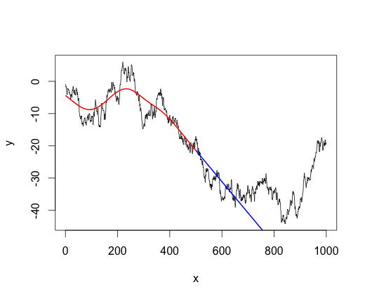

DSP and Time Series analysis are the same thing. DSP uses enginering "lingo" and time series analysis uses mathematical "lingo" but the models are quite simular. Ehler's cyber cycle indicator is an ARMA(3,2). Ehlers has some unique ideas: What is the meaning of the phase of a random variable?

-----------------------------------

http://quantitative-tradingg.blogspot.nl/2014/02/sinewave-indicator.html

**February 3, 2014, Monday**

Adaptive shock indicators - The Sinewave Indicator

    Here Sinewave  indicator, Sinewave indicator there are several versions of the **John F. Ehlers** writings there are two versions. In fact, the various versions are similar, the difference is mainly in place numericalapproximation technique.

**(1) the For Traders Rocket Science -  John F. Ehlers  -2001**

**(2) Cybernetic the Analysis for Stocks and Futures -  John F. Ehlers -2004**

**(3) E-mini watch the Better Sinewave**

[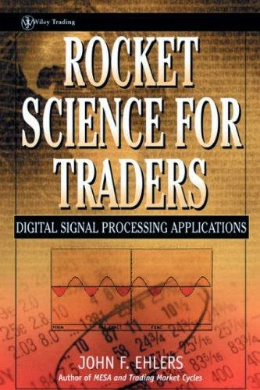](http://2.bp.blogspot.com/-tykPEEJmUHI/Uu9RPtHhF8I/AAAAAAAANFM/_ZKhNbJhxio/s1600/1.png)

      Personally feel Rocket Science For Traders version than Cybernetic Analysis for Stocks and Futures better, and Rocket This explains in more detail, and the E-mini watch version of Rocket Science For Trader versionsimilar.

**➢  Introduction**

    OF assume a simple model of market trends :

       Trend = Trend (Trend) and consolidation (Cycle) plus total.

[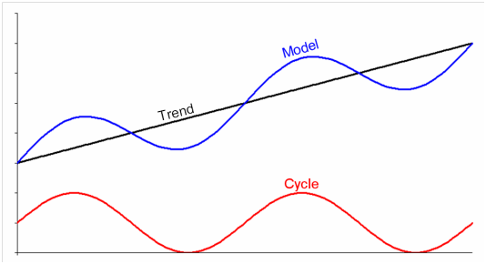](http://4.bp.blogspot.com/-DFxf8NavkNM/Uu9R0HsGpuI/AAAAAAAANFU/XREfPewd718/s1600/2.png)

     In the trend of the disc when ( Trend Mode) , the price continues to move in the same direction, the direction of movement prices were little changed. So you can put Trend thought of as a low-frequency signal.EMA is actually a simple low-pass filter (Low Pass the filter) , so most of the average policy trend mode when performance is very good.

    In the consolidation disc (Cycle mode) , the frequent changes in the direction of price movement, so you can put Cycle thought of as a high-frequency signals, and general oscillators are actually a simple high-pass filter (the filter High Pass) , so general range consolidation, when most of the shock indicators seemed very accurate.

    The authors assume that the market is a dynamic cycle cycle , try to continue using a mathematical method, remove the current market trendcycle period. After calculating the current cycle of the market, followed by the development of a Sinewave  indicators.

**➢  Hilbert 's T ransform**

    The authors used a complex concept phasor to describe a Cycle .

**E jθ = COS ([theta]) + jsin ([theta])**

[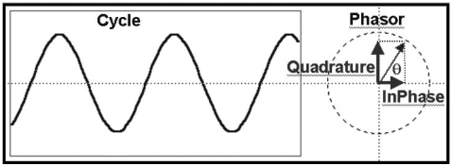](http://4.bp.blogspot.com/-gtGm_m_YHLs/Uu9Ue9Dz4HI/AAAAAAAANFc/hHy2_QRqb3w/s1600/33.png)

**A Phasor Can Represent a Cycle**

    On a start using Hilbert 's T ransform , from a small amount of information on the approximate price of a cycle of phasor type, followed by some action smoothing, remove Quadrature , InPhase .

Smooth = ( **4** * Price + **3** * Price [ **1** ] + **2** * Price [ **2** ] + Price [ **3**]) / **10** ;

Detrender = ( **.0962** * Smooth + **.5769** * Smooth [ **2** ] - **.5769** * Smooth [**4** ] - **.0962** * Smooth [ **. 6** ]) * ( **.075** * of the Period [ **1** ] + **.54** );

{Compute InPhase and Quadrature components.}

Ql = ( **.0962** * Detrender + **.5769** * Detrender [ **2** ] - **.5769** * Detrender[ **4** ] - **.0962** * Detrender [ **. 6** ]) * ( **.075** * of the Period [ **1** ] + **.54** );

I1 is = Detrender [ **3** ];

**➢  homodyne Discriminator**

Remove the Quadrature , InPhase , the author as a basis, the use ofHomodyne Discriminator approximation of the current cycle of the cycle (period) .

HomodyneDiscriminator the concept, this root bar of the complex signal and before a bar conjugate complex multiplication. The following formula can be obtained angular frequency ( angular frequency ) , Amplitude .

[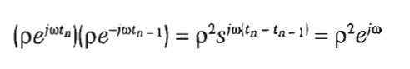](http://4.bp.blogspot.com/-nEvjE6sQnyk/Uu9WMFjh_1I/AAAAAAAANFo/7yGhdWjiKMQ/s1600/44.png)

The angular frequency ( angular frequency ) = (2 [pi] / of the Period) , which can get the current cycle of the cycle ( period)

{Homodyne Discriminator}

Re = I2 is * I2 is [ **1** ] + Q2 is * Q2 is [ **1** ];

IM = I2 is * Q2 is [ **1** ] - Q2 is * I2 is [ **1** ];

Re = **.2** * Re + **.8** * Re [ **1** ];

Im = **.2** * IM + **.8** * Im [ **1** ];

IF Im <> **0** and Re <> **0**

    the then of the Period = **360** / ARCtangent ( Im / Re );

**➢  at The SINEWAVE On Indicator**

    Sinewave indicators The following picture shows the basic concept.Suppose the trend as a perfect cycle- sinewave trend, if known to the current cycle (period) and the current Phase .

So long as the angle of forward shift a volume, you can achieve a leading effect , from the figure can be observed LeadSine trend leadingSine trend. But in fact not a perfect prices Cycle , as well as some smooth action when the approximate calculation has been delayed (lag) of the.The authors said that in fact he just wanted to try to make the lag is reduced.

Plot1 ( the Sine ( DCPhase ), "the Sine" );

Plot2 ( the Sine ( DCPhase + **45** ), "LeadSine" );

[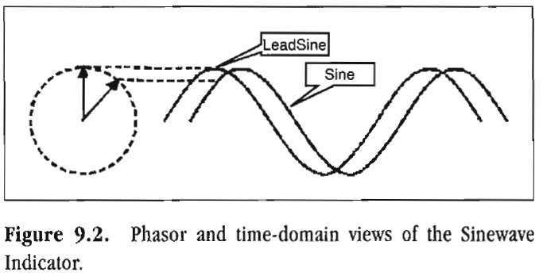](http://4.bp.blogspot.com/-HDGY68dh444/Uu9XY4r5CkI/AAAAAAAANFw/4-Guy4hQdkk/s1600/55.png)

    Price trend has been a dynamic period (Period) , the next step is to remove the current market Phase . If cycle mode , then look at the current state of the market is in a cycle they go one place.

**MODE Cycle :   Phase will always be from 0 degrees to 360degrees.**

**Trend mode:  the trend continues towards the same direction, while the phase does not increase.**

    Remove the phase after taking sine (phase) and Sine (phase + 45) , is in a range from +1 to -1 shock indicators. The following figure shows the use of a perfect cycle of sinewave indicators do the test, the middlesinewave , following the Phase . You can see in the figure belowsinewave indicators turning point than the cross- cycle faster turning point.

[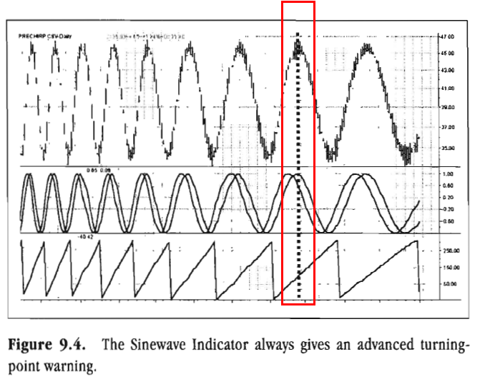](http://4.bp.blogspot.com/-N6NPBJZIL7o/Uu9Yg1VZuDI/AAAAAAAANF4/9gB-RYFGRO0/s1600/3.png)

**➢  at The SINEWAVE On Indicator Observation**

    Sinewave with the average volatility index has two advantages compared

(1) If the cycle mode , then the turning point can be caught faster.

(2) can distinguish Cycle MODE , Trend MODE:

  If the trend mode when phase will not continue forward, and the author has mentioned that, if the rising trend in, phase        will continue in the180 or so degrees. In declining trend in, Phase will continue in the 0 or so degrees.

[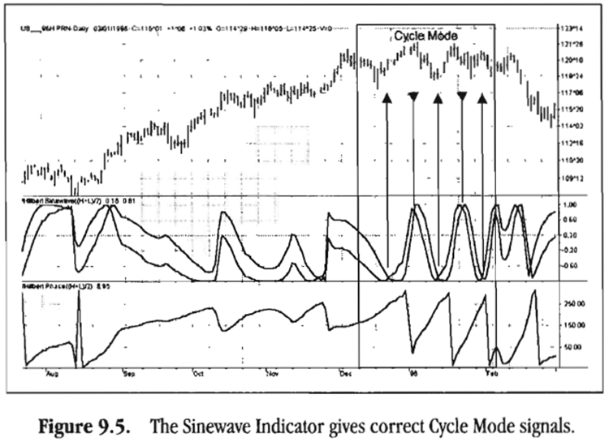](http://1.bp.blogspot.com/-NS6ttPhdWNg/Uu9Y8b_k2kI/AAAAAAAANGA/FQFxT3UEpq4/s1600/4.png)

**➢  identify Cycle mode and Trend mode**

        The following figure is about 2012/08 ~ 2013/02 Tai Zhiqi trend corresponds sinewave index and phase diagram, it can be observedcycle mode and Trend MODE . And up tremd of phase mostly in 180degrees, Down Trend of phase mostly at 0 degrees.

    The following figure also sine indicators golden cross and death cross price points marked out, a pressure and support. Death Cross gray dot, indicating that cycle mode pressure. Gold Cross for the red dot represents the cycle mode support. In the up trend when prices can be observed over the gray dot represents a break-up cycle mode pressure operation. In the down trend , the price can be observed under the red dot, indicating a downward below the cycle mode support action.

[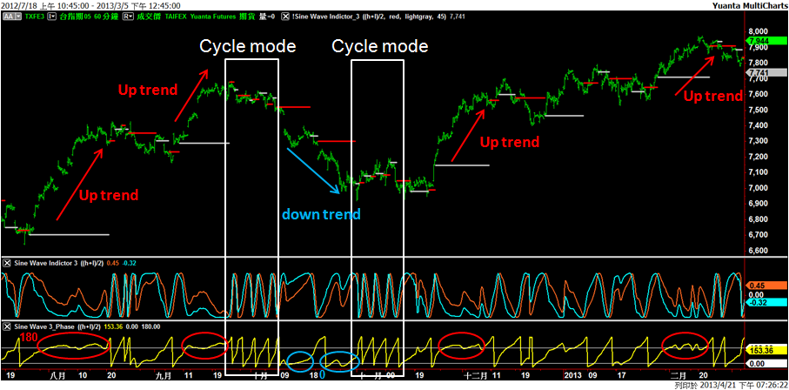](http://1.bp.blogspot.com/-dZMxCP3bkoI/Uu9ZjY6Na0I/AAAAAAAANGI/imBT6PcWtOc/s1600/5.png)

**➢  at The SINEWAVE On Indicator program code ( Rocket Science the For Traders)**

The Inputs : Price (( H + L ) / **2** );

Of the Vars : the Smooth ( **0** ), Detrender ( **0** ) , I1 is ( **0** ), Ql ( **0**), jI ( **0** ), of JQ ( **0** ), I2 is ( **0** ), Q2 is ( **0** ), Re ( **0** ), Im's ( **0**), of the Period ( **0** ), SmoothPeriod ( **0** ), SmoothPrice ( **0** ), DCPeriod ( **0** ), RealPart ( **0** ),

Imagpart ( **0** ), COUNT ( **0** ), DCPhase ( **0** ), DCSine ( **0** ), LeadSine ( **0**), Itrend ( **0** ), Trendline ( **0** ),

Trend ( **0** ), DaysinTrend ( **0** );

IF CurrentBar > **5** the then the begin

Smooth = ( **4** * Price + **3** * Price [ **1** ] + **2** * Price [ **2** ] + Price [ **3**]) / **10** ;

Detrender = ( **.0962** * Smooth + **.5769** * Smooth [ **2** ] - **.5769** * Smooth [**4** ] - **.0962** * Smooth [ **. 6** ]) * ( **.075** * of the Period [ **1** ] + **.54** );

{Compute InPhase and Quadrature components.}

Ql = ( **.0962** * Detrender + **.5769** * Detrender [ **2** ] - **.5769** * Detrender[ **4** ] - **.0962** * Detrender [ **. 6** ]) * ( **.075** * of the Period [ **1** ] + **.54** );

I1 is = Detrender [ **3** ];

{Advance the phase of I1 and Q1 by 90 degrees}

jI = ( **.0962** * I1 + **.5769** * I1 [ **2** ] - **.5769** * I1 [ **4** ] - **.0962** * I1 [**. 6** ]) * ( **.075** * of the Period [ **1** ] + **.54** );

JQ = ( **.0962** * Ql + **.5769** * Ql [ **2** ] - **.5769** * Ql [ **4** ] - **.0962** * Ql [**. 6** ]) * ( **.075** * of the Period [ **1** ] + **.54** );

{Phasor addition for 3 bar averaging)}

I2 = I1 - JQ ;

Q2 = Ql + jI ;

{Smooth the I and Q components before applying the discriminator}

I2 = **.2** * I2 + **.8** * I2 [ **1** ];

Q2 = **.2** * Q2 + **.8** * Q2 [ **1** ];

{Homodyne Discriminator}

Re = I2 is * I2 is [ **1** ] + Q2 is * Q2 is [ **1** ];

IM = I2 is * Q2 is [ **1** ] - Q2 is * I2 is [ **1** ];

Re = **.2** * Re + **.8** * Re [ **1** ];

Im = **.2** * IM + **.8** * Im [ **1** ];

IF Im <> **0** and Re <> **0** the then of the Period = **360** / ARCtangent ( Im/ Re );

IF of the Period > **for 1.5** * of the Period [ **1** ] the then of the Period = **for 1.5** * of the Period [ **1** ];

IF of the Period < **.67** * of the Period [ **1** ] the then of the Period = **.67** * of the Period [ **1** ];

IF of the Period < **. 6** the then of the Period = **. 6** ;

IF of the Period > **50** the then of the Period = **50** ;

Of the Period = **.2** * of the Period + **.8** * of the Period [ **1** ];

SmoothPeriod = **.33** * of the Period + **.67** * SmoothPeriod [ **1** ];

{Compute Dominant Cycle Phase}

SmoothPrice = ( **4** * . Price + **3** * Price [ **1** ] + **2** * Price [ **2** ] + Price [ **3** ]) / **10** ;

DCPeriod = IntPortion ( SmoothPeriod + **.5** );

RealPart = **0** ;

ImagPart = **0** ;

The For COUNT = **0** the To DCPeriod - **1** the begin

       RealPart = RealPart + Sine ( **360** * COUNT / DCPeriod ) *

       ( SmoothPrice [ COUNT ]);

       ImagPart = imagPart + CoSine ( **360** * COUNT / DCPeriod ) *

       ( SmoothPrice [ COUNT ]);

End ;

IF AbsValue ( ImagPart ) > **0**

       the then DCPhase = Arctangent ( RealPart / ImagPart );

IF AbsValue ( ImagPart ) <= **.001**

 the then DCPhase = DCPhase + **90** * the Sign ( RealPart );

DCPhase = DCPhase + **90** ;

{Compensate for one bar lag of the Weighted Moving Average}

DCPhase = DCPhase + **360** / SmoothPeriod ;

IF ImagPart < **0** the then DCPhase = DCPhase + **180** ;

IF DCPhase > **315** the then DCPhase = DCPhase - **360** ;

Plot1 ( the Sine ( DCPhase ), "the Sine" );

Plot2 ( the Sine ( DCPhase + **45** ), "LeadSine" );

End ;