**http://swamicharts.com/swami/Default.aspx**

**Swami Intraday Fisher**

The Swami Intraday Fisher indicator is an indicator for short time frames of 5-15 minutes. As with other "stoplight" SwamiCharts, green is a bullish indication, red is a bearish indication, and yellow is indeterminate.   
  
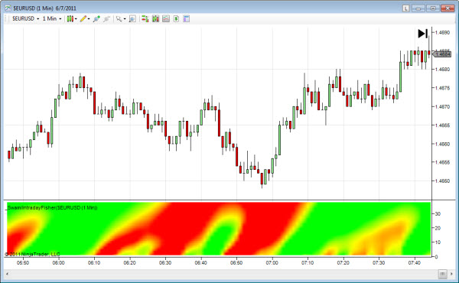  
  
The Fisher Transform is a mathematical function that provides non-linear gain that accentuates extremes. The Swami Intraday Fisher uses this function to amplify peak swings of price movements. Since only the larger swings are amplified, the output is well-suited for intraday trading as price moves are often identified early without whipsaws.  
  
The above chart shows the EURUSD Forex using 5 minute data. A bullish short-term reversal is quickly identified just after 6:45 and continues until 8:30.

# Swami Intraday Impulse

The Swami Intraday Impulse gives a fast-acting notification of changes in intraday prices.  Transitions from red to green are bullish and from green to red are bearish. Yellow is indicates a transitioning or indeterminite condition.  
  
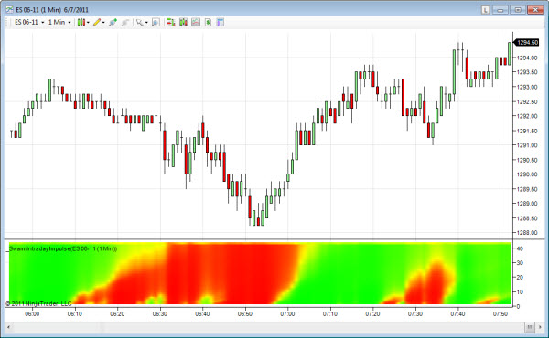  
  
In engineering the impulse response of a system is the output waveform in response to a single sharp input excitation, much like the ringing of a bell struck by a clapper.  Swami Intraday Impulse is an advanced DSP indicator that recovers the impulse response of intraday prices. The design intent is to provide an early and sharp delineation of ultra short-term price fluctuations.  
  
In the chart above, we see the 5 minute prices for the USDJPY Forex. Although the overall trend is up across the entire chart, there are several tradeable swing reversals seen at about 5:00,  6:45, and 7:45.

# Swami Intraday Volume

Swami Volume shows volume relative to its recent average. Higher relative volume is shown in white and lower volume is shown in blue.  This indicator has been optimized for intraday timeframes.  
  
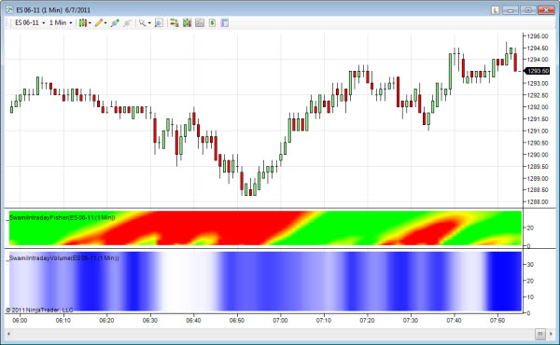  
  
The Swami Intraday volume has been characterized for immediate action.  This indicator is similar to its cousin the [Swami Volume](http://swamicharts.com/swami/Pages/SwamiVolume.aspx) except that it is faster acting and generally more appropriate for intraday timeframes.  
  
Be aware of the sharp volume increases in intraday charts that occur as the 24 hour markets begin to open in various parts of the world.  This is especially seen in the Forex and Globex markets for the equity indexes.  In the chart above for the E-Mini SP 500 contract, we see abrupt increase in volume at 7:00 AM at the U.S. stock market open.

# Swami Convolution

Swami Convolution shows price turning points as lavendar plumes against a blue background.  To determine whether a turning point represents a peak or valley, locate the onset of a plume at the bottom of the chart and go back in time a few bars to locate the most recent peak or valley.  
  
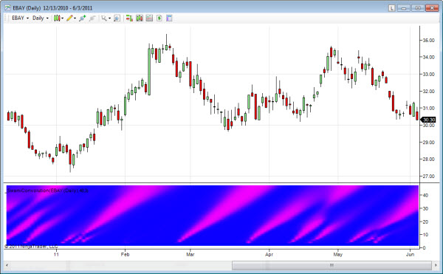  
  
Convolution is term used in the engineering field of digital signal processing (DSP) to the measure of overlap of one function as it is shifted against another.   
  
Swami Convolution shifts the inverse time series of prices relative to the observed time series of prices over a range of lookback periods. Performing the computation this way, the two functions become highly correlated at major price turning points. As a result, Swami Convolution can often identify major turning points with only a few bars of delay.   
  
In the example chart above for EBay, a short-term bottom is identified by the plume in early 2011 followed by a top identified by the plume in the 4th week of Feb. Then another bottom is identified by the plume beginning during the 3rd week of Apr.

# Swami Laguerre Trend

Swami Laguerre Trend can often identify the onset of trend without the whipsaws that occur in other trend indicators. Uptrends are indicated in green, downtrends are indicated in red, and yellow is indeterminate.   
  
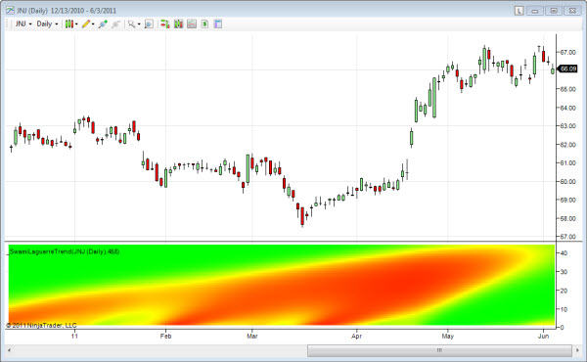  
  
Laguerre polynomial filters were described by SwamiCharts co-founder John Ehlers in his book [Cybernetic Analysis for Stocks and Futures](http://swamicharts.com/swami/Books.aspx). The basic idea is to create the equivalent of very long filters using a relatively small amount of data so the filter would be responsive to data changes. Swami Laguerre uses real filter lengths over the range from 12 to 48 bars to create the equivalent of much longer moving averages. As a result, the onset of trends can often be clearly identified without whipsaws.   
  
In the example chart for JNJ above, an intermediate-term downtrend was in play until the beginning of April with a minor excursion to the upside in January. The indicator was early in detecting the new uptrend during the 1st week of April. The trend remains in effect although appears to be weakening at the far right of the chart (1st week of June).

# Swami Relative Performance

Swami Relative Performance shows the relative price performance between a pair of securities. When the plotted security is outperforming the base security, the indicator is green. When underperforming, the indicator is red. Yellow indicates the securities are performing equally.   
  
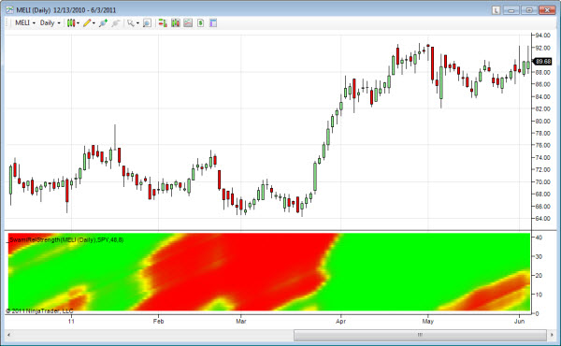  
  
The base security ticker symbol is set in the parameters section of the indicator. The default setting for the comparison symbol is SPY so that a selected stock performance is measured against the general market.   
  
Note that Swami Relative Performance is not the same as an RSI indicator. Swami Relative Performance simply measures the price movement of one ticker symbol against another. The comparison is made over a filter span from 12 to 48 bars.   
  
In the above example the base security is SPY, the overall S&P 500 market. We see that MELI was underperforming the S&P from late January through early March and then began to outperform the index. Then in early may, MELI again began underperforming the overall market but now appears to again be picking up steam in early June.

# Swami SwingWave

This indicator shows the cyclic price swings at multiple lookback periods. Blue sections indicate wave troughs (valleys) and orange indicates wave crests (peaks).   
  
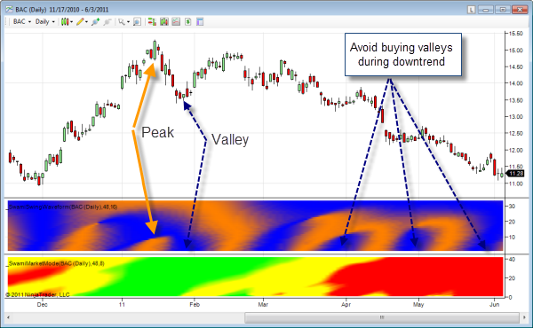  
  
Swami SwingWave uses advanced DSP cycles-measuring techniques to extract only the short-term wave components from price data. Wave peaks are displayed in orange and wave valleys are displayed in blue. Lookback periods from 16 to 48 bars are displayed on the vertical axis. This indicator is often able to detect wave peaks and valleys with only 2 or 3 bars of delay.   
  
In the sample chart for BAC above, swing peaks are shown in orange and valleys in blue. Notice that many of the swing trades would have been profitable on the left hand portion of the chart. However as we get into April and beyond, the market is in a strong downtrend as shown in the [Swami Market Mode](http://swamicharts.com/swami/Pages/SwamiMarketMode.aspx) (bottom) chart. Because of this, any short-term bullish swings are being swamped out by the downtrend and therefore swing trading the long side (but not the short side) would have produced disappointing results during Apr-Jun.

# Swami Volatility

The Swami Volatility indicator gives you a clearer picture of price volatility. Periods of high volatility are shown as lighter shades of blue while periods of low volatility are in darker blue.   
  
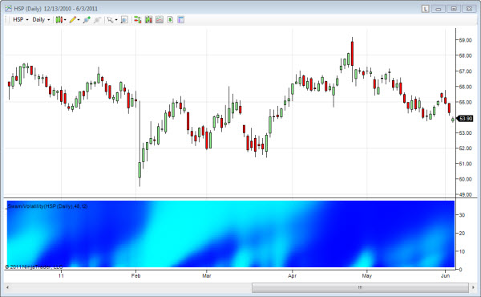  
  
While there are a number of algorithms to compute volatility, most attempt to identify unusual changes in price activity because these unusual changes signal price reversals.   
  
Swami Volatility gives a clear picture of volatility by comparing the current true range of price movement to the average true range over a range of filtering periods from 12 to 48 bars. Higher volatility is indicated in light blue and lower volatility is indicated in darker blue.   
  
In the example chart above for HSP above, the increasing volatility shown in late January anticipates the gap down on the first of February. Two other price reversal are signaled by Swami Volatility at the second and third weeks of March. The large range bars in the last week of April is identified as an increase in volatility with the subsequent downturn in prices.

# Swami Accumulation/Distribution

The Swami A/D indicator is a measure of net money flow into or out of the market. Accumulation is indicated as green and distribution is indicated as red, with black indicating roughly equal money flowing into and out of the market.  
  
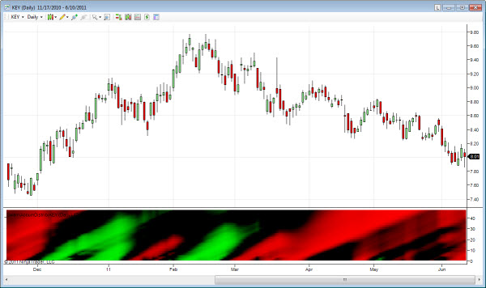  
  
Every transaction obviously requires both a buyer and seller.  However when prices are increasing on increasing volume, the bulls are predominant (and vise-versa). Due to its' volume component, the Swami A/D can sometimes spot large institutional investors getting into or out of the market ahead of big price moves.   
  
Swami A/D computes the average difference between the closing and opening prices each day multiplied by the volume for the day. As with all SwamiCharts, the algorithm is computed over a range of lookback periods.   
  
In the example for Key Bank above, accumulation begins around the first of February and continues for about 3 weeks. This short-term accumulation turns decidedly toward distribution in March as a new downtrend begins. Up until early April, longer-term the A/D has been inteterminate with occasional periods of accumulation. As the downtrend continues from March-June, selling continues causing distribution to begin to show up at the longer lookback periods. At the shorter lookback periods, distribution is drying up in late May / early June and we may now be near a bottom.

# Swami Market Mode

The Swami Market Mode indicator shows you whether a security is in trend mode or swing mode. Green indicates an uptrend and red indicates a downtrend while yellow indicates trading within a range (i.e., support-resistance channel or swing mode).   
  
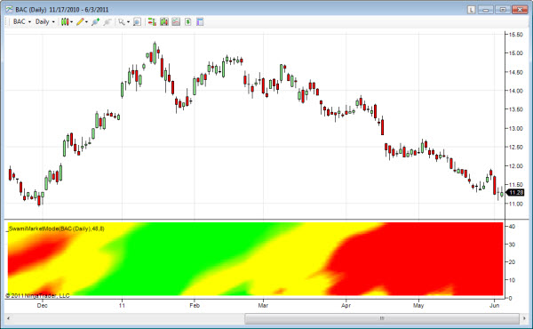  
  
Swami Market Mode operates by measuring the direction and slope of then trend across a cycle period and comparing this slope to the peak-to-peak amplitude swing of the cycle across the same period. The cycle period ranges from 12 to 48 bars, and is scaled on the vertical axis. If the ratio is greater than one (green), an uptrend is indicated. If the ratio is less than minus one (red), a downtrend is in effect. If the cycle amplitude is greater than the absolute value of the trend, the cycle mode is indicated. The swing mode has the most effectiveness for swing trading. An uptrend is indicated by green, a downtrend is indicated by red, and the swing mode is indicated by yellow.   
  
In the example chart for BAC above, the beginning of an uptrend (green) is detected in the middle of December. By the first of February the swing mode (yellow) has started to replace the uptrend, although the uptrend remains in effect through mid-February for the longer lookback periods. The swing mode however turns decidedly into a downtrend (red) beginning around the third week of March.

# Swami Predict

While similar to classical price oscillators, Swami Predict can often be 2 to 4 bars earlier. Green indicates a bullish condition, red indicates a bearish condition, and yellow is indeterminate.   
  
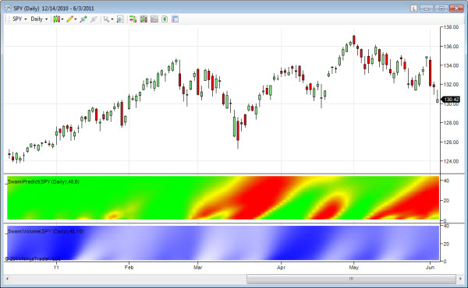  
  
Swami Predict is a momentum oscillator that measures the speed and change of price movements using advanced digital signal processing (DSP) filtering techniques.   
  
Swami Predict gives you an early view of the change of price movements by varying the calculation period over a range of periods and displaying price movement to the upside in green and price movement to the downside in red. As a result you see both the early stages of a price movement for the shorter periods and a measure of the persistence of the movement for longer periods toward the top of the chart.   
  
In the example chart above for the S&P 500 ETF, we show both the Swami Predict (red-yellow-green) and [Swami Volume](http://swamicharts.com/swami/Pages/SwamiVolume.aspx) (blue-white) indicators. At the left of the chart we see that the market is in a bullish trend on low volume. Volume picks up during the 2nd week of January as the uptrend continues. About the 3rd week of Feb, it appears that the trend is growing old as volume begins to diminish and then prices begin to fall. Swami Predict gives us a sell indication (red) late in Feb, just before a sizeable correction. Then a new bullish (green) indication begins with a lot of buyers stepping in just after the low in March. That upward reversal is short lived however and Swami Predict again gives a bearish signal after the early-April peak reverses direction on low volume. Another peak occurs around May 1st with Swami Predict giving an early bullish prediction during the 3rd week of April. Finally, the market moves south with Swami Predict signalling the move in the 2nd week of May.

# Swami Volume

Swami Volume shows volume relative to its recent average. Higher relative volume is shown in white and lower volume is shown in blue.   
  
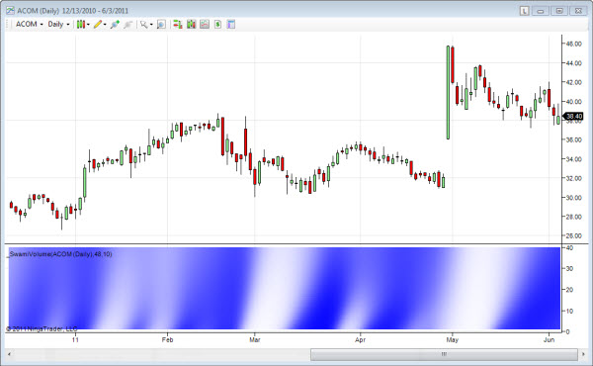  
  
Unlike a traditional volume bar chart, the Swami Volume shows smoothed volume deviations from recent averages.  The net effect of this is to make abrupt volume changes easier to perceive whether or not the absolute volume is high, low, or in-between.  Swami Volume produces a clear picture of the often complex relationship where volume often leads major price movements.  
  
In the chart above we see volume drying up as the bullish trend is ending in mid February  (additional buyers in short supply). With no more buyers, a downward price move begins on low volume and then accelerates (sellers anxious to get out) in early March.  Then in the second week of March most of the sellers are gone and prices again begin to rise on low volume.  Finally at the beginning of the fourth week in March we see profit taking (volume rising as a peak is rounded) and we are again beginning a downward move. This time the selling is less frenetic as indicated by the low volume and orderly price decline. But somebody knows something as we see the stealth accumulation occuring just before a big leap in prices near the 1st of May.

# Swami Aroon

The Aroon indicator was introduced by Tushar Chande in his book, "New Concepts in Technical Trading Systems". Chande designed the Aroon indicator to distinguish between periods of trending versus trading ranges. Green indicates uptrends and red indicates downtrends. As with all SwamiCharts, the lower portion of the chart shows shorter lookback periods and gives you an early view while the middle portion provides confirmation and the upper portion (longest lookback periods) provides continuation.   
  
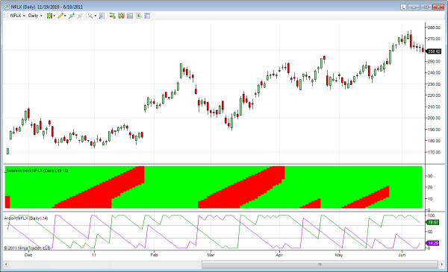  
  
SwamiCharts Aroon gives you additional insight into the confirmation and continuation of the trend because you're visualizing a composite of lookback range from 12 to 48 bars. An early emergence of an uptrend (downtrend) is identified by a transition from red to green (green to red) at the lower lookback periods (bottom of the chart). If the trend is confirmed and continues, the indicator will "stairstep" to longer lookback periods. An abrupt color change at multiple lookback periods often signals a significant change. This indicator can often be effectively used in conjunction with [Swami Market Mode](http://swamicharts.com/swami/Pages/SwamiMarketMode.aspx) or [Swami Swing Wave](http://swamicharts.com/swami/Pages/SwamiSwingWave.aspx).  
  
In the example chart for Netflix above, the middle chart shows SwamiAroon and the bottom chart shows the traditional Arron indicator. The traditional Aroon gives you a view at only a single lookback period, in this case 14 bars. SwamiAroon shows a composite range of lookback periods and is typically easier to interpret. At the short lookback periods (bottom of chart) SwamiArron gives you an early indication of a change in trend. Similarly at the longer lookback periods, you are able to have a view of trend continuation.

# Swami CCI

The SwamiCCI is an indicator based on the classic Commodity Channel Index (CCI) oscillator originally introduced by Donald Lambert. An overbought (bearish) condition is shown in red and an oversold (bullish) condition is shown in green. A yellow color indicates an intermediate condition.  
  
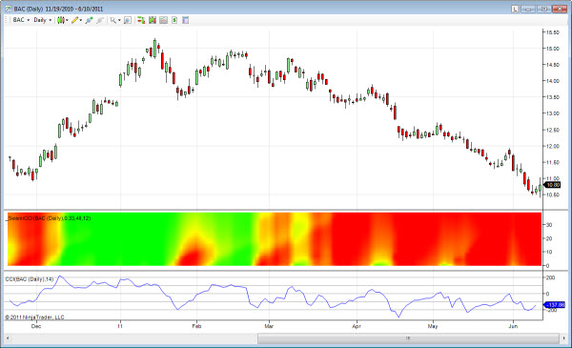  
  
SwamiCharts CCI gives a larger overview by using channel lengths that vary from 12 to 48 bars in the vertical scale and by displaying the position relative to the channel using colors. Green represents a position in the upper part of the channel and red represents a position in the lower part of the channel, with yellow being an intermediate position.   
  
In the example for BAC above, the middle chart (red-yellow-green) is SwamiCCI and the bottom chart (blue) is the classic CCI indicator.  The classic CCI shows the indicator values at a single lookback period only - in this case, 14 bars. SwamiCCI is easier to interpret and provides additional info for pattern continuation due to its rendering at the longer lookback periods.

# Swami RSI

The Swami RSI displays upside price movements in green and downside price movements in red. Indeterminate periods are shown in yellow.   
  
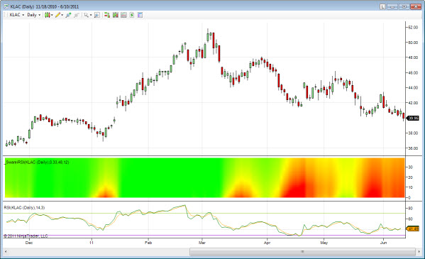  
  
The relative strength index (RSI) indicator is a well-known momentum oscillator that measures the speed and change of price movements. It does this by measuring the sum of the differential closes up to the absolute value of all differential closes, usually over a period of 14 days. Despite being developed before the computer age, RSI has stood the test of time and remains extremely popular.   
  
SwamiCharts RSI gives you an early view of the change of price movements by varying the calculation period over a range of lookback periods. As a result you see both the early stages of a price movement at the shorter periods (near the bottom of the SwamiChart) and a measure of the persistence of the movement for longer periods at the top of the chart.   
  
In the example chart above for KLAC,  the middle chart is SwamiRSI and the bottom chart is a traditional RSI indicator.  The traditional RSI displays indicator values at a single lookback period only.  SwamiRSI is easier to interpret and provides additional info for pattern continuation due to its rendering over an entire range of lookback periods.

# Swami Stochastics

Stochastics is another popular price oscillator that has withstood the test of time. The Swami Stochastics indicator becomes green when entering an expected bullish period and red when entering an expected bearish period. When yellow, the indicator is indeterminate.   
  
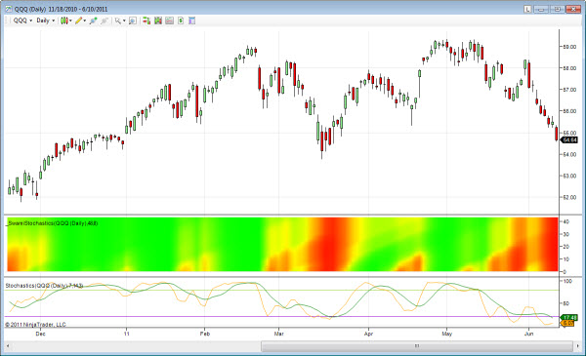  
  
The Stochastics indicator was popularized by Dr. George Lane. Stochastics is a momentum oscillator that measures the speed and change of price movements. It does this by measuring the position of the current closing price relative to the highest close and lowest close in recent history.   
  
SwamiCharts Stochastics gives you an early view of the change of price movements by varying the calculation period over a range from 12 to 48 bars and displaying price movement to the upside as green and price movement to the downside as red. As a result you see both the early stages of a price movement for the shorter periods and a measure of the persistence of the movement for longer periods at the top of the subgraph.   
  
In the above chart for the Nasdaq 100 index (QQQ), Swami Stochastics became bullish on the first of February and remained that way for the next several weeks. During the last week of February the QQQ began a downtrend which remained in effect through mid-March.