一、suse

<https://www.linuxidc.com/topicnews.aspx?tid=3>

二、docker，k8s，jenkins

<https://pan.baidu.com/s/1ZUpqnkwp4B4fDExcVLADrg>

三、prometheus

<https://shimo.im/docs/cBScYt8Z4K4V2i8s/>

四、升级openssh

<http://blog.51cto.com/techsnail/2138927>

升级后报错： key-exchange failed No compatible hostkey.The server supports  these methods: ssh-ed25519

<https://blog.51cto.com/zfno111/1939945>

sshd –t重要查看命令

ls -al /etc/ssh/ssh*key 秘钥文件600，切记

/usr/sbin/sshd启动

五、升级ntpd

<https://www.jianshu.com/p/33933c240f59>

chrony配置文件：

driftfile /var/lib/chrony/drift

makestep 1.0 3

rtcsync

local stratum 10

logchange 1

logdir /var/log/chrony

server 10.238.0.1 iburst minpoll 4 maxpoll 4

server 10.238.0.13 iburst minpoll 4 maxpoll 4

六、使用SecureCRT如何进行文件上传

<https://jingyan.baidu.com/article/d8072ac487073aec94cefd63.html>

上传：先切换文件所在路径，put文件名

下载：get 本地路径

七、报错**mkfs.xfs: cannot open /dev/sdm: Device or resource busy**

<https://blog.csdn.net/man_in_the_night/article/details/86570882>

八、逻辑卷分区

<https://blog.csdn.net/sehejs_a/article/details/80932946>

<https://www.cnblogs.com/kevingrace/p/5825963.html>

九、cat /proc/net/dev实时网速统计详细说明<https://blog.csdn.net/yzy1103203312/article/details/77848192>

十、镜像文件下载地址

http://archive.kernel.org/centos-vault/

https://developer.aliyun.com/mirror/

十一、CentOS桌面字体边方框（乱码）的解决方法

<https://www.llm.me/linux/solution-of-centos-box-font-or-garbled.html>

yum install cjkuni-ukai-fonts cjkuni-uming-fonts wqy-zenhei-fonts –y

十二、安装vnc server

https://blog.csdn.net/L835311324/article/details/86608835

yum install tigervnc-server –y

vncserver(设置密码)

<https://blog.csdn.net/geeksoarsky/article/details/98083846>

https://jingyan.baidu.com/article/e4511cf32f67ee2b855eaf7d.html

十三、ntp

<https://www.cnblogs.com/lei0213/p/8723106.html>

十四、rhce

<https://www.linuxprobe.com/tools>

ensp <https://edu.51cto.com/center/course/lesson/index?id=242152>

https://edu.51cto.com/center/course/lesson/index?id=366061

docker <https://edu.51cto.com//center/course/lesson/index?id=347205>

十五、esxi

<https://zhuanlan.zhihu.com/p/30129843>

<https://ithelp.ithome.com.tw/articles/10184459>

十六、[对linux下挂载磁盘遭遇Structure needs cleaning的处理](http://sfc.wz58.com/index.php/post/72.html)

<http://sfc.wz58.com/index.php/post/72.html>

十七、找不到/var/empty/sshd

[https://blog.csdn.net/zhanglh046/article/details/78890432#](https://blog.csdn.net/zhanglh046/article/details/78890432)

**十八、**[**资产管理 cmdb之ansible 获取服务器硬件、软件等信息**](https://www.cnblogs.com/huangxiaoxue/p/5931904.html)

<https://www.cnblogs.com/huangxiaoxue/p/5931904.html>

十九、ansible1.7.2源码安装教程

<https://blog.51cto.com/wutengfei/1973792>

ansible2.4.2源码安装教程

https://blog.csdn.net/xzm5708796/article/details/89357434

二十、ESXi6.5

<https://blog.51cto.com/daniel1205/1873834>

二十一、下载红帽

<http://220.195.2.232:8080/iso/rhel/>

http://220.195.2.232:8080/iso/

二十二、破解root密码

CentOS7

<https://blog.csdn.net/weixin_41078837/article/details/80539986>

CentOS6

<https://blog.csdn.net/PeersLee/article/details/48416275>

二十三、老男孩宝库

<https://blog.oldboyedu.com/>

自注：Linux踢出已登录用户的方法：

# pkill -KILL -t pts/0 (pts/0为w指令看到的用户终端号)

二十四、Linux终端显示[-bash-4.x]的解决办法

https://blog.csdn.net/hzylmf/article/details/43699177

一次手贱无意中删除了当前用户登录目录下的文件，结果导致控制台不能显示[user@hostname path]#这种格式，而是变成了-bash-4.x#，于是从别的机器同路径下拷贝.bash_profile和.bashrc两个文件到该目录，然后执行source .bash_profile，恢复正常

注意对比用户家目录下.bash*文件数量，权限，属组

二十五、出现Failed to start OpenSSH server daemon

<https://blog.csdn.net/zyd_15221378768/article/details/80091181>

chmod 600

二十六、ansible 提示安装sshpass

<https://www.cnblogs.com/JiangLe/p/7226284.html>

127.0.0.1:127.0.0.2 可以指定多台

all:\!127.0.0.1 不操作127.0.0.1

ansible all –m shell –a “cat /etc/passwd|awk –F ‘:’ ‘{print \$1}’” 特殊字符转义

ansible spark –m shell –a ‘echo root:WXRuan|chpasswd’ --become

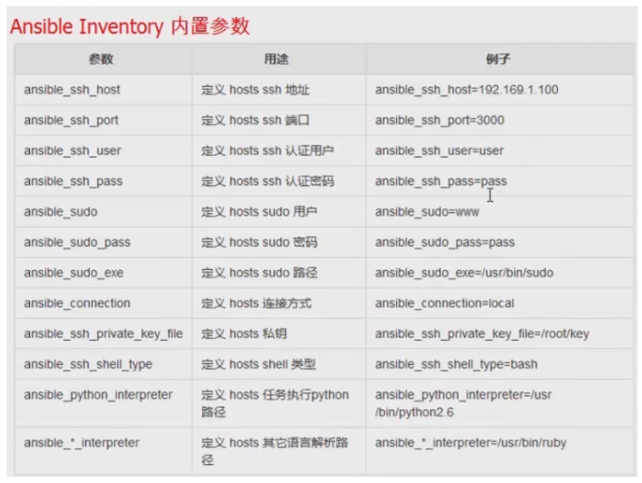

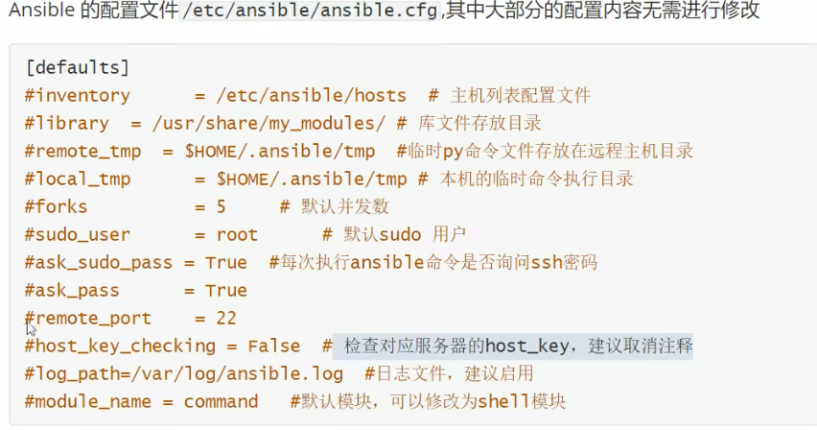

注：从ansible2.0开始，

ansible_ssh_user  ----------------->ansible_user

ansible_ssh_host  ------------------->ansible_host

ansible_ssh_port    ------------------> ansible_port

简单免密：ssh-keygen

ssh-copy-id 192.168.192.151

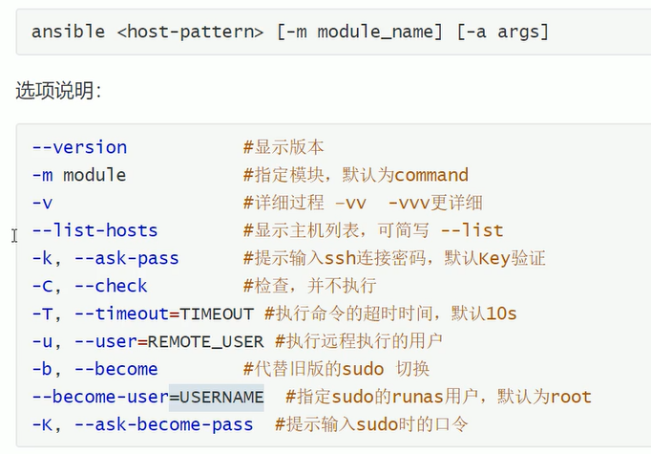

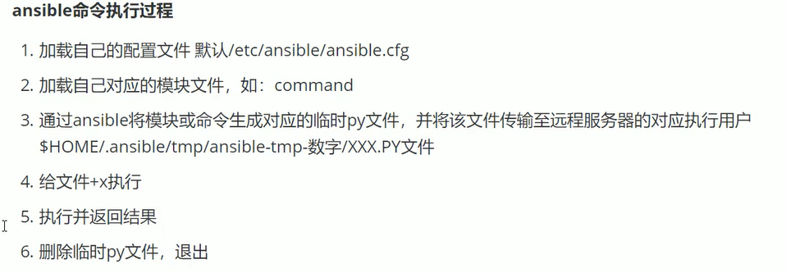

二十七、ansible视频

<https://edu.51cto.com/center/course/lesson/index?id=306550>

二十八、zabbix视频

<https://edu.51cto.com/center/course/lesson/index?id=378007>

二十九、kubernetes视频

<https://edu.51cto.com/course/16518.html?source=so>

三十、IPMI系统简单介绍操作、**联想IPMI固件SMASH-CLP 管理**

<https://blog.csdn.net/weixin_34075268/article/details/92138144>

三十一、openssl加密

<https://www.cnblogs.com/imageangel/articles/7529292.html>

**三十二、重新安装openssh,出现 Failed to get properties: Access denied**

<https://blog.csdn.net/lanmo555/article/details/51907828>

systemctl daemon-reexec

daemon-reload将重新加载所有单元文件,不是systemd本身的配置。systemctl daemon-reexec将重新执行systemd并导致其消化新配置的过程。

<https://blog.mallux.me/2017/02/13/systemd/>

三十三、prometheus下载

<https://github.com/prometheus/prometheus/releases>

三十四、VNC远程界面卡死解决方法

<https://blog.csdn.net/qq_27022241/article/details/78631425>

三十五、出现

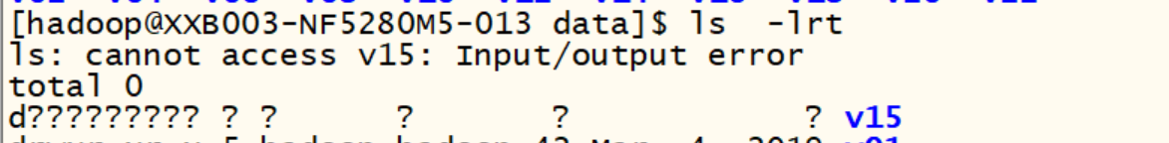

1、出现ll

d????????? ? ? ? ? ? v15

2、umount /data/v15

3、mount /dev/sdp1 /data/v15

出现

mount: mount /dev/sdp1 on /data/v15 failed: No data available

[root@04a130301 ~]# mount -a

mount: /vdata: can't read superblock on /dev/mapper/rootvg-lv_data.

4、xfs_repair -L /dev/sdp1 （fsck）

5、mount /dev/sdp1 /data/v15成功

三十六、杀僵尸进程

ps -A -o stat,ppid,pid,cmd | grep -e '^[Zz]' | awk '{print $2}' | xargs -i kill -9 {}

<https://blog.csdn.net/vbaspdelphi/article/details/70048539>

三十七、powerlinux9核查cpu:

<https://www.cnblogs.com/xingzifei/articles/5930679.html>

<https://blog.csdn.net/zhaihaifei/article/details/51037094>

ppc64_cpu –help

三十八、安装winserver2008r2

<https://zhinan.sogou.com/guide/detail/?id=316513603495>

在win+r下输入mstsc,连接远程桌面

三十九、win10激活office被拦截

<http://www.tudoupe.com/a/jihuo001.html>

四十、office激活

<https://mp.weixin.qq.com/s?src=11&timestamp=1587003764&ver=2281&signature=lVHM3s7OALtj8dtuHloDNYLIzrG0niXFBY-iYZ-Ly6QY-C41ctH73bHiqej1kbvr9jXCPw-uJg412fj0deRjrNl8uIDyb-ySwtQ7pg22o845JZdMh0U-vHyrjmNvVUm3&new=1>

四十一、Linux下离线安装Docker1.7.1

<https://www.35youth.cn/484.html>

docker的补全功能，安装 bash-completion

yum install -y bash-completion

安装完成之后重启系统或者重新登录 shell

四十二、VMware虚拟机各版本密钥

<https://www.cnblogs.com/vhhi/p/10202204.html>

四十三、Centos7（Linux）下安装VMware12

<https://blog.csdn.net/u012605477/article/details/65627234>

四十四、Vmware由于centos升级内核不可运行（C header files matching your running kernel were not found）的解决方案

<https://www.cnblogs.com/rgqancy/p/10310178.html>

<https://blog.csdn.net/jcxch/article/details/48857741>

四十五、Centos7 之虚拟机添加网卡找不到网卡配置文件

<https://blog.csdn.net/yulei_qq/article/details/104148410>

可以使用nmcli con show 查看网卡的设备名称(Device)

nmcli con show

添加网卡信息，会自动生成一个ifcfg-ens37配置文件

nmcli con add con-name ens37 type ethernet ifname ens37

四十六、windows 2008 R2 域环境下更改时钟源

<https://blog.51cto.com/lixiaosong/1310025>

四十七、windows产品镜像

<https://msdn.itellyou.cn/>

四十八、suse网卡配置工具

<http://www.361way.com/suse12-wicked/6080.html>

suse12 sp2系统bond网卡并且设置vlanID

<https://blog.csdn.net/arv002/article/details/104561305>

四十九、记录一次Docker无法启动问题

<http://www.suoniao.com/article/5f2bcfeddb700000a5000f11>

journalctl -ru docker看日志

Error starting daemon: Devices cgroup isn't mounted

五十、环境变量错误导致Linux指令不可用

<https://blog.csdn.net/pepping798/article/details/50378663>

export PATH=/usr/local/sbin:/usr/local/bin:/usr/sbin:/usr/bin/:/sbin:/bin

五十一、配置ubuntu源（有部分改动，按实际使用）

<https://zhuanlan.zhihu.com/p/346562578>

五十二、制作本地yum仓库

yum -y install createrepo

mkdir -p /application/yum/centos7/x86_64

cd /application/yum/centos7/x86_64/

createrepo -pdo /application/yum/centos7/x86_64/ /application/yum/centos7/x86_64/

createrepo --update /application/yum/centos7/x86_64/

python -m SimpleHTTPServer 80 &>/dev/null &

<https://www.bilibili.com/video/BV1nV411d7Ne/?p=4&spm_id_from=pageDriver>

<https://www.bilibili.com/video/BV1KZ4y1s7Ve?p=9&spm_id_from=pageDriver>

五十三、安装KVM虚机

[https://mp.weixin.qq.com/s?src=3&timestamp=1629680350&ver=1&signature=Q4gcE*oTqYFu0sNWQY1KC1-vggQvBDJrHfiXIPdr5RX9UXdlIKymGMzO2H*WBh1GTolA1T*cFihnl4MpgjTom*z5LdNwgSbl7G1ASrRffw0nTAYleSkuUIaxCVoRv9thk*MfHzf0fJt4QxZqRbc3Pn6o1cw7sSyjJq8MId7cdvI](https://mp.weixin.qq.com/s?src=3&timestamp=1629680350&ver=1&signature=Q4gcE*oTqYFu0sNWQY1KC1-vggQvBDJrHfiXIPdr5RX9UXdlIKymGMzO2H*WBh1GTolA1T*cFihnl4MpgjTom*z5LdNwgSbl7G1ASrRffw0nTAYleSkuUIaxCVoRv9thk*MfHzf0fJt4QxZqRbc3Pn6o1cw7sSyjJq8MId7cdvI)=

[https://mp.weixin.qq.com/s?src=11&timestamp=1629691781&ver=3269&signature=ByElTzqcMXUmjDabnNrFZS-kCQlsvDxd5Ji47dL72ajhA6rWWyhinIKzDpMMIEBN7vh2AcDSD*hVdyLNWIJLjEvfrO-KQnYTnH*ykc0ddx9MZPAAihPpnKX0aZGW2oi1&new=1](https://mp.weixin.qq.com/s?src=11&timestamp=1629691781&ver=3269&signature=ByElTzqcMXUmjDabnNrFZS-kCQlsvDxd5Ji47dL72ajhA6rWWyhinIKzDpMMIEBN7vh2AcDSD*hVdyLNWIJLjEvfrO-KQnYTnH*ykc0ddx9MZPAAihPpnKX0aZGW2oi1&new=1)

lsmod|grep kvm

yum install qemu-kvm qemu-img virt-manager libvirt libvirt-python virt-manager libvirt-client virt-install virt-viewer -y

systemctl start libvirtd

virsh list --all

virsh start 10.188.48.230

qemu-img create -f raw /vms/CentOS-7_230.raw 800G

virt-install --virt-type kvm --name 10.188.48.230 --ram 46080 --cdrom=/tmp/CentOS-7-x86_64-DVD-1708.iso --disk path=/vms/CentOS-7_230.raw --network=default --graphics vnc,listen=0.0.0.0 --noautoconsole

virt-install --virt-type kvm --name 10.188.48.231 --ram 46080 --cdrom=/tmp/CentOS-7-x86_64-DVD-1708.iso --disk path=/vms/CentOS-7_231.raw --network bridge=br0 --graphics vnc,listen=0.0.0.0 --noautoconsole

五十四、ssh错误登录太多,锁定Permission denied, please try again解决

<https://blog.51cto.com/u_9499607/2431490>

查看pam_tally2 --user prom

重置pam_tally2 --reset -u prom

五十五、制作OpenSSL1.1.1i rpm包

<https://blog.csdn.net/huhahuhahu/article/details/111242945>

别的版本可以把i替换

五十六、centos7的文件目录说明

https://www.cnblogs.com/zhoulujun/p/12111375.html

<https://blog.csdn.net/VariatioZbw/article/details/106395682>

五十七、tower

<https://releases.ansible.com/ansible-tower/setup-bundle/>

五十八、iptables规则实例

<https://www.cnblogs.com/zhanghuilong/p/7600910.html>

https://www.cnblogs.com/kevingrace/p/6265113.html

iptables -I INPUT -p tcp --dport 23188 -s 0.0.0.0/0 -j DROP

iptables -I INPUT -p tcp --dport 23188 -s 10.172.49.0/24 -j ACCEPT

容器规则操作容器端口非暴露端口

iptables -nL --line-numbers(显示规则的编号)

iptables -D INPUT 3 按照编号删除规则

iptables -I INPUT -s 10.125.138.0/24 -p tcp --dport 10021:10022 -j ACCEPT

iptables -I INPUT -s 10.172.32.0/24 -p tcp -m multiport --dports 1583,1584,1545,1546,1563,1564,1569,1570 -j ACCEPT

iptables -I INPUT -p tcp -m -multiport --dports 1583,1584,1545,1546,1563,1564,1569,1570 -j DROP

五十九、K8s命令及资源缩写

<https://studygolang.com/articles/16287>

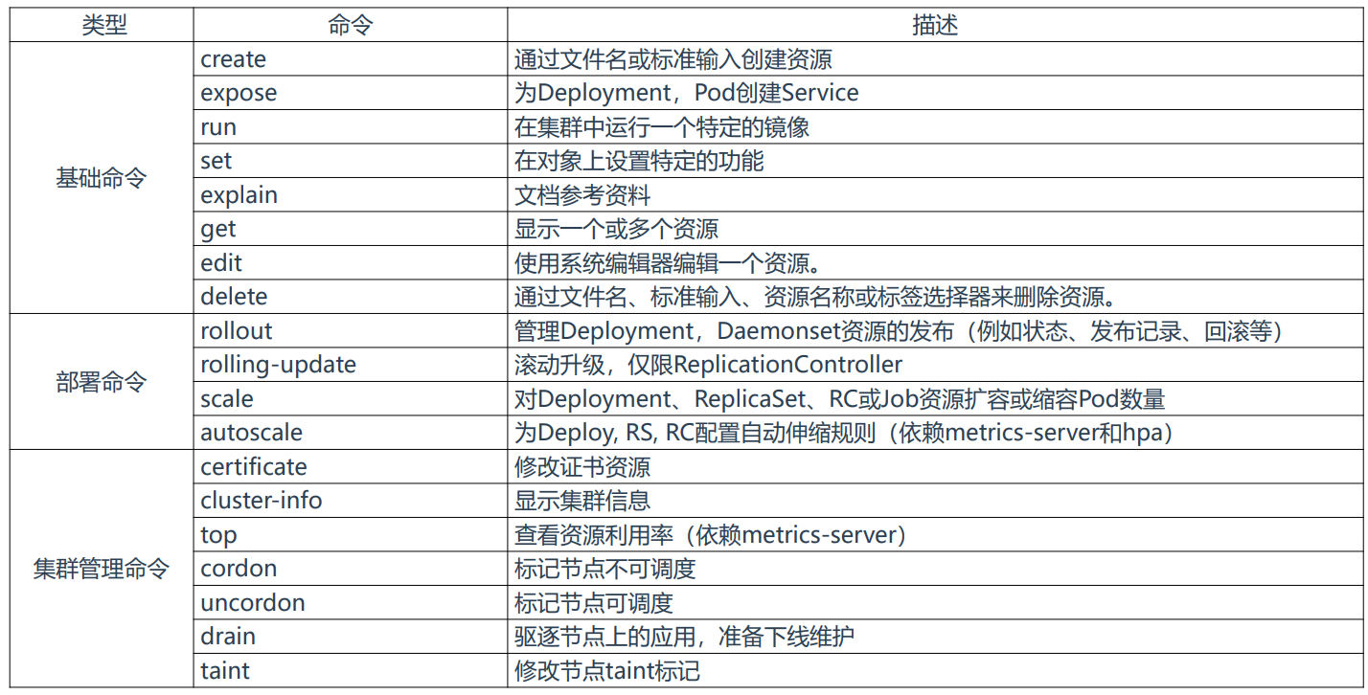

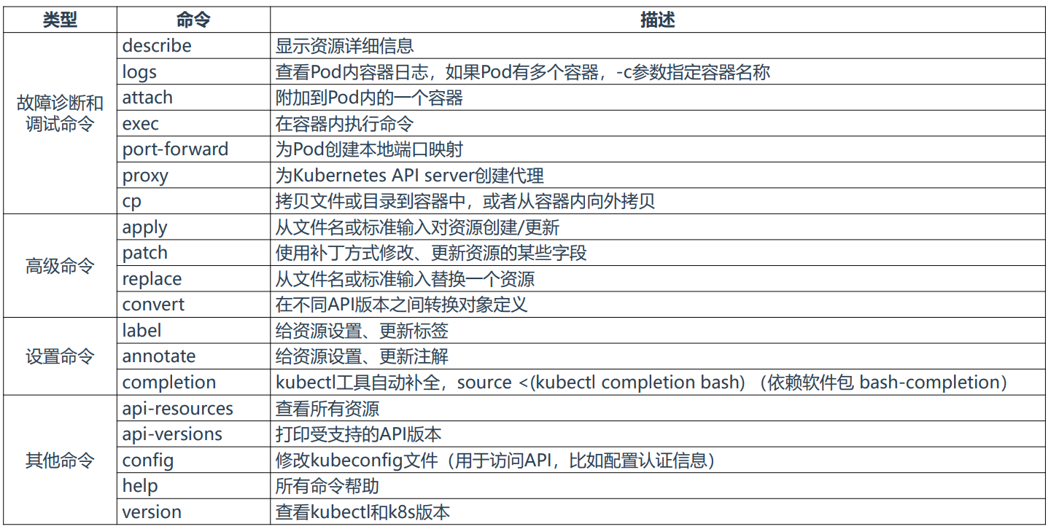

六十、出现sudoers文件异常

pkexec visudo

<https://blog.csdn.net/wuliangtianzu/article/details/109175564>

六十一、Kubernetes v1.22.1部署报错2：error: Get “http://localhost:10248/healthz“: dial t...

<https://blog.51cto.com/u_15266039/3704102>

六十二、使用kubeadm创建集群

<https://www.cnblogs.com/varden/p/15042830.html>

<https://blog.csdn.net/xjjj064/article/details/122606837>

<https://blog.51cto.com/lizhenliang/2530583>

六十三、搭建一套完整的企业级Kubernetes高可用集群（v1.20，二进制）

<https://blog.51cto.com/lizhenliang/2717923>

六十四、分区步骤

1 parted -s /dev/sdc mklabel gpt mkpart primary 0% 100% && pvcreate -f /dev/sdc1 && vgextend datavg /dev/sdc1（注意先创建datavg）

2 parted -s /dev/sdb mklabel gpt mkpart primary 0% 100% && pvcreate -f /dev/sdb1 && vgcreate -s 32 datavg /dev/sdb1

3 lvcreate -n lv_qlog -l 57119 datavg

4 mkfs.xfs /dev/datavg/lv_qdata

5 mkdir /qdata

6 mount /dev/datavg/lv_qdata /qdata

7 vi /etc/fstab

/dev/mapper/datavg-lv_qdata /qdata xfs defaults 0 0

8 mount -a没有返回值表示正确

六十五、磁盘vg、分区丢失，参考

<https://www.cnblogs.com/kcxg/p/10929287.html>

dd if=/dev/sdb bs=512 count=2|hexdump -C

<https://blog.csdn.net/qq_44377437/article/details/118863264>

六十六、[CentOS](https://so.csdn.net/so/search?q=CentOS&spm=1001.2101.3001.7020)修改主机名，区分大小写

hostnamectl set-hostname --static e3BASE44 不需要重启

<https://blog.csdn.net/adminpower/article/details/108337704>

六十七、进入救援模式

<https://www.jianshu.com/p/de42301187e5>

六十八、更新ubuntu apt源

<https://www.jb51.net/article/187442.htm>

cat /etc/apt/sources.list

apt update：只检查，不更新（已安装的软件包是否有可用的更新，给出汇总报告）

用法：sudo apt update

apt upgrade：更新已安装的软件包

用法：sudo apt upgrade 软件包名

六十九、ubuntu配置网卡

cat /etc/network/interfaces

auto ens33

iface ens33 inet static

address 192.168.234.6

netmask 255.255.255.0

gateway 192.168.234.2

/etc/init.d/networking restart

ubuntu从17.10开始，已放弃在/etc/network/interface里固定IP的配置，即使配置也不会生效，而是改成netplan方式

七十、解决ubuntu下DNS配置重启失效

https://blog.csdn.net/liuzhi0724/article/details/95615239

域名解析在/etc/resolv.conf

nameserver 192.168.234.2

nameserver 114.114.114.114

nameserver 223.5.5.5

七十一、Ubuntu18.04破解root密码

<https://blog.51cto.com/dlican/5109396>

七十二、linux磁盘之回环设备

<https://www.cnblogs.com/aozhejin/p/15867559.html>

七十三、ubuntu中apt与apt-get命令的区别

<https://blog.csdn.net/taotongning/article/details/82320472?utm_medium=distribute.pc_relevant.none-task-blog-2~default~baidujs_baidulandingword~default-0.essearch_pc_relevant&spm=1001.2101.3001.4242>

简单来说就是：apt = apt-get、apt-cache 和 apt-config 中最常用命令选项的集合。

Ubuntu18.04service文件路径/lib/systemd/system/node_exporter.service

七十四、vmmare安装之后，主机上没有VMnet1和VMnet8和虚拟机上外网连接设置

<https://blog.51cto.com/u_12182612/2082674>

七十五、ubuntu下运行./mysqld_exporter --config.my-cnf=".my.cnf"

出现-bash: ./mysqld_exporter: 无法执行二进制文件: 可执行文件格式错误

执行: apt install binfmt-support qemu qemu-user-static -y

<https://ubuntuqa.com/article/1367.html>

七十六、Panabit和Panalog如何怎么修改密码/忘记密码

ssh查看Web管理密码   控制台登录 用户名root，默认密码panaos  
输入cat /usr/ramdisk/admin/.htpasswd 查看web密码

七十七、Ceph存储osd清除

<https://cloud.tencent.com/developer/article/1892371>

清理lvm残留， 卸载osd重新启用盘时使用

lvdisplay | grep "LV Path" | awk '{print $NF}' | xargs -i lvremove -f {}

vgdisplay | grep "VG Name" | awk '{print $NF}' | xargs -i vgremove {}

pvremove /dev/sd[b-j]

ceph-volume lvm list

<https://blog.csdn.net/nasooo/article/details/117947537>

ceph osd crush rm cephtest003（主机名）

<https://www.cnblogs.com/itzhao/p/11336327.html>

**七十八、**华为交换机使用ACL限制特定用户上网

<https://jingyan.baidu.com/article/48b37f8dd8b4bf1a646488f1.html>

七十九、Kali-Linux-2021.2 汉化设置参考

<https://zhuanlan.zhihu.com/p/389606416>

八十、CentOS6网卡不存在

<https://blog.51cto.com/shenzhijin/1859932>

八十一、Tcpdump抓包示例

<https://mp.weixin.qq.com/s/PDME3moWZeJCh-1qm8CYkA>

八十二、windows常用命令

<https://zhuanlan.zhihu.com/p/35773611>

八十三、字体编辑用中日韩汉字Unicode编码表

<http://www.chi2ko.com/tool/CJK.htm>

遇到不能复制的，在IE浏览器中找到设置，搜素javascript，关闭允许推荐选项刷新网页即可

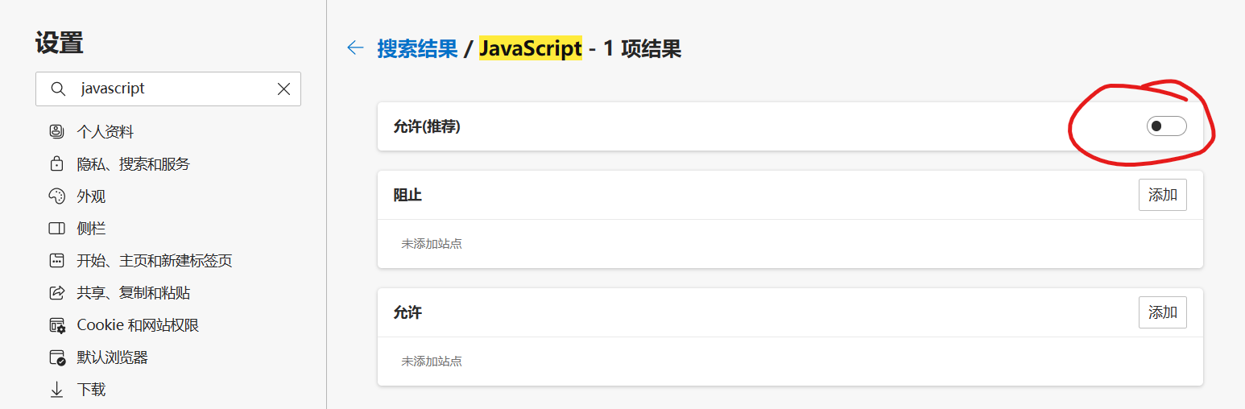

八十四、通过ipmitool修改管理口口令

https://cloud.tencent.com/developer/ask/sof/836391

ipmitool user list 查看用户列表，主要查看ID

ipmitool user set password 2 Admin123! 2是ID，Admin123!是密码