PT1 Filter (Forward Euler) – Block Description
Item | Value
Model | PT1_Filter_Demo.slx → PT1_Filter
Version | <x.y>
Author | <name>
Date | <yyyy-mm-dd>

1. Purpose
Discrete 1st-order low-pass filter (PT1) that smooths a noisy signal with an adjustable filter time.

2. Interface
Port / Parameter | Type | Unit | Description
u (In1) | double | <> | Signal to be filtered
reset (In2) | double / boolean | – | ≠ 0 → output set to input (y = u)
T_filt (In3) | double | s | Filter time constant
y (Out1) | double | <> | Filtered signal
Ts (mask) | double | s | Task time (sample time), must be > 0
y0 (mask) | double | <> | Initial output

3. Algorithm
Continuous model:
T · dy/dt + y = u
Forward Euler discretisation, executed every task k:
K = Ts / max(T_filt, Ts)
y[k] = (u[k] − y[k−1]) · K + y[k−1] if reset = 0
y[k] = u[k] if reset ≠ 0

4. Protection
Condition | Behaviour
T_filt < Ts | K = 1 → pass-through (y = u)
T_filt = 0 | K = 1 → no division by zero
T_filt < 0 | K = 1 → pass-through

K is limited to 0 < K ≤ 1, so the filter can't overshoot or become unstable (pole z = 1 − K lies in [0, 1)).

5. Characteristics
- Step response reaches ≈ 63 % after T_filt and ≈ 99 % after 5 · T_filt
- Cut-off frequency: f_c ≈ 1 / (2π · T_filt)
- Accuracy: forward Euler responds slightly faster than the ideal PT1; the error is ≈ 1 % at T_filt/Ts = 100 and ≈ 5 % at T_filt/Ts = 10
- Recommended: T_filt ≥ 10 · Ts

6. Reset and Initialisation
- At start: y[−1] = y0
- reset ≠ 0: output follows the input directly; filtering restarts from the current input value when reset is released (no transient)

7. Verification
Test setup: Ts = 1 ms, T_filt = 0.1 s, input = step at 0.5 s + 50 Hz noise (amplitude 0.2), reset pulse 3.00–3.05 s.
Test | Result
Model vs. formula, sample by sample | Identical (error 0)
Output after T_filt (ideal 0.632) | 0.6376
T_filt = 0, < Ts, < 0 | y = u (no NaN / Inf)
Reset active | y = u

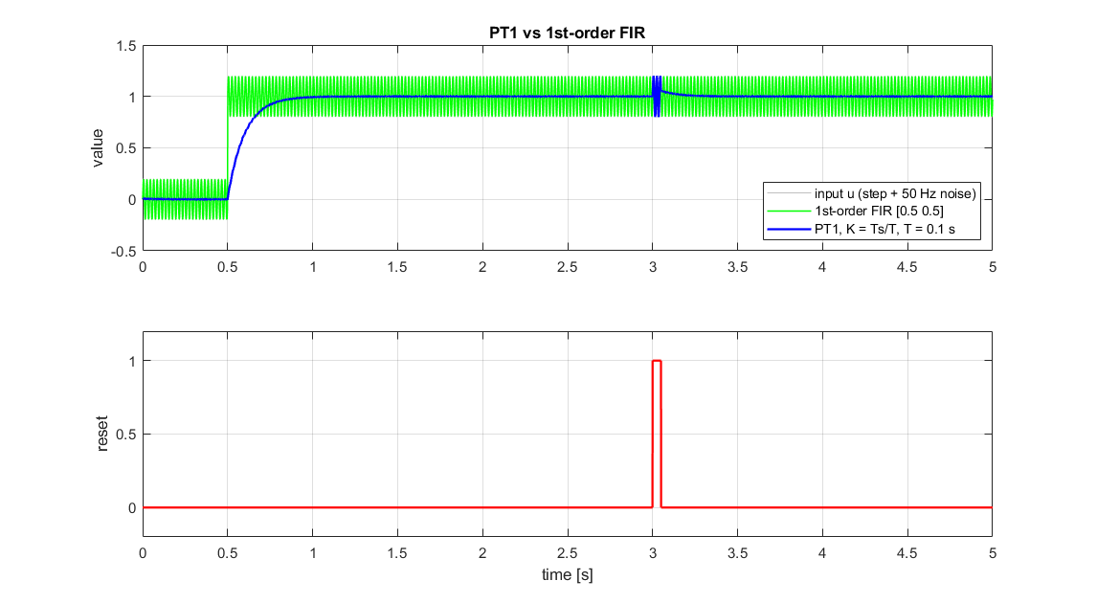
Figure 1: PT1 output (blue) vs. noisy input and 1st-order FIR; reset pulse at 3 s.

8. Limitations / Notes
- <add project-specific notes, e.g. data type, fixed-point scaling, code-generation settings>

