|  |
| --- |
| SOFTWARE DESIGN SPECIFICATION  **Project Code:**  AMS-20    **External Advisor:**  Dr. Qaisar Abbas  **Project Manager:**  Mr. Fahad Maqbool  **Project Team:**  Bilal Ishrat (BSCS-F16-E059)  Ishmal khan (BSCS-F16-E019)  Anam Sahar (BSCS-F16-E026)  **Submission Date:**  Jan 6th , 2020 _____________________ Project Manager’s Signature |

**Document Information**

| Category | Information |
| --- | --- |
| Customer | University of Sargodha |
| Project | Affiliation Management System |
| Document | Design Specifications |
| Document Version | 1.0 |
| Identifier | AMS-20 |
| Status | Documentation |
| Author(s) | Bilal Ishrat ,Ishmal khan ,Anam Sahar |
| Approver(s) | Dr. Qaisar Niazi |
| Issue Date | Jan 06, 2020 |
| Document Location | Sargodha, Pakistan |
| Distribution | 1. Advisor 2. PM 3. Project Office |

**Table of Contents**

1. Introduction 4

1.1 Purpose of Document 4

1.2 Project Overview 4

1.3 Scope 4

2. System Architecture 6

2.1 System Level Architecture 7

2.1.1 Class Diagram of Affiliation Management System: 7

2.1.2 Use case Diagram of Affiliation Management System: 8

2.2 Module Designs 9

2.2.1 Database and Page layout Design: 9

2.2.2 Database Generation: 9

2.3 Sub-Module Level Architecture 10

2.3.1 Integrate Login with SMS and Email servive : 10

2.3.2 Institutional infrastructure Details: 11

2.3.3 Remote Control Verification and notifications: 11

2.3.4 Remotely control of members Account: 11

2.3.5 Management of Security Deposits and Grants: 11

2.3.6 Report Configuration: 11

2.3.6 RDLC Development: 11

3. Detailed System Design 13

4.1 Class Diagram of Affiliation Management System: 13

4.2 Sequence Diagram of Affiliation Management System: 14

4. References 14

# Introduction

* 1. Purpose of Document

An educational institution that operates independently, but also has a formal collaborative agreement with another, usually larger institution that may have some level of control or influence over its academic policies, standards or programs.

For this, an **Affiliation Management System** has been designed for University of Sargodha to facilitate the affiliated colleges. The purpose of this document to describe the design details of each module of affiliation.

* 1. Project Overview

The colleges are facilitated to submit their application for affiliation and choose program. Our affiliation system deals with various activities related to the affiliation. In this affiliation system, it has three roles Admin (Affiliation Branch), Affiliation Committee Member (the committee, which guides the university regarding the affiliation of institute) and Institution (education institution seeking affiliation with university).

Through this online system we can provide following facilities:

* Time and money is saved.
* Nothing is done manually.
* Less chance to lose the data.
* Easy to access data.
  1. Scope

AMS accepts the affiliation application of Extension and grant of every college, after this it verifies and authenticate the application and make visit schedule of Committee members and then assign dates to committee members for visit. After visit Completion, committee members submit the feedback. Later on the seats are assigned to the colleges according to their degree programs for which they have granted the affiliation.

1. System Level Architecture
   * 1. Class Diagram of Affiliation Management System:

Class diagram in the Unified Modeling Language (UML) is a type of static structure diagram that describes the structure of a system by showing the system's classes, their attributes, operations (or methods), and the relationships among objects.

In **Figure 2.2.1** shows class diagram of Affiliation Management system.

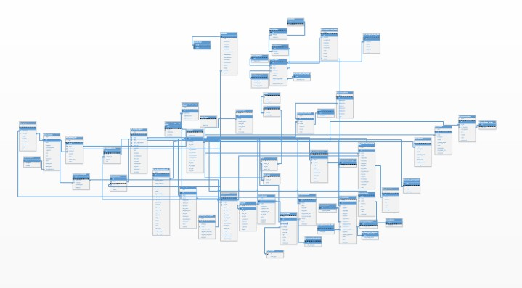

**Figure 2.1.1** Class Diagram of Affiliation Management System

* + 1. Use case Diagram of Affiliation Management System:

Use case is represented as a sequence of simple steps, beginning with a user's goal and ending when that goal is fulfilled. Here use case of affiliation management system describes the user’s goal and ending when that goal is fulfilled.



 