**Ishmal Tahir**

**225868**

**BSCS 7B**

**Web Technologies 2**

**Lab 09: React Native using Expo**

# Code:

## App.js

import * as React from 'react';

import { View, Text, Button, Image, Linking, StyleSheet } from 'react-native';

import { NavigationContainer } from '@react-navigation/native';

import { createStackNavigator, header, Header } from '@react-navigation/stack';

import bird from './public/bird.jfif';

import bg from './public/bird.jpg';

const Stack = createStackNavigator();

function HomeScreen() {

return (

<View style={{ flex: 1, alignItems: 'center', justifyContent: 'center' }}>

<h1>Ishmal Tahir</h1>

<p>My name is Ishmal Tahir. I am a final year student doing bachelors in Computer Science from NUST.<br />

I have developed excellent analytical and programming skills through my degree. <br />

I consider myself a good public speaker. <br /><br /></p>

<Button

onPress={() => Linking.openURL('mailto:itahir.bscs17seecs@seecs.edu.pk')}

title="Email"

/>

<br />

<Button

onPress={() => Linking.openURL('https://github.com/ishmaltahir/Web-Tech-II')}

title="Github"

/>

</View>

);

}

function LogoTitle() {

return (

<Image

style={{ width: 50, height: 50 }}

source={bird}

/>

);

}

function App() {

return (

<NavigationContainer>

<Stack.Navigator>

<Stack.Screen

name="Home"

component={HomeScreen}

options={{

headerTitle: props => <LogoTitle {...props} />,

headerBackground: () => (

<Image

style={ StyleSheet.absoluteFill }

source={bg}

/>

),

}}

/>

</Stack.Navigator>

</NavigationContainer>

);

}

export default App;

## Output:

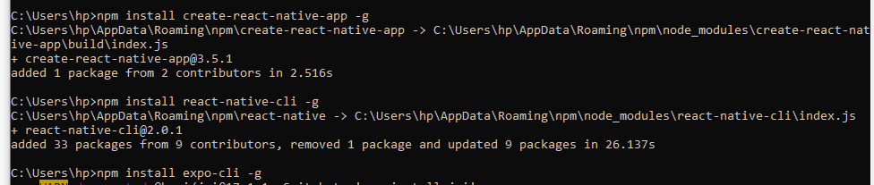

C:\Users\hp\Desktop\lab9-2.PNG

