**Assignment1**

**CS 6304**

**Purpose:** The purpose of this assignment is to give you some practice with importing raw images to tensors using numpy.

**Reference:** Please use materials from week1 as references to complete this assignment.

**What to submit:** You should submit the jupyter notebook of your code. Your Jupyter notebook should beorganized into different sections to match the different subtasks in the assignment**.**

**Description and Data:**

You are given two folders ‘NORMAL’ and ‘PNEUMONIA’ that contain chest x-ray images from normal patients and patients with pneumonia, respectively. Images are of the same dimensions. You are given several tasks to perform for this assignment listed below.

‘NORMAL’ images can be downloaded here: <https://www.dropbox.com/sh/d54u559x2kx3ny3/AADEmUJhEdRhqvOkeKWprUKTa?dl=0>‘PNEUMONIA’ images can be downloaded here: <https://www.dropbox.com/sh/4nvzj1rsmqs9pbd/AAA1nXNMEIG-WfMbi4XVqPnea?dl=0>

**Grading:** Tasks 1 – 4: each worth 10 points; Tasks 4-5: each worth 30 points.

1. Load these images into 3D Tensor (# of samples,width,height). Do this separately for the images in ‘NORMAL’ and ‘PNEUMONIA’ folders.
2. Reshape the tensors to 4D tensors to be in the form of (# of samples,width,height,1).
3. By displaying the shape of the tensors, find out the image dimensions.
4. Display the first five normal x-ray images, and first five x-ray images with pneumonia.

• To display an image **I** as grayscale, you may want to provide the option **cmap = ‘gray’** in the **imshow** function. See below.

from skimage import io # to display images from matplotlib import pyplot as plt io.imshow(Image, **cmap='gray'**) plt.show()

1. It is a common practice to crop images before feeding them to a model because most of the important characteristics in the images are not in the corners. Slice the tensors containing the images in such a way that each image is cropped to the portion defined

by the red box as illustrated below. Along the height of the image, remove 200 pixels (100 pixels from top, 100 pixels from bottom) and 100 pixels along the width of the image (50 pixels from left, 50 pixels from right).

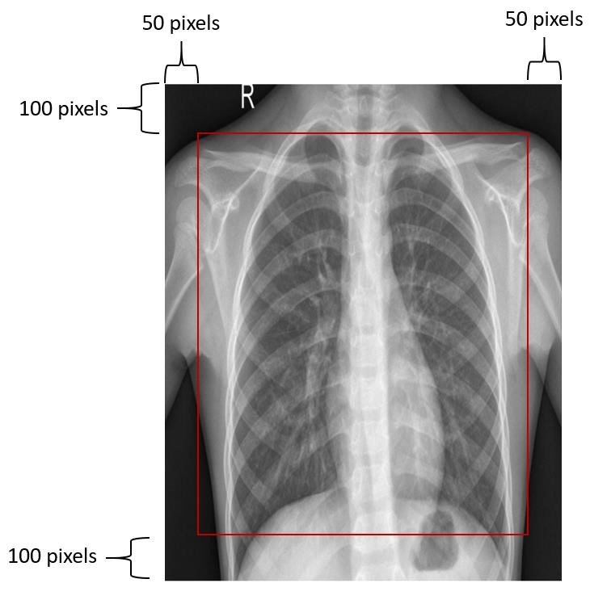

After slicing, display the shapes of the new tensors to make sure you have cropped the images properly. Display the first five cropped normal x-ray images, and first five cropped x-ray images with pneumonia.

1. It is also possible that the important characteristics in the images are located on onehalf of the image. Slice the original tensors (from subtask 2) containing the images in such a way that each image is cropped to contain only the right-half portion as illustrated by the red box below. After slicing, display the shapes of the new tensors to make sure you have cropped the images properly. Display the first five cropped normal x-ray images, and first five cropped x-ray images with pneumonia.

