**[50 points]**

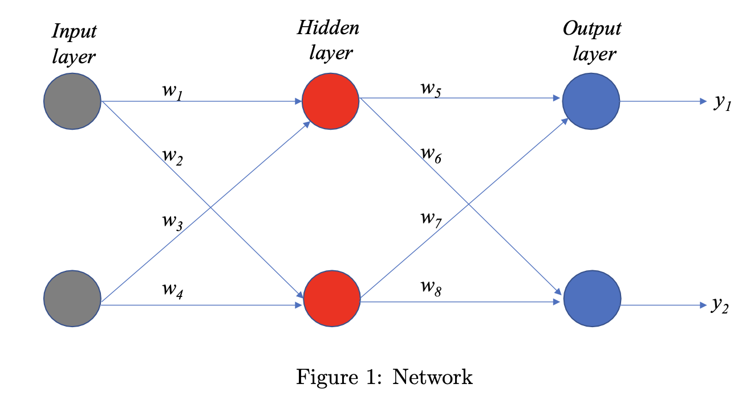

Below, you are given two different sets of weights. These two sets of weights represent two sets of trained weights of the model using two different optimization algorithms. You are also given a test data set in ‘testdata.txt’ with class labels in ‘test class.txt’. The test data is already scaled. Your task is to figure out which of the two sets of weights represents a better trained model based on the prediction accuracy on the test data. With the knowledge of the weights and activation functions, use Python code to compute the probabilities of classifying each point in the test data as class 0 or class 1. Based on the prediction accuracy on the test data, conclude which set of weights is a better trained model.

