GEOG 4057 – Guided Project 1

Step 1: Opening and exploring the json file

Step 2: Convert json to shapefile (full code provided in the GitHub repository as project_1.py)

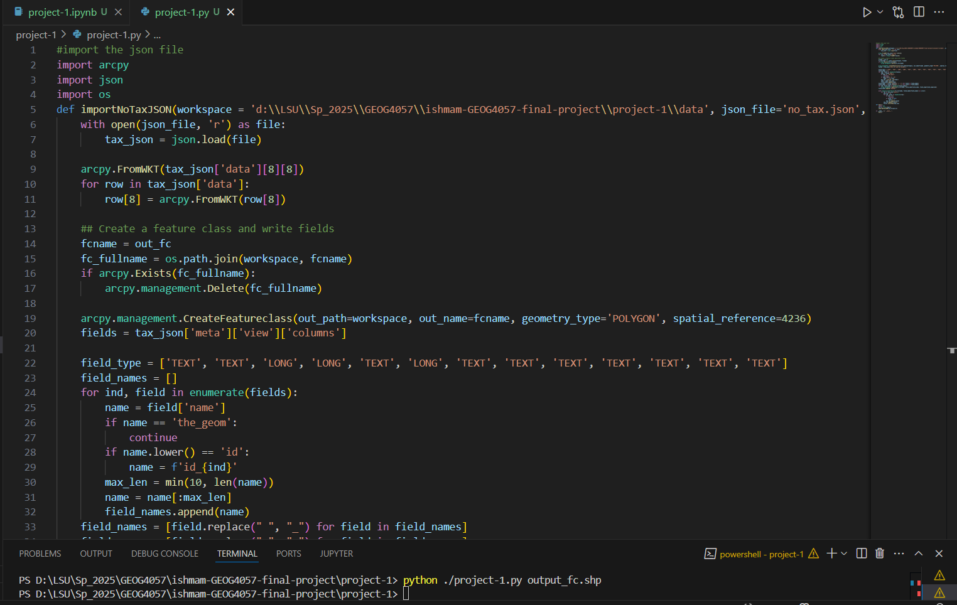

Step 3: Achieving the same task but by creating a python toolbox

Link to Github repository:

<https://github.com/ishmamshahid/ishmam-GEOG4057-final-project/tree/main/project-1>