ANALYSIS OF CHEMICAL COMPONENTS
IN COSMETICS
REPORT
Submitted in partial fulfilment of the requirements for
FOUR WEEKS INDUSTRIAL TRAINING (TR-102)
at
MED TOUR EASY
Training Period: 22 June 2026 to 21 July 2026
SUBMITTED BY
ISHMEET SINGH CHADHA BHAGATPREET SINGH DIWANSHU SINGLA
(URN: 2435550) (URN: 2435503) (URN: 2435519)


DEPARTMENT OF INFORMATION TECHNOLOGY
GURU NANAK DEV ENGINEERING COLLEGE
GILL PARK, GILL ROAD, LUDHIANA

CANDIDATES DECLARATION
We, Ishmeet Singh Chadha, Bhagatpreet Singh, DIwanshu SIngla, students of B.Tech. Information Technology at Guru Nanak Dev Engineering College, Ludhiana, hereby declare that we undertook four weeks of industrial training at MED TOUR EASY from 22 June 2026 to 21 July 2026 in partial fulfilment of the requirements of TR-102.
The project documented in this report, titled “Analysis of Chemical Components”, was undertaken as a group project with total three team members. This report is prepared for our academic submission and describes the project workflow together with everyone’s contributions. The final version must accurately represent the tasks performed by each group member and must not claim work that was not completed.
We further declare that the data analysis, results, figures, references and screenshots included in the final submitted copy will be checked against the supplied dataset, executed notebook, and actual Power BI report. Any external material used will be acknowledged in the references.
We understand that the report is subject to verification by the department and the training organisation.

Student Name: Ishmeet Singh Chadha, Bhagatpreet Singh, Diwanshu Singla
Signature: ______________________________
Date: ___________________________________
Place: Ludhiana

ABSTRACT
This report documents the four-week industrial training project “Analysis of Chemical Components” completed at MED TOUR EASY from 22 June 2026 to 21 July 2026. The project uses a supplied cosmetics catalogue dataset containing 1,472 product records and 11 fields. The available attributes include product category, brand, product name, listed price, rank, ingredient-list text, and five binary skin-type indicators. The analytical workflow is designed to convert the raw CSV file into a clean and reusable dataset, explore catalogue characteristics, process ingredient lists as text, and prepare data for business-intelligence reporting.
The Python workflow covers dataset loading, schema inspection, missing-value and duplicate checks, type conversion, category and brand summaries, price and rank distributions, skin-type flag counts, ingredient tokenisation, and ingredient-frequency analysis. A content-based comparison method is also included: ingredient lists are transformed into TF-IDF vectors and compared using cosine similarity. An optional t-SNE projection can be used to inspect local patterns in the high-dimensional feature space.
Power BI is used as the planned reporting layer. The prepared tables support KPI cards, category comparisons, price and rank analysis, skin-type coverage visuals, ingredient-frequency charts, and a product-level explorer. The project is descriptive and exploratory. The source data does not specify price currency, ingredient concentration, verified allergy information, or clinical outcomes. Consequently, ingredient frequency, skin-type flags, and text similarity must not be interpreted as medical advice or proof of product safety.

ACKNOWLEDGEMENT
We express our sincere gratitude to MED TOUR EASY for providing the opportunity to undertake the four-week Data Analytics Professional training and work on the project “Analysis of Chemical Components”. The training provided an opportunity to understand a practical data-analysis workflow, from examining a raw dataset to preparing analytical outputs and communicating findings through visual reporting.
We are thankful to the project mentor and the members of the project group for their guidance, discussions, and collaboration during the training. The work was undertaken as a group project, and the final report should acknowledge the contributions of all members in accordance with the work actually performed.
We also express our gratitude to the Principal, faculty members and Department of Information Technology of Guru Nanak Dev Engineering College, Ludhiana, for providing the academic framework and support required to complete the industrial training.
Finally, We acknowledge the developers and maintainers of Python, pandas, NumPy, scikit-learn, Matplotlib, Jupyter and Microsoft Power BI, whose tools support the analytical workflow described in this report.

TABLE OF CONTENTS
Section | Indicative page
Certificate by Company / Organisation | i
Candidate’s Declaration | ii
Abstract | iii
Acknowledgement | iv
About the Organisation | v
List of Figures | vi
List of Tables | vii
Definitions, Acronyms and Abbreviations | viii
Chapter 1 – Introduction | 1
Chapter 2 – Requirement Analysis and System Specification | 5
Chapter 3 – System Design | 10
Chapter 4 – Implementation, Testing and Maintenance | 15
Chapter 5 – Results and Discussions | 26
Chapter 6 – Conclusion and Future Scope | 32
References / Bibliography | 33
Appendices | 34

ABOUT THE ORGANISATION

MED TOUR EASY
MED TOUR EASY is identified as the organisation that provided the four-week training documented in this report. The supplied training certificate records the training period as 22 June 2026 to 21 July 2026 and identifies the project as “Analysis of Chemical Components”.
A detailed corporate profile, official address, website, service portfolio, founding history, and organisational structure were not present in the materials available for preparing this draft. These details should be inserted only after confirmation from the organisation or its official information channels.

Training context
The training was described as Data Analytics Professional training. The project provided an opportunity to work with a structured product catalogue containing textual ingredient information and numerical product attributes. The work combined data preparation, exploratory data analysis, text processing, similarity analysis, and business-intelligence reporting.

Project team
Member | Branch | URN
Ishmeet Singh Chadha | Information Technology | 2435550
Bhagatpreet Singh | Information Technology | 2435503
Diwanshu Singla | Information Technology | 2435519

LIST OF FIGURES AND TABLES

List of figures
Figure 3.1: Overall data analytics workflow
Figure 4.1: Product category distribution
Figure 4.2: Price and rank distributions
Figure 4.3: Skin-type flag coverage
Figure 4.4: Ingredient-frequency chart
Figure 5.1: Power BI dashboard overview
Figure 5.2: Filtered product explorer view

List of tables
Table 2.1: Functional requirements
Table 2.2: Non-functional requirements
Table 3.1: Dataset dictionary
Table 4.1: Data-quality checks
Table 5.1: Product counts by category
Table 5.2: Skin-type flag counts
Table 5.3: Frequently mentioned ingredient tokens

DEFINITIONS, ACRONYMS AND ABBREVIATIONS
Term | Definition
CSV | Comma-Separated Values file format
EDA | Exploratory Data Analysis
BI | Business Intelligence
TF-IDF | Term Frequency–Inverse Document Frequency
DTM | Document-Term Matrix
t-SNE | t-distributed Stochastic Neighbour Embedding
NLP | Natural Language Processing
KPI | Key Performance Indicator
ETL | Extract, Transform, Load
UI | User Interface
.pbix | Power BI Desktop report file
Cosine similarity | A vector similarity measure based on the cosine of the angle between two vectors

Price: The numerical product-price field supplied in the dataset. Its currency is not identified in the CSV and must not be assumed.
Rank: A numerical field supplied by the dataset. The precise definition and rating scale should be confirmed from the dataset provider before it is described as a customer rating.
Skin-type flag: A binary column indicating whether the dataset marks a product for a particular skin-type category. The flags are dataset labels, not individual medical assessments.

CHAPTER 1 – INTRODUCTION

1.1 Introduction
Cosmetic products are commonly described through a combination of structured product information and long ingredient lists. Product catalogues may contain hundreds or thousands of records, making manual comparison difficult. Data analytics can organise this information into consistent tables, summarise patterns, and support interactive exploration.
The project “Analysis of Chemical Components” focuses on the ingredient-list and catalogue information present in a supplied cosmetics dataset. The work does not perform laboratory chemical testing. Instead, it analyses the textual ingredient declarations provided in the dataset and compares them computationally.

1.2 Background and motivation
A product catalogue contains different kinds of information. Category and brand are categorical attributes; price and rank are numerical attributes; ingredients are free-form text; and skin-type columns are binary indicators. Each data type requires a suitable analytical treatment. Categorical fields can be grouped and counted, numerical fields can be summarised statistically, and ingredient text can be tokenised and converted into numerical features.
The motivation is to create a repeatable workflow that can be executed again when a revised catalogue is supplied. The workflow should also produce outputs that can be presented to a non-technical audience through a dashboard.

1.3 Project category
The project is classified as a data analytics and exploratory text-analysis project with a business-intelligence reporting component. It is not a laboratory experiment, medical evaluation, or regulatory assessment.

1.4 Objectives
- Understand the structure and fields of the supplied cosmetics dataset.
- Check data completeness, duplicates, data types, and basic consistency.
- Prepare a cleaned analytical dataset without losing the original source file.
- Analyse product counts by category and brand.
- Explore listed-price and rank distributions.
- Summarise the five skin-type indicator columns.
- Tokenise ingredient lists and calculate ingredient mention frequencies.
- Represent ingredient lists using TF-IDF features.
- Compare ingredient profiles using cosine similarity.
- Prepare Power BI-ready tables and an interactive dashboard.
- Document limitations and present findings responsibly.

1.5 Problem formulation
The core problem is to transform a raw cosmetics catalogue into a clean analytical resource and provide useful descriptive views of its contents. Ingredient lists are not directly suitable for numerical comparison. They must first be converted into tokens and feature vectors. The project therefore addresses both conventional tabular analysis and text-based feature engineering.

1.6 Identification of need
A repeatable process is useful because manual inspection does not scale well across a large catalogue. A structured data pipeline reduces repetitive work, provides consistent calculations, and makes the underlying assumptions visible. A dashboard further allows users to explore records using filters rather than manually searching the raw CSV.

1.7 Existing system
The basic existing approach is direct inspection of product rows and ingredient labels. This approach can help with individual products but makes it difficult to compare categories, brands, price distributions, ingredient frequencies, and many product records at once. It also makes repeat analysis difficult when the dataset changes.

1.8 Proposed system
The proposed system uses Python for data ingestion, cleaning, analysis, and text processing. It exports clean product and summary tables in CSV format. Power BI imports these tables and presents selected metrics and product records through interactive visuals.

1.9 Unique features
- Combines structured catalogue fields with unstructured ingredient-list text.
- Provides repeatable ingredient-token frequency calculations.
- Uses TF-IDF and cosine similarity for exploratory ingredient-profile comparison.
- Exports separate tables for dashboard development.
- Includes explicit limitations concerning currency, rank definitions, ingredient concentration, and clinical interpretation.

CHAPTER 2 – REQUIREMENT ANALYSIS AND SYSTEM SPECIFICATION

2.1 Requirement analysis
Requirement analysis identifies the inputs, processing operations, outputs, and quality expectations of the proposed analytical workflow. The main input is the company-provided CSV dataset. The primary outputs are a cleaned product table, analytical summaries, a Python notebook, and a Power BI report.

2.1.1 Input requirements
- The supplied cosmetics CSV file must be available in the notebook working directory.
- The input file must contain the expected product, brand, price, rank, ingredient, and skin-type fields.
- The source file should be retained unchanged so that processing can be reproduced.
- Any updated dataset must be checked for schema changes before analysis.

2.1.2 Functional requirements
ID | Requirement
FR-01 | Load the source CSV and display its dimensions and sample records.
FR-02 | Inspect column names, data types, unique values, and missing values.
FR-03 | Convert numerical fields to numeric types and validate indicator fields.
FR-04 | Calculate product counts by category and brand.
FR-05 | Calculate descriptive statistics for price and rank.
FR-06 | Calculate skin-type flag coverage.
FR-07 | Split ingredient lists into tokens and count token occurrences.
FR-08 | Create TF-IDF vectors and calculate cosine similarity.
FR-09 | Export Power BI-ready CSV tables.
FR-10 | Display dashboard visuals and allow product filtering.
Table 2.1: Functional requirements

2.1.3 Non-functional requirements
Quality | Requirement
Reproducibility | The same input and code should produce consistent tabular results.
Usability | Notebook sections and dashboard labels should be understandable.
Maintainability | Processing stages should be separated and documented.
Data integrity | Original source values should remain recoverable.
Performance | The analysis should run on a typical student laptop for this dataset size.
Interpretability | Visuals and metrics should include clear labels and units where known.
Responsible use | No medical or safety conclusion should be inferred from similarity alone.

Table 2.2: Non-functional requirements

2.2 Feasibility study
Technical feasibility: Python and its data-analysis libraries support CSV processing, descriptive statistics, text vectorisation, and visualisation. Power BI Desktop supports interactive dashboard construction from CSV files.
Economic feasibility: The project uses a dataset supplied for training and widely available software. Costs may depend on licensing and the method used to share a published Power BI report.
Operational feasibility: The notebook can be run locally or in a hosted Jupyter environment, while the exported tables can be imported into Power BI Desktop.

2.3 Validation
Validation checks include confirming the source dimensions, checking expected columns, inspecting missing values, reviewing data types, validating binary indicators, manually inspecting sample ingredient tokens, and reconciling dashboard totals with notebook outputs.

2.4 Expected hurdles
- Ingredient spelling variants and synonyms may be counted as separate tokens.
- Some ingredient lists may include punctuation or inconsistent spacing.
- The price currency is not stated in the source file.
- The meaning and scale of the Rank field are not documented in the CSV.
- The ingredient list does not provide concentration or formulation context.
- t-SNE is stochastic and its axes do not have direct business meaning.
- Power BI relationships and filters must be configured and tested carefully.

2.5 Development model
An iterative analytics lifecycle is suitable: understand the task, inspect data, prepare data, explore patterns, engineer text features, evaluate outputs, visualise, validate, and document. Each stage should produce inspectable outputs before the next stage is accepted.

CHAPTER 3 - SYSTEM DESIGN

3.1 Design approach
The system follows a modular, notebook-based data pipeline. Each logical stage is implemented in a separate notebook section. This structure supports debugging, review, and reuse.

3.2 Overall architecture
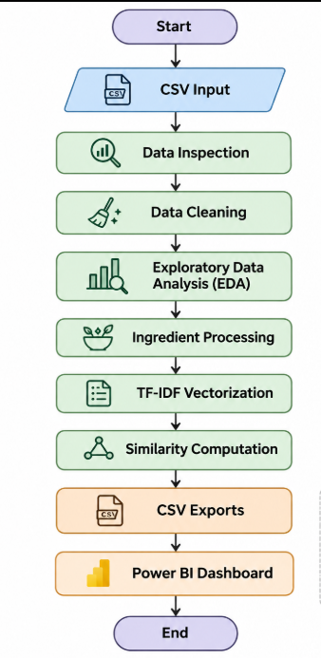
Figure 3.1 – Data Processing, Ingredient Similarity Analysis and Power BI Visualization Workflow

3.3 Dataset dictionary
Field | Description | Data type / interpretation
Label | Product category | Categorical text
Brand | Brand name | Categorical text
Name | Product name | Text
Price | Listed product price | Numeric; currency unspecified
Rank | Numerical rank field | Numeric; definition/scale to confirm
Ingredients | Comma-separated ingredient list | Text
Combination | Flag for combination skin | Binary indicator
Dry | Flag for dry skin | Binary indicator
Normal | Flag for normal skin | Binary indicator
Oily | Flag for oily skin | Binary indicator
Sensitive | Flag for sensitive skin | Binary indicator

Table 3.1: Dataset Directory

3.4 Data design
The original dataset is retained as a source input. A cleaned analytical table contains the original fields plus derived fields such as IngredientCount and PriceBand. Summary tables aggregate records by category, brand, and skin-type flag. A separate ingredient-frequency table contains normalised ingredient tokens and their mention counts.

3.5 Text feature design
Each ingredient string is split on commas. Tokens are trimmed and converted to lowercase. A token-frequency table counts the number of product ingredient lists in which a token appears. For similarity analysis, TF-IDF assigns weights to tokens based on their frequency within a product and their distribution across the catalogue.
Cosine similarity compares two product vectors. A higher score indicates more similar token-weight patterns under the selected preprocessing and vectorisation method. It does not establish product equivalence, performance, safety, or suitability.

3.6 Dashboard design
- KPI cards: product count, average listed price, average rank, and average ingredient count.
- Category bar chart: number of product records by category.
- Price chart: price distribution or average price by category.
- Rank chart: distribution of the Rank field.
- Skin-type chart: number of records flagged for each skin type.
- Ingredient chart: most frequently mentioned ingredient tokens.
- Product explorer: product, brand, category, price, rank, and ingredient count.
- Slicers: category, brand, and selected skin-type indicators.

3.7 User interface design
The dashboard should use a consistent grid, readable labels, restrained colours, and sufficient spacing. KPI cards should be placed near the top. Comparison charts should use common scales where appropriate. Product-level details should be displayed in a table with sorting and filtering. A visible note should state that the source does not identify price currency.

3.8 Methodology
- Load the source CSV file.
- Inspect the dimensions, fields, data types, and missing values.
- Clean text and convert numeric and binary fields.
- Generate descriptive summaries and exploratory charts.
- Tokenise ingredient lists and count ingredient mentions.
- Create TF-IDF ingredient vectors.
- Calculate cosine similarity for selected products.
- Export cleaned and aggregated CSV files.
- Import data into Power BI and create visuals.
- Validate dashboard values against notebook results.
- Document limitations, findings, and future scope.

CHAPTER 4 – IMPLEMENTATION, TESTING AND MAINTENANCE

4.1 Tools and technologies
Tool / technology | Use in the project
Python 3 | Main programming language for analysis.
Jupyter Notebook / Google Colab | Interactive execution and documentation.
pandas | CSV loading, cleaning, grouping, and export.
NumPy | Numerical operations.
Matplotlib | Exploratory charts.
scikit-learn | TF-IDF vectorisation, cosine similarity, and t-SNE.
Microsoft Power BI Desktop | Interactive dashboard and report authoring.
CSV | Interchange format for source and exported tables.

4.2 Data ingestion
The dataset is loaded using pandas read_csv. The first inspection checks the shape, first records, column names, data types, missing-value counts, and unique values. This establishes whether the supplied data matches the expected schema.

4.3 Data cleaning
Text columns are converted to strings and trimmed. Price and Rank are converted to numeric values with invalid entries represented as missing values. Skin-type fields are converted to numeric indicators and missing flags are filled with zero for the analytical copy. The source file itself is not overwritten.
A derived IngredientCount field records the number of comma-separated tokens in each product ingredient list. A PriceBand field can be used for grouped price analysis. Since currency is not specified, the price field should be labelled simply as listed price.

4.4 Exploratory data analysis
The exploratory analysis examines category counts, brand counts, price distribution, rank distribution, and ingredient-list length. Grouped summaries help identify which categories have more records and how price and rank values vary between categories. These are catalogue-level descriptions, not sales or demand measures.
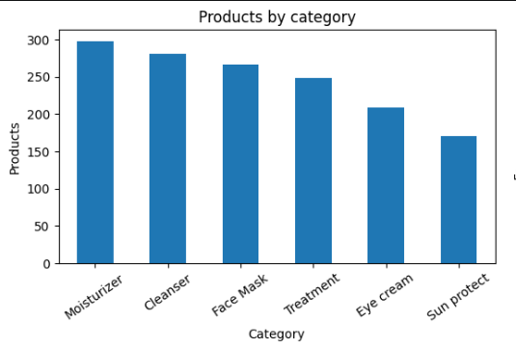
Figure 4.1: Product Category Distribution
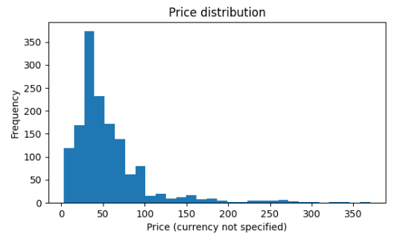
Figure 4.2: Price and rank Distributions
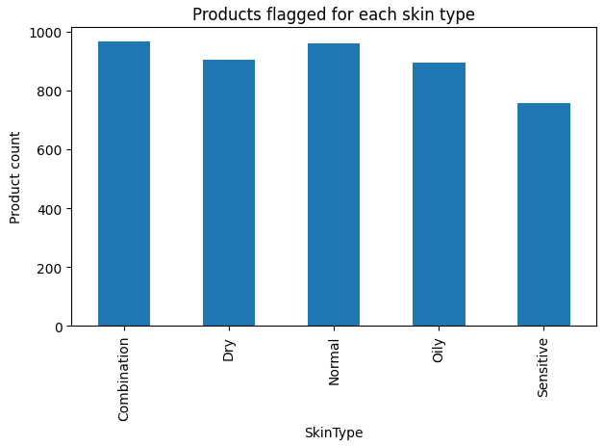
Figure 4.3: Skin-type flag coverage

4.5 Ingredient tokenisation
Each ingredient list is split on commas. Tokens are stripped of surrounding spaces and normalised to lowercase. A frequency counter aggregates mentions across all product lists. Token counts can be used to create a ranked table and bar chart.
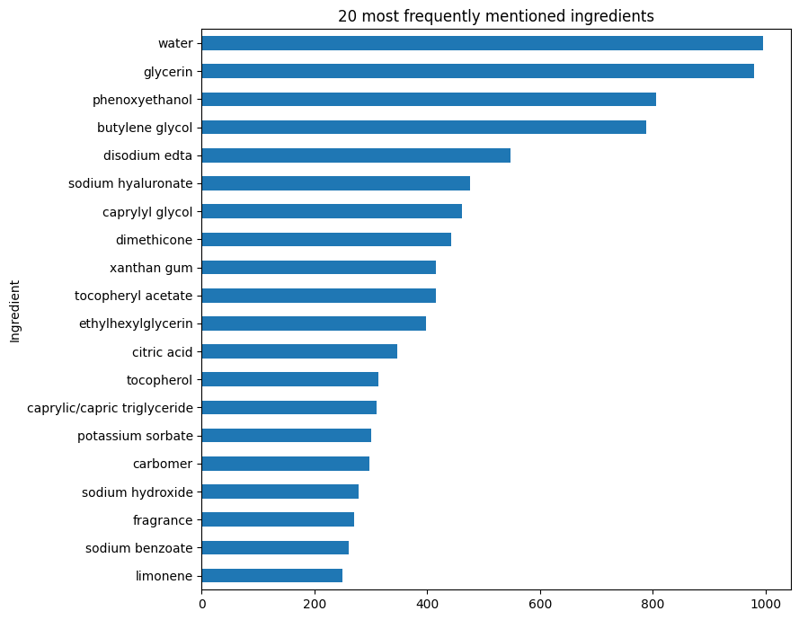
Figure 4.4: Ingredient-Frequency Chart
4.6 TF-IDF and cosine similarity
TF-IDF converts the tokenised ingredient lists into numerical vectors. Terms that occur in many documents receive less distinguishing weight than terms that are more specific to a subset of products. Cosine similarity compares vectors and returns a score between zero and one for non-negative TF-IDF vectors.
The similarity function should exclude the selected product from its own results. Results should be checked for duplicate product names and interpreted as text similarity only.

4.7 t-SNE visualisation
t-SNE can project high-dimensional TF-IDF vectors into two dimensions for exploratory visualisation. A fixed random seed improves reproducibility. The plotted axes are embedding coordinates and should not be interpreted as meaningful physical or business units. A sample may be used to keep execution time manageable.
4.8 Power BI implementation
The cleaned product CSV is imported into Power BI Desktop. Supporting summary tables may be imported as separate tables. Data types are checked in Power Query before applying changes. Measures are created for product count, average listed price, average rank, average ingredient count, and distinct brand count.
The final report should be saved as a native .pbix file. A local HTML dashboard can be used as a supplementary prototype but does not replace the required Power BI Desktop file.

4.9 Testing and validation
Test ID | Test case | Expected result
T-01 | Load the source CSV. | Dataset dimensions and columns display correctly.
T-02 | Inspect missing values. | Missing-value counts are reported.
T-03 | Convert price and rank. | Numeric columns are usable for summaries.
T-04 | Validate skin flags. | Flags contain expected binary values after cleaning.
T-05 | Tokenise sample ingredient list. | Tokens are separated and trimmed.
T-06 | Find similar products. | Selected product is excluded from its own matches.
T-07 | Export summary CSV files. | Files are created and can be reopened.
T-08 | Compare Power BI KPI values. | Values agree with notebook calculations.
T-09 | Test dashboard slicers. | Relevant visuals respond to filter selections.

Table 4.1: Data-quality Checks

4.10 Maintenance
The source CSV should be stored separately from generated outputs. The notebook and package dependencies should be versioned. If a new dataset is received, the schema and data types should be revalidated before rerunning the analysis. Power BI should be refreshed after regenerated CSV files are supplied. Final report screenshots should be captured from the actual current version of the dashboard.

CHAPTER 5 – RESULTS AND DISCUSSIONS

5.1 Dataset overview
The supplied CSV contains 1,472 records and 11 columns. The dataset includes 6 product categories and 116 distinct brand names. The fields include product metadata, a listed-price value, a numerical Rank field, ingredient-list text, and five skin-type indicators.
The mean listed price is 55.58 and the median listed price is 42.50. The mean Rank value is 4.15. The currency and the exact interpretation of Rank are not defined in the supplied CSV; therefore these values are reported without assigning a currency symbol or assuming a rating scale.

5.2 Data quality observations
Check | Observed result
Rows | 1,472
Columns | 11
Duplicate full rows | 0
Missing values in Label | 0
Missing values in Brand | 0
Missing values in Name | 0
Missing values in Price | 0
Missing values in Rank | 0
Missing values in Ingredients | 0
The checks above describe the source file as loaded. Any cleaning transformation should be documented separately and should not be confused with the original source values.

5.3 Product category distribution
Category | Product records | Average listed price | Average Rank
Cleanser | 281 | 32.60 | 4.31
Eye cream | 209 | 63.60 | 3.81
Face Mask | 266 | 42.62 | 4.17
Moisturizer | 298 | 69.09 | 4.24
Sun protect | 170 | 45.91 | 4.05
Treatment | 248 | 79.18 | 4.22
Table 5.1: Product counts by category
The category with the largest number of records is Moisturizer, with 298 products. This indicates catalogue representation in the supplied file; it does not indicate market share or sales volume.

5.4 Brand coverage
The dataset contains 116 distinct brand names. Brand-level counts can be used to identify brands with comparatively more records in the supplied catalogue. A high record count should not be interpreted as a measure of popularity or commercial performance.

5.5 Price and Rank analysis
The Price and Rank fields are numeric and can be analysed using distributions, means, medians, and category-level comparisons. Before publishing dashboard labels, confirm whether Rank represents a customer rating, a ranking position, or another metric. Until confirmed, retain the source field name “Rank”.

5.6 Skin-type flag analysis
Skin type field | Records with flag = 1
Combination | 966
Dry | 904
Normal | 960
Oily | 894
Sensitive | 756
Table 5.2: Skin-type flag counts
These counts represent the number of products marked with each flag in the supplied data. A product may be marked for more than one skin type, so the totals should not be added as if the categories were mutually exclusive. The flags are not an individual suitability assessment.

5.7 Ingredient frequency
Ingredient token (normalised) | Product-list mentions
water | 995
glycerin | 980
phenoxyethanol | 806
butylene glycol | 788
disodium edta | 547
sodium hyaluronate | 476
caprylyl glycol | 461
dimethicone | 442
xanthan gum | 416
tocopheryl acetate | 415
Table 5.3: Frequently mentioned ingredient tokens
Ingredient frequency is based on comma-separated text tokens. It does not measure the concentration of an ingredient in a formulation, its function, effectiveness, or safety. Spelling variants and synonyms may be counted separately.

5.8 Similarity analysis
TF-IDF and cosine similarity provide an exploratory method for comparing ingredient-list text. A product can be compared with other records and the highest-scoring matches can be returned. The results depend on tokenisation, minimum document frequency, and the vocabulary represented in the dataset. Similarity does not mean that two formulations are identical.

5.9 Power BI dashboard
The final Power BI report should contain the KPI cards and comparison visuals described in Chapter 3. Insert a genuine screenshot of the completed Power BI Desktop report here. A second screenshot should show a filtered view demonstrating that category, brand, or skin-type slicers work.
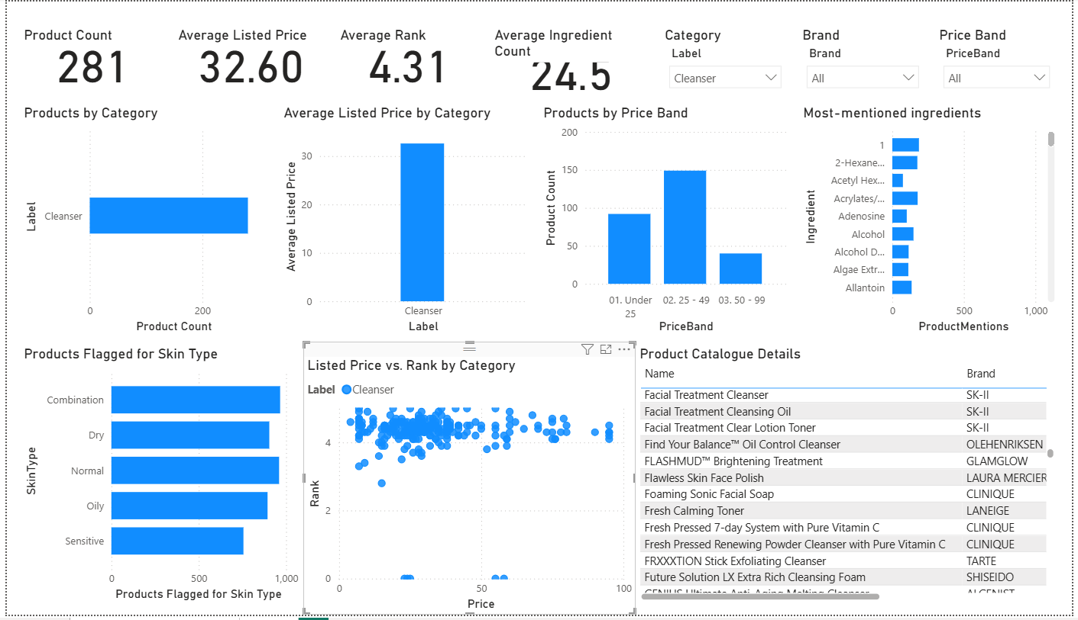
FIGURE 5.1 – FINAL POWER BI DASHBOARD
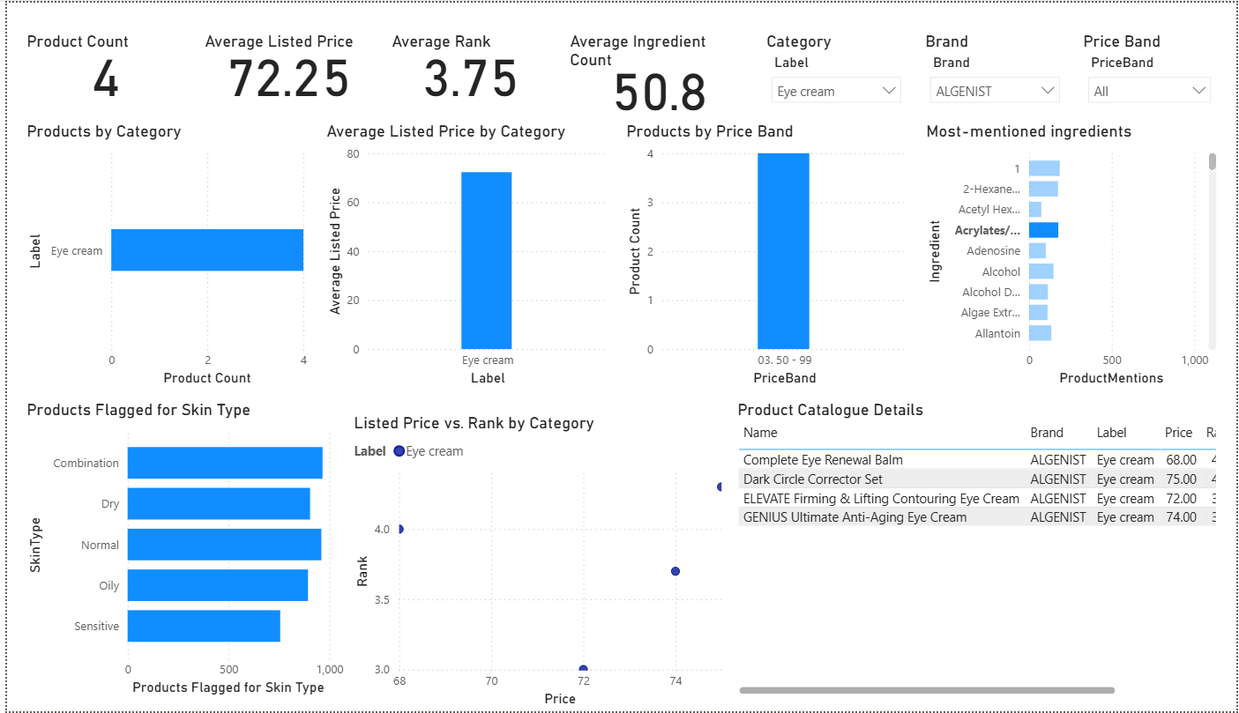
FIGURE 5.2 – FILTERED DASHBOARD / PRODUCT EXPLORER

5.10 Discussion
The dataset supports catalogue-level descriptive analysis and text-based comparison. The combination of tabular summaries and ingredient-text processing creates a more complete view than a simple count of product categories. However, the scope is constrained by the fields available. Additional verified data would be needed to make claims about sales, consumer preferences, ingredient concentration, product safety, or clinical suitability.
5.11 Limitations of the study
- The source file does not state the currency for Price.
- The Rank field is not defined in the supplied CSV documentation.
- Ingredient concentrations and formulation order are not analysed.
- The dataset does not provide clinical outcomes or verified allergy data.
- Skin-type flags are accepted as supplied and have not been independently validated.
- Ingredient synonyms, spelling variants, and naming conventions may affect token counts.
- Cosine similarity measures text-vector similarity, not product efficacy or safety.
- The dashboard reflects only the records and fields present in the supplied dataset.

5.12 Ethical and responsible interpretation
The report should avoid medical or dermatological advice. It should not recommend a product for an individual based solely on a skin-type flag or similarity score. Users with allergies or skin conditions should rely on qualified professionals and verified product information. The project should also avoid presenting dataset frequency as proof that an ingredient is beneficial or harmful.

5.13 Evidence required for final submission
- Notebook output showing dataset dimensions and schema.
- Notebook output showing missing-value and duplicate checks.
- Category and price/rank charts generated by the executed notebook.
- Ingredient-frequency output and chart.
- A sample similarity result generated by the notebook.
- Final Power BI .pbix file and genuine screenshots.
- Daily diary entries verified against actual training work and dates.

CHAPTER 6 - CONCLUSION AND FUTURE SCOPE

6.1 Conclusion
The project demonstrates a practical data-analytics workflow for a cosmetics product catalogue. The source dataset is inspected and prepared using Python, descriptive summaries are generated for product attributes, ingredient strings are tokenised, and text features are represented using TF-IDF. Cosine similarity provides an exploratory method for comparing product ingredient lists. Exported CSV tables can be used to build an interactive Power BI dashboard.
The project also highlights the importance of responsible interpretation. Price currency and Rank semantics are not specified in the source CSV. Ingredient-list frequency and similarity do not provide evidence of ingredient concentration, product efficacy, allergy risk, or clinical suitability. These limitations should remain visible in the report and dashboard.

6.2 Future scope
- Obtain documented data provenance and field definitions from the dataset provider.
- Confirm price currency and the exact meaning and scale of Rank.
- Normalise ingredient synonyms and spelling variants using a verified ingredient dictionary.
- Add product formulation metadata and concentration information if available and reliable.
- Automate dataset refresh and dashboard refresh procedures.
- Evaluate dashboard usability with intended users.
- Consider more advanced text-analysis methods only where they answer a clearly defined question.

6.3 Learning outcomes
The project provides experience in data inspection, data cleaning, descriptive statistics, text preprocessing, feature extraction, similarity measures, data visualisation, Power BI reporting, and technical documentation. It also demonstrates the importance of validation, reproducibility, and communicating limitations.

REFERENCES / BIBLIOGRAPHY
[1] pandas development team, “pandas documentation,” Available: https://pandas.pydata.org/docs/ (accessed 2 Nov. 2026).
[2] scikit-learn developers, “scikit-learn documentation,” Available: https://scikit-learn.org/stable/ (accessed 2 Nov. 2026).
[3] Matplotlib development team, “Matplotlib documentation,” Available: https://matplotlib.org/stable/ (accessed 2 Nov. 2026).
[4] Project Jupyter, “Jupyter documentation,” Available: https://docs.jupyter.org/ (accessed 2 Nov. 2026).
[5] Microsoft, “Power BI documentation,” Available: https://learn.microsoft.com/power-bi/ (accessed 2 Nov. 2026).
[6] MED TOUR EASY, “Cosmetics product dataset supplied for the training project,” CSV file, provided during the four-week training, 2026.
[7] Guru Nanak Dev Engineering College, “B.Tech Training Report Guidelines and GNDEC Citation Reference,” department-provided training report format.
Note: Confirm the original dataset source/provenance with MED TOUR EASY. If the dataset was sourced from a public website or third-party provider, cite that original source rather than treating the training organisation as the creator.

APPENDIX A – NOTEBOOK STRUCTURE

A.1 Notebook sections
- Import libraries and configure file paths.
- Load the CSV and inspect sample records.
- Review data types, missing values, and unique values.
- Clean text and numeric fields.
- Create derived fields such as ingredient count and price band.
- Generate category, brand, price, and rank summaries.
- Analyse skin-type indicator coverage.
- Tokenise ingredient lists and calculate frequencies.
- Create TF-IDF feature vectors.
- Calculate cosine similarity for selected products.
- Optionally run t-SNE for exploratory visualisation.
- Export Power BI-ready CSV tables.

A.2 Reproducibility checklist
- Place the CSV in the notebook working directory or update DATA_PATH.
- Install pandas, NumPy, Matplotlib, and scikit-learn if not already installed.
- Run notebook cells in order from top to bottom.
- Review all outputs and warnings.
- Confirm that the export directory contains the expected CSV files.
- Save the executed notebook with outputs for evidence.

APPENDIX B – POWER BI IMPLEMENTATION

B.1 Import files
- Products_Clean.csv – primary product-level table.
- Category_Summary.csv – category-level summary.
- Brand_Summary.csv – brand-level summary.
- SkinType_Summary.csv – skin-type coverage summary.
- Ingredient_Frequency.csv – ingredient mention counts.

B.2 Suggested DAX measures
Product Count = COUNTROWS(Products_Clean)
Average Listed Price = AVERAGE(Products_Clean[Price])
Median Listed Price = MEDIAN(Products_Clean[Price])
Average Rank = AVERAGE(Products_Clean[Rank])
Average Ingredient Count = AVERAGE(Products_Clean[IngredientCount])
Brand Count = DISTINCTCOUNT(Products_Clean[Brand])

B.3 Suggested visuals
Visual | Fields
Card | Product Count
Card | Average Listed Price
Card | Average Rank
Clustered bar | Label and product count
Column chart | Label and average Price
Bar chart | SkinType and SuitableProductCount
Bar chart | Ingredient and ProductMentions
Table | Name, Brand, Label, Price, Rank, IngredientCount
Slicers | Label, Brand, skin-type field
Add a visible note that the source price currency is unspecified and that skin-type flags and ingredient similarity are not medical advice.

APPENDIX C – DAILY TRAINING DIARY
The separate HTML daily diary contains 24 proposed entries across four weeks. The training certificate confirms the overall period as 22 June 2026 to 21 July 2026. The exact workdays and daily activities must be verified against the actual training calendar and mentor records before signing.
Week | Focus
Week 1 | Orientation, project briefing, dataset understanding, data quality, cleaning, exploratory analysis.
Week 2 | Skin-type flag analysis, ingredient tokenisation, frequency analysis, TF-IDF, cosine similarity.
Week 3 | Dimensionality reduction concepts, t-SNE, Power BI planning, data exports, dashboard development.
Week 4 | Notebook integration, testing, interpretation, report preparation, diary, and final review.

