CLASH ROYALE
DATA ANALYTICS PROJECT REPORT
Data Cleaning • SQL Analysis • Power BI Dashboard

Prepared from the supplied dataset, Python script, SQL queries and Power BI file

Executive Summary
This project analyses a Clash Royale card dataset to understand the composition and characteristics of cards, including rarity, card type, elixir cost, usage, hitpoints, mobility, targets, attack type and evolution status. The supplied workflow uses Python for data preparation, MySQL for structured queries and a Power BI dashboard for visual reporting.
The cleaned dataset contains 120 card records and 11 columns. It includes 3 card types and 5 rarity categories. The average recorded elixir cost is 3.96, average usage is 5.32, and average hitpoints is 1064. These are descriptive values from the supplied dataset, not live game statistics.

1. Introduction
Clash Royale is a strategy game in which cards differ in cost, durability, role and combat behaviour. Analysing card attributes can help users explore how the card collection is distributed and compare usage with attributes such as elixir cost and hitpoints.

2. Problem Statement
The project aims to convert raw card data into a structured and analysis-ready dataset, then use database queries and a dashboard to answer questions about card distribution, usage patterns, durability and evolution status.

3. Objectives
- Inspect and clean the supplied Clash Royale card dataset.
- Remove duplicate records and handle missing values.
- Standardise column names and remove image URL fields not needed for analysis.
- Store and query card information using MySQL.
- Calculate summary KPIs and compare card groups.
- Present analytical results through the supplied Power BI dashboard.

4. Tools and Technologies
Tool | Role in the project
Python (Pandas) | Data loading, duplicate removal, type conversion, missing-value treatment and export of the cleaned CSV.
MySQL | Database creation and analytical queries, including counts, averages, rankings and group comparisons.
Power BI | Dashboard/reporting layer; a .pbix file was supplied with the project.
CSV | Input raw data and output cleaned data.

5. Dataset Description
The cleaned file contains 120 rows and 11 columns. Each row represents a card. The fields describe card identity, evolution level, elixir cost, rarity, type, mobility, targets, attack type, group-card flag, usage and hitpoints.
Field | Description
name | Card name.
maxevolutionlevel | Evolution-level indicator used to classify Evolution and Non-Evolution cards.
elixircost | Elixir cost of a card.
rarity | Card rarity category.
type | Card type such as troop, spell or building.
mobility | Mobility classification.
targets | Target category.
attack_type | Attack classification, such as single or splash.
groupcard | Boolean-style indicator for group cards.
usage | Usage measure supplied in the dataset.
hitpoints | Hitpoints value supplied in the dataset.

6. Data Cleaning Using Python
The supplied Python script uses Pandas to read the raw CSV and prepare the data. The operations documented in the script are:
- Remove duplicate rows using drop_duplicates().
- Convert maxEvolutionLevel, elixirCost, usage and hitpoints to numeric values, coercing invalid values to missing.
- Fill missing maxEvolutionLevel and hitpoints values with 0.
- Fill missing usage values with the median usage.
- Fill missing categorical values in rarity, type, mobility, targets and attack_type with 'Unknown'.
- Remove iconUrls and evolutionIcons because image URL fields are not required for the analytical table.
- Convert column names to lowercase and strip surrounding whitespace.
- Export the result as clash_royal_cleaned.csv.
Data-quality note: the cleaned file still contains one missing elixircost value. The supplied cleaning script does not fill missing elixircost values. This should be reviewed before calculations that require a complete elixir-cost field.

7. MySQL Analysis
The supplied SQL script creates and selects the clash_royale_db database and includes queries for card totals, average hitpoints, average elixir cost, average usage, evolution-card counts, cards by rarity and type, top 15 cards by usage, hitpoints by rarity, elixir cost versus hitpoints, usage versus hitpoints, evolution comparisons, top tank cards, usage-to-elixir efficiency, and usage by mobility, targets and attack type.
The SQL file refers to a table named clash_royale and uses card_usage in several queries, whereas the cleaned CSV field is named usage. The database table definition/import mapping was not included in the supplied SQL excerpt. Confirm that the table and column names are mapped consistently before executing the queries.

8. Key Findings from the Cleaned Dataset
Metric | Result
Total card records | 120
Average elixir cost | 3.96 (one value missing)
Average usage | 5.32
Average hitpoints | 1064
Evolution cards | 38
Non-evolution cards | 82

8.1 Card distribution
Troops form the largest card type group, with spells and buildings making up the remaining records. Epic is the most frequent rarity category in this dataset.
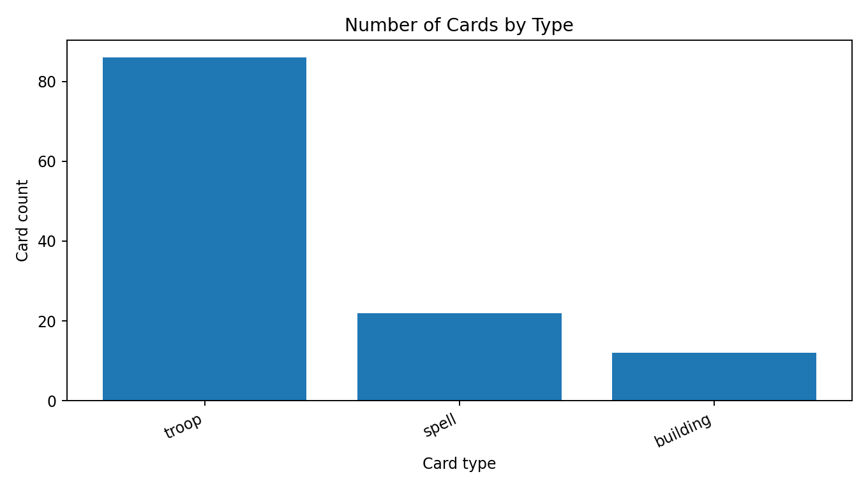
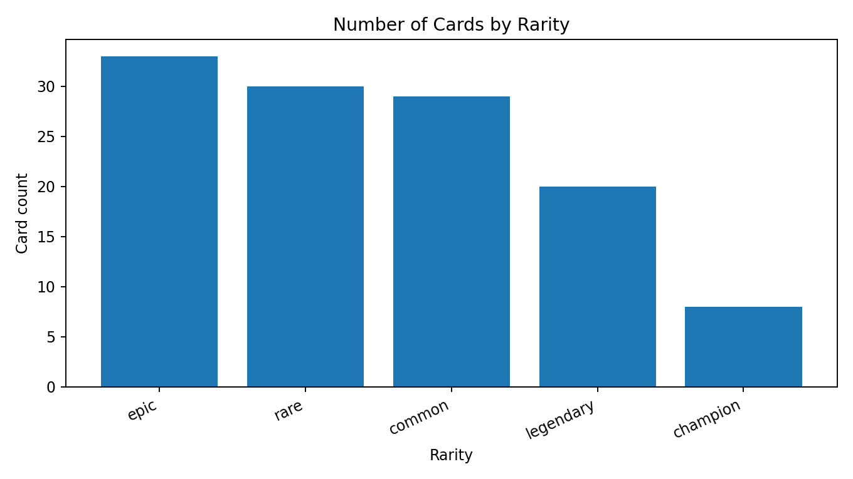

8.2 Most-used cards
The Log has the highest usage value in the supplied data, followed by Arrows and Goblin Gang. Usage values are reproduced as stored in the dataset.
Rank | Card | Usage
1 | The Log | 42.88
2 | Arrows | 30.64
3 | Goblin Gang | 26.16
4 | Ice Spirit | 20.64
5 | Hog Rider | 19.44
6 | Fireball | 18.64
7 | Skeletons | 14.56
8 | Tornado | 13.52
9 | Guards | 11.84
10 | Zap | 11.36

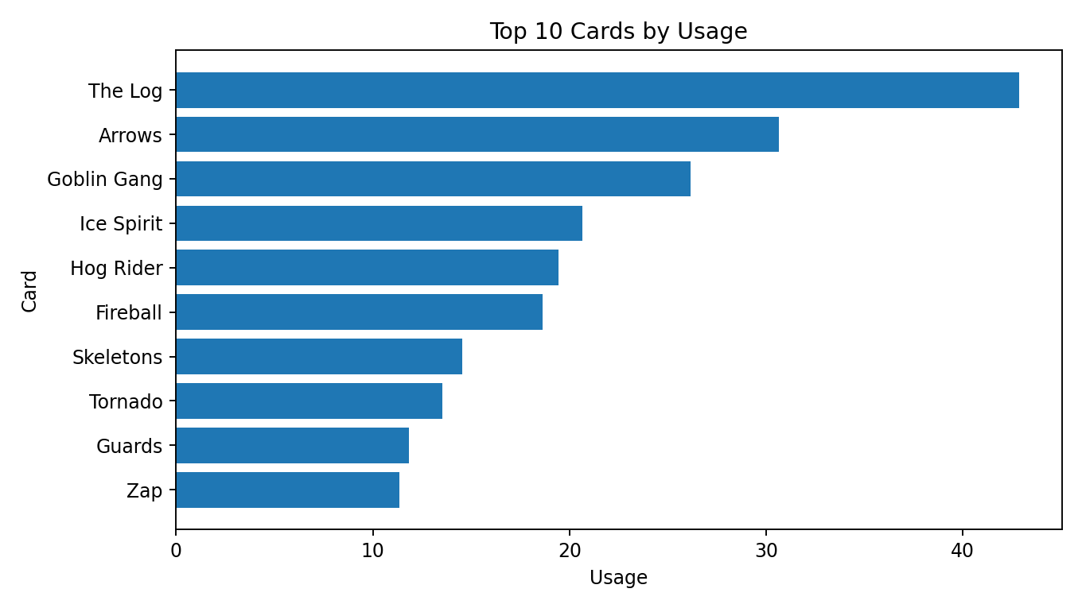

8.3 Evolution comparison
The dataset contains 38 Evolution cards and 82 Non-Evolution cards. Average usage is 5.21 for Evolution cards and 5.37 for Non-Evolution cards. In this dataset, the averages are close; this comparison alone does not establish that evolution status causes usage differences.
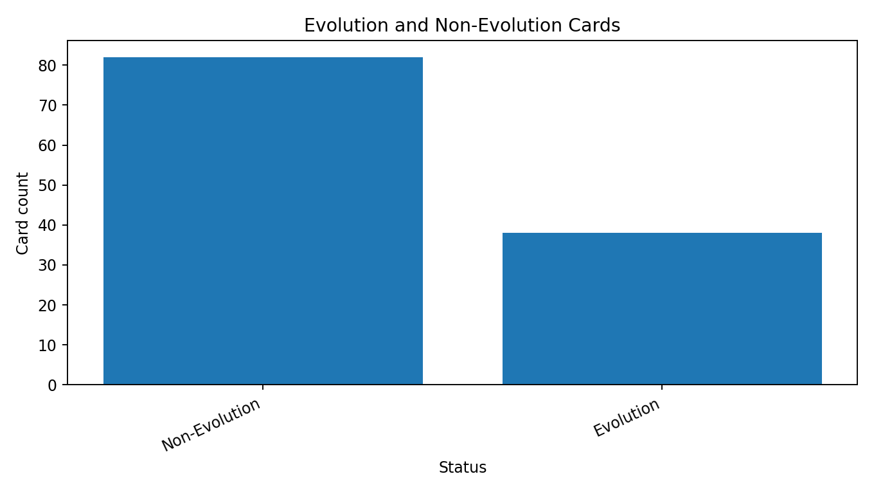

8.4 Hitpoints and durability
Golem has the highest hitpoints value in the dataset, followed by Giant and Mega Knight. Cards with zero hitpoints are present, including spells; therefore, zero should not automatically be interpreted as a missing value.
Rank | Card | Hitpoints
1 | Golem | 5120
2 | Giant | 4090
3 | Mega Knight | 3993
4 | Electro Giant | 3855
5 | P.E.K.K.A | 3760
6 | Giant Skeleton | 3617
7 | Lava Hound | 3581
8 | Goblin Giant | 3233
9 | Royal Giant | 3164
10 | Boss Bandit | 2803

8.5 Usage per elixir
A simple efficiency measure in the SQL script is usage divided by elixir cost, restricted to records where elixir cost is greater than zero. This is a descriptive ratio for comparison, not a game-performance score.
Card | Usage | Elixir cost | Usage / elixir
The Log | 42.88 | 2 | 21.44
Ice Spirit | 20.64 | 1 | 20.64
Skeletons | 14.56 | 1 | 14.56
Arrows | 30.64 | 3 | 10.21
Goblin Gang | 26.16 | 3 | 8.72

9. Power BI Dashboard
A Power BI .pbix dashboard file was included in the supplied project materials. The SQL analysis indicates the intended dashboard topics: KPI summaries, card distribution by rarity and type, top-used cards, hitpoints comparisons, elixir-cost comparisons, evolution status and usage breakdowns by card attributes. The report does not claim specific dashboard page layouts or slicers because those details were not independently extracted from the PBIX file.

10. Recommendations
- Resolve the missing elixir-cost value or explicitly exclude it from elixir-based calculations.
- Confirm that the MySQL table uses the expected column names, particularly usage versus card_usage.
- Add clear labels and units to all Power BI visuals so users understand the meaning of usage and hitpoints.
- Use filters for rarity, card type and evolution status to make comparisons easier.
- Refresh the analysis when a newer dataset is available, and record the dataset date or source.

11. Limitations
- The analysis is limited to the supplied 120-row dataset and its recorded attributes.
- The dataset's collection date, source methodology and definition/units of usage are not specified in the supplied files.
- One elixir-cost value is missing in the cleaned CSV.
- The SQL file does not include the table creation/import schema, so the database mapping cannot be fully verified.
- The PBIX file was supplied, but its exact visual layout and interactive behaviour were not independently documented here.

12. Conclusion
The project demonstrates an end-to-end data analytics workflow using Python, MySQL and Power BI. Python prepares the raw card data, SQL provides structured analysis, and Power BI is used as the reporting layer. The dataset shows that troops are the largest card category, Epic is the most common rarity, The Log has the highest recorded usage, and Golem has the highest hitpoints. Addressing the missing elixir-cost value and confirming the SQL column mapping would improve the reliability and reproducibility of the project.

Appendix: Supplied Project Files
File | Purpose
clash_royal.csv | Raw dataset.
clash_royal.py | Python data-cleaning script.
clash_royal_cleaned.csv | Cleaned dataset produced by the workflow.
clash_royal_db.sql | MySQL database and analysis queries.
clash_royale_dashboard - Copy.pbix | Power BI dashboard file.

Prepared from the project files supplied in this conversation. No external game statistics or live data were added.

