Bank Management System

About Project: This project is based on banking system which is made by combined use of Database and Python.
Prerequisites: Python 2.7 should be installed in the system.

Documentation: Firstly, there are two splash screens.

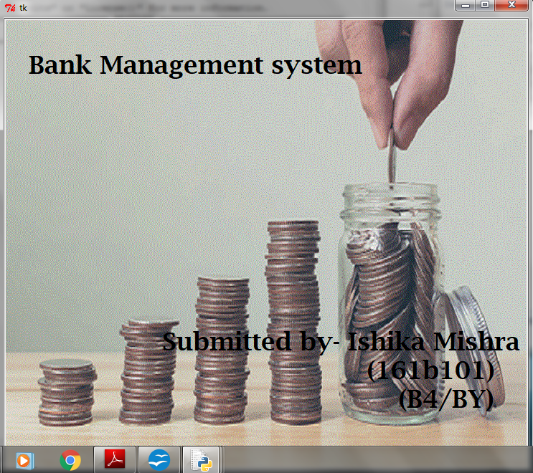
Screen 1

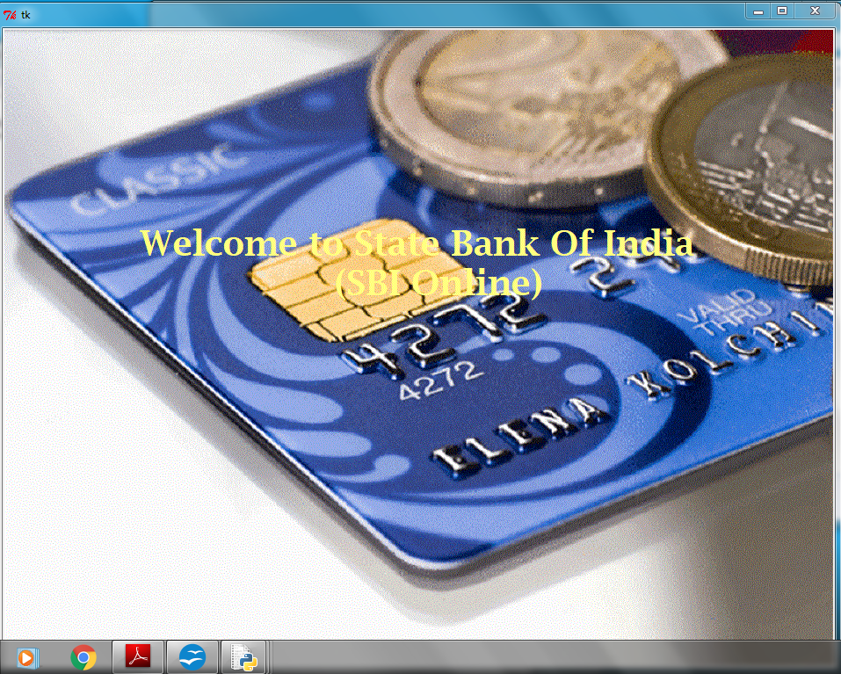
Screen 2

After this the main project window will be opened which consists of 6 buttons as shown in fig 1.

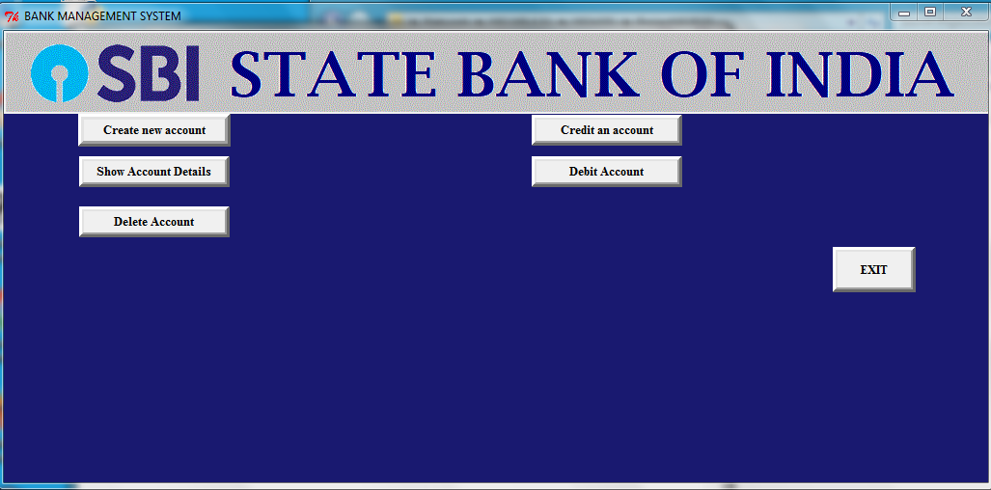
fig 1

The First button is “Create an Account” which is used to add a new account of a new customer. After pressing this we will be directed to a new window named “Add new account” as shown in fig 2 below:
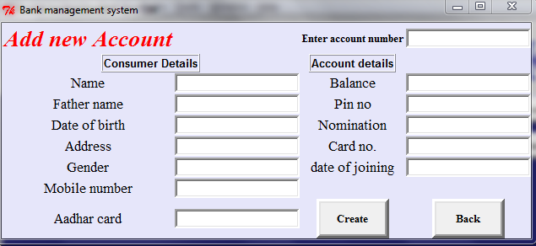
fig 2
This window as (shown in fig 2) consists of 13 entries ,2 buttons.
Name – format Varchar ,size 20
Father name-format Varchar ,size 30
Date of birth -format date
Address- format Varchar , size 60
Gender- format Varchar , size 20
Mobile number- format number
Aadhar Card -format varchar,size 40
Enter account number-format number
Balance- format number
pin no-format number
Nomination- format varchar ,size 30
Card no.-format number
Date-format date

After filling all entries when we press the 'create' button a function 'create' will be called and in that another function 'insert' is called which take the values of entries given by user in database and following confirmation window will be opened.

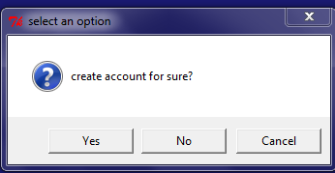
Fig 3
After pressing yes...

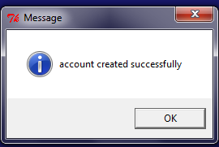
fig 4
and if we want to go back to the main window we will press the back button.

Next Button : Credit an account
On the main window when we will press 'Credit an account' button a function credit will be called and a new window will be opened as shown below:

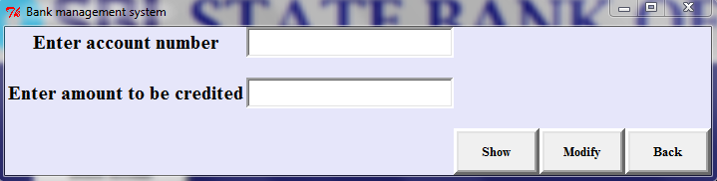

in this two entries are given when we fill these entries and press modify under credit function a new function modify will be called and the balance corresponding to the account number will be changed.
When we press show button a new function show will be called under credit function which will show all the details corresponding to particular account number. As shown in fig.

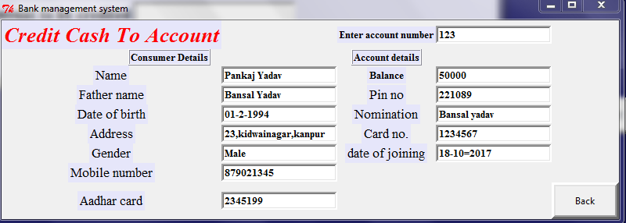
fig 6

if we want to go back to the previous window we will press back button.

Debit account button: After pressing this button a function debit will be called and we will directed to new window as shown below:

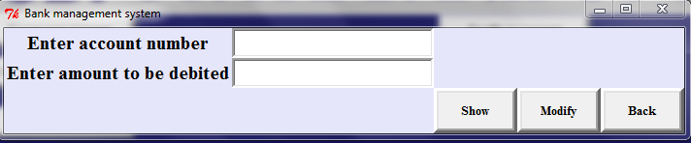
Here we will enter the account number and the amount to be debited n press modify button a new function modify under debit function will be called and it will modify the values .to show the values we will press show button a new function show under debit function is called and it will show the entire information.

Button Show account details
after pressing show account details a new function acc_details is called and new window is opened consisting of 1 entry account number and 1 button show when we press show button a new function shows under function acc_details is called which will show the account details corresponding to a particular account number.

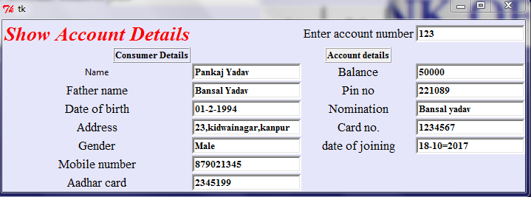

Delete Button:
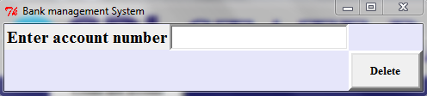
When we will press the delete button a new function delete is called and a new window will be opened which consists of 1 entry of account number and a delete button.After pressing delete button a new function dele is called under delete function and the particular account details corresponding to that account number will be deleted.

