Supporting Online Material: Misinformation Spread as a Graph Process
This document contains numbered supplementary tables and figures supporting the revised manuscript. Main-text values are rounded for readability; tables below report consistent additional precision, dispersion, confidence intervals, and multiplicity-adjusted tests.

Supplementary Table S1. Abbreviations
Abbreviation | Meaning
ANOVA | Analysis of variance
AUC | Area under the active-spreader curve
BA | Barabási-Albert
CI | Confidence interval
ER | Erdős-Rényi
GG | Greenhouse-Geisser
SBM | Stochastic block model
SIR | Susceptible-infected-recovered
WS | Watts-Strogatz
η² | Proportion of total variance associated with an effect
partial η² | Proportion of effect-plus-error variance associated with a repeated-measures effect
Cohen's dz | Mean paired difference divided by its standard deviation

Supplementary Table S2. Extended Literature Matrix
Study | Data/network | Process | Intervention/metric | Analysis | Headline finding | Connection
Vosoughi et al.¹ | Twitter cascades | Empirical true/false diffusion | Cascade depth, breadth, speed | Descriptive and comparative cascade analysis | Falsehood diffused farther, faster, deeper, and more broadly | Motivates threshold timing and reach.
Pastor-Satorras and Vespignani¹² | Synthetic complex networks | Epidemic diffusion | Targeted immunization | Analytical and simulation comparison | Connectivity targeting outperformed uniform immunization in heterogeneous networks | Foundational structural-immunization comparison.
Morone and Makse¹⁹ | Complex networks | Optimal percolation | Collective influence | Percolation analysis and simulations | Collective influence identified small dismantling sets | Motivates fragmentation mechanism.
Porter and Wood²⁸ | Four-country experiments | Behavioral correction | Professional fact checks | Simultaneous randomized experiments | Fact checks improved factual accuracy across settings | Shows behaviorally realistic correction differs from immunity.
Zhu et al.²⁰ | Directed social networks with groups | Misinformation minimization | Group disbanding | Optimization and algorithm evaluation | Group-aware intervention reduced spread under echo-chamber effects | Recent community-sensitive minimization.
Dou et al.³⁷ | FakeNewsNet propagation graphs | Graph neural detection | User preference-aware classification | Benchmark experiments | Joint user-preference and graph modeling improved detection | Recent GNN detection relevant to upstream identification.
Ni et al. (2024)²¹ | Social networks | Competitive concern minimization | Correct-information agents | Optimization and simulation | Selected correct-information agents reduced concern about misinformation | Extends objectives beyond infection counts.
Sakiyama et al.²² | Social networks | Competing information diffusion | Efficient truth-seed selection | Heuristic-vs-greedy runtime and spread comparison | Heuristic achieved comparable correction spread at lower cost | Recent scalable corrective-cascade intervention.
Govindankutty and Gopalan³¹ | Simulated populations | Multi-compartment epidemic misinformation model | Infection/recovery rate scenarios | Mathematical analysis and simulation | Multi-compartment model in which the infection-type rate exceeds the recovery-type rate | Contextualizes parameter magnitude without implying platform calibration.
DeVerna et al.²⁹ | Preregistered online experiment | LLM fact checking | AI and human fact checks | Randomized experiment | LLM fact checks did not improve average discernment and could cause harm | Motivates caution about automated fact checking.
Chang et al.³⁸ | News and social-context graphs | Graph neural detection | Global attention and memory | Benchmark classification experiments | Graph-attention architecture improved fake-news detection | Recent graph-based detection method.
Malik et al.³⁹ | User-engagement graphs and text | Graph neural detection | GNN ensemble | Benchmark classification experiments | Combining graph and text features improved classification | Illustrates multimodal detection pipelines.
Ghoshal et al.²³ | Empirical and synthetic networks | Misinformation minimization | Topology-based target search | Algorithmic and simulation comparison | Community/topology information reduced intervention search space | Recent topology-aware intervention study.
Allen et al.⁷ | U.S. media-use data | Information-ecosystem prevalence | Share of overall media consumption | Cross-source exposure accounting | News was a small share of U.S. participants' total media consumption | Places news within the U.S. media ecosystem.
Allen et al.⁸ | Facebook vaccine-related content | Exposure × persuasion impact | Flagged misinformation and unflagged vaccine-skeptical content | Exposure-impact decomposition | Unflagged vaccine-skeptical content had substantially greater estimated aggregate impact | Distinguishes content impact from user-level concentration of exposure.
Butts et al.³² | Compartmental networked model | Disinformation epidemic dynamics | Content moderation, education, counter-campaigns | Mathematical modeling and policy optimization | Compared mitigation policies for reducing disinformation | Contextualizes mitigation-policy alternatives to structural immunization.
Jones et al.³³ | Social networks; coordination game | Fake-news sharing as a coordination game | Distributed sanctioning by designated agents | Game-theoretic model and simulation | Network structure let spreaders form echo chambers, more than doubling resistance to sanctioning | Shows network structure conditions intervention effectiveness.
Stein et al.³⁴ | Experimental human networks | Empirical true/false message propagation | Ideological integration vs. segregation | Randomized network experiment | False information circulated more in ideologically segregated networks | Motivates modularity and segregation sensitivity.
Ni et al. (2023)³⁵ | Multi-social networks | Misinformation influence minimization | Entity protection | Two-stage discrete gradient-descent optimization | Protecting entities across networks reduced misinformation influence | Recent cross-network influence-minimization method.
Prike et al.³⁶ | Online behavioral experiment | Behavioral truth discernment | Source-credibility labels and social-norm cues | Randomized experiment | Credibility information and social norms improved discernment and reduced misinformation engagement | Behaviorally realistic intervention distinct from structural immunity.
Present study | Matched ER, WS, and BA graphs | SIR-like structural diffusion | Eight protection rules | Matched simulation, RM ANOVA, CIs, sensitivity, mechanisms | Topology robustly affected speed; strategy ranking was conditional | Separates topology, exposure, mechanism, heterogeneity, and cost.

Supplementary Table S3. Detailed Outcome Definitions
Outcome | Definition | Direction for stronger intervention | Caution
Time to 10% | First step at which cumulative ever-infected count reaches 10% of N. | Higher, or threshold not reached. | Undefined for censored runs.
Time to 50% | First step at which cumulative ever-infected count reaches 50% of N. | Higher, or threshold not reached. | Report with reached-50 probability.
Peak active spreaders | Maximum simultaneously infected count. | Lower. | Not the same as final reach.
Final outbreak size | Fraction of all nodes ever infected. | Lower. | Compressed near saturation.
Active-spreader AUC | Sum of active infected count over time. | Lower. | Burden measure, not exposure.
Unique directly exposed | Fraction receiving at least one infected-susceptible contact attempt. | Lower. | Does not count off-network impressions.
Exposure attempts | All infected-susceptible contacts while target remains susceptible. | Lower. | Includes repeated attempts.
Reached 50% | Fraction of runs crossing the 50% cumulative threshold. | Lower. | Binary threshold outcome.

Supplementary Table S4. Complete Experimental Record Counts
Analysis family | Graph realizations or settings | Records
Primary baseline | 100 per topology × 3 topologies | 300
Primary interventions | 100 × 3 topologies × 8 strategies × 3 coverage levels | 7,200
Diffusion and seed-count sensitivity | 20 per topology across β-γ and seed-count settings | 780
Near-threshold intervention sensitivity | 20 × 3 topologies × 8 strategies × 4 β values | 1,920
Behavioral heterogeneity | 20 × 3 topologies × 8 strategies × 4 behavior modes | 1,920
Seed placement | 20 × 3 topologies × 4 seed modes | 240
Structural sensitivity | Network-size, density, WS, BA, and SBM families | 540
Structural × strategy sensitivity (WS rewiring, SBM mixing, network size) | 20 × (3 WS + 4 SBM + 2×3 N values) × 8 strategies × up to 2 β values, 5% coverage | 3,200
Seed-count × strategy sensitivity | 20 × 3 topologies × 3 seed counts × 8 strategies × 2 β values, 5% coverage | 2,880
Seed-count baseline, near-threshold extension | 20 × 3 topologies × 3 seed counts × 2 β values | 360
Scalability benchmark | 2 topologies × 3 sizes × 2 repeats × 7 rankings | 84

Supplementary Table S5. Baseline Descriptive and Inferential Results
Outcome | BA mean (SD); 95% CI | ER mean (SD); 95% CI | WS mean (SD); 95% CI | F | Holm p | η²
t10 | 4.600 (0.921); 95% CI [4.417, 4.783] | 5.880 (0.671); 95% CI [5.747, 6.013] | 8.160 (1.012); 95% CI [7.959, 8.361] | 419.90 | <0.001 | 0.739
t50 | 7.510 (0.959); 95% CI [7.320, 7.700] | 9.830 (0.779); 95% CI [9.675, 9.985] | 16.030 (1.403); 95% CI [15.752, 16.308] | 1665.40 | <0.001 | 0.918
peak_infected | 736.860 (17.326); 95% CI [733.422, 740.298] | 730.100 (17.713); 95% CI [726.585, 733.615] | 639.250 (21.141); 95% CI [635.055, 643.445] | 840.18 | <0.001 | 0.850
final_size | 0.995 (0.002); 95% CI [0.994, 0.995] | 0.991 (0.003); 95% CI [0.990, 0.991] | 1.000 (0.001); 95% CI [1.000, 1.000] | 333.19 | <0.001 | 0.692
active_spreader_auc | 19927.290 (625.357); 95% CI [19803.206, 20051.374] | 19784.860 (655.273); 95% CI [19654.840, 19914.880] | 20039.240 (673.934); 95% CI [19905.517, 20172.963] | 3.83 | 0.069 | 0.025
unique_exposed_fraction | 0.995 (0.000); 95% CI [0.995, 0.995] | 0.993 (0.002); 95% CI [0.992, 0.993] | 0.995 (0.000); 95% CI [0.995, 0.995] | 235.36 | <0.001 | 0.613
attempted_exposures | 7413.550 (183.137); 95% CI [7377.212, 7449.888] | 7431.090 (177.529); 95% CI [7395.864, 7466.316] | 7478.760 (182.965); 95% CI [7442.456, 7515.064] | 3.47 | 0.069 | 0.023

Supplementary Table S6. Baseline Assumption and Robustness Diagnostics
Outcome | Levene p | Shapiro-Wilk p by topology | Robust tests (Welch ANOVA; Kruskal–Wallis)
t10 | 0.0107 | BA: 3.08e-09, ER: 1.76e-10, WS: 3.46e-06 | Welch F = 343.15, p = 5.23e-64; Kruskal–Wallis H = 226.80, p = 5.63e-50
t50 | 9.7e-05 | BA: 4.89e-09, ER: 8.9e-10, WS: 9.13e-05 | Welch F = 1258.59, p = 4.75e-110; Kruskal–Wallis H = 258.31, p = 8.09e-57
peak_infected | 0.03 | BA: 0.828, ER: 0.436, WS: 0.226 | Welch F = 741.86, p = 2.47e-92; Kruskal–Wallis H = 202.17, p = 1.26e-44
final_size | 3.22e-21 | BA: 0.0516, ER: 0.00452, WS: 2.84e-19 | Welch F = 462.25, p = 3.79e-66; Kruskal–Wallis H = 227.71, p = 3.58e-50
active_spreader_auc | 0.598 | BA: 0.549, ER: 0.717, WS: 0.341 | Welch F = 3.68, p = 0.027; Kruskal–Wallis H = 7.93, p = 0.019
unique_exposed_fraction | 1.37e-36 | BA: 1, ER: 1.11e-05, WS: 3.37e-22 | Welch ANOVA undefined (zero within-group variance); Kruskal–Wallis H = 257.01, p = 1.55e-56
attempted_exposures | 0.92 | BA: 0.77, ER: 0.928, WS: 0.402 | Welch F = 3.40, p = 0.0354; Kruskal–Wallis H = 6.76, p = 0.034

Supplementary Table S7. Five-Percent Intervention Means, SDs, and 95% CIs
Topology | Strategy | Final size | Active AUC | Unique exposed | Exposure attempts | Peak
BA | random | 0.942 (0.003); [0.942, 0.943] | 18873.7 (659.1); [18742.9, 19004.5] | 0.945 (0.000); [0.945, 0.945] | 6966.7 (207.2); [6925.5, 7007.8] | 686.6 (15.0); [683.6, 689.5]
BA | degree | 0.886 (0.010); [0.884, 0.888] | 17714.3 (696.9); [17576.0, 17852.6] | 0.924 (0.005); [0.923, 0.925] | 6158.9 (173.0); [6124.6, 6193.2] | 529.2 (21.4); [525.0, 533.5]
BA | betweenness | 0.895 (0.010); [0.893, 0.897] | 17912.7 (712.2); [17771.4, 18054.0] | 0.929 (0.005); [0.928, 0.930] | 6256.4 (202.6); [6216.2, 6296.6] | 547.6 (20.3); [543.5, 551.6]
BA | pagerank | 0.887 (0.010); [0.885, 0.890] | 17692.0 (625.2); [17568.0, 17816.1] | 0.925 (0.005); [0.924, 0.926] | 6154.3 (166.0); [6121.3, 6187.2] | 531.7 (19.3); [527.8, 535.5]
BA | eigenvector | 0.904 (0.009); [0.903, 0.906] | 18076.4 (757.4); [17926.1, 18226.6] | 0.933 (0.004); [0.932, 0.933] | 6311.7 (175.4); [6276.9, 6346.5] | 567.4 (22.4); [563.0, 571.9]
BA | kcore | 0.887 (0.010); [0.885, 0.890] | 17756.7 (651.6); [17627.4, 17885.9] | 0.925 (0.005); [0.924, 0.926] | 6149.1 (165.2); [6116.3, 6181.9] | 529.2 (23.8); [524.5, 534.0]
BA | collective_influence | 0.891 (0.010); [0.889, 0.893] | 17710.8 (598.6); [17592.0, 17829.5] | 0.926 (0.005); [0.925, 0.927] | 6171.4 (176.0); [6136.5, 6206.4] | 536.5 (22.2); [532.1, 540.9]
BA | community_bridge | 0.889 (0.011); [0.887, 0.891] | 17763.7 (597.2); [17645.2, 17882.2] | 0.926 (0.005); [0.925, 0.927] | 6190.0 (172.8); [6155.7, 6224.3] | 530.9 (23.8); [526.2, 535.6]
ER | random | 0.938 (0.003); [0.938, 0.939] | 18856.2 (627.9); [18731.6, 18980.8] | 0.942 (0.002); [0.941, 0.942] | 6951.2 (163.2); [6918.8, 6983.6] | 678.8 (16.6); [675.5, 682.0]
ER | degree | 0.935 (0.004); [0.934, 0.936] | 18652.7 (601.6); [18533.3, 18772.1] | 0.941 (0.002); [0.940, 0.941] | 6801.8 (182.6); [6765.5, 6838.0] | 654.1 (17.3); [650.7, 657.5]
ER | betweenness | 0.934 (0.005); [0.933, 0.935] | 18614.4 (639.1); [18487.6, 18741.2] | 0.939 (0.002); [0.939, 0.940] | 6823.5 (197.4); [6784.4, 6862.7] | 656.5 (15.2); [653.4, 659.5]
ER | pagerank | 0.933 (0.005); [0.932, 0.934] | 18685.6 (656.9); [18555.3, 18816.0] | 0.939 (0.003); [0.939, 0.940] | 6796.3 (206.8); [6755.2, 6837.3] | 652.0 (16.1); [648.8, 655.2]
ER | eigenvector | 0.937 (0.004); [0.936, 0.937] | 18681.1 (551.8); [18571.6, 18790.6] | 0.942 (0.002); [0.941, 0.942] | 6829.4 (177.3); [6794.3, 6864.6] | 664.5 (16.8); [661.1, 667.8]
ER | kcore | 0.935 (0.004); [0.934, 0.935] | 18617.4 (653.5); [18487.7, 18747.1] | 0.941 (0.002); [0.940, 0.941] | 6788.1 (197.0); [6749.0, 6827.2] | 653.3 (19.1); [649.5, 657.1]
ER | collective_influence | 0.936 (0.004); [0.935, 0.937] | 18752.3 (590.5); [18635.2, 18869.5] | 0.941 (0.002); [0.941, 0.942] | 6830.2 (177.1); [6795.0, 6865.3] | 658.7 (16.4); [655.5, 662.0]
ER | community_bridge | 0.935 (0.004); [0.935, 0.936] | 18848.5 (564.9); [18736.4, 18960.6] | 0.941 (0.002); [0.941, 0.942] | 6838.9 (197.3); [6799.7, 6878.0] | 658.5 (15.6); [655.4, 661.6]
WS | random | 0.949 (0.001); [0.949, 0.949] | 19024.7 (594.2); [18906.7, 19142.6] | 0.945 (0.000); [0.945, 0.945] | 6991.4 (172.9); [6957.0, 7025.7] | 585.6 (21.8); [581.3, 589.9]
WS | degree | 0.947 (0.005); [0.946, 0.948] | 18940.3 (561.0); [18829.0, 19051.6] | 0.944 (0.004); [0.943, 0.944] | 6972.1 (194.6); [6933.5, 7010.7] | 539.6 (23.2); [535.0, 544.2]
WS | betweenness | 0.948 (0.003); [0.948, 0.949] | 18954.5 (637.9); [18828.0, 19081.1] | 0.945 (0.001); [0.944, 0.945] | 7009.0 (198.1); [6969.7, 7048.3] | 547.7 (28.6); [542.0, 553.3]
WS | pagerank | 0.948 (0.002); [0.948, 0.949] | 19017.2 (602.6); [18897.6, 19136.7] | 0.945 (0.001); [0.945, 0.945] | 6974.9 (199.7); [6935.3, 7014.5] | 545.8 (25.5); [540.8, 550.9]
WS | eigenvector | 0.948 (0.003); [0.947, 0.948] | 18966.1 (564.1); [18854.2, 19078.1] | 0.944 (0.002); [0.944, 0.944] | 7044.1 (193.7); [7005.7, 7082.5] | 582.8 (23.2); [578.1, 587.4]
WS | kcore | 0.946 (0.005); [0.945, 0.947] | 18949.0 (523.3); [18845.1, 19052.8] | 0.943 (0.004); [0.943, 0.944] | 6971.1 (211.9); [6929.1, 7013.2] | 541.4 (27.4); [535.9, 546.8]
WS | collective_influence | 0.949 (0.002); [0.948, 0.949] | 18971.0 (598.3); [18852.3, 19089.7] | 0.945 (0.001); [0.945, 0.945] | 7004.1 (160.8); [6972.2, 7036.0] | 539.0 (26.1); [533.8, 544.2]
WS | community_bridge | 0.949 (0.002); [0.948, 0.949] | 19005.9 (604.6); [18885.9, 19125.8] | 0.945 (0.001); [0.945, 0.945] | 6997.4 (203.1); [6957.1, 7037.8] | 544.7 (25.5); [539.6, 549.7]

Supplementary Table S8. Repeated-Measures ANOVA at five-percent Coverage
Topology | Outcome | F | Unadjusted df | GG ε | GG p | Holm-adjusted GG p | Partial η²
BA | active_spreader_auc | 36.27 | 7,693 | 0.928 | <0.001 | <0.001 | 0.268
BA | final_size | 541.25 | 7,693 | 0.926 | <0.001 | <0.001 | 0.845
BA | unique_exposed_fraction | 502.87 | 7,693 | 0.796 | <0.001 | <0.001 | 0.836
BA | attempted_exposures | 249.87 | 7,693 | 0.915 | <0.001 | <0.001 | 0.716
BA | peak_infected | 743.24 | 7,693 | 0.915 | <0.001 | <0.001 | 0.882
ER | active_spreader_auc | 2.56 | 7,693 | 0.923 | 0.016 | 0.047 | 0.025
ER | final_size | 21.49 | 7,693 | 0.910 | <0.001 | <0.001 | 0.178
ER | unique_exposed_fraction | 63.08 | 7,693 | 0.599 | <0.001 | <0.001 | 0.389
ER | attempted_exposures | 7.82 | 7,693 | 0.926 | <0.001 | <0.001 | 0.073
ER | peak_infected | 30.90 | 7,693 | 0.911 | <0.001 | <0.001 | 0.238
WS | active_spreader_auc | 0.31 | 7,693 | 0.935 | 0.942 | 0.942 | 0.003
WS | final_size | 11.81 | 7,693 | 0.567 | <0.001 | <0.001 | 0.107
WS | unique_exposed_fraction | 10.35 | 7,693 | 0.415 | <0.001 | <0.001 | 0.095
WS | attempted_exposures | 1.66 | 7,693 | 0.929 | 0.122 | 0.245 | 0.016
WS | peak_infected | 64.52 | 7,693 | 0.924 | <0.001 | <0.001 | 0.395

Supplementary Table S9. Ten-Percent Intervention Means, SDs, and 95% CIs
Topology | Strategy | Final size | Active AUC | Unique exposed | Exposure attempts | Peak
BA | random | 0.888 (0.004); [0.887, 0.889] | 17694.8 (645.6); [17566.7, 17822.8] | 0.895 (0.001); [0.894, 0.895] | 6502.0 (174.0); [6467.5, 6536.5] | 636.9 (16.6); [633.6, 640.2]
BA | degree | 0.757 (0.020); [0.753, 0.761] | 15056.9 (746.3); [14908.8, 15205.0] | 0.818 (0.013); [0.815, 0.820] | 5113.4 (190.7); [5075.5, 5151.2] | 371.6 (27.1); [366.2, 377.0]
BA | betweenness | 0.787 (0.016); [0.783, 0.790] | 15793.2 (655.3); [15663.2, 15923.2] | 0.841 (0.011); [0.839, 0.843] | 5359.2 (182.3); [5323.1, 5395.4] | 419.7 (25.6); [414.6, 424.8]
BA | pagerank | 0.752 (0.020); [0.748, 0.756] | 15014.0 (789.0); [14857.4, 15170.6] | 0.816 (0.014); [0.813, 0.819] | 5078.8 (187.9); [5041.5, 5116.1] | 363.1 (29.6); [357.2, 368.9]
BA | eigenvector | 0.824 (0.015); [0.821, 0.827] | 16496.7 (653.3); [16367.1, 16626.4] | 0.865 (0.008); [0.864, 0.867] | 5686.3 (197.3); [5647.1, 5725.4] | 481.2 (24.2); [476.4, 486.0]
BA | kcore | 0.754 (0.020); [0.750, 0.758] | 15033.0 (766.3); [14880.9, 15185.0] | 0.817 (0.013); [0.814, 0.819] | 5111.5 (179.8); [5075.8, 5147.2] | 367.0 (30.0); [361.0, 372.9]
BA | collective_influence | 0.764 (0.019); [0.760, 0.768] | 15268.6 (679.3); [15133.8, 15403.4] | 0.824 (0.013); [0.821, 0.826] | 5194.1 (200.8); [5154.2, 5233.9] | 386.8 (23.8); [382.1, 391.5]
BA | community_bridge | 0.763 (0.018); [0.759, 0.767] | 15435.7 (700.0); [15296.8, 15574.6] | 0.823 (0.012); [0.821, 0.825] | 5154.9 (170.1); [5121.1, 5188.6] | 379.1 (30.0); [373.2, 385.1]
ER | random | 0.886 (0.004); [0.885, 0.887] | 17698.4 (566.0); [17586.0, 17810.7] | 0.891 (0.002); [0.890, 0.891] | 6490.2 (173.8); [6455.8, 6524.7] | 629.9 (13.7); [627.1, 632.6]
ER | degree | 0.877 (0.005); [0.876, 0.878] | 17460.8 (591.1); [17343.5, 17578.1] | 0.887 (0.003); [0.887, 0.888] | 6286.3 (172.5); [6252.1, 6320.5] | 579.6 (19.6); [575.7, 583.5]
ER | betweenness | 0.877 (0.005); [0.875, 0.878] | 17454.3 (537.7); [17347.6, 17561.0] | 0.886 (0.003); [0.885, 0.886] | 6318.8 (185.7); [6282.0, 6355.7] | 592.3 (16.0); [589.2, 595.5]
ER | pagerank | 0.874 (0.006); [0.873, 0.875] | 17570.4 (666.1); [17438.2, 17702.6] | 0.885 (0.003); [0.884, 0.885] | 6234.8 (174.0); [6200.3, 6269.3] | 578.8 (17.9); [575.2, 582.3]
ER | eigenvector | 0.882 (0.005); [0.881, 0.882] | 17598.2 (618.7); [17475.5, 17721.0] | 0.889 (0.002); [0.889, 0.890] | 6325.8 (188.4); [6288.4, 6363.2] | 598.1 (15.4); [595.1, 601.2]
ER | kcore | 0.877 (0.005); [0.876, 0.878] | 17569.3 (601.0); [17450.0, 17688.5] | 0.887 (0.003); [0.887, 0.888] | 6279.6 (203.8); [6239.2, 6320.1] | 582.9 (19.0); [579.1, 586.7]
ER | collective_influence | 0.880 (0.005); [0.879, 0.880] | 17564.5 (520.4); [17461.3, 17667.8] | 0.889 (0.002); [0.888, 0.889] | 6308.2 (165.9); [6275.3, 6341.1] | 587.7 (17.4); [584.3, 591.2]
ER | community_bridge | 0.879 (0.005); [0.878, 0.880] | 17605.8 (467.3); [17513.1, 17698.5] | 0.889 (0.003); [0.888, 0.889] | 6289.5 (179.1); [6254.0, 6325.1] | 588.0 (16.7); [584.7, 591.3]
WS | random | 0.898 (0.002); [0.898, 0.899] | 18030.2 (640.1); [17903.2, 18157.2] | 0.895 (0.001); [0.895, 0.895] | 6619.4 (169.6); [6585.7, 6653.0] | 530.1 (24.4); [525.3, 535.0]
WS | degree | 0.885 (0.011); [0.883, 0.887] | 17673.4 (649.5); [17544.6, 17802.3] | 0.887 (0.009); [0.885, 0.888] | 6433.1 (191.0); [6395.2, 6471.0] | 445.3 (28.7); [439.6, 451.0]
WS | betweenness | 0.895 (0.005); [0.894, 0.896] | 17961.2 (673.5); [17827.5, 18094.8] | 0.893 (0.003); [0.893, 0.894] | 6522.3 (187.2); [6485.1, 6559.4] | 473.2 (27.9); [467.7, 478.7]
WS | pagerank | 0.894 (0.005); [0.893, 0.895] | 17867.5 (581.6); [17752.1, 17982.9] | 0.893 (0.002); [0.893, 0.894] | 6504.2 (188.2); [6466.9, 6541.5] | 443.9 (29.8); [438.0, 449.8]
WS | eigenvector | 0.896 (0.004); [0.895, 0.897] | 17969.4 (599.9); [17850.4, 18088.4] | 0.893 (0.003); [0.892, 0.893] | 6599.2 (169.2); [6565.6, 6632.8] | 528.3 (22.0); [524.0, 532.7]
WS | kcore | 0.883 (0.012); [0.880, 0.885] | 17644.8 (628.8); [17520.0, 17769.5] | 0.885 (0.010); [0.883, 0.887] | 6429.5 (193.7); [6391.1, 6468.0] | 445.8 (28.7); [440.1, 451.5]
WS | collective_influence | 0.895 (0.005); [0.894, 0.896] | 17814.5 (542.8); [17706.8, 17922.2] | 0.893 (0.003); [0.893, 0.894] | 6517.4 (148.4); [6488.0, 6546.9] | 443.6 (28.2); [438.1, 449.2]
WS | community_bridge | 0.893 (0.007); [0.891, 0.894] | 17878.1 (571.7); [17764.6, 17991.5] | 0.892 (0.005); [0.891, 0.892] | 6512.9 (170.1); [6479.1, 6546.7] | 452.8 (26.2); [447.6, 458.0]

Supplementary Table S10. Repeated-Measures ANOVA at ten-percent Coverage
Topology | Outcome | F | Unadjusted df | GG ε | GG p | Holm-adjusted GG p | Partial η²
BA | active_spreader_auc | 185.87 | 7,693 | 0.917 | <0.001 | <0.001 | 0.652
BA | final_size | 1131.29 | 7,693 | 0.875 | <0.001 | <0.001 | 0.920
BA | unique_exposed_fraction | 1213.03 | 7,693 | 0.748 | <0.001 | <0.001 | 0.925
BA | attempted_exposures | 770.46 | 7,693 | 0.932 | <0.001 | <0.001 | 0.886
BA | peak_infected | 1622.88 | 7,693 | 0.874 | <0.001 | <0.001 | 0.943
ER | active_spreader_auc | 1.90 | 7,693 | 0.876 | 0.077 | 0.077 | 0.019
ER | final_size | 78.30 | 7,693 | 0.942 | <0.001 | <0.001 | 0.442
ER | unique_exposed_fraction | 140.42 | 7,693 | 0.747 | <0.001 | <0.001 | 0.586
ER | attempted_exposures | 18.21 | 7,693 | 0.950 | <0.001 | <0.001 | 0.155
ER | peak_infected | 109.61 | 7,693 | 0.922 | <0.001 | <0.001 | 0.525
WS | active_spreader_auc | 5.13 | 7,693 | 0.953 | <0.001 | <0.001 | 0.049
WS | final_size | 60.90 | 7,693 | 0.531 | <0.001 | <0.001 | 0.381
WS | unique_exposed_fraction | 48.29 | 7,693 | 0.429 | <0.001 | <0.001 | 0.328
WS | attempted_exposures | 14.16 | 7,693 | 0.937 | <0.001 | <0.001 | 0.125
WS | peak_infected | 211.58 | 7,693 | 0.941 | <0.001 | <0.001 | 0.681

Supplementary Table S11. Paired Final-Size Comparisons with Random Placement
Coverage | Topology | Strategy | Random mean | Targeted mean | Difference | 95% CI | Cohen dz | Holm p
5% | BA | betweenness | 0.942 | 0.895 | -0.047 | [-0.049, -0.045] | -4.52 | <0.001
5% | BA | collective_influence | 0.942 | 0.891 | -0.051 | [-0.053, -0.049] | -4.74 | <0.001
5% | BA | community_bridge | 0.942 | 0.889 | -0.053 | [-0.055, -0.051] | -4.61 | <0.001
5% | BA | degree | 0.942 | 0.886 | -0.056 | [-0.058, -0.054] | -5.64 | <0.001
5% | BA | eigenvector | 0.942 | 0.904 | -0.038 | [-0.040, -0.036] | -3.82 | <0.001
5% | BA | kcore | 0.942 | 0.887 | -0.055 | [-0.057, -0.053] | -5.09 | <0.001
5% | BA | pagerank | 0.942 | 0.887 | -0.055 | [-0.057, -0.053] | -5.12 | <0.001
5% | ER | betweenness | 0.938 | 0.934 | -0.004 | [-0.005, -0.004] | -0.92 | <0.001
5% | ER | collective_influence | 0.938 | 0.936 | -0.002 | [-0.003, -0.001] | -0.46 | <0.001
5% | ER | community_bridge | 0.938 | 0.935 | -0.003 | [-0.004, -0.002] | -0.69 | <0.001
5% | ER | degree | 0.938 | 0.935 | -0.003 | [-0.004, -0.002] | -0.69 | <0.001
5% | ER | eigenvector | 0.938 | 0.937 | -0.002 | [-0.002, -0.001] | -0.33 | 0.001
5% | ER | kcore | 0.938 | 0.935 | -0.004 | [-0.005, -0.003] | -0.77 | <0.001
5% | ER | pagerank | 0.938 | 0.933 | -0.005 | [-0.006, -0.004] | -0.92 | <0.001
5% | WS | betweenness | 0.949 | 0.948 | -0.001 | [-0.001, -0.000] | -0.28 | 0.021
5% | WS | collective_influence | 0.949 | 0.949 | -0.001 | [-0.001, -0.000] | -0.22 | 0.049
5% | WS | community_bridge | 0.949 | 0.949 | -0.001 | [-0.001, -0.000] | -0.23 | 0.049
5% | WS | degree | 0.949 | 0.947 | -0.003 | [-0.004, -0.001] | -0.48 | <0.001
5% | WS | eigenvector | 0.949 | 0.948 | -0.001 | [-0.002, -0.001] | -0.47 | <0.001
5% | WS | kcore | 0.949 | 0.946 | -0.003 | [-0.004, -0.002] | -0.57 | <0.001
5% | WS | pagerank | 0.949 | 0.948 | -0.001 | [-0.001, -0.000] | -0.42 | <0.001
10% | BA | betweenness | 0.888 | 0.787 | -0.102 | [-0.105, -0.098] | -5.94 | <0.001
10% | BA | collective_influence | 0.888 | 0.764 | -0.124 | [-0.128, -0.120] | -6.29 | <0.001
10% | BA | community_bridge | 0.888 | 0.763 | -0.125 | [-0.129, -0.121] | -6.56 | <0.001
10% | BA | degree | 0.888 | 0.757 | -0.131 | [-0.135, -0.127] | -6.26 | <0.001
10% | BA | eigenvector | 0.888 | 0.824 | -0.064 | [-0.067, -0.061] | -4.26 | <0.001
10% | BA | kcore | 0.888 | 0.754 | -0.134 | [-0.139, -0.130] | -6.29 | <0.001
10% | BA | pagerank | 0.888 | 0.752 | -0.136 | [-0.140, -0.132] | -6.65 | <0.001
10% | ER | betweenness | 0.886 | 0.877 | -0.009 | [-0.011, -0.008] | -1.66 | <0.001
10% | ER | collective_influence | 0.886 | 0.880 | -0.006 | [-0.008, -0.005] | -1.20 | <0.001
10% | ER | community_bridge | 0.886 | 0.879 | -0.007 | [-0.008, -0.006] | -1.43 | <0.001
10% | ER | degree | 0.886 | 0.877 | -0.009 | [-0.010, -0.008] | -1.57 | <0.001
10% | ER | eigenvector | 0.886 | 0.882 | -0.004 | [-0.005, -0.003] | -0.88 | <0.001
10% | ER | kcore | 0.886 | 0.877 | -0.009 | [-0.010, -0.008] | -1.48 | <0.001
10% | ER | pagerank | 0.886 | 0.874 | -0.012 | [-0.013, -0.011] | -1.93 | <0.001
10% | WS | betweenness | 0.898 | 0.895 | -0.003 | [-0.004, -0.002] | -0.54 | <0.001
10% | WS | collective_influence | 0.898 | 0.895 | -0.003 | [-0.004, -0.002] | -0.58 | <0.001
10% | WS | community_bridge | 0.898 | 0.893 | -0.005 | [-0.007, -0.004] | -0.81 | <0.001
10% | WS | degree | 0.898 | 0.885 | -0.013 | [-0.015, -0.011] | -1.19 | <0.001
10% | WS | eigenvector | 0.898 | 0.896 | -0.002 | [-0.003, -0.001] | -0.52 | <0.001
10% | WS | kcore | 0.898 | 0.883 | -0.015 | [-0.018, -0.013] | -1.21 | <0.001
10% | WS | pagerank | 0.898 | 0.894 | -0.004 | [-0.005, -0.003] | -0.72 | <0.001

Supplementary Table S12. Near-Threshold Intervention Summary
Topology | Strategy | Final size | Reached 50% | Unique exposed | Exposure attempts
BA | random | 0.526 | 0.85 | 0.805 | 26116
BA | degree | 0.143 | 0.00 | 0.358 | 6769
BA | betweenness | 0.105 | 0.00 | 0.256 | 5102
BA | kcore | 0.081 | 0.00 | 0.222 | 3833
BA | collective_influence | 0.082 | 0.00 | 0.226 | 3733
BA | community_bridge | 0.108 | 0.00 | 0.292 | 5127
BA | pagerank | 0.093 | 0.00 | 0.247 | 4338
BA | eigenvector | 0.182 | 0.00 | 0.433 | 8931
ER | random | 0.520 | 0.80 | 0.749 | 25477
ER | degree | 0.501 | 0.60 | 0.849 | 24722
ER | betweenness | 0.467 | 0.70 | 0.769 | 23150
ER | kcore | 0.474 | 0.70 | 0.771 | 23558
ER | collective_influence | 0.510 | 0.80 | 0.857 | 25590
ER | community_bridge | 0.511 | 0.75 | 0.850 | 25449
ER | pagerank | 0.484 | 0.70 | 0.837 | 24253
ER | eigenvector | 0.496 | 0.75 | 0.816 | 24666
WS | random | 0.125 | 0.00 | 0.264 | 6075
WS | degree | 0.073 | 0.00 | 0.153 | 3542
WS | betweenness | 0.105 | 0.00 | 0.204 | 4851
WS | kcore | 0.083 | 0.00 | 0.169 | 3876
WS | collective_influence | 0.056 | 0.00 | 0.118 | 2544
WS | community_bridge | 0.095 | 0.00 | 0.188 | 4357
WS | pagerank | 0.063 | 0.00 | 0.134 | 2945
WS | eigenvector | 0.102 | 0.00 | 0.211 | 4934

Supplementary Table S13. Behavioral Heterogeneity Summary
Homogeneous-condition means here are computed from 20 matched realizations and therefore differ slightly from the 100-realization primary values in Supplementary Table S7 (for example, BA degree 0.890 versus 0.886); the difference reflects the smaller matched sample rather than a change in the model, as also noted for the seed-placement family.
Behavior | Topology | Lowest final-size strategy | Best mean | Random mean | Relative change
homogeneous | BA | degree | 0.890 | 0.942 | -5.5%
homogeneous | ER | pagerank | 0.931 | 0.938 | -0.7%
homogeneous | WS | degree | 0.947 | 0.949 | -0.3%
moderate | BA | pagerank | 0.877 | 0.938 | -6.5%
moderate | ER | pagerank | 0.929 | 0.937 | -0.8%
moderate | WS | kcore | 0.942 | 0.948 | -0.6%
strong | BA | pagerank | 0.833 | 0.923 | -9.8%
strong | ER | pagerank | 0.916 | 0.927 | -1.2%
strong | WS | degree | 0.930 | 0.944 | -1.5%
degree_correlated | BA | degree | 0.808 | 0.931 | -13.3%
degree_correlated | ER | pagerank | 0.930 | 0.938 | -0.8%
degree_correlated | WS | kcore | 0.945 | 0.948 | -0.4%

Supplementary Table S14. Ranking-Time and Complexity Summary
Strategy | Median seconds at N=1,000 | Maximum seconds | Complexity note
degree | 0.0007 | 0.0649 | O(V + E)
kcore | 0.0025 | 0.0677 | O(V + E)
pagerank | 0.0047 | 0.5749 | O(kE)
collective_influence | 0.0170 | 0.0988 | Local radius-2 scoring; implementation-dependent
eigenvector | 0.0851 | 0.9880 | O(kE)
betweenness | 0.3175 | 0.6959 | Sampled-source implementation; exact unweighted O(VE)
community_bridge | 0.6989 | 1.4652 | Community detection dominates; implementation-dependent

Supplementary Table S15. Structural Sensitivity, Baseline Diffusion
Baseline (unprotected) diffusion outcomes across 20 matched realizations per setting, beta = 0.15, gamma = 0.05. Mean (SD) reported for each outcome; reached-50% is a proportion of trials.
Family | Value | Topology | t10 | t50 | Peak active | Final size | Unique exposed | Reached 50%
Network size (N) | 500 | BA | 4.10 (0.64) | 7.00 (0.65) | 366.8 (13.6) | 0.993 (0.005) | 0.990 (0.000) | 1.00 (0.00)
Network size (N) | 500 | ER | 4.65 (0.67) | 8.60 (0.68) | 361.1 (10.8) | 0.991 (0.003) | 0.988 (0.002) | 1.00 (0.00)
Network size (N) | 500 | WS | 5.85 (1.18) | 13.45 (1.67) | 318.9 (17.1) | 0.999 (0.002) | 0.990 (0.000) | 1.00 (0.00)
Network size (N) | 1000 | BA | 4.60 (1.14) | 7.75 (1.12) | 735.5 (15.6) | 0.995 (0.003) | 0.995 (0.000) | 1.00 (0.00)
Network size (N) | 1000 | ER | 5.95 (0.69) | 9.85 (0.75) | 730.0 (17.3) | 0.991 (0.003) | 0.992 (0.001) | 1.00 (0.00)
Network size (N) | 1000 | WS | 8.15 (1.18) | 16.00 (1.34) | 626.4 (23.1) | 1.000 (0.000) | 0.995 (0.000) | 1.00 (0.00)
Network size (N) | 2000 | BA | 5.45 (0.83) | 8.35 (0.75) | 1478.0 (22.1) | 0.995 (0.002) | 0.997 (0.000) | 1.00 (0.00)
Network size (N) | 2000 | ER | 7.50 (0.76) | 11.50 (0.76) | 1455.0 (22.0) | 0.990 (0.002) | 0.995 (0.001) | 1.00 (0.00)
Network size (N) | 2000 | WS | 10.70 (0.92) | 18.85 (1.18) | 1273.8 (37.4) | 1.000 (0.000) | 0.997 (0.000) | 1.00 (0.00)
Mean degree | 4 | BA | 6.15 (1.39) | 10.80 (1.61) | 632.6 (23.1) | 0.970 (0.008) | 0.995 (0.000) | 1.00 (0.00)
Mean degree | 4 | ER | 8.75 (1.29) | 15.35 (1.27) | 604.2 (21.5) | 0.951 (0.007) | 0.973 (0.005) | 1.00 (0.00)
Mean degree | 4 | WS | 14.20 (3.14) | 31.05 (4.78) | 437.0 (28.4) | 0.985 (0.008) | 0.992 (0.004) | 1.00 (0.00)
Mean degree | 6 | BA | 4.60 (0.60) | 7.60 (0.50) | 738.0 (15.8) | 0.996 (0.002) | 0.995 (0.000) | 1.00 (0.00)
Mean degree | 6 | ER | 5.90 (0.85) | 9.85 (0.88) | 730.5 (10.9) | 0.991 (0.003) | 0.993 (0.002) | 1.00 (0.00)
Mean degree | 6 | WS | 8.35 (0.99) | 16.15 (1.09) | 641.0 (25.5) | 1.000 (0.001) | 0.995 (0.000) | 1.00 (0.00)
Mean degree | 10 | BA | 3.35 (0.49) | 5.30 (0.57) | 819.4 (13.8) | 1.000 (0.001) | 0.995 (0.000) | 1.00 (0.00)
Mean degree | 10 | ER | 4.10 (0.45) | 6.50 (0.51) | 831.2 (7.5) | 0.999 (0.001) | 0.995 (0.000) | 1.00 (0.00)
Mean degree | 10 | WS | 5.00 (0.56) | 9.40 (0.68) | 785.6 (15.3) | 1.000 (0.000) | 0.995 (0.000) | 1.00 (0.00)
WS rewiring probability | 0.01 | WS | 10.65 (2.13) | 34.65 (5.59) | 346.9 (34.3) | 0.998 (0.006) | 0.994 (0.004) | 1.00 (0.00)
WS rewiring probability | 0.1 | WS | 8.30 (1.08) | 16.00 (1.65) | 640.9 (22.7) | 1.000 (0.001) | 0.995 (0.000) | 1.00 (0.00)
WS rewiring probability | 0.5 | WS | 6.45 (0.69) | 10.95 (0.76) | 743.1 (14.8) | 0.999 (0.001) | 0.995 (0.000) | 1.00 (0.00)
BA attachment (m) | 2 | BA | 5.90 (1.25) | 10.50 (1.32) | 633.1 (23.4) | 0.968 (0.008) | 0.995 (0.000) | 1.00 (0.00)
BA attachment (m) | 3 | BA | 4.55 (0.69) | 7.40 (0.68) | 739.1 (13.1) | 0.995 (0.003) | 0.995 (0.000) | 1.00 (0.00)
BA attachment (m) | 5 | BA | 3.40 (0.60) | 5.35 (0.59) | 828.0 (13.1) | 1.000 (0.000) | 0.995 (0.000) | 1.00 (0.00)
SBM mixing parameter | 0.02 | SBM | 5.95 (0.60) | 10.75 (1.02) | 677.8 (35.9) | 0.990 (0.002) | 0.992 (0.001) | 1.00 (0.00)
SBM mixing parameter | 0.1 | SBM | 6.10 (0.72) | 10.25 (1.12) | 716.4 (23.3) | 0.991 (0.003) | 0.993 (0.001) | 1.00 (0.00)
SBM mixing parameter | 0.3 | SBM | 6.40 (1.14) | 10.20 (1.24) | 726.1 (21.2) | 0.991 (0.003) | 0.993 (0.001) | 1.00 (0.00)

Supplementary Table S16. Structural and Seed-Count Sensitivity of Intervention Rankings
Fixed 5% coverage, 20 matched realizations per setting, all eight structural-immunization strategies. Rank-1 and Rank-2 are the two lowest-mean-final-size strategies (excluding random) at that setting; Holm p is the Holm-adjusted p value from a paired t test against random placement across matched realizations (* indicates p < .05 with the targeted strategy's mean below random's). Stability was pre-registered (Methods) as a per-strategy criterion, not a constant-pair criterion: a strategy is a stable winner if it remains among the two lowest-final-size strategies (i.e., appears as Rank-1 or Rank-2) and remains significantly better than random at every tested value of the family's varied parameter; the identity of the other top-two strategy is not required to stay the same across values. '-' in the Stable-winner column means no single strategy met this criterion across the full tested range for that topology/beta combination.
The Initial-spreader-count rows below (BA, β = 0.02) were generated from an independent set of 20 graph realizations and random-number-generator streams, separate from the ones underlying Supplementary Table S12 (Near-Threshold Intervention Summary). For the one nominally overlapping condition -- BA, β = 0.02, 5% coverage, five initial spreaders -- S12 reports random = 0.526 and degree = 0.143 (a 72.8% relative reduction), while this table reports random = 0.604 and degree = 0.062 (an 89.8% relative reduction) from its own realization set. Both estimates show large, direction-consistent suppression under degree targeting; the magnitude differs because outcomes in this near-threshold, bimodal ignition/extinction regime are highly sensitive to which 20 graphs and transmission draws are sampled, not because the two tables disagree about direction or existence of the effect. Readers comparing S12 and S16 point estimates directly should treat them as independent replications of the same qualitative finding rather than as repeated measures of the same realizations.
Family | Value | Topology | β | Rank-1  strategy | Rank-1  mean | Rank-1  Holm p | Rank-2  strategy | Rank-2  mean | Rank-2  Holm p | Random  mean | Stable  winner
WS rewiring probability | 0.01 | WS | 0.02 | betweenness | 0.033 | 1.0000 | pagerank | 0.035 | 1.0000 | 0.043 | -
WS rewiring probability | 0.1 | WS | 0.02 | collective_influence | 0.057 | 0.2356 | community_bridge | 0.064 | 0.2356 | 0.119 | -
WS rewiring probability | 0.5 | WS | 0.02 | collective_influence | 0.465 | 1.0000 | degree | 0.501 | 1.0000 | 0.554 | -
WS rewiring probability | 0.01 | WS | 0.15 | pagerank | 0.606 | 0.0000* | community_bridge | 0.648 | 0.0000* | 0.944 | -
WS rewiring probability | 0.1 | WS | 0.15 | degree | 0.946 | 0.0429* | kcore | 0.946 | 0.1042 | 0.949 | -
WS rewiring probability | 0.5 | WS | 0.15 | pagerank | 0.947 | 0.0731 | community_bridge | 0.948 | 0.0283* | 0.949 | -
SBM mixing parameter | 0.02 | SBM | 0.02 | community_bridge | 0.297 | 0.0000* | collective_influence | 0.317 | 0.0005* | 0.572 | -
SBM mixing parameter | 0.05 | SBM | 0.02 | collective_influence | 0.394 | 0.0539 | degree | 0.409 | 0.2587 | 0.557 | -
SBM mixing parameter | 0.15 | SBM | 0.02 | degree | 0.444 | 0.0720 | kcore | 0.482 | 0.2580 | 0.596 | -
SBM mixing parameter | 0.3 | SBM | 0.02 | community_bridge | 0.490 | 0.2347 | eigenvector | 0.503 | 0.0479* | 0.599 | -
SBM mixing parameter | 0.02 | SBM | 0.15 | community_bridge | 0.924 | 0.2220 | pagerank | 0.932 | 0.0016* | 0.938 | pagerank
SBM mixing parameter | 0.05 | SBM | 0.15 | degree | 0.934 | 0.0004* | pagerank | 0.934 | 0.0003* | 0.938 | pagerank
SBM mixing parameter | 0.15 | SBM | 0.15 | pagerank | 0.932 | 0.0016* | betweenness | 0.933 | 0.0009* | 0.938 | pagerank
SBM mixing parameter | 0.3 | SBM | 0.15 | pagerank | 0.932 | 0.0001* | betweenness | 0.933 | 0.0028* | 0.939 | pagerank
Initial spreader count | 1 | BA | 0.02 | degree | 0.013 | 0.0011* | community_bridge | 0.018 | 0.0011* | 0.342 | degree
Initial spreader count | 5 | BA | 0.02 | degree | 0.062 | 0.0000* | kcore | 0.066 | 0.0000* | 0.604 | degree
Initial spreader count | 10 | BA | 0.02 | pagerank | 0.094 | 0.0000* | degree | 0.126 | 0.0000* | 0.596 | degree
Initial spreader count | 1 | BA | 0.15 | degree | 0.756 | 1.0000 | collective_influence | 0.802 | 1.0000 | 0.848 | -
Initial spreader count | 5 | BA | 0.15 | pagerank | 0.885 | 0.0000* | degree | 0.886 | 0.0000* | 0.943 | -
Initial spreader count | 10 | BA | 0.15 | pagerank | 0.887 | 0.0000* | degree | 0.888 | 0.0000* | 0.942 | -
Initial spreader count | 1 | ER | 0.02 | community_bridge | 0.132 | 0.0148* | collective_influence | 0.161 | 0.0034* | 0.437 | -
Initial spreader count | 5 | ER | 0.02 | degree | 0.443 | 0.0391* | collective_influence | 0.473 | 0.1517 | 0.614 | -
Initial spreader count | 10 | ER | 0.02 | kcore | 0.529 | 0.0000* | betweenness | 0.538 | 0.0004* | 0.653 | -
Initial spreader count | 1 | ER | 0.15 | betweenness | 0.840 | 0.6897 | degree | 0.842 | 0.6897 | 0.940 | -
Initial spreader count | 5 | ER | 0.15 | pagerank | 0.933 | 0.0000* | kcore | 0.934 | 0.0024* | 0.939 | -
Initial spreader count | 10 | ER | 0.15 | pagerank | 0.933 | 0.0028* | betweenness | 0.934 | 0.0045* | 0.939 | -
Initial spreader count | 1 | WS | 0.02 | betweenness | 0.013 | 1.0000 | kcore | 0.021 | 1.0000 | 0.021 | -
Initial spreader count | 5 | WS | 0.02 | kcore | 0.068 | 0.7648 | degree | 0.069 | 0.7648 | 0.099 | -
Initial spreader count | 10 | WS | 0.02 | collective_influence | 0.128 | 0.2692 | community_bridge | 0.132 | 0.3597 | 0.196 | -
Initial spreader count | 1 | WS | 0.15 | degree | 0.899 | 1.0000 | eigenvector | 0.901 | 1.0000 | 0.949 | -
Initial spreader count | 5 | WS | 0.15 | degree | 0.946 | 0.0348* | kcore | 0.947 | 0.3092 | 0.949 | -
Initial spreader count | 10 | WS | 0.15 | kcore | 0.946 | 0.1129 | degree | 0.946 | 0.2339 | 0.949 | -
Network size (N) | 500 | BA | 0.02 | betweenness | 0.111 | 0.0000* | pagerank | 0.119 | 0.0000* | 0.606 | -
Network size (N) | 2000 | BA | 0.02 | kcore | 0.023 | 0.0000* | degree | 0.039 | 0.0000* | 0.610 | -
Network size (N) | 500 | ER | 0.02 | collective_influence | 0.451 | 0.2929 | pagerank | 0.499 | 0.3325 | 0.584 | -
Network size (N) | 2000 | ER | 0.02 | betweenness | 0.464 | 0.2275 | degree | 0.503 | 0.1996 | 0.609 | -
Network size (N) | 500 | WS | 0.02 | pagerank | 0.129 | 0.0125* | kcore | 0.142 | 0.0773 | 0.238 | -
Network size (N) | 2000 | WS | 0.02 | degree | 0.029 | 0.0348* | community_bridge | 0.039 | 0.0968 | 0.078 | -

Supplementary Table S17. Seed-Count Sensitivity
Baseline (unprotected) diffusion outcomes across 20 matched realizations per setting, crossed with initial spreader count and transmission regime; gamma = 0.05. Mean (SD) reported for each outcome; reached-50% is a proportion of trials. WS t50 is undefined at beta = 0.02 because no trial reached 50% infected.
Seeds | Topology | β | t10 | t50 | Peak active | Final size | Unique exposed | Reached 50%
1 | BA | 0.15 | 7.95 (2.33) | 11.00 (2.34) | 734.3 (18.8) | 0.995 (0.004) | 0.999 (0.000) | 1.00 (0.00)
5 | BA | 0.15 | 4.85 (0.81) | 7.85 (0.81) | 741.2 (13.4) | 0.995 (0.003) | 0.995 (0.000) | 1.00 (0.00)
10 | BA | 0.15 | 3.80 (0.62) | 6.80 (0.70) | 740.5 (15.6) | 0.994 (0.002) | 0.990 (0.000) | 1.00 (0.00)
1 | ER | 0.15 | 10.25 (3.19) | 14.40 (3.38) | 727.1 (15.8) | 0.990 (0.004) | 0.997 (0.002) | 1.00 (0.00)
5 | ER | 0.15 | 5.80 (0.89) | 9.65 (0.67) | 728.9 (16.8) | 0.991 (0.003) | 0.993 (0.002) | 1.00 (0.00)
10 | ER | 0.15 | 4.65 (0.49) | 8.50 (0.69) | 738.5 (11.0) | 0.990 (0.003) | 0.988 (0.002) | 1.00 (0.00)
1 | WS | 0.15 | 15.28 (3.20) | 23.00 (3.43) | 575.4 (197.9) | 0.900 (0.307) | 0.900 (0.306) | 0.90 (0.31)
5 | WS | 0.15 | 8.40 (0.94) | 16.15 (1.04) | 629.6 (24.7) | 1.000 (0.001) | 0.995 (0.000) | 1.00 (0.00)
10 | WS | 0.15 | 5.65 (0.75) | 13.25 (1.12) | 639.0 (15.4) | 1.000 (0.001) | 0.990 (0.000) | 1.00 (0.00)
1 | BA | 0.02 | 50.33 (10.57) | 86.11 (9.96) | 94.0 (106.2) | 0.307 (0.348) | 0.451 (0.504) | 0.45 (0.51)
5 | BA | 0.02 | 30.42 (12.05) | 65.53 (14.96) | 202.9 (52.7) | 0.640 (0.154) | 0.947 (0.205) | 0.95 (0.22)
10 | BA | 0.02 | 23.05 (5.59) | 56.95 (10.00) | 212.7 (24.0) | 0.683 (0.028) | 0.988 (0.002) | 1.00 (0.00)
1 | ER | 0.02 | 80.30 (27.58) | 140.40 (30.79) | 78.0 (81.3) | 0.353 (0.360) | 0.500 (0.498) | 0.50 (0.51)
5 | ER | 0.02 | 54.53 (16.42) | 106.47 (22.01) | 158.3 (41.1) | 0.685 (0.160) | 0.937 (0.201) | 0.95 (0.22)
10 | ER | 0.02 | 39.50 (15.97) | 98.30 (29.21) | 156.1 (21.5) | 0.710 (0.038) | 0.977 (0.006) | 1.00 (0.00)
1 | WS | 0.02 | 162.00 (56.51) | — | 11.5 (12.9) | 0.051 (0.083) | 0.108 (0.157) | 0.00 (0.00)
5 | WS | 0.02 | 130.50 (54.11) | — | 29.5 (20.7) | 0.188 (0.158) | 0.361 (0.265) | 0.00 (0.00)
10 | WS | 0.02 | 71.88 (26.46) | — | 36.0 (13.5) | 0.244 (0.129) | 0.471 (0.203) | 0.00 (0.00)

Supplementary Table S18. Log-Rank Threshold Tests (Time to 50% Infected)
Two-group log-rank tests (statsmodels survdiff) compare each strategy's time-to-50%-infected distribution against random placement at 5% coverage; runs that never reached 50% were censored at their observed duration. p values are Holm-adjusted within each topology. In the saturated primary regime (β = 0.15) every protected Barabási–Albert run crosses 50% later than every random run, so the rank statistic is completely separated and therefore identical (χ² = 226.8) across strategies; the test confirms each strategy delays threshold crossing but cannot rank them. Watts–Strogatz near-threshold rows are undefined because no run reached 50% under any condition.
Design | Topology | Strategy (vs. random) | χ² | Holm-adj. p | Reached 50% (target / random)
Primary (β = 0.15) | BA | betweenness | 226.8 | < 1e-16 | 1.00 / 1.00
Primary (β = 0.15) | BA | collective influence | 226.8 | < 1e-16 | 1.00 / 1.00
Primary (β = 0.15) | BA | community bridge | 226.8 | < 1e-16 | 1.00 / 1.00
Primary (β = 0.15) | BA | degree | 226.8 | < 1e-16 | 1.00 / 1.00
Primary (β = 0.15) | BA | eigenvector | 226.8 | < 1e-16 | 1.00 / 1.00
Primary (β = 0.15) | BA | k-core | 226.8 | < 1e-16 | 1.00 / 1.00
Primary (β = 0.15) | BA | PageRank | 226.8 | < 1e-16 | 1.00 / 1.00
Primary (β = 0.15) | ER | betweenness | 31.7 | 1.77e-08 | 1.00 / 1.00
Primary (β = 0.15) | ER | collective influence | 51.1 | 3.50e-12 | 1.00 / 1.00
Primary (β = 0.15) | ER | community bridge | 49.6 | 5.66e-12 | 1.00 / 1.00
Primary (β = 0.15) | ER | degree | 53.6 | 1.24e-12 | 1.00 / 1.00
Primary (β = 0.15) | ER | eigenvector | 42.4 | 1.48e-10 | 1.00 / 1.00
Primary (β = 0.15) | ER | k-core | 69.4 | 7.77e-16 | 1.00 / 1.00
Primary (β = 0.15) | ER | PageRank | 68.6 | 7.77e-16 | 1.00 / 1.00
Primary (β = 0.15) | WS | betweenness | 70.1 | 2.22e-16 | 1.00 / 1.00
Primary (β = 0.15) | WS | collective influence | 122.1 | < 1e-16 | 1.00 / 1.00
Primary (β = 0.15) | WS | community bridge | 102.2 | < 1e-16 | 1.00 / 1.00
Primary (β = 0.15) | WS | degree | 96.9 | < 1e-16 | 1.00 / 1.00
Primary (β = 0.15) | WS | eigenvector | 4.7 | 0.0298 | 1.00 / 1.00
Primary (β = 0.15) | WS | k-core | 76.8 | < 1e-16 | 1.00 / 1.00
Primary (β = 0.15) | WS | PageRank | 97.7 | < 1e-16 | 1.00 / 1.00
Near-threshold (β = 0.02) | BA | betweenness | 25.1 | 5.38e-07 | 0.00 / 0.85
Near-threshold (β = 0.02) | BA | collective influence | 28.1 | 3.45e-07 | 0.00 / 0.85
Near-threshold (β = 0.02) | BA | community bridge | 38.4 | 4.06e-09 | 0.00 / 0.85
Near-threshold (β = 0.02) | BA | degree | 36.4 | 9.85e-09 | 0.00 / 0.85
Near-threshold (β = 0.02) | BA | eigenvector | 33.2 | 4.22e-08 | 0.00 / 0.85
Near-threshold (β = 0.02) | BA | k-core | 27.5 | 3.45e-07 | 0.00 / 0.85
Near-threshold (β = 0.02) | BA | PageRank | 31.6 | 7.52e-08 | 0.00 / 0.85
Near-threshold (β = 0.02) | ER | betweenness | 26.1 | 3.26e-07 | 0.70 / 0.80
Near-threshold (β = 0.02) | ER | collective influence | 40.4 | 1.20e-09 | 0.80 / 0.80
Near-threshold (β = 0.02) | ER | community bridge | 40.5 | 1.20e-09 | 0.75 / 0.80
Near-threshold (β = 0.02) | ER | degree | 39.7 | 1.21e-09 | 0.60 / 0.80
Near-threshold (β = 0.02) | ER | eigenvector | 28.8 | 1.63e-07 | 0.75 / 0.80
Near-threshold (β = 0.02) | ER | k-core | 31.8 | 5.24e-08 | 0.70 / 0.80
Near-threshold (β = 0.02) | ER | PageRank | 43.6 | 2.79e-10 | 0.70 / 0.80
Near-threshold (β = 0.02) | WS | betweenness | undefined | undefined | 0.00 / 0.00
Near-threshold (β = 0.02) | WS | collective influence | undefined | undefined | 0.00 / 0.00
Near-threshold (β = 0.02) | WS | community bridge | undefined | undefined | 0.00 / 0.00
Near-threshold (β = 0.02) | WS | degree | undefined | undefined | 0.00 / 0.00
Near-threshold (β = 0.02) | WS | eigenvector | undefined | undefined | 0.00 / 0.00
Near-threshold (β = 0.02) | WS | k-core | undefined | undefined | 0.00 / 0.00
Near-threshold (β = 0.02) | WS | PageRank | undefined | undefined | 0.00 / 0.00

Supplementary Table S19. One-Percent Coverage Intervention Summary
Mean outcomes at 1% coverage (10 protected nodes) across the 100 primary graph realizations per topology, for all eight strategies. Reduction vs. random is the relative decrease in mean final size. At 1% coverage suppression is negligible in every topology and all runs still reach 50% infected; the 1% arm is therefore summarized here but not carried into the paired inferential tables (Supplementary Tables S7–S11), which report the 5% and 10% coverage levels.
Topology | Strategy | Final size | Reached 50% | Unique exposed | Reduction vs. random
BA | random | 0.985 | 1.00 | 0.985 | —
BA | degree | 0.974 | 1.00 | 0.984 | +1.1%
BA | betweenness | 0.975 | 1.00 | 0.984 | +1.0%
BA | pagerank | 0.975 | 1.00 | 0.984 | +1.0%
BA | eigenvector | 0.976 | 1.00 | 0.984 | +0.9%
BA | kcore | 0.975 | 1.00 | 0.984 | +1.0%
BA | collective_influence | 0.975 | 1.00 | 0.984 | +1.0%
BA | community_bridge | 0.975 | 1.00 | 0.984 | +1.0%
ER | random | 0.980 | 1.00 | 0.982 | —
ER | degree | 0.979 | 1.00 | 0.982 | +0.1%
ER | betweenness | 0.979 | 1.00 | 0.982 | +0.1%
ER | pagerank | 0.979 | 1.00 | 0.982 | +0.1%
ER | eigenvector | 0.980 | 1.00 | 0.982 | +0.0%
ER | kcore | 0.980 | 1.00 | 0.982 | +0.1%
ER | collective_influence | 0.980 | 1.00 | 0.982 | +0.0%
ER | community_bridge | 0.980 | 1.00 | 0.982 | +0.1%
WS | random | 0.990 | 1.00 | 0.985 | —
WS | degree | 0.990 | 1.00 | 0.985 | +0.0%
WS | betweenness | 0.990 | 1.00 | 0.985 | +0.0%
WS | pagerank | 0.990 | 1.00 | 0.985 | +0.0%
WS | eigenvector | 0.990 | 1.00 | 0.985 | +0.0%
WS | kcore | 0.990 | 1.00 | 0.985 | +0.0%
WS | collective_influence | 0.990 | 1.00 | 0.985 | +0.0%
WS | community_bridge | 0.990 | 1.00 | 0.985 | +0.0%

Supplementary Table S20. Paired Targeted-versus-Random Comparisons Across Outcomes (5% Coverage)
Graph-matched paired comparisons of each targeted strategy against random placement at 5% coverage (100 realizations per topology). Mean difference and percentage are targeted minus random. Cohen's dz is the standardized paired effect; p values are Holm-adjusted within each topology-by-outcome family, separately for the paired t test and the Wilcoxon signed-rank test. This table consolidates and extends Supplementary Table S11 (final size across coverage) to all five primary outcomes and supplies the Wilcoxon results referenced in the main text.
Topology | Outcome | Strategy | Mean diff | % | Cohen dz | t Holm p | Wilcoxon Holm p
BA | Final size | betweenness | -0.047 | -5.0% | -4.52 | <0.001 | <0.001
BA | Final size | collective_influence | -0.051 | -5.4% | -4.74 | <0.001 | <0.001
BA | Final size | community_bridge | -0.053 | -5.6% | -4.61 | <0.001 | <0.001
BA | Final size | degree | -0.056 | -5.9% | -5.64 | <0.001 | <0.001
BA | Final size | eigenvector | -0.038 | -4.0% | -3.82 | <0.001 | <0.001
BA | Final size | kcore | -0.055 | -5.8% | -5.09 | <0.001 | <0.001
BA | Final size | pagerank | -0.055 | -5.8% | -5.12 | <0.001 | <0.001
BA | Active-spreader AUC | betweenness | -961 | -5.1% | -0.94 | <0.001 | <0.001
BA | Active-spreader AUC | collective_influence | -1163 | -6.2% | -1.30 | <0.001 | <0.001
BA | Active-spreader AUC | community_bridge | -1110 | -5.9% | -1.18 | <0.001 | <0.001
BA | Active-spreader AUC | degree | -1159 | -6.1% | -1.21 | <0.001 | <0.001
BA | Active-spreader AUC | eigenvector | -797 | -4.2% | -0.81 | <0.001 | <0.001
BA | Active-spreader AUC | kcore | -1117 | -5.9% | -1.17 | <0.001 | <0.001
BA | Active-spreader AUC | pagerank | -1182 | -6.3% | -1.33 | <0.001 | <0.001
BA | Unique exposed | betweenness | -0.016 | -1.7% | -3.58 | <0.001 | <0.001
BA | Unique exposed | collective_influence | -0.019 | -2.0% | -3.97 | <0.001 | <0.001
BA | Unique exposed | community_bridge | -0.019 | -2.0% | -3.94 | <0.001 | <0.001
BA | Unique exposed | degree | -0.021 | -2.2% | -4.39 | <0.001 | <0.001
BA | Unique exposed | eigenvector | -0.012 | -1.3% | -2.88 | <0.001 | <0.001
BA | Unique exposed | kcore | -0.020 | -2.1% | -3.87 | <0.001 | <0.001
BA | Unique exposed | pagerank | -0.020 | -2.2% | -4.00 | <0.001 | <0.001
BA | Exposure attempts | betweenness | -710 | -10.2% | -2.74 | <0.001 | <0.001
BA | Exposure attempts | collective_influence | -795 | -11.4% | -2.76 | <0.001 | <0.001
BA | Exposure attempts | community_bridge | -777 | -11.1% | -3.19 | <0.001 | <0.001
BA | Exposure attempts | degree | -808 | -11.6% | -3.00 | <0.001 | <0.001
BA | Exposure attempts | eigenvector | -655 | -9.4% | -2.62 | <0.001 | <0.001
BA | Exposure attempts | kcore | -818 | -11.7% | -3.20 | <0.001 | <0.001
BA | Exposure attempts | pagerank | -812 | -11.7% | -3.04 | <0.001 | <0.001
BA | Peak active | betweenness | -139 | -20.2% | -5.68 | <0.001 | <0.001
BA | Peak active | collective_influence | -150 | -21.9% | -5.48 | <0.001 | <0.001
BA | Peak active | community_bridge | -156 | -22.7% | -5.20 | <0.001 | <0.001
BA | Peak active | degree | -157 | -22.9% | -6.11 | <0.001 | <0.001
BA | Peak active | eigenvector | -119 | -17.4% | -4.23 | <0.001 | <0.001
BA | Peak active | kcore | -157 | -22.9% | -5.49 | <0.001 | <0.001
BA | Peak active | pagerank | -155 | -22.6% | -5.64 | <0.001 | <0.001
ER | Final size | betweenness | -0.004 | -0.5% | -0.92 | <0.001 | <0.001
ER | Final size | collective_influence | -0.002 | -0.2% | -0.46 | <0.001 | <0.001
ER | Final size | community_bridge | -0.003 | -0.3% | -0.69 | <0.001 | <0.001
ER | Final size | degree | -0.003 | -0.3% | -0.69 | <0.001 | <0.001
ER | Final size | eigenvector | -0.002 | -0.2% | -0.33 | 0.001 | 0.002
ER | Final size | kcore | -0.004 | -0.4% | -0.77 | <0.001 | <0.001
ER | Final size | pagerank | -0.005 | -0.5% | -0.92 | <0.001 | <0.001
ER | Active-spreader AUC | betweenness | -242 | -1.3% | -0.29 | 0.032 | 0.046
ER | Active-spreader AUC | collective_influence | -104 | -0.6% | -0.11 | 0.517 | 0.553
ER | Active-spreader AUC | community_bridge | -7.66 | -0.0% | -0.01 | 0.917 | 0.873
ER | Active-spreader AUC | degree | -203 | -1.1% | -0.22 | 0.138 | 0.133
ER | Active-spreader AUC | eigenvector | -175 | -0.9% | -0.22 | 0.138 | 0.223
ER | Active-spreader AUC | kcore | -239 | -1.3% | -0.29 | 0.032 | 0.072
ER | Active-spreader AUC | pagerank | -171 | -0.9% | -0.19 | 0.164 | 0.452
ER | Unique exposed | betweenness | -0.002 | -0.3% | -1.19 | <0.001 | <0.001
ER | Unique exposed | collective_influence | -0.001 | -0.1% | -0.29 | 0.013 | 0.021
ER | Unique exposed | community_bridge | -0.000 | -0.0% | -0.26 | 0.020 | 0.024
ER | Unique exposed | degree | -0.001 | -0.1% | -0.58 | <0.001 | <0.001
ER | Unique exposed | eigenvector | -0.000 | -0.0% | -0.12 | 0.229 | 0.400
ER | Unique exposed | kcore | -0.001 | -0.1% | -0.61 | <0.001 | <0.001
ER | Unique exposed | pagerank | -0.002 | -0.2% | -0.94 | <0.001 | <0.001
ER | Exposure attempts | betweenness | -128 | -1.8% | -0.48 | <0.001 | <0.001
ER | Exposure attempts | collective_influence | -121 | -1.7% | -0.50 | <0.001 | <0.001
ER | Exposure attempts | community_bridge | -112 | -1.6% | -0.48 | <0.001 | <0.001
ER | Exposure attempts | degree | -149 | -2.1% | -0.60 | <0.001 | <0.001
ER | Exposure attempts | eigenvector | -122 | -1.8% | -0.55 | <0.001 | <0.001
ER | Exposure attempts | kcore | -163 | -2.3% | -0.60 | <0.001 | <0.001
ER | Exposure attempts | pagerank | -155 | -2.2% | -0.56 | <0.001 | <0.001
ER | Peak active | betweenness | -22.29 | -3.3% | -1.01 | <0.001 | <0.001
ER | Peak active | collective_influence | -20.02 | -2.9% | -0.92 | <0.001 | <0.001
ER | Peak active | community_bridge | -20.24 | -3.0% | -0.97 | <0.001 | <0.001
ER | Peak active | degree | -24.66 | -3.6% | -1.25 | <0.001 | <0.001
ER | Peak active | eigenvector | -14.28 | -2.1% | -0.69 | <0.001 | <0.001
ER | Peak active | kcore | -25.48 | -3.8% | -1.14 | <0.001 | <0.001
ER | Peak active | pagerank | -26.71 | -3.9% | -1.20 | <0.001 | <0.001
WS | Final size | betweenness | -0.001 | -0.1% | -0.28 | 0.021 | 0.042
WS | Final size | collective_influence | -0.001 | -0.1% | -0.22 | 0.049 | 0.067
WS | Final size | community_bridge | -0.001 | -0.1% | -0.23 | 0.049 | 0.067
WS | Final size | degree | -0.003 | -0.3% | -0.48 | <0.001 | <0.001
WS | Final size | eigenvector | -0.001 | -0.1% | -0.47 | <0.001 | <0.001
WS | Final size | kcore | -0.003 | -0.3% | -0.57 | <0.001 | <0.001
WS | Final size | pagerank | -0.001 | -0.1% | -0.42 | <0.001 | <0.001
WS | Active-spreader AUC | betweenness | -70.10 | -0.4% | -0.07 | 1.000 | 1.000
WS | Active-spreader AUC | collective_influence | -53.67 | -0.3% | -0.07 | 1.000 | 1.000
WS | Active-spreader AUC | community_bridge | -18.79 | -0.1% | -0.02 | 1.000 | 1.000
WS | Active-spreader AUC | degree | -84.38 | -0.4% | -0.10 | 1.000 | 1.000
WS | Active-spreader AUC | eigenvector | -58.52 | -0.3% | -0.07 | 1.000 | 1.000
WS | Active-spreader AUC | kcore | -75.68 | -0.4% | -0.09 | 1.000 | 1.000
WS | Active-spreader AUC | pagerank | -7.50 | -0.0% | -0.01 | 1.000 | 1.000
WS | Unique exposed | betweenness | -0.000 | -0.0% | -0.20 | 0.098 | 0.036
WS | Unique exposed | collective_influence | -0.000 | -0.0% | -0.16 | 0.118 | 0.084
WS | Unique exposed | community_bridge | -0.000 | -0.0% | -0.27 | 0.033 | 0.028
WS | Unique exposed | degree | -0.001 | -0.1% | -0.37 | 0.002 | <0.001
WS | Unique exposed | eigenvector | -0.001 | -0.1% | -0.57 | <0.001 | <0.001
WS | Unique exposed | kcore | -0.002 | -0.2% | -0.46 | <0.001 | <0.001
WS | Unique exposed | pagerank | -0.000 | -0.0% | -0.23 | 0.064 | 0.036
WS | Exposure attempts | betweenness | 17.62 | +0.3% | 0.07 | 1.000 | 1.000
WS | Exposure attempts | collective_influence | 12.73 | +0.2% | 0.06 | 1.000 | 1.000
WS | Exposure attempts | community_bridge | 6.10 | +0.1% | 0.02 | 1.000 | 1.000
WS | Exposure attempts | degree | -19.26 | -0.3% | -0.08 | 1.000 | 1.000
WS | Exposure attempts | eigenvector | 52.73 | +0.8% | 0.20 | 0.306 | 0.295
WS | Exposure attempts | kcore | -20.20 | -0.3% | -0.08 | 1.000 | 1.000
WS | Exposure attempts | pagerank | -16.45 | -0.2% | -0.06 | 1.000 | 1.000
WS | Peak active | betweenness | -37.92 | -6.5% | -1.00 | <0.001 | <0.001
WS | Peak active | collective_influence | -46.60 | -8.0% | -1.38 | <0.001 | <0.001
WS | Peak active | community_bridge | -40.92 | -7.0% | -1.13 | <0.001 | <0.001
WS | Peak active | degree | -45.97 | -7.9% | -1.48 | <0.001 | <0.001
WS | Peak active | eigenvector | -2.84 | -0.5% | -0.09 | 0.364 | 0.381
WS | Peak active | kcore | -44.21 | -7.5% | -1.39 | <0.001 | <0.001
WS | Peak active | pagerank | -39.77 | -6.8% | -1.18 | <0.001 | <0.001

Supplementary Table S21. Structural Mechanism Measures by Strategy, Topology, and Coverage
Structural mechanism measures averaged over 100 graph realizations per topology at 5% and 10% coverage. Components is the number of connected components after node removal; LCC fraction is the largest remaining component as a share of the original N; incident-edge fraction is the share of edges touching a protected node; cross-community edges is the count of protected edges spanning greedy-modularity communities; path length is the approximate post-removal mean shortest path on a fixed node sample. More components, a smaller largest-remaining component, and larger blocked-edge fractions accompany smaller outbreaks (main-text mechanism analysis; Supplementary Table S11).
Topology | Coverage | Strategy | Components | LCC fraction | Incident-edge frac. | Cross-comm. edges | Path length
BA | 5% | random | 1 | 0.950 | 0.097 | 143 | 1.85
BA | 5% | degree | 17 | 0.934 | 0.438 | 805 | 4.48
BA | 5% | betweenness | 13 | 0.937 | 0.420 | 771 | 4.17
BA | 5% | pagerank | 17 | 0.933 | 0.439 | 807 | 4.41
BA | 5% | eigenvector | 11 | 0.940 | 0.387 | 706 | 3.90
BA | 5% | kcore | 17 | 0.934 | 0.438 | 805 | 4.48
BA | 5% | collective_influence | 16 | 0.935 | 0.432 | 793 | 4.49
BA | 5% | community_bridge | 15 | 0.935 | 0.435 | 816 | 4.33
BA | 10% | random | 1 | 0.900 | 0.191 | 283 | 1.89
BA | 10% | degree | 50 | 0.844 | 0.595 | 1067 | 6.38
BA | 10% | betweenness | 38 | 0.859 | 0.561 | 1000 | 5.25
BA | 10% | pagerank | 51 | 0.843 | 0.597 | 1072 | 6.19
BA | 10% | eigenvector | 23 | 0.876 | 0.495 | 878 | 4.40
BA | 10% | kcore | 50 | 0.844 | 0.595 | 1067 | 6.38
BA | 10% | collective_influence | 47 | 0.847 | 0.583 | 1045 | 6.13
BA | 10% | community_bridge | 47 | 0.848 | 0.590 | 1082 | 6.04
ER | 5% | random | 4 | 0.947 | 0.098 | 148 | 4.13
ER | 5% | degree | 5 | 0.946 | 0.183 | 328 | 4.41
ER | 5% | betweenness | 6 | 0.945 | 0.162 | 285 | 4.31
ER | 5% | pagerank | 6 | 0.945 | 0.184 | 329 | 4.40
ER | 5% | eigenvector | 4 | 0.947 | 0.165 | 292 | 4.32
ER | 5% | kcore | 5 | 0.946 | 0.183 | 328 | 4.41
ER | 5% | collective_influence | 5 | 0.946 | 0.177 | 316 | 4.36
ER | 5% | community_bridge | 4 | 0.946 | 0.174 | 364 | 4.36
ER | 10% | random | 5 | 0.896 | 0.191 | 287 | 4.22
ER | 10% | degree | 8 | 0.893 | 0.322 | 568 | 4.77
ER | 10% | betweenness | 9 | 0.891 | 0.290 | 500 | 4.56
ER | 10% | pagerank | 10 | 0.890 | 0.325 | 572 | 4.74
ER | 10% | eigenvector | 6 | 0.895 | 0.290 | 505 | 4.59
ER | 10% | kcore | 8 | 0.893 | 0.322 | 568 | 4.77
ER | 10% | collective_influence | 7 | 0.894 | 0.310 | 546 | 4.67
ER | 10% | community_bridge | 6 | 0.894 | 0.309 | 618 | 4.68
WS | 5% | random | 1 | 0.950 | 0.097 | 29 | 2.89
WS | 5% | degree | 1 | 0.950 | 0.120 | 84 | 3.80
WS | 5% | betweenness | 1 | 0.950 | 0.107 | 86 | 2.94
WS | 5% | pagerank | 1 | 0.950 | 0.124 | 85 | 2.94
WS | 5% | eigenvector | 1 | 0.949 | 0.082 | 45 | 2.89
WS | 5% | kcore | 1 | 0.950 | 0.120 | 84 | 3.80
WS | 5% | collective_influence | 1 | 0.950 | 0.116 | 97 | 2.99
WS | 5% | community_bridge | 1 | 0.950 | 0.110 | 125 | 3.02
WS | 10% | random | 1 | 0.900 | 0.190 | 57 | 3.05
WS | 10% | degree | 1 | 0.899 | 0.223 | 138 | 3.87
WS | 10% | betweenness | 1 | 0.900 | 0.198 | 139 | 3.13
WS | 10% | pagerank | 1 | 0.900 | 0.233 | 142 | 3.22
WS | 10% | eigenvector | 2 | 0.899 | 0.156 | 80 | 3.11
WS | 10% | kcore | 1 | 0.899 | 0.223 | 138 | 3.87
WS | 10% | collective_influence | 1 | 0.900 | 0.211 | 159 | 3.23
WS | 10% | community_bridge | 1 | 0.899 | 0.203 | 192 | 3.36

Supplementary Figures
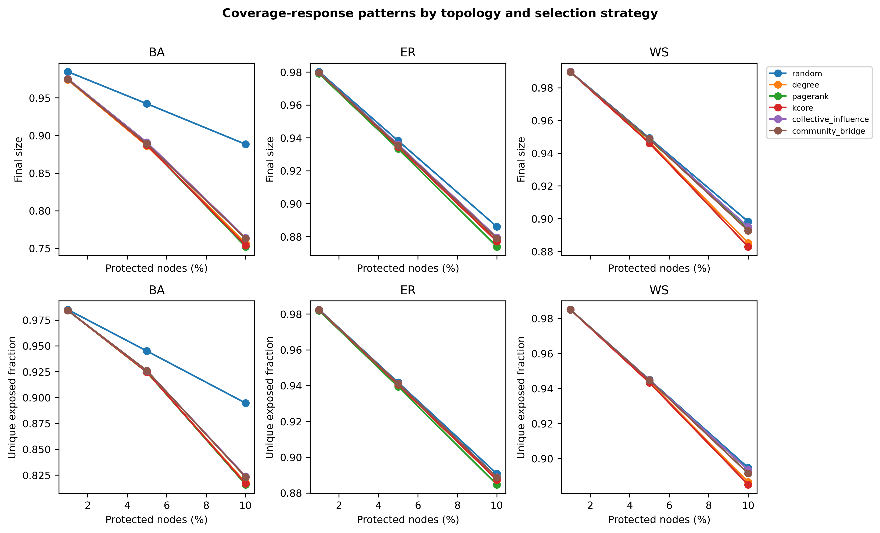
Supplementary Figure S1. Coverage-response curves for final size and unique direct exposure across six representative strategies. Increasing coverage produced the largest targeted-versus-random separation in BA networks; differences were smaller and outcome-dependent in ER and WS.
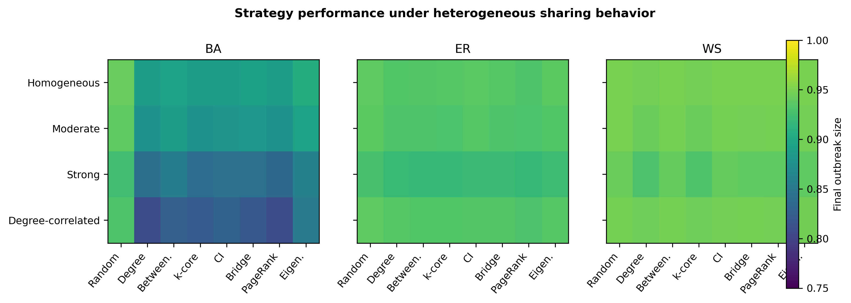
Supplementary Figure S2. Final outbreak size under homogeneous, moderate, strong, and degree-correlated sharing heterogeneity. Heterogeneity changed the best-ranked strategy but preserved the clearest targeting advantage in BA networks.
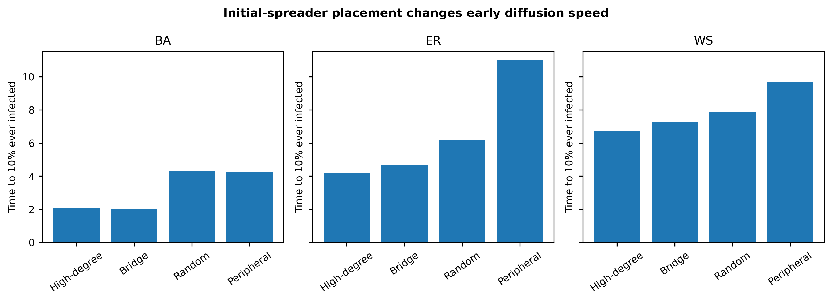
Supplementary Figure S3. Sensitivity of early diffusion to initial-spreader placement. High-degree and bridge seeds accelerated BA diffusion, while peripheral seeds most strongly delayed ER diffusion.
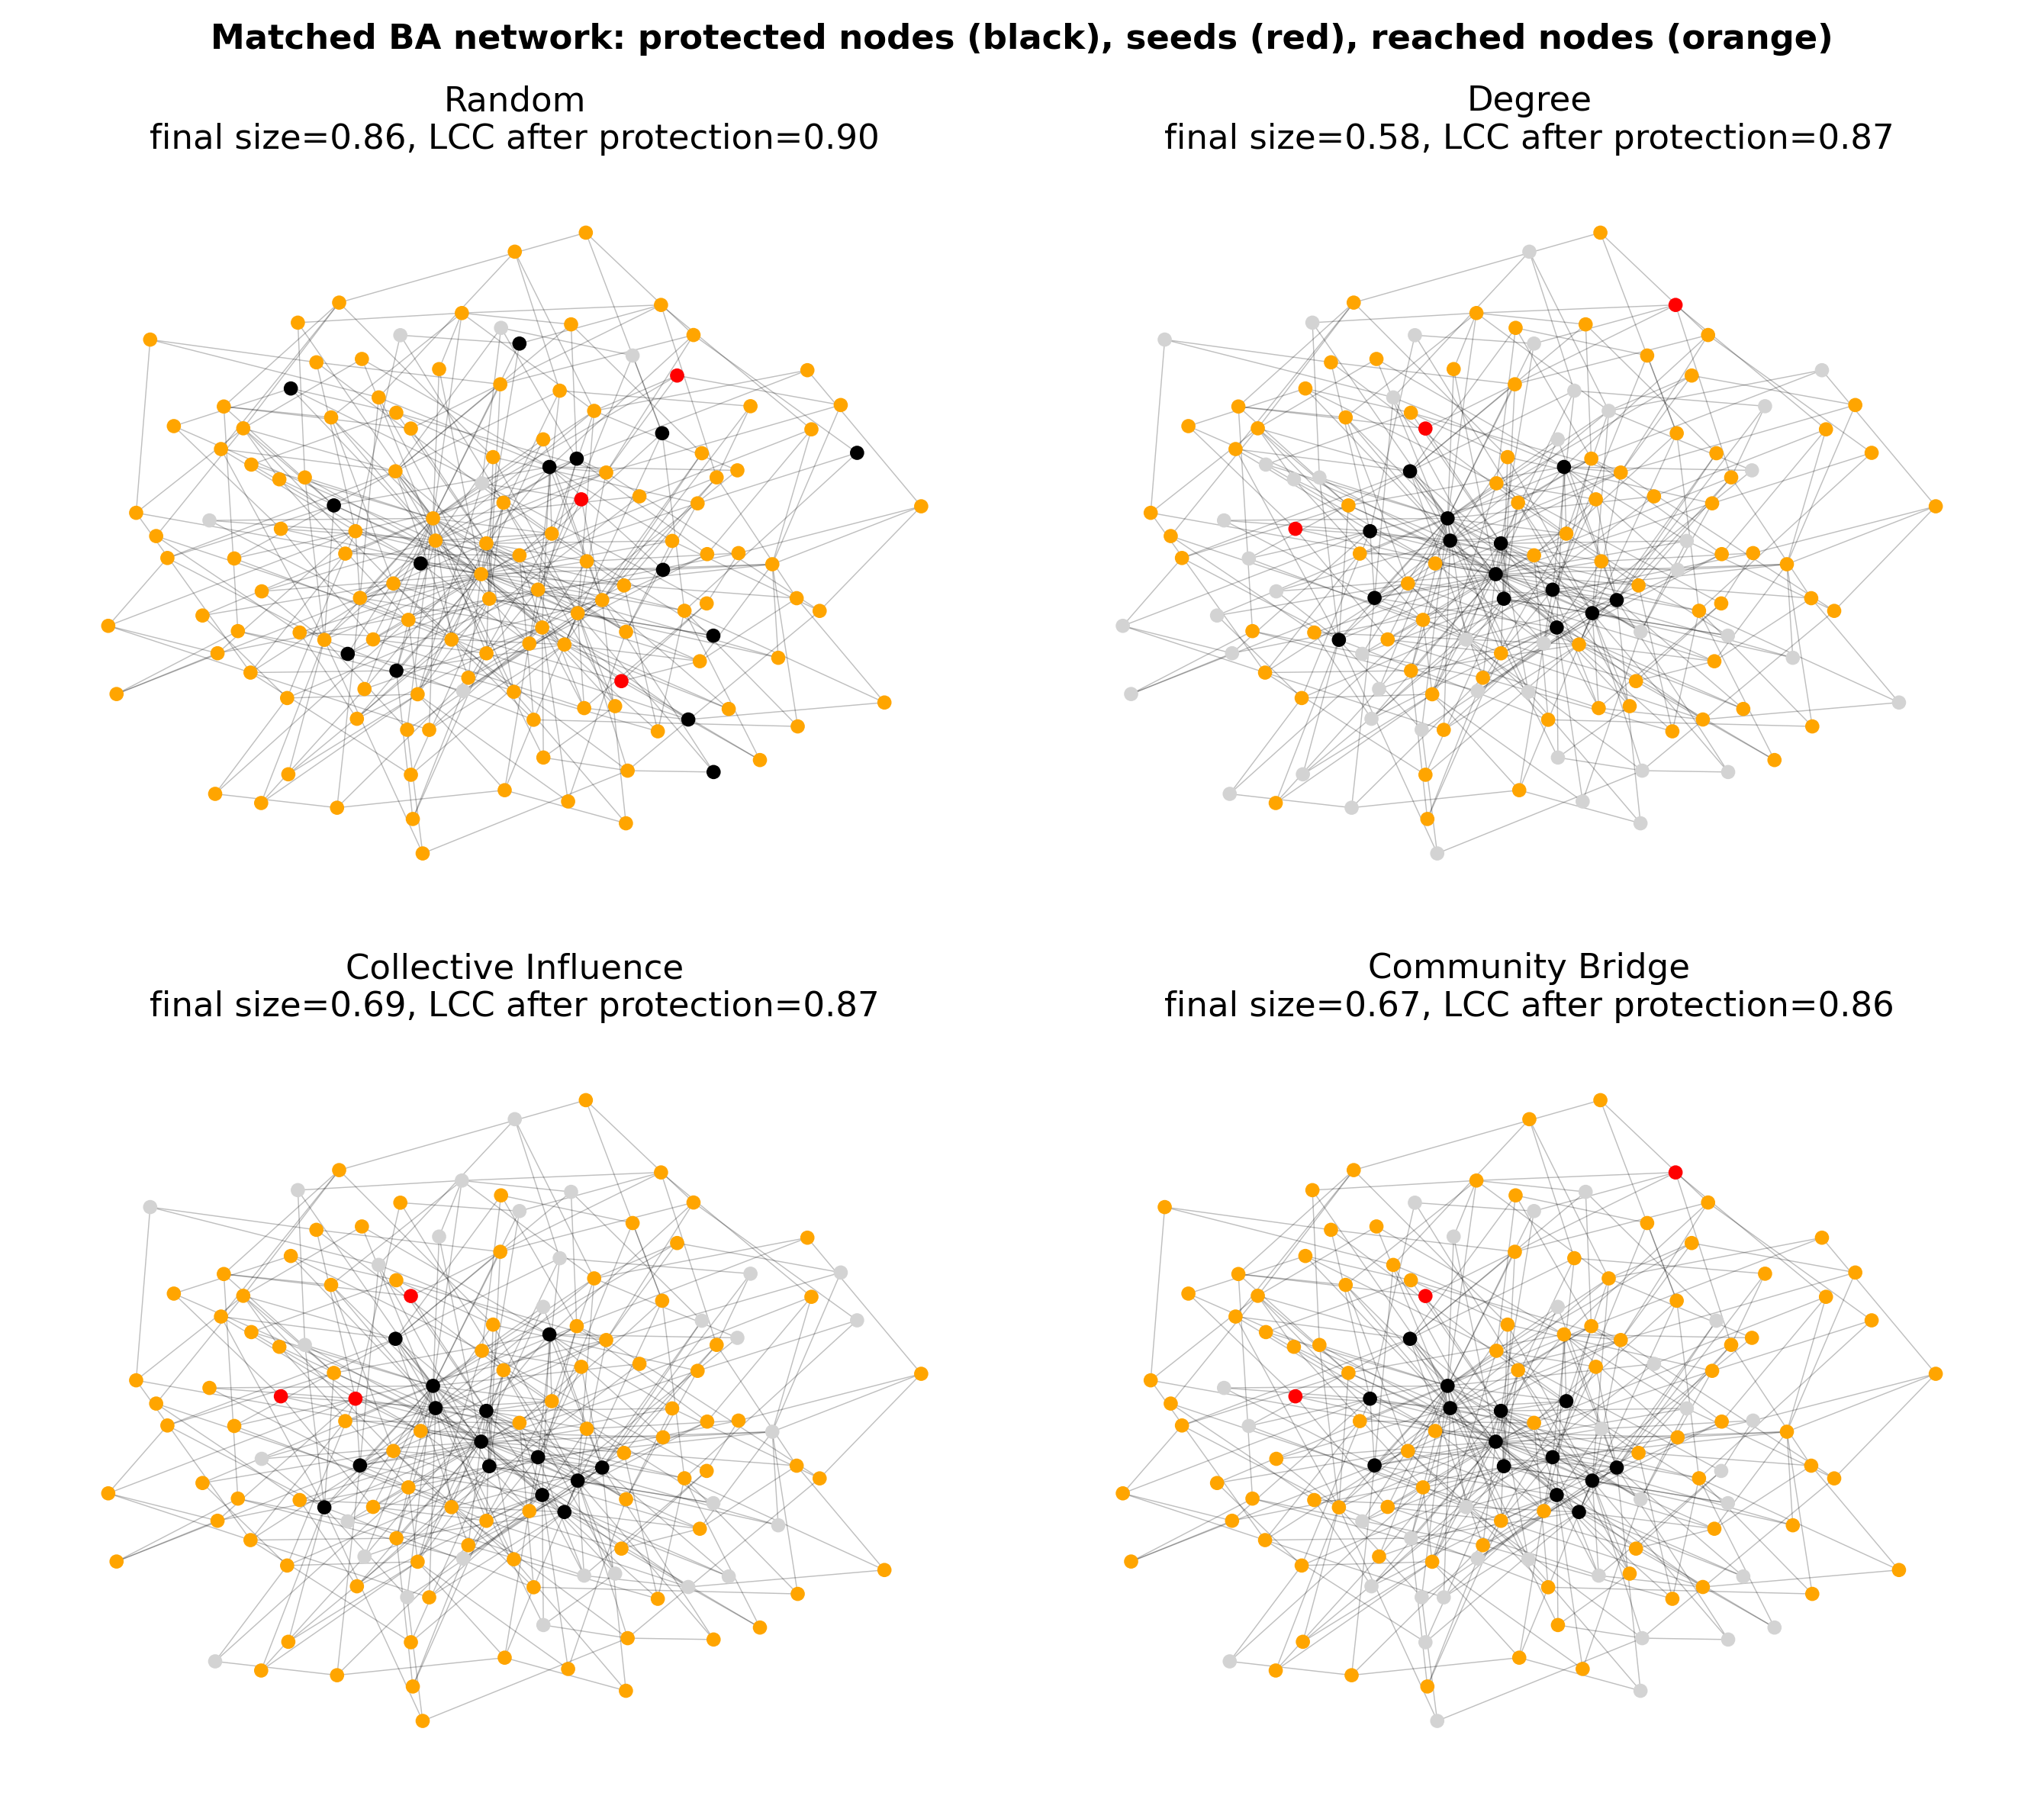
Supplementary Figure S4. Matched BA visualization showing protected nodes, seeds, reached nodes, and structural fragmentation. Topology-aware strategies interrupt hubs or bridges more consistently than random placement.
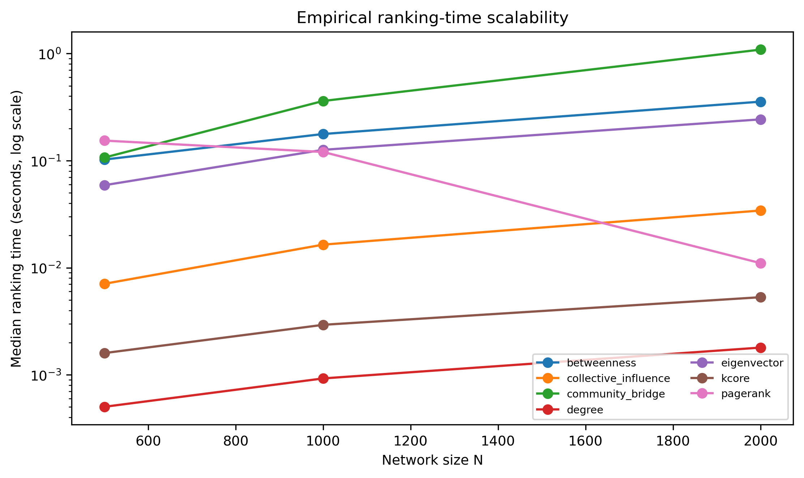
Supplementary Figure S5. Empirical ranking-time scalability from N = 500 to 2,000; the vertical axis is logarithmic. Degree and k-core remained fastest, while sampled betweenness and community detection grew more steeply.
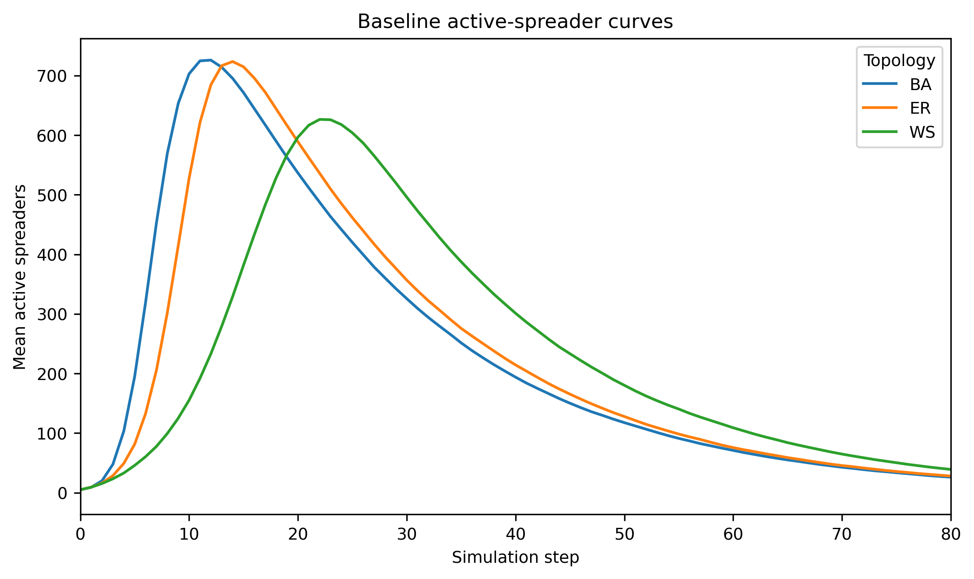
Supplementary Figure S6. Mean active-spreader curves for the high-transmission baseline. BA peaks earliest, ER is intermediate, and WS peaks later at a lower level despite near-complete final reach.

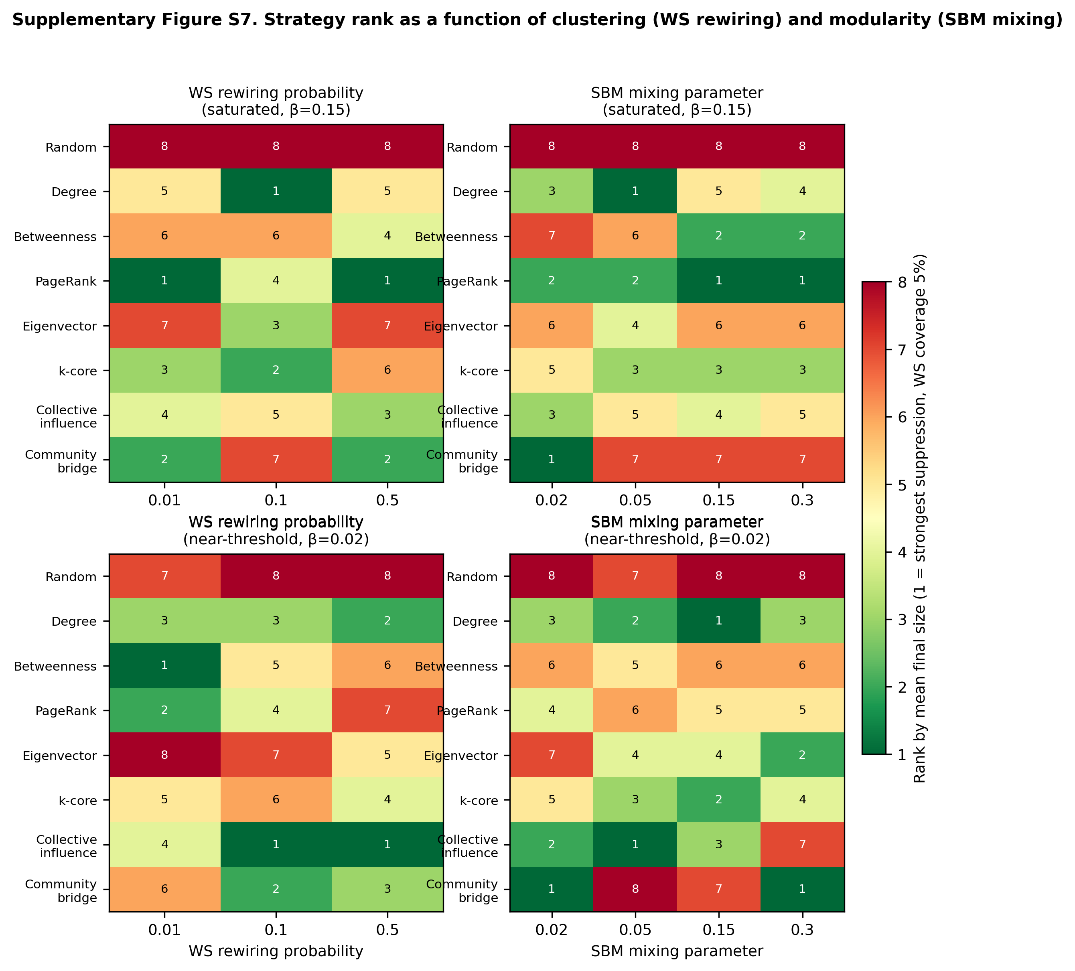
Supplementary Figure S7. Strategy rank (1 = strongest suppression of final outbreak size, 5% coverage) as a function of Watts-Strogatz rewiring probability and stochastic-block-model mixing, at the saturated (beta = 0.15) and near-threshold (beta = 0.02) transmission regimes. Random placement ranked last in every panel; the identity of the best and second-best topology-aware strategy changed across nearly every tested parameter value and regime, confirming that intervention rankings are conditional on structural parameters, not only on topology.

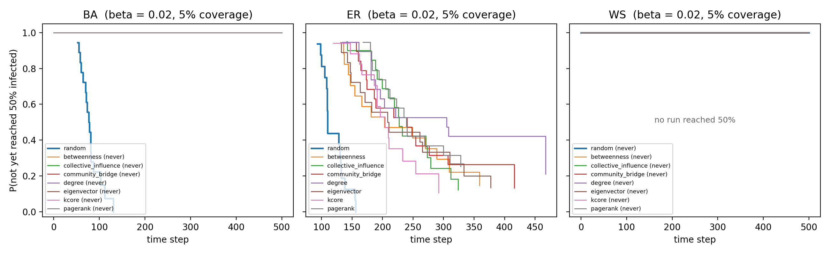
Supplementary Figure S8. Kaplan–Meier curves for time to 50% infection in the near-threshold regime (β = 0.02, 5% coverage), showing the probability that a run has not yet reached 50% infected. Under random placement most runs cross the threshold; every topology-aware strategy keeps all Barabási–Albert and all Watts–Strogatz runs below 50%, while delaying and reducing threshold crossing in Erdős–Rényi networks.

