Open Virtual Switch (OpenVSwitch/OVS):
- Enter as root user.
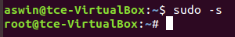
- Create 2 namespace (in my case VRF1 and VRF2)
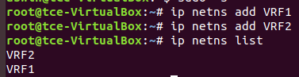
- Create 4 Virtual ethernet port to attach with bridge and namespaces.
Similarly add veth3 and veth4.
- If the configuration is done to create the topology shown in the image, the links will be as
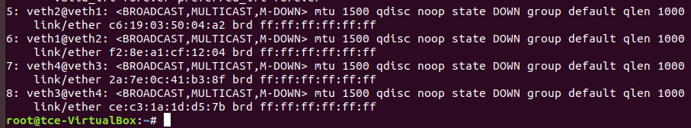
- Assign each virtual ethernet port to the particular namespace
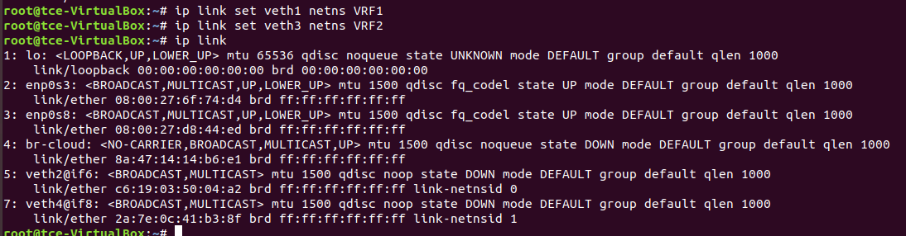
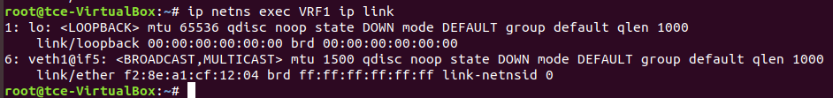
You can see that veth1 port is attached to the VRF1 namespace.
- Assign IP addresses to the virtual ethernet ports
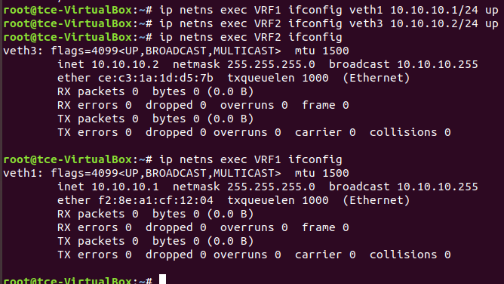
- Check the configuration using the default routing table
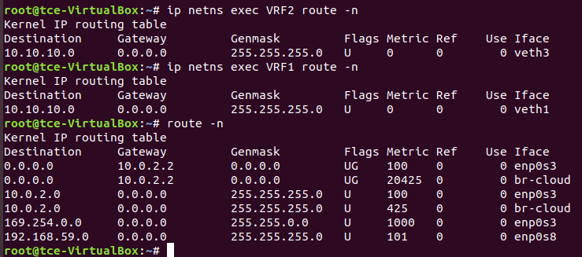
- Install openVswitch and its dependencies
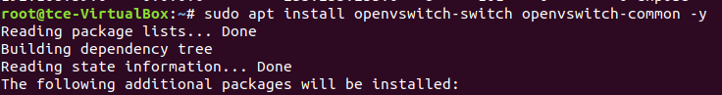
- Check the status of the openvswitch service, if off turn it on.
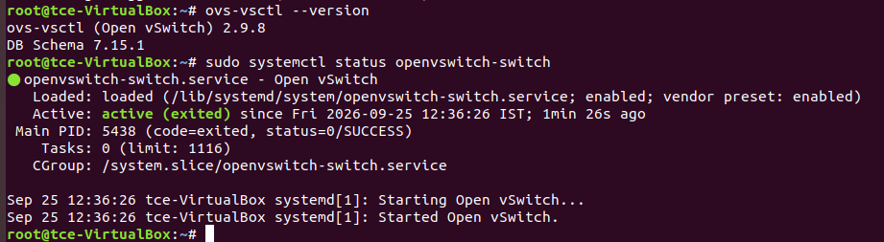
- Add the switch using ovs commandline tools and check the configuration
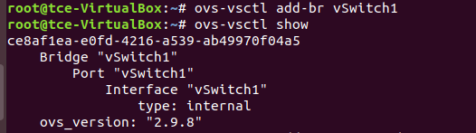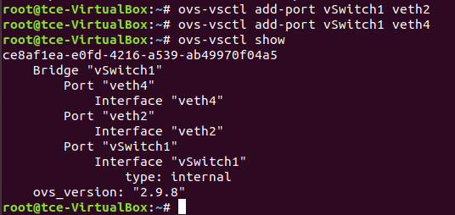
- Turn the virtual ethernet ports up and configure IP for switch check their status
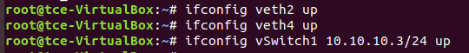
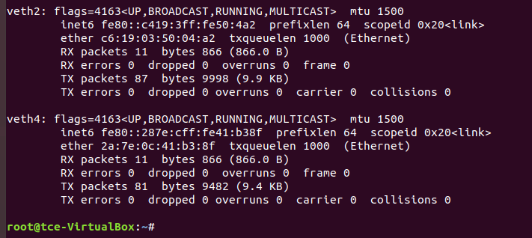
- Ping the namespace at the other end, if the configuration is done correct we can ping the Virtual namespace 2 from virtual namespace 1 via the switch (ovs bridge)
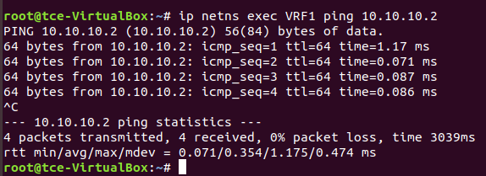
- Optionally you can turn on the spanning tree protocol (to prevent broadcast storms and network loops)
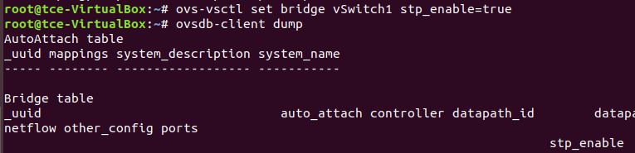
- Finally check the MAC address attached with the switch and the actual mac address of the virtual namespace device, if they match everything is done right.
