

**EEE 4626**

**Utilization of Energy Lab**

**Project Report**

**Project:** Automatic Power Factor Improvement by PIC Microcontroller.

**Section:** B

**Lab Group:** B2

**Team Members:**

**ID-160021048**

**160021056**

**160021058**

**160021066**

**160021068**

**160021074**

**160021078**

**ABSTRACT**  
  
Power Factor Correction (PFC) is the process of improving a low power factor present on a power system by means of installing Power Factor Correction (PFC) capacitors and in so doing, increase the ratio of active power to apparent power. When the apparent power is greater than active power, then the utility provider must supply the excess reactive power and the working power. When the apparent power is greater than active power, then the utility provider must supply the excess reactive power and the working power. Power capacitors act as reactive power generators and when connected to an electrical system, to reduce or eliminate the amount of reactive power the electrical system draws from the grid.

The benefits of Power Factor Correction are Reduction in apparent power (also known as maximum demand), Increased system capacity.

In order to reduce line losses and improve the transmission efficiency, power factor correction research became a hot topic. Many control methods for the Power Factor Correction (PFC) were proposed. This paper describes the design and development of a single-phase power factor correction using PIC (Programmable Interface Circuit) micro-controlling chip. This involves measuring the power factor value from the load using current transformer, potential transformer, and zero crossing detector, then using proper algorithm to switching on and switching off the capacitors in order to compensate excessive reactive power, thus withdraw PF near to unity as a result acquires higher efficiency and better quality AC output.

The measurement and monitoring of three different possible load types suggested that only the inductive loads required power factor correction. After employing the correction equipment the targeted power factor of 0.95 is achieved and the increase in power factor varied from 9% to 19% based on the combination of load. There is also a decrease of 1.7% in the total energy consumption due to reduction in load current. The economic analysis for power factor improvement considering the data from a local coalmine suggested the payback period to be around 9 months if the correction equipment is implemented. Measuring of power factor from load is achieved by using PIC Microcontroller-based developed algorithm to determine and trigger sufficient switching of capacitors in order to make the power factor as close to unity to compensate demand of excessive reactive power. It reads power factor from line voltage and line current and determine the delay in the arrival of the current signal with respect to voltage signal from the function generator with high accuracy by using a timer and hence calibrating as phase angle and corresponding power factor.

**INTRODUCTION**

In an electric power system, the power factor of an AC electrical power system is defined as the ratio of the real power absorbed by the load to the apparent power flowing in the circuit, and is a dimensionless number in the closed interval of −1 to 1. A power factor of less than one indicates the voltage and current are not in phase, reducing the average product of the two. Real power is the instantaneous product of voltage and current and represents the capacity of the electricity for performing work. Apparent power is the average product of current and voltage. Due to energy stored in the load and returned to the source, or due to a non-linear load that distorts the wave shape of the current drawn from the source, the apparent power may be greater than the real power. A negative power factor occurs when the device (which is normally the load) generates power, which then flows back towards the source

AC systems has two components in power flow:

* Real power (active power)
* Reactive Power

These are combined to the complex power The magnitude of the complex power is the apparent. {\displaystyle |S|}Also expressed in volt-amperes (VA).

The VA and VAR are non-SI units mathematically identical to the watt, but are used in engineering practice instead of the watt to be expressed. The SI explicitly does not allow using units for this purpose or as the only source of information about a physical quantity as used.

The power factor is defined as the ratio of real power to apparent power. Power does not consist purely of real power that can do work once transferred to the load as power is transferred along a transmission line but rather consists of a combination of real and reactive power, called apparent power. The power factor describes the amount of real power transmitted along a transmission line relative to the total apparent power flowing in the line.

**Power triangle**

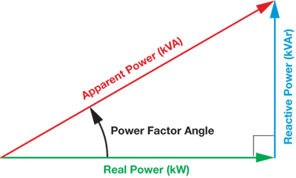

One can relate the various components of AC power by using the power triangle in vector space. Real power extends horizontally in the î direction as it represents a purely real component of AC power. Reactive power extends in the direction of ĵ as it represents a purely imaginary component of AC power. Complex power (and its magnitude, Apparent power) represents a combination of both real and reactive power. Real power extends horizontally in the î direction as it represents a purely real component of AC power. True power (real power) is symbolized by the letter P and is measured in the unit of Watts (W). Reactive power extends in the direction of ĵ as it represents a purely imaginary component of AC power. Power simply absorbed and returned in load due to its reactive properties is stated to as reactive power. Reactive power is represented by the letter Q and is measured in the unit of Volt-Amps-Reactive, Entire power in an AC circuit, both dissipated and absorbed/returned is mentioned as apparent power. Apparent power is represented by the letter S and is measured in the unit of Volt-Amps (VA), therefore can be calculated by using the vector sum of these two components.

**Increasing the power factor**

As the power factor (i.e. cos θ) increases, the ratio of real power to apparent power (which = cos θ), increases and approaches unity (1), while the angle θ decreases and the reactive power decreases. [As cos θ → 1, its maximum possible value, θ → 0 and so Q → 0, as the load becomes less reactive and more purely resistive].

**Decreasing the power factor**

As the power factor decreases, the ratio of real power to apparent power also decreases, as the angle θ increases and reactive power increases. The poor load current phase angle can be generally the result of inductive loads such as induction motor, power transformers and lighting ballasts. A distorted current wave form can be the result of rectifier, variable speed drive, switched mode power supply and other electric loads. Low power factor loads increases losses in power supply and distribution system and it increases the cost in electricity in bills. Since the purely resistive ac circuit of the sinusoidal voltage and current waveforms are in phase; changing polarity at the same instant in each cycle circuits containing purely resistive heating elements such as filament lamps and cooking stoves have a power factor of 1.0. Circuits containing inductive or capacitive elements such as lamp ballasts and motors often have a power factor below 1.0. Reactive power compensation has been increasing, mainly because of the way in which energy supplier charge a customer for reactive power. In addition to the above explanation, the energy price is growing, what force the industry plants and individual customers to minimize energy consumption, including reactive power. Generally, there are solutions that allow handle the problem of reactive power compensation. The first one is reactive power compensator using power factor capacitors. This is very important compensating device, due to economic reasons and they are very cheap comparing with active filters by means of electric motors.

The current drawn by inductance lags the voltage while the one by capacitance leads the voltage. Almost all industrial loads are inductive in nature and hence draw lagging wattles current, which unnecessarily load the system, performing no work. Since the capacitive currents is leading in nature, loading the system with capacitors wipes out them. The lower the power factor, the worse the situation becomes from the supply authorities’ viewpoint. Accordingly, consumers are encouraged to improve their load power factor and in many cases are penalized if they do not. Improving the power factor means reducing the angle of lag between supply voltage and supply current. Power factor correction brings the power factor of an AC power circuit closer to 1 by supplying reactive power of opposite sign, adding capacitors or inductors which act to cancel the inductive or capacitive effects of the load, respectively.

**Lagging and leading power factors**

In pure resistive circuit, power factor is 1 due to zero phase angle difference between current and voltage.

In pure capacitive circuit, power factor is leading due to the lagging VARs i.e. Voltage is lagging 90° behind the current. In other words, Current is leading 90° from voltage (Current and voltage are 90° out of phase with each other, where current is leading and voltage is lagging).

In pure inductive circuit, power factor is lagging due to the leading VARs i.e. Voltage is leading 90° from current. In other words, Current is lagging begging 90° behind the voltage (Current and voltage are 90° out of phase with each, others where voltage is leading and current is lagging).

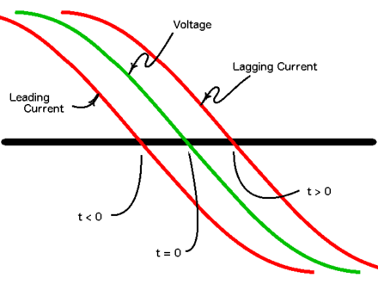

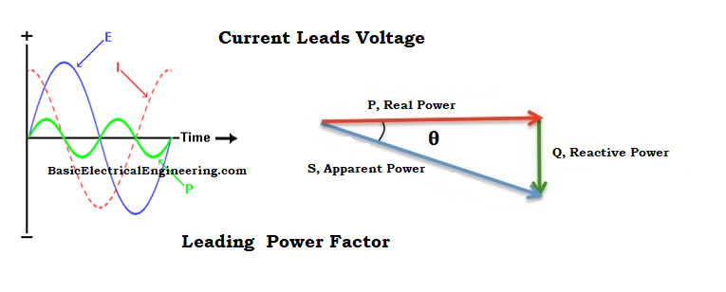

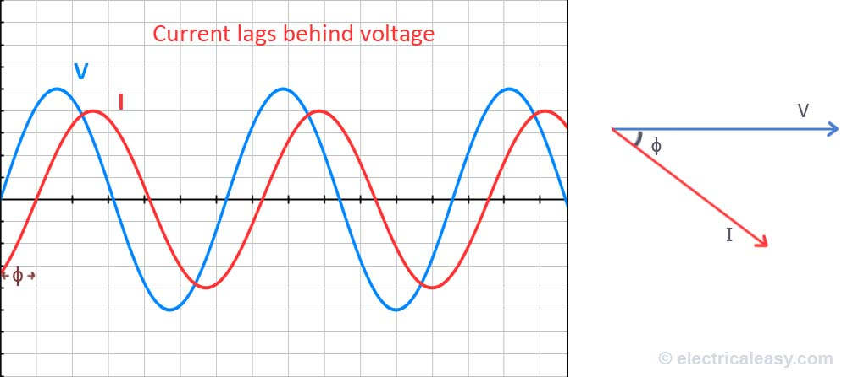

There is also a difference between a lagging and leading power factor. The terms refer to whether the phase of the current is leading or lagging the phase of the voltage. A lagging power factor signifies that the load is inductive, as the load will “consume” reactive power, and therefore the reactive component Q {\displaystyle Q}Q is positive as reactive power travels through the circuit and is “consumed” by the inductive load. A leading power factor signifies that the load is capacitive, as the load “supplies” reactive power, and therefore the reactive component{\displaystyle Q}Qqqq Q is negative as reactive power is being supplied to the circuit.

A load with a low power factor draws more current than a load with a high power factor for the same amount of useful power transferred. The higher currents increase the energy lost in the distribution system, and require larger wires and other equipment. Because of the costs of larger equipment and wasted energy, electrical utilities will usually charge a higher cost to industrial or commercial customers where there is a low power factor.

A load with a low power factor draws more current than a load with a high power factor for the same amount of useful power transferred. Active power is the product of the sinusoidal voltage and current wave form. Reactive power is the power consumed in the ac circuit because of the inductive and capacitive field. The higher currents increase the energy lost in the distribution system, and require larger wires and other equipment. Because of the costs of larger equipment and wasted energy, electrical utilities will usually charge a higher cost to industrial or commercial customers where there is a low power factor. Power-factor correction increases the power factor of a load, improving efficiency for the distribution system to which it is attached.

**Power Factor Correction**

The power factor correction is a technique of increasing the power factor of a power supply. Switching power supplies without power factor correction draw current in short, high-magnitude pulses. These pulses can be smoothed out by using active or passive techniques. This reduces the input RMS current and apparent input power, thereby increasing the power factor. The power factor correction shapes the input current in order to maximize the real power from the AC supply. Ideally, electrical equipment should present a load that emulates a pure resistor, meaning that the reactive power would be zero. And the current and voltage waveforms would be the same sine wave and in phase with one another. However, due to the reactive components in a majority of circuits, there is always a power lag that leads to lower power factors.

In an ideal system, all the power drawn from the AC mains is utilized in doing useful work. This is only possible when the current is in phase with the voltage. When the phase between the two varies, some of the energy from the AC outlet does not perform useful work and is lost.

The power generating company must therefore produce more power to meet the demand for the useful power and the one that is lost. This means more capital investments in generation, transmission, distribution and control. The costs are passed on to the consumer in addition to contributing to global warming. Power factor correction tries to push the power factor of the electrical system such as the power supply towards 1, and even though it doesn’t reach this it gets to as close as 0.95 which is acceptable for most applications. One of the power factor correction is static power factor correction. Static power factor correction is commonly applied by using one contactor to control both the motor and the capacitors. It is better practice to use two contactors, one for the motor and one for the capacitors. Where one contactor is employed, it should be up sized for the capacitive load. The use of a second contactor eliminates the problems of resonance between the motor and the capacitors. Electric motor loads are phase lagging (inductive), therefore requiring capacitor banks to counter their inductance. Sometimes, when the power factor is leading due to capacitive loading, inductors are used to correct the power factor. In the electric industry, inductors are said to consume reactive power and capacitors are said to supply it, even though the reactive power is just moving back and forth between each AC cycle.

As a large proportion of the inductive or lagging current on the supply is due to the magnetizing current of induction motors, it is easy to correct each individual motor by connecting the correction capacitors to the motor starters. With static correction, it is important that the capacitive current is less than the inductive magnetizing current of the induction motor. In many installations employing static power factor correction, the correction capacitors are connected directly in parallel with the motor windings. When the motor is Off Line, the capacitors are also Off Line. When the motor is connected to the supply, the capacitors are also connected providing correction at all times that the motor is connected to the supply. This removes the requirement for any expensive power factor monitoring and control equipment. In this situation, the capacitors remain connected to the motor terminals as the motor slows down. An induction motor, while connected to the supply, is driven by a rotating magnetic field in the stator which induces current into the rotor. When the motor is disconnected from the supply, there is for a period of time, a magnetic field associated with the rotor. As the motor decelerates, it generates voltage out its terminals at a frequency which is related to its speed. The capacitors connected across the motor terminals, form a resonant circuit with the motor inductance. If the motor is critically corrected, (corrected to a power factor of 1.0 the inductive reactance equals the capacitive reactance at the line frequency and therefore the resonant frequency is equal to the line frequency. If the motor is over corrected, the resonant frequency will be below the line frequency. If the frequency of the voltage generated by the decelerating motor passes through the resonant frequency of the corrected motor, there will be high currents and voltages around the motor/capacitor circuit. This can result in severe damage to the capacitors and motor. It is imperative that motors are never over corrected or critically corrected when static correction is employed.

The benefits of power factor correction are reduction in apparent power (also known as maximum demand)**,** Lower electricity bills**,** Increased system capacity (free up capacity on your supply transformer)**,** Reduced voltage drop on the supply transformer and supply cables**,** Reduced transmission losses**,** Reduced carbon footprint. The overall benefits include reduced system losses and less capital cost for the generating company. In addition, there are saving on electricity costs, since there are no charges for the excess reactive power. Another benefit is that the transmission and distribution equipment and systems runs cooler and last longer.

Power factor correction using capacitor banks reduces reactive power consumption which will lead to minimization of losses and at the same time increases efficiency of the electrical system. Power factor correction using capacitor banks reduces reactive power consumption which will lead to minimization of losses and at the same time increases the electrical system's efficiency. Power saving issues and reactive power management has led to the development of single phase capacitor banks for domestic and industrial applications. The development of this project is to enhance and upgrade the operation of single phase capacitor banks by developing a micro-processor based control system. The output of this device which obtains from the simulation result and hardware implementation will be analyzed to see the effect of controlling and correcting activity. This paper proposed the controlling and correction of power factor automatically.

Significant savings inutility power costs can be realized by keeping up an average monthly power factor close to unity. Utilizing shunt capacitor banks for Power Factor Correction (PFC) is an exceptionally established methodology. The recent trend is to automate the switching procedure of capacitors to get greatest advantage in real time basis. Embedded systems based on microcontrollers can be used to monitor and control the switching of correction devices because of its dependability and execution. Power saving issues and reactive power management has led to the development of single phase capacitor banks for domestic and industrial applications. Automatic power factor correction techniques can be applied to industrial units, power systems and also households to make them stable. The system becomes stable and efficiency of the system and apparatus increases. Therefore, the use of microcontroller based power factor corrector results in reduced overall costs for both the consumers and the suppliers of electrical energy.

In this case we are using PIC Microcontroller model PIC18F4550 for the power factor improvement project.

**SOFTWARE USED**:

Proteus Professional 8.0

**COMPONENTS**:

1N4007

1N4733A

CAP

Crystal

ELJ-FA150KF

LAMP

LM044L

LM358

MINRES1K

MINRES10K

PIC18F4550

ULN2003A

**Transformer**

The main function of the transformer I the APFC panel is to step down the input AC 230V voltage. Then this output voltage is given to the rectifier unit.

**Rectifier**

The main function of the rectifier is to convert the AC voltage into the DC output. In the APFC panel we are using the bridge rectifier.

**Voltage regulator**

The main function of the voltage regulator is to convert the variable output DC voltage into the constant DC voltage. The U LM317 is used as a voltage regulator. It gives the two different DC supply for the working of microcontroller and LCD display.

**Current transformer**

The main function of the current transformer is to step down the current in a measurable value. Basically the C.T. senses the load current in the line. The part of the C.T. is its transformation ratio on which it will transform the current. These ratios are such as 100A/10A, 50A/5A, etc. then this C.T sends the signal to the microcontroller .

**CAPACITOR COMPENSATORS**

Shunt capacitors are being extensively used in industrial distribution systems. They supply reactive power to counteract the out-of-phase component of current required by an inductive load. The application of shunt capacitor banks results in a decrease in the magnitude of the source-current, improves the power factor and consequently improves voltage regulation throughout the system. However, shunt capacitor

banks do not affect current or power factor beyond their point of application. Capacitor banks can be fixed, switched, or a combination of both. The switching process can be manual or automatic. Capacitor

banks are rugged and simple to configure and install. It should be noted that it is concerned with the installation of power-factor correction capacitors in high-voltage power centers. Even though the capacitors have bleeder resistors .Each capacitor bank should have an alternative built-in means for discharging the capacitors.

**Power Factor capacitors:**

Power factor capacitors may conveniently be switched on and off with individual motors. This assures that the capacitor is energized only during the times when the motor is energized - when you need power factor correction. For this type of application, typically a Fixed Capacitor Bank is used. This is the simplest and most economical form of power factor correction. Depending on the manner in which you connect the capacitor, you may or may not need to include fuses Harmonics will reduce the life of power factor capacitors. Whenever there are harmonic producing loads on the power system, the capacitor bank should include a capacitor protection reactor that will detune ‖ the capacitor bank to a frequency where no harmonic energy exists. Instead of the capacitor protection reactor we intend using a microcontroller to detune the capacitor bank to a frequency where no harmonics energy can exist thereby improving the correction of Power factor.

**Resistors:**

A resistor is a passive two-terminal electrical component that implements electrical resistance as a circuit element. The current through a resistor is in direct proportion to the voltage across the resistor's terminals. This relationship is represented by:

where I is the current through the conductor in units of amperes, V is the potential difference measured across the conductor in units of volts, and R is the resistance of the conductor in units of ohms (symbol: Ω). The ratio of the voltage applied across a resistor's terminals to the intensity of current in the circuit is called its resistance, and this can be assumed to be a constant (independent of the voltage) for ordinary resistors working within their ratings.

Resistors are common elements of electrical networks and electronic circuits and are ubiquitous in electronic equipment. Practical resistors can be made of various compounds and films, as well as resistance wire (wire made of a high-resistivity alloy, such as nickel-chrome). Resistors are also implemented within integrated circuits, particularly analog devices, and can also be integrated into hybrid and printed circuits.

The electrical functionality of a resistor is specified by its resistance: common commercial resistors are manufactured over a range of more than nine orders of magnitude. When specifying that resistance in an electronic design, the required precision of the resistance may require attention to the manufacturing tolerance of the chosen resistor, according to its specific application. The temperature coefficient of the resistance may also be of concern in some precision applications. Practical resistors are also specified as having a maximum power rating which must exceed the anticipated power dissipation of that resistor in a particular circuit: this is mainly of concern in power electronics applications. Resistors with higher power ratings are physically larger and may require heat sinks. In a high-voltage circuit, attention must sometimes be paid to the rated maximum working voltage of the resistor. While there is no minimum working voltage for a given resistor, failure to account for a resistor's maximum rating may cause the resistor to incinerate when current is run through it.

**Relay Module:**

The relay module comprises of eight electro-magnetic relays which are controlled by the outputs on the digital pins of the Arduino microcontroller. The relays are used to switch on the required number of capacitors as required for power factor correction. The relays are normally in the Normally Open‖ (NO) state and the contacts are closed only when the logic on any of the digital pins is high. As the logic on a pin goes high, the Normally Open‖ contacts of the relay are now closed and the corresponding capacitor in connected in parallel with the load.

The relay module is interfaced with the digital pins of the Arduino microcontroller using a parallel port and bus. The relay driver is supplied with a voltage of 12V from the power supply. Each of the relays has an LED connected across its terminals to indicate that the relay has been switched on and is functional.

**Relay Driver:**

The ULN2001A, ULN2002A, ULN2003A and ULN2004A are high voltage, high current Darlington arrays each containing seven open collector Darlington pairs with common emitters. Each channel rated at 500mA and can withstand peak currents of 600mA. Suppression diodes are included for inductive load driving and the inputs are pinned opposite the outputs to simplify board layout. The four versions interface to all common logic families.

These versatile devices are useful for driving a wide range of loads including solenoids, relays, DC motors, LED displays filament lamps, thermal print heads and high power buffers. The ULN2001A/2002A/2003A and 2004A are supplied in 16 pin plastic DIP packages with a copper lead frame to reduce thermal resistance. They are available also in small outline package (SO-16) as ULN2001D/2002D/2003D/2004D.We used ULN 200 3A as relay driver.

**PIC MICROCONTROLLER**

PIC (usually pronounced as "pick") is a family of microcontrollers made by Microchip Technology, derived from the PIC1650 originally developed by General Instrument's Microelectronics Division. The name PIC initially referred to Peripheral Interface Controller, and is currently expanded as Programmable Intelligent Computer. The first parts of the family were available in 1976; by 2013 the company had shipped more than twelve billion individual parts, used in a wide variety of embedded systems.

Early models of PIC had read-only memory (ROM) or field-programmable EPROM for program storage, some with provision for erasing memory. All current models use flash memory for program storage, and newer models allow the PIC to reprogram itself. Program memory and data memory are separated. Data memory is 8-bit, 16-bit, and, in latest models, 32-bit wide. Program instructions vary in bit-count by family of PIC, and may be 12, 14, 16, or 24 bits long. The instruction set also varies by model, with more powerful chips adding instructions for digital signal processing functions.

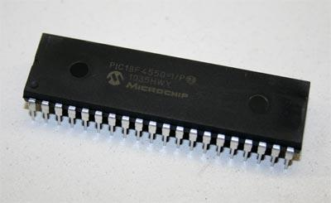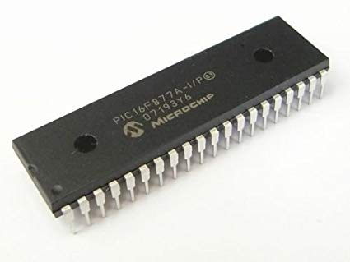

PIC micro chips are designed with a Harvard architecture, and are offered in various device families. The baseline and mid-range families use 8-bit wide data memory, and the high-end families use 16-bit data memory. The latest series, PIC32MZ is a 32-bit MIPS-based microcontroller. Instruction words are in sizes of 12-bit (PIC10 and PIC12), 14-bit (PIC16) and 24-bit (PIC24 and dsPIC). The binary representations of the machine instructions vary by family and are shown in PIC instruction listings.

Within these families, devices may be designated PICnnCxxx (CMOS) or PICnnFxxx (Flash). "C" devices are generally classified as "Not suitable for new development" (not actively promoted by Microchip). The program memory of "C" devices is variously described as OTP, ROM, or EEPROM. As of October 2016, the only OTP product classified as "In production" is the pic16HV540. "C" devices with quartz windows (for erasure), are in general no longer available.

The hardware capabilities of PIC devices range from 6-pin SMD, 8-pin DIP chips up to 144-pin SMD chips, with discrete I/O pins, ADC and DAC modules, and communications ports such as UART, I2C, CAN, and even USB. Low-power and high-speed variations exist for many types.

The manufacturer supplies computer software for development known as MPLAB X, assemblers and C/C++ compilers, and programmer/debugger hardware under the MPLAB and PICKit series. Third party and some open-source tools are also available. Some parts have in-circuit programming capability; low-cost development programmers are available as well as high-production programmers.

PIC devices are popular with both industrial developers and hobbyists due to their low cost, wide availability, large user base, extensive collection of application notes, availability of low cost or free development tools, serial programming, and re-programmable flash-memory capability

PIC microcontrollers ( Programmable Interface Controllers), are electronic circuits that can be programmed to carry out a vast range of tasks. They can be programmed to be timers or to control a production line and much more. They are found in most electronic devices such as alarm systems, computer control systems, phones, in fact almost any electronic device. Many types of PIC microcontrollers exist, although the best are probably found in the GENIE range of programmable microcontrollers. These are programmed and simulated by Circuit Wizard software.

PIC Microcontrollers are relatively cheap and can be bought as pre-built circuits or as kits that can be assembled by the user.

There are many PICs available in the market ranging from PIC16F84 to PIC16C84. These types of PICs are affordable flash PICs. Microchip has recently introduced flash chips with different types, such as 16F628, 16F877 and 18F452. The 16F877 costs twice the price of the old 16F84, but it is eight times more than the code size, with more RAM and much more I/O pins, a UART, A/D converter and a lot more features.

**PIC Microcontrollers Architecture**

PIC Microcontroller architecture is based on Harvard architecture and supports RISC architecture (Reduced Instruction Set Computer). PIC microcontroller architecture consists of memory organization (ram, rom, stack), CPU, timers, counter, ADC, DAC, serial communication, CCP module and I/O ports. PIC microcontroller also supports the protocols like CAN, SPI, UART for interfacing with other peripherals.

The PIC microcontroller is based on RISC architecture. Its memory architecture follows the Harvard pattern of separate memories for program and data, with separate buses.

PIC microcontroller architecture

ALU is used for arithmetic operations and for logical decisions. Memory is used for storing the instructions after processing. Control unit is used to control the internal and external peripherals which are connected to the CPU and accumulator is used for storing the results.

**Memory Structure**

The PIC architecture consists of two memories: Program memory and the Data memory.

Program Memory: This is a 4K*14 memory space. It is used to store 13-bit instructions, or the program code. The program memory data is accessed by the program counter register that holds the address of the program memory. The address 0000H is used as reset memory space and 0004H is used as interrupt memory space.

Data Memory: The data memory consists of the 368 bytes of RAM and 256 bytes of EEPROM. The 368 bytes of RAM consists of multiple banks. Each bank consists of general purpose registers and special function registers. It is a RAM type which is used to store the data temporarily in its registers. The RAM memory is classified into banks. Each bank extends up to 7Fh (128 bytes). Number of banks may vary depending on the microcontroller. PIC16F84 has only two banks. Banks contain Special Function Registers (SFR) and General Purpose Registers (GPR). The lower locations of each bank are reserved for the Special Function Registers and upper locations are for General Purpose Registers.

The special function registers consist of control registers to control different operations of the chip resources like Timers, Analog to Digital Converters, Serial ports, I/O ports, etc. For example, the TRISA register whose bits can be changed to alter the input or output operations of the port A.

General purpose registers consist of registers that are used to store temporary data and processing results of the data. These general purpose registers are each 8-bit registers.

Working Register: It consists of a memory space that stores the operands for each instruction. It also stores the results of each execution.

Status Register: The bits of the status register denote the status of the ALU (arithmetic logic unit) after every execution of the instruction. It is also used to select any one of the 4 banks of the RAM.

File Selection Register: It acts as a pointer to any other general-purpose register. It consists of a register file address, and it is used in indirect addressing.

Another general purpose register is the program-counter register, which is a 13-bit register. The 5 upper bits are used as PCLATH (Program Counter Latch) to independently function as any other register, and the lower 8-bits are used as the program counter bits. The program counter acts as a pointer to the instructions stored in the program memory.

EEPROM: Electrically Erasable Programmable Read Only Memory (EEPROM pronounced as “double E prom) is like a ROM but data can be erased from it electrically without removing it from the computer. Data is created in them by electrical pulses and a grid. We can also change the data in it according to our requirement, to erase a certain data we don’t have to erase the prom completely like in a regular rom. A basic ROM chip can only be programmed once whereas an EEPROM can be programmed again and again. It consists of 256 bytes of memory space. It is a permanent memory like ROM, but its contents can be erased and changed during the operation of the microcontroller. This memory allows storing the variables as a result of burning the written program. It is readable and writable during normal operation (over the full VDD range). This memory is not directly mapped in the register file. It is indirectly addressed through the SFRs. There are six SFRs which are used to read and write to this memory (EECON1, EECON2, EEDATA, EEDATH, EEADR, EEADRH).

**I/O Ports**

PIC16 series consists of five ports, such as Port A, Port B, Port C, Port D and Port E. However, input output ports of PIC18F455 microcontroller has a number of input/output pins which are used for connection with external devices. It has total 40 pins. Out of these 40 pins, 34 pins can be used as input output pins. These pins are grouped into five which are called PORTS denoted by A, B, C, D and E. Here in this article we will learn how to use I/O Ports of PIC18F455

Port A: It is a 16-bit port, which can be used as input or output port based on the status of the TRISA register.

Port B: It is an 8-bit port, which can be used as both input and output port. 4 of its bits when used as input can be changed upon interrupt signals.

Port C: It is an 8-bit port whose operation (input or output) is determined by the status of the TRISC register.

Port D: It is an 8-bit port, which apart from being an I/O port, acts as a slave port for connection to the microprocessor bus.

Port E: It is a 3-bit port that serves the additional function of the control signals to the A/D converter.

Some pins of the I/O ports are multiplexed with an alternate function from the peripheral features on the device. If a pin is used as any other function, then it may not be used as a general purpose I/O pin. Here we will just restrict with the input output features of ports.

**Timers**

PIC microcontrollers consist of 3 timers, out of which the Timer 0 and Timer 2 are 8-bit timers and the Time-1 is a 16-bit timer, which can also be used as a counter.

**INTERRUPTS:**

There are 20 internal interrupts and three external interrupt sources in PIC microcontrollers which are related with different peripherals like ADC, USART, Timers, and CCP etc. Interrupts stops the CPU program from normal execution and ask it to serve first what appear as an interrupt. CPU does not know when these interrupt will happen, so CPU will keep doing its normal execution until interrupt occurs. For example, the microcontroller does not know when a user will press a button, so the microcontroller will continue its operation until a interrupt is received. So the CPU keeps on doing its normal job, which may be for example read temperature using LM35 sensor and display on LCD.

**A/D Converter**

The PIC Microcontroller consists of 8-channels, 10-bit Analog to Digital Converter. The operation of the A/D converter is controlled by these special function registers: ADCON0 and ADCON1. The lower bits of the converter are stored in ADRESL (8 bits), and the upper bits are stored in the ADRESH register. It requires an analog reference voltage of 5V for its operation.

**Oscillators**

Oscillators are used for timing generation. PIC microcontrollers consist of external oscillators like crystals or RC oscillators. In case of crystal oscillators, the crystal is connected between two oscillator pins, and the value of the capacitor connected to each pin determines the mode of operation of the oscillator. The different modes are low-power mode, crystal mode and the high- speed mode. In case of RC oscillators, the value of the Resistor and Capacitor determine the clock frequency. The clock frequency ranges from 30 KHz to 4 MHz.

**CCP module**:

A CCP module works in the following three modes:

Capture Mode: This mode captures the time of arrival of a signal, or in other words, captures the value of the Timer1 when the CCP pin goes high.

Compare Mode: It acts as an analog comparator that generates an output when the timer1 value reaches a certain reference value.

PWM Mode: It provides pulse width modulated output with a 10-bit resolution and programmable duty cycle.

Other special peripherals include a Watchdog timer that resets the microcontroller in case of any software malfunction and a Brown out reset that resets the microcontroller in case of any power fluctuation and others. For better understanding of this PIC microcontroller we are giving one practical project which uses this controller for its operation.

**PIC18 Microcontroller Pinout**

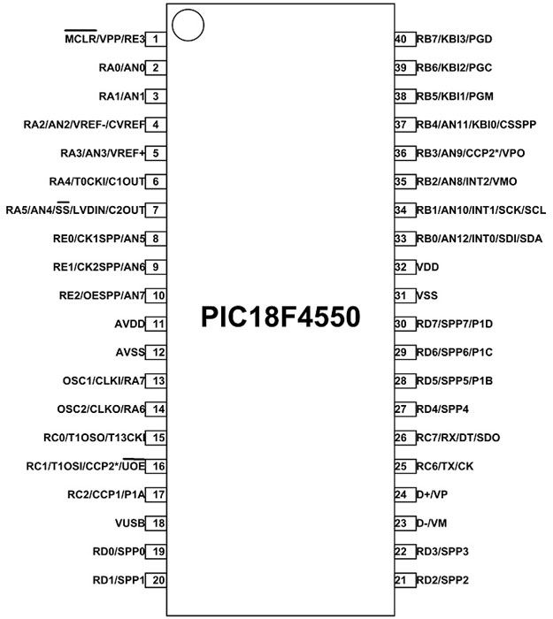

**Simulations and Diagram:**

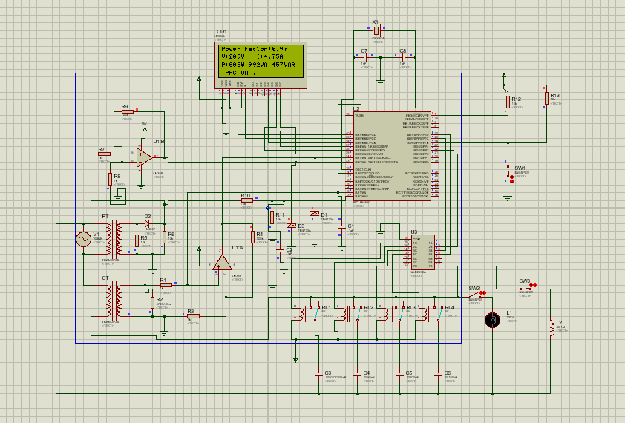

The components that we used in proteus are briefly explained above.

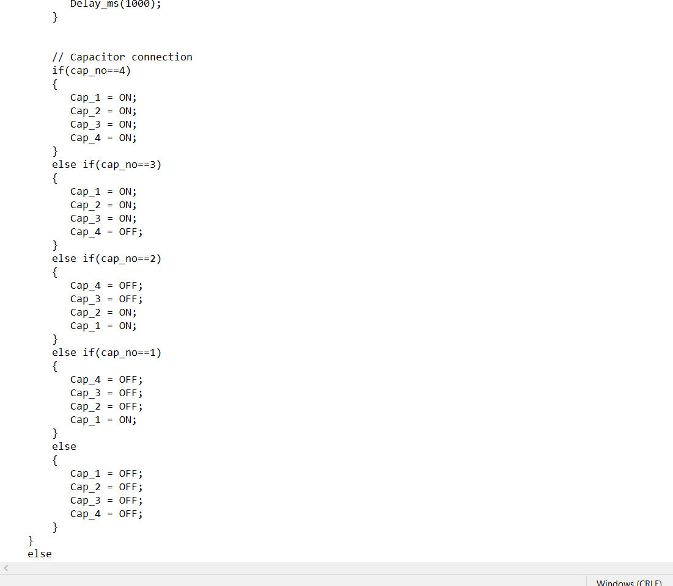

**+**

**Conclusion:**

For improving the power factor with a suitable method of automatic power factor correction, the study undertakes the design and simulation of an automatic power factor correction that is developed using PIC (Programmable Interface Controller) microcontroller chip. Use of microcontroller reduces the costs and the customers become beneficial according to the simulated output because the power factor of the specific selected industry is corrected from 0.66 to 0.92 improved value. This work describes the design and development of a power factor corrector using PIC (Programmable Interface Controller) micro controller chip. Measuring of power factor from load is achieved by using PIC Microcontroller-based developed algorithm to determine and trigger sufficient switching of capacitors in order to compensate demand of excessive reactive power locally, thus bringing power factor near to unity.