Breast Cancer Diagnosis using KNN

Results :

With random state= 0

The confusion Matrix Plot:

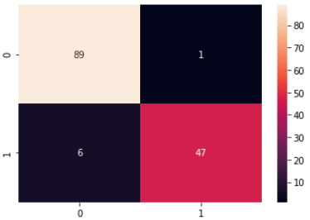

Confusion matrix Report:

precision recall f1-score support

M 0.94 0.99 0.96 90

B 0.98 0.89 0.93 53

accuracy 0.95 143

macro avg 0.96 0.94 0.95 143

weighted avg 0.95 0.95 0.95 143

With random state= 42

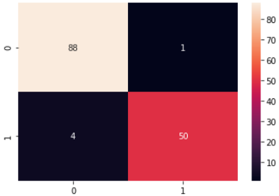

precision recall f1-score support

M 0.96 0.99 0.97 89

B 0.98 0.93 0.95 54

accuracy 0.97 143

macro avg 0.97 0.96 0.96 143

weighted avg 0.97 0.97 0.96 143

with increasing number of random state its very benificial to increases the accuracy results