User Manual

How to wire up the AVR board
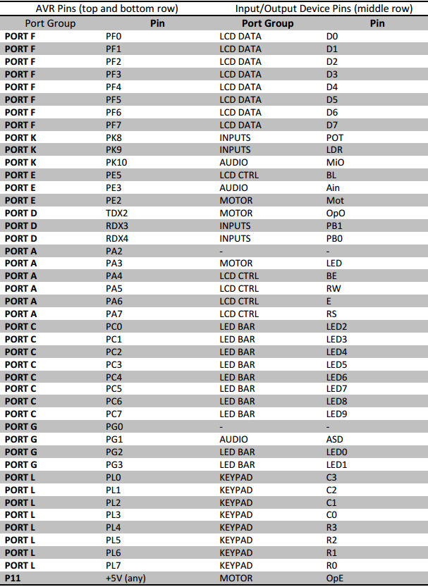
Firstly connect the speaker between the pin labelled PB3 and the pin labelled GND. Then, wire up the board as described in 'Board Test Procedure'.

How to play the game

Board setup
Connect the board to a stable power supply and press the reset button. You should see the 'Safe Cracker' title screen.
2121 16s1
Safe Cracker

Setting the difficulty
On the title screen, press the letter keys to set the amount of time you will have to find the correct potentiometer position.
Difficulty Level | Time Limit
A | 20 seconds
B | 15 seconds
C | 10 seconds
D | 6 seconds

Starting a new game
Press PB1 (the left push-button) to start the countdown timer to begin a new game.

Find POT
In this stage, you will have to set the potentiometer to the correct position before the time runs out. The time remaining will be displayed on the LCD. The correct position is a secret and will be different every time.
If the potentiometer is not set to 0, you will see the 'Reset POT' screen.
Reset POT to 0
Remaining: ?

Rotate the potentiometer anti-clockwise as far as possible and leave it there for 500ms until you see the 'Find POT' screen.
Find POT Pos
Remaining: ?

Now rotate the potentiometer clockwise to find the correct potentiometer position without going past it. If you go too far, you will have to reset the POT and the correct position will be changed! As you approach the correct position, the LEDs will light up. The closer you are to the correct position, the more LEDs will be lit.
Once all the LEDs are lit, leave the potentiometer for 1 second in that position to advance to the 'Find Code' screen.

Find Code
Position found!
Scan for number

In this stage you need to find the correct key on the keypad. The correct key is secret and will be different every time. Whenever the correct key is held, the motor will spin.
Find and hold the correct key for 1 second to advance to the next stage.

Enter Code
Once you have found the correct key 3 times in a row, you will reach the 'Enter Code' screen. Enter the 3 secret keys you found in order to win the game!

Restarting the game
At any time, press PB0 (the right push-button) to return to the title screen.

References
Board Test Procedure, http://webapps.cse.unsw.edu.au/webcms2/course/showfile.php?cid=2435&color=orange&addr=Labs/Board%20Test%20Procedure.pdf
COMP2121 Project specifications, http://webapps.cse.unsw.edu.au/webcms2/course/showfile.php?cid=2435&color=orange&addr=Assignments/Project%2016s1.pdf

