190026T

AHMAED M.I.I

GitHub: https://github.com/ishrath99/S4_EN_2550/tree/main/Assignments/Assignment_1

**EN 2550**

**Assignment 1 – Report**

**Question 1**

After applying the following transformation, the result appears as follows.

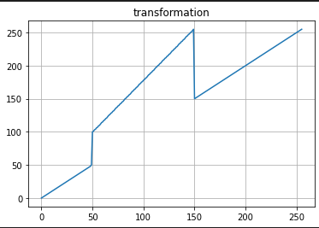

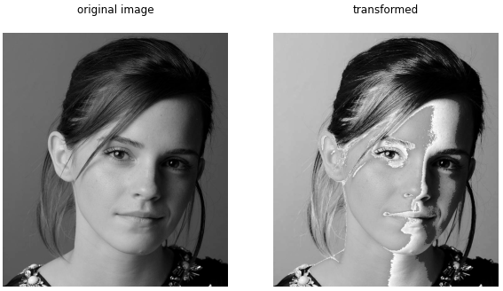

Figure: Intensity transformation & Comparison of original and transformed images

The white (150-255) and the black (0-50) pixels of the image is stays the same. Gray pixels of the image have been transformed to white pixels. Pixels ranging from 51 to 99 does not appear in the transformed image.

**Question 2**

White and gray matter accentuation is done to the following image.

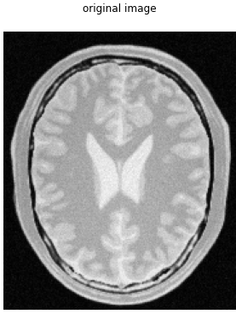

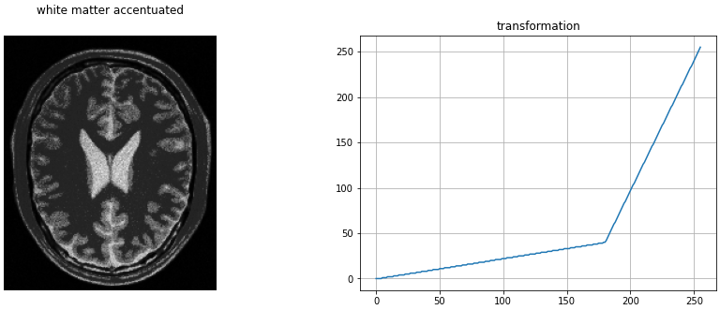

As we can observe, details of the white pixels are accentuated. They are mapped to a larger range.

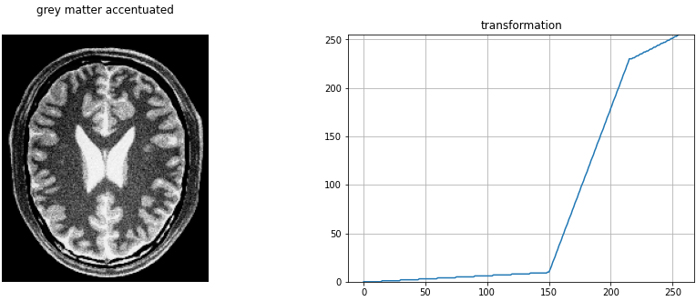

Here, grey pixels (150-230) are mapped to a larger range to accentuate the gray pixels of the image.

**Question 3**

Gamma correction has been done on the L plane in the L*a*b plane of the image. Gamma value is chosen to 0.5. As the L refers to the lightness of the image, we can expect to gamma corrected image to be brighter. Because, for a gamma value like 0.5, darker pixels get mapped to a larger range of lighter pixels.

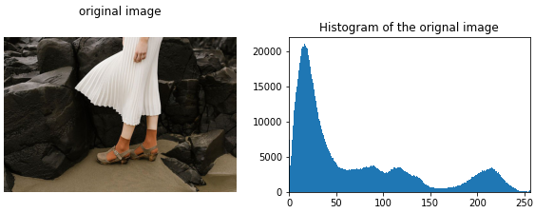

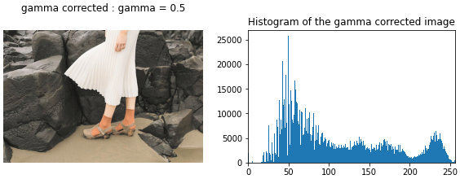

It can be observed from both histogram and the image that, darker pixels are reduced and they are shifted to the right side (towards lighter pixels).

**Question 4**

Following is the function to carry out histogram equalization.



The following figure shows the results after applying the above function to an image.

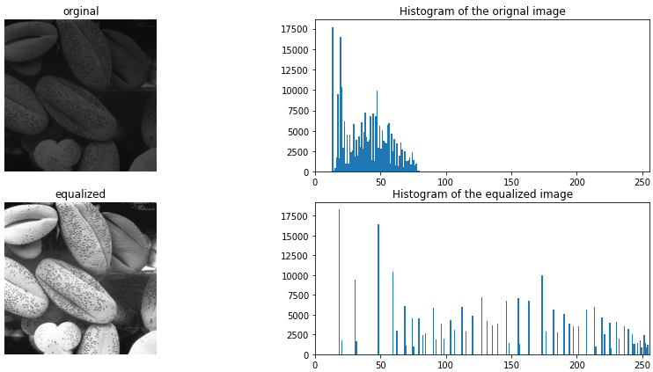

**Question 5**

**Question 6**

**Question 7**