190026T

AHMAED M.I.I

GitHub: https://github.com/ishrath99/S4_EN_2550/tree/main/Assignments/Assignment_2

**EN 2550**

**Assignment 2 – Report**

**Question 1**

Algorithm:

In addition to RANSAC algorithm, a new condition was passed to eliminate the bigger circles caused by points in the straight line.

**Choosing parameters:**

(Number of iterations)

**Functions:**





**Results:**

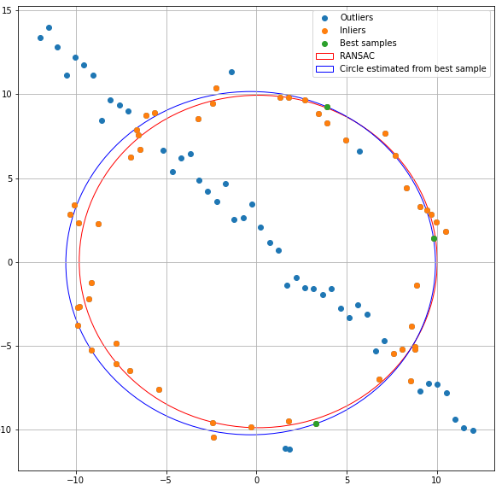

**Question 2**

**Functions:**



**Results:**

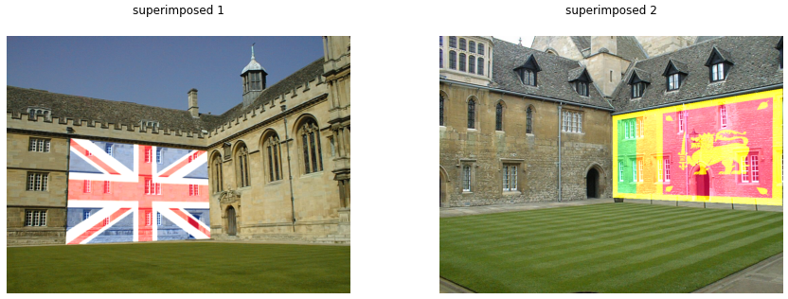

**Non-technical rationale of choice of images:**

This kind of warping can be used for advertising and photo editing. When warping, we can consider the weightage of the source and the destination images. We must also consider the alignment and the points of contact of the images.

**Question 3**

**(a)**

Sift features are detected of the 2 images. Then features are matched using Flann based KNN matcher. Good matches are extracted as per Lowe’s ration test. Ratio is selected to be **0.7**.

Since the good matching points between ***img1*** and ***img5*** are not enough to come up with a good homography. Homography is calculated associatively by starting from ***img1*** and ***img2*** and propagating the homography until ***img4*** and ***img5.***

**(b)**

Homography is calculated from the good matches. The function ***cv.findhomography()*** is used to obtain the homography with RANSAC implementation with the confidence of **0.95**.

**Comparison:**

Homography calculated:

Homography given:

Calculated homography is almost the same as the given homography in the dataset.

**(c)**

Following images shows the resulting image after stitching and the matching features between the images. The images are not perfectly stitched. The reason is, calculated homography is slightly different than the one in the dataset.

