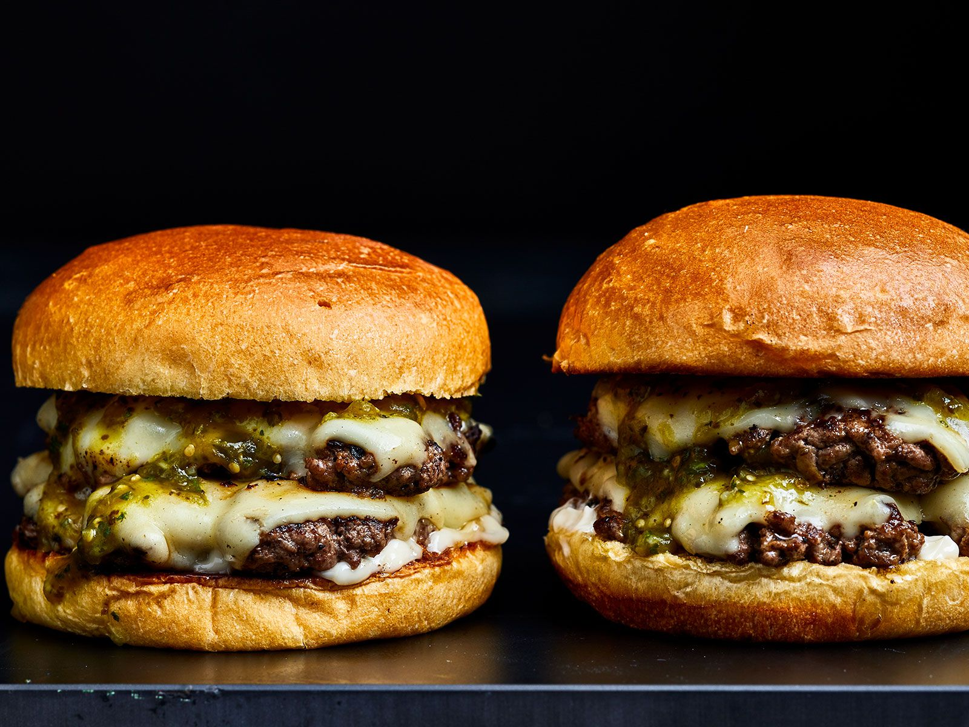

CHEESEBURGER NA WALANG CHEESE

121 Kanto Kanto Street  
Contact no.:8700-700

E-mail address: Lutosakanto@gmail.com

**PERSONAL INFORMATION:**

**NICKNAME:** Burger

**GENDER:** Male

**BIRTHDAY:** August 2023

**AGE:** 18

**NATIONALITY:** Mc Jollibee

**RELIGION:** None

**CIVIL STATUS:** Married with patty

**MOTHER:** Hotdog  
` **FATHER:**  Footlong

**EDUCATIONAL BACKGROUND:**

**ELEMENTARY EDUCATION:**

LA CONSOLACION COLLEGE CALOOCAN 496 A. Mabini St. Caloocan City 2008 – 2014

**SECONDARY EDUCATION:**

LA CONSOLACION COLLEGE CALOOCAN Information Communication Technology 496 A. Mabini St. Caloocan City 2014 – 2020

**COLLEGE:**

UNIVERSITY OF THE EAST CALOOCAN

Bachelor of Science in Information Technology

105 Samson Rd, Caloocan, Metro Manila

2020-2024