RAMIREZ, ISHMAEL L.

20201132141

1. Create a queue class in python that will accept maximum of 4 data items only!

**Screenshot:**

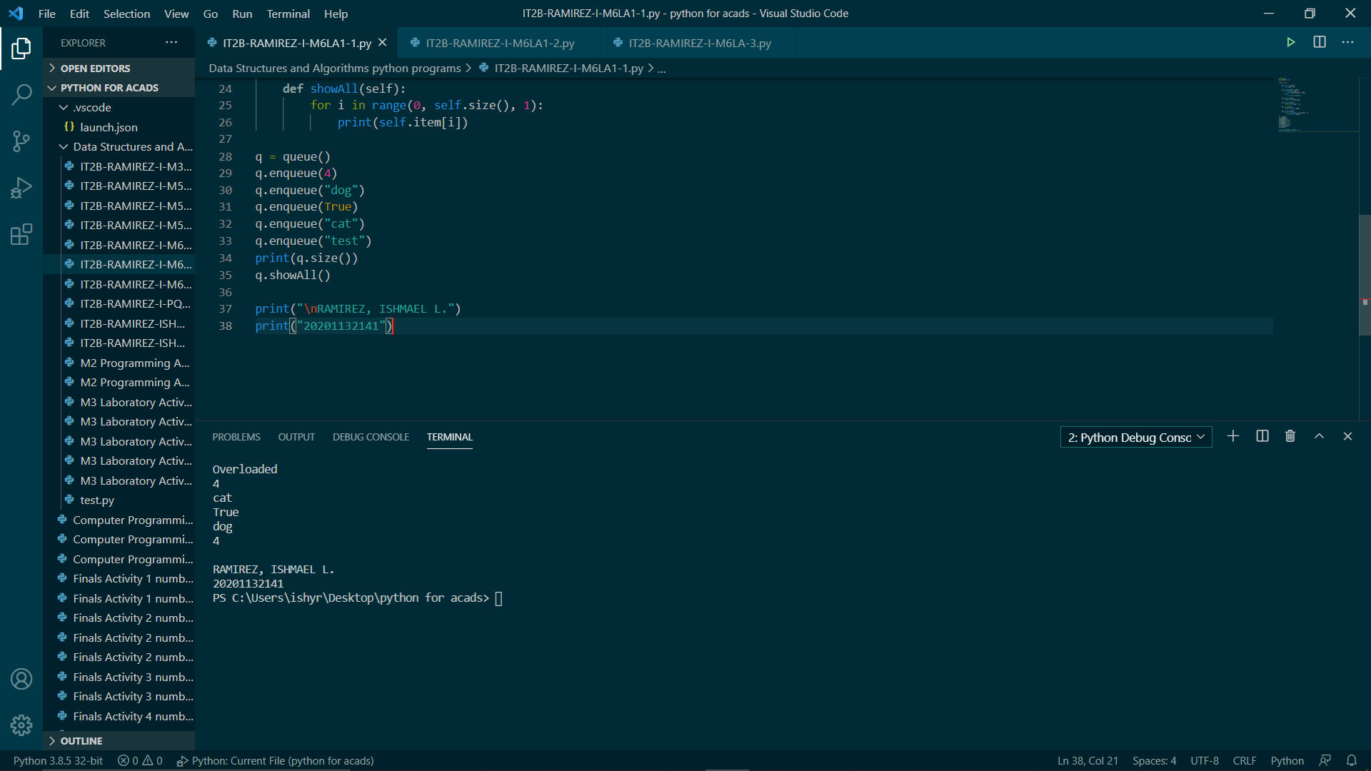

**Python Code:**

import os

os.system("cls")

class queue:

def __init__(self):

self.item = []

def enqueue(self, item):

if len(self.item) < 4:

self.item.insert(0, item)

else:

print("Overloaded")

def dequeue(self):

return self.item.pop()

def isEmpty(self):

return self.item == []

def size(self):

return len(self.item)

def showAll(self):

for i in range(0, self.size(), 1):

print(self.item[i])

q = queue()

q.enqueue(4)

q.enqueue("dog")

q.enqueue(True)

q.enqueue("cat")

q.enqueue("test")

print(q.size())

q.showAll()

print("\nRAMIREZ, ISHMAEL L.")

print("20201132141")

1. Create a queue class in python that will only accept integers less than 10.

**Screenshot:**

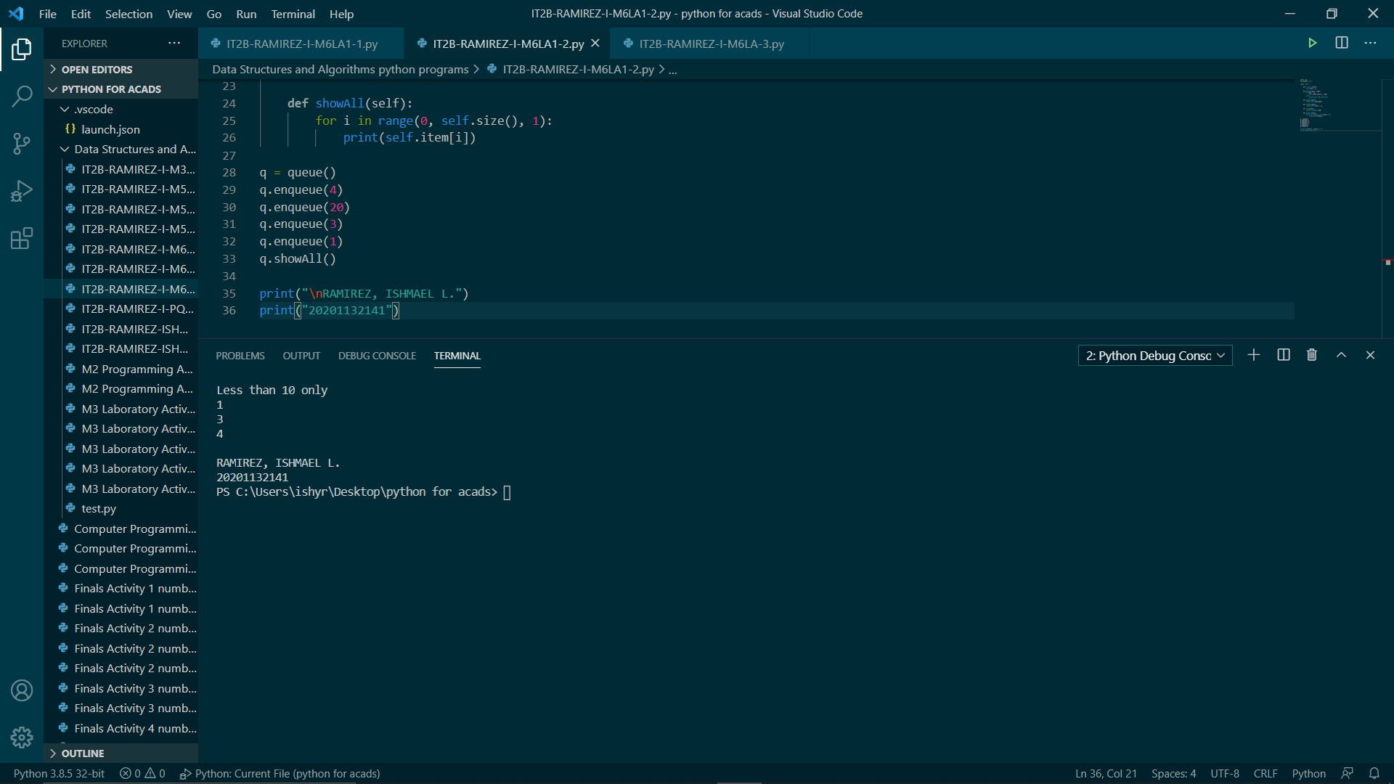

**Python Code:**

import os

os.system("cls")

class queue:

def __init__(self):

self.item = []

def enqueue(self, item):

if item < 10:

self.item.insert(0, item)

else:

print("Less than 10 only")

def dequeue(self):

return self.item.pop()

def isEmpty(self):

return self.item == []

def size(self):

return len(self.item)

def showAll(self):

for i in range(0, self.size(), 1):

print(self.item[i])

q = queue()

q.enqueue(4)

q.enqueue(20)

q.enqueue(3)

q.enqueue(1)

q.showAll()

print("\nRAMIREZ, ISHMAEL L.")

print("20201132141")

1. Create a new method in queue class that will clear all the contents inside of it.

**Screenshot:**

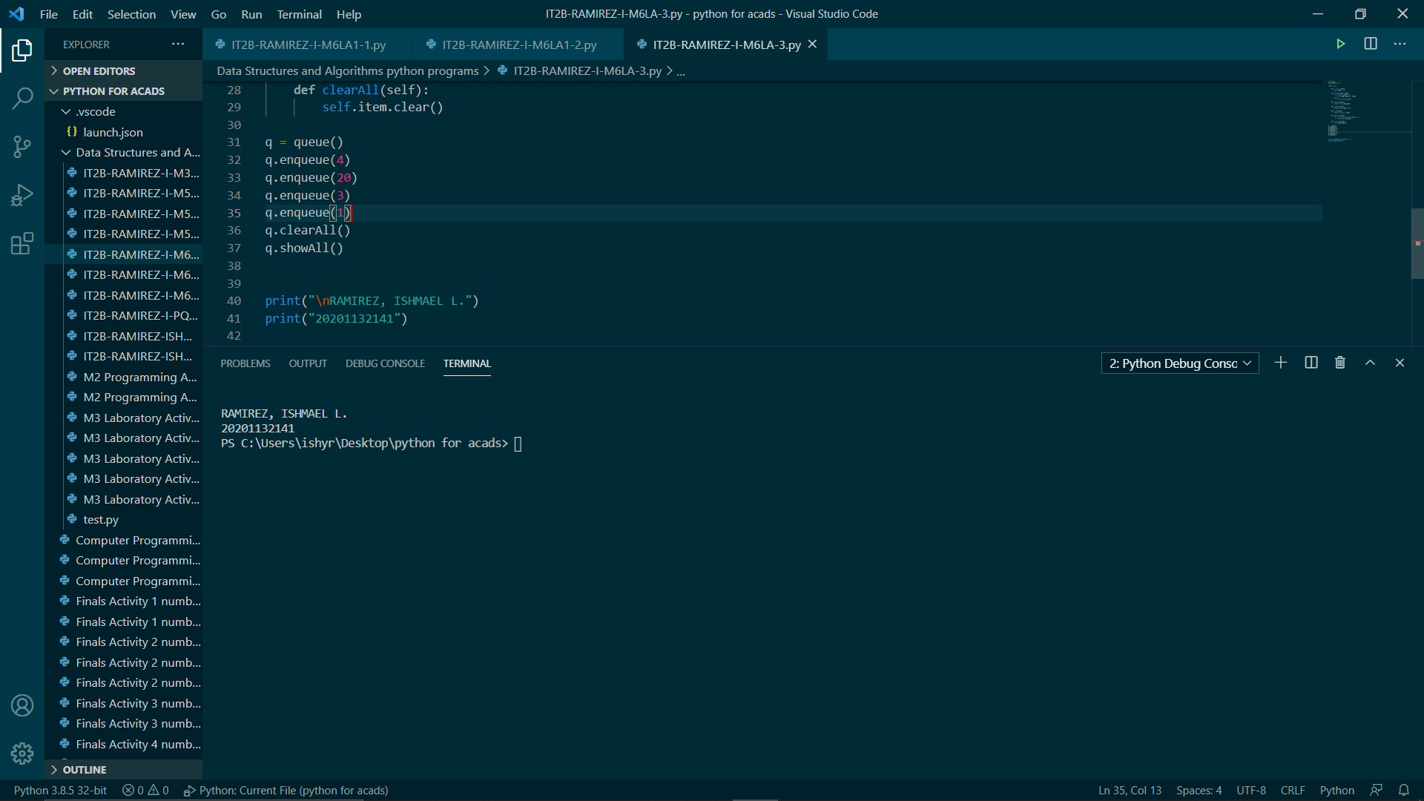

**Python Code:**

import os

os.system("cls")

class queue:

def __init__(self):

self.item = []

def enqueue(self, item):

self.item.insert(0, item)

def dequeue(self):

return self.item.pop()

def isEmpty(self):

return self.item == []

def size(self):

return len(self.item)

def showAll(self):

for i in range(0, self.size(), 1):

print(self.item[i])

def clearAll(self):

self.item.clear()

q = queue()

q.enqueue(4)

q.enqueue(20)

q.enqueue(3)

q.enqueue(1)

q.clearAll()

q.showAll()

print("\nRAMIREZ, ISHMAEL L.")

print("20201132141")