RAMIREZ, ISHMAEL L.

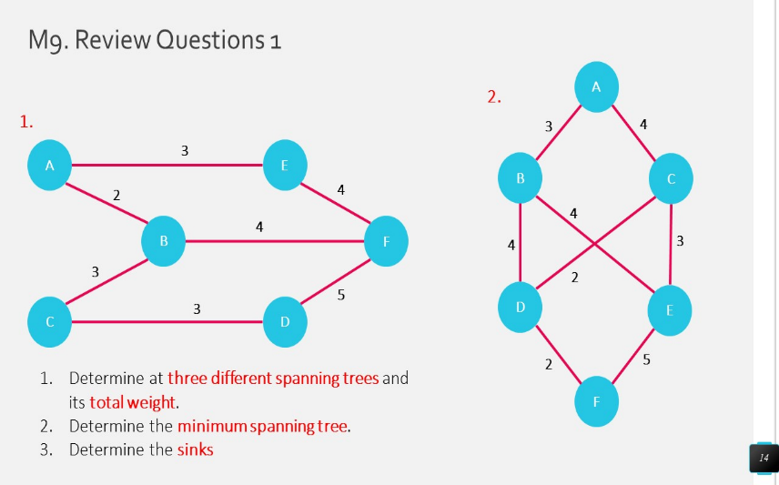20201132141

Question 1:

Number 1: Number 2:

1. A – B – C – D – F – E 1. A – B – D – F – E – C

Total weight = 17 Total weight = 17

1. F – D – C – B – A – E 2. E – B – A – C – D – F

Total weight = 16 Total weight = 15

1. D – C – B – A – E – F 3. F – D – C – E – B – A

Total weight = 15 Total weight = 14

Question 2:

Number 1: Number 2:

D – C – B – A – E – F F – D – C – E – B – A

Total weight = 15 Total weight = 14

Question 3:

Number 1: Number 2:

1. A – B – C – D – F – E 1. A – B – D – F – E – C

A and E are sinks A and C are sinks

1. F – D – C – B – A – E 2. E – B – A – C – D – F

F and E are sinks E and F are sinks

1. D – C – B – A – E – F 3. F – D – C – E – B – A

D and F are sinks F and A are sinks