**UNIVERSITY OF THE EAST**

152 Samson Road, Caloocan City

College of Engineering

Information Technology Department

**CCS4102 – PROGRAMMING LANGUAGES**

**Laboratory Activity 1**



| ***Name*** | RAMIREZ, Ishmael L. | ***Section:*** | IT2G |
| --- | --- | --- | --- |
| ***Student Number*** | 20201132141 | ***Professor:*** | **Celis, J. R. E.** |

**INSTRUCTIONS:**

* For each problem, paste the code and sample output here.
* Make sure your name and student number are printed at the end of the output.

**EXAMPLE:**

**Sample Problem:**

Create a program that accepts two numbers, then displays the sum, difference, product, and quotient.

**Code: Sample Output:**

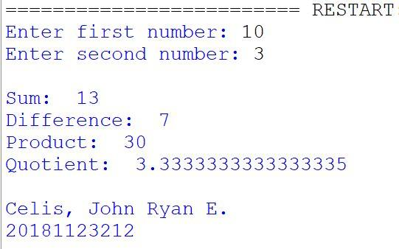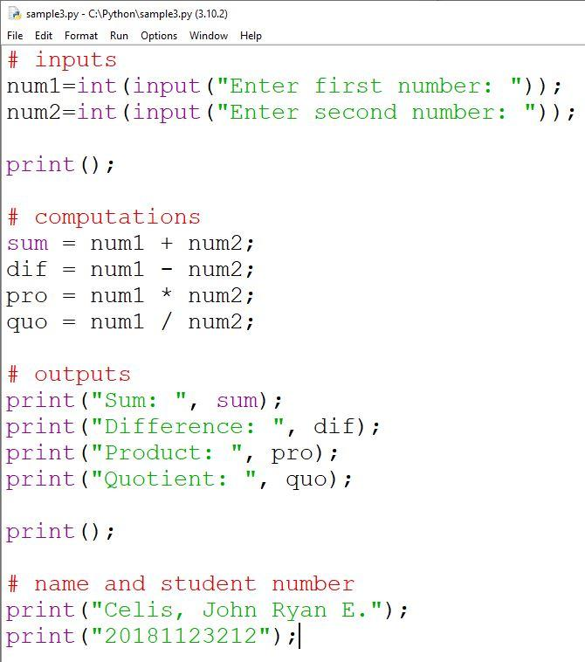

**Problem 1:**

A new law states that a driver will be fined P500 if his speed goes beyond 80 KPH, and will be fined an extra P50 for every KPH beyond 100KPH. Design a C++ program that will input the driver’s speed and will output the corresponding fine.

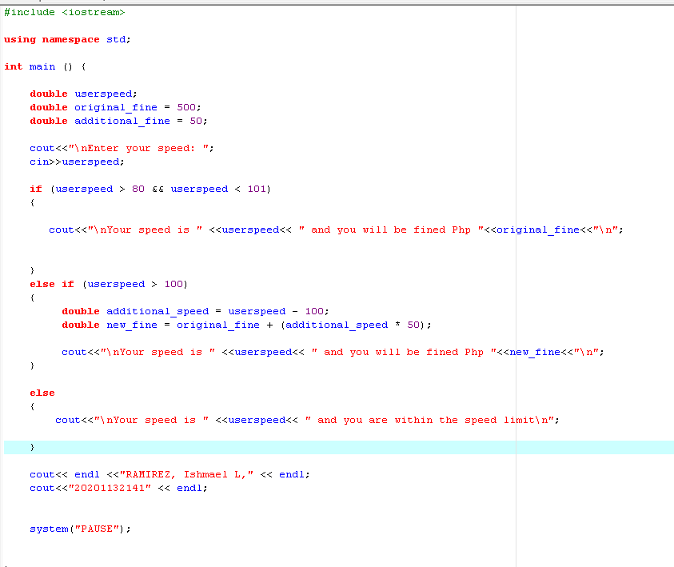

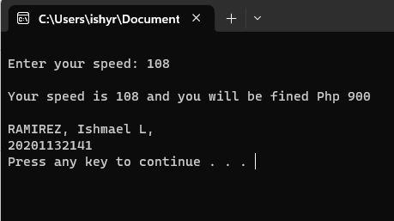

**Problem 2:**

Create a C++ application that will allow the user to enter any number. The input will only stop if the entered number is 0. The program will then display the sum of all the numbers entered.

