**UNIVERSITY OF THE EAST**

**Rating**

152 Samson Road, Caloocan City

College of Engineering

Information Technology Department

**CCS2102 – OBJECT ORIENTED PROGRAMMING**

**Laboratory Activity 5**

|  |  |  |  |
| --- | --- | --- | --- |
| ***Name*** | **RAMIREZ, Ishmael L.** | ***Section:*** | **IT2G** |
| ***Student Number*** | **20201132141** | ***Professor:*** | **Celis, J. R. E.** |

**INSTRUCTIONS:**

* For each problem, paste the code and sample output here.
* Make sure your name and student number are printed at the end of the output.

**EXAMPLE:**

**Sample Problem:**

Create a program that accepts two numbers, then displays the sum, difference, product, and quotient.

**Code: Sample Output:**

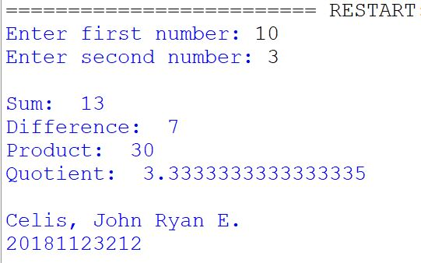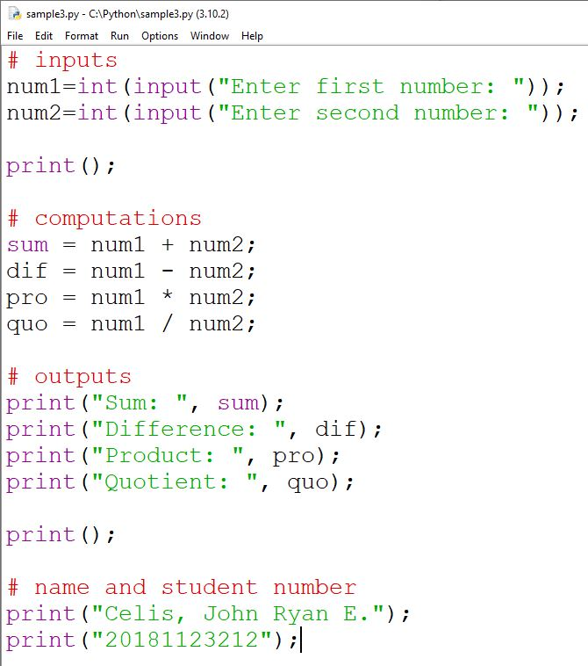

**Problem:**

Create a C++ program that will input the following:

* Employee Name
* Position Code
* Tax Code

The program will output the following:

* Employee Name
* Position Code Equivalent
* Tax Code Equivalent
* Gross Pay
* Net Pay

Based on the following:

* Position Codes:
  + M = “Manager” (Gross Pay of Manager is 50,000)
  + S = “Supervisor” (Gross Pay of Supervisor is 35,000)
  + R = “Regular” (Gross Pay of Regular is 25,000)
  + C = “Contractual” (Gross Pay of Contractual is 15,000)
  + Other letter = “Unknown” (Gross Pay of Unknown is 0)
* Tax Code Equivalent:
  + A = 10% tax
  + B = 20% tax
  + C = 30% tax
  + D = 40% tax
  + Other Letter = 0%
* Gross Pay is based on the entered Position Code
* Net Pay is Gross Pay minus the tax based on the entered tax code

**NOTE:**

* Make sure that you write the program based on Classes, Objects, and Methods.
* Make sure you implement Setters and Getters.
* Update your Journal to include this laboratory activity.

For live preview, download the program here:

<https://drive.google.com/file/d/1G64lq6iAgTcE5AGjDgn9dwO9Gg-DaNAh/view?usp=sharing>

Note: Your browser, anti-virus, or operating system may consider this file as a virus because this is an executable file.

**Code:**

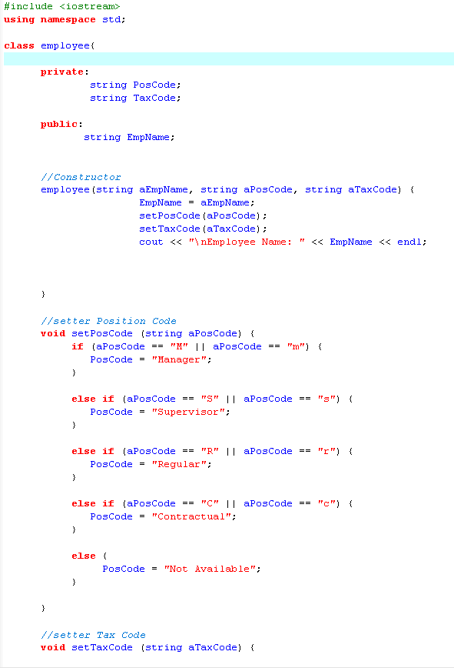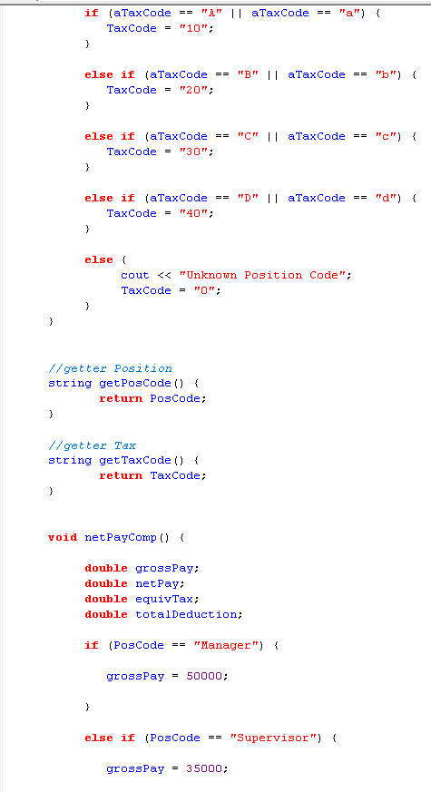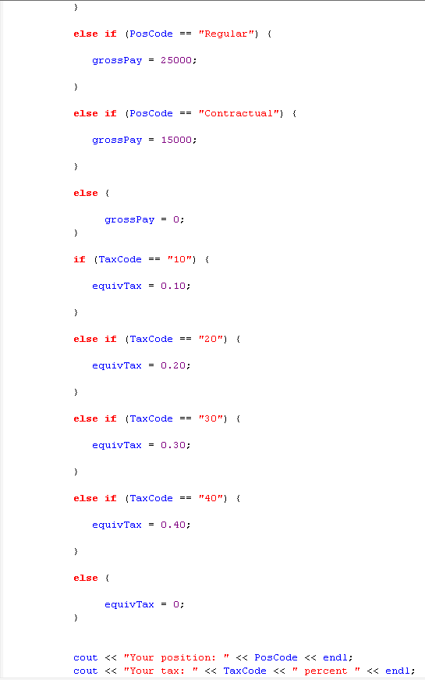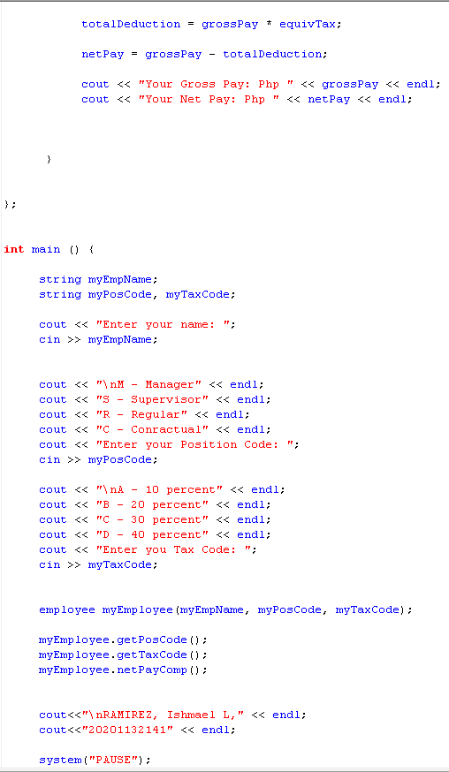

Output:

