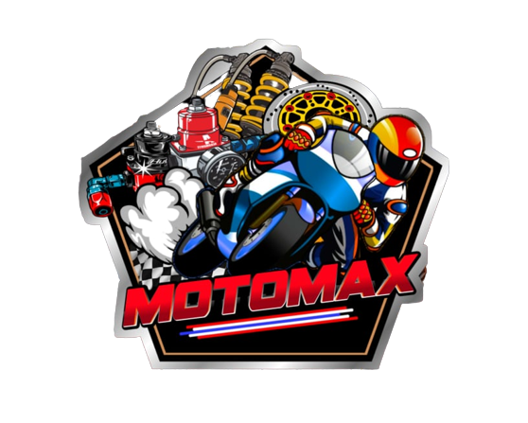

**System: Motorshop Management System**

**Introduction:**

As you know, running a successful motor shop requires efficient and effective management of various aspects of the business, including customer management, inventory management, service management, invoicing and billing, and financial management.

Unfortunately, many motor shops still rely on manual processes and disparate systems to manage these tasks, leading to inefficiencies, errors, and increased costs. That's where our proposed motorshop system comes in.

Our system is designed to streamline and automate the processes involved in running a motor shop, helping you to increase efficiency, reduce costs, and provide an exceptional customer experience. With features such as customer management, inventory management, service management, invoicing and billing, and financial management, our system is the comprehensive solution you need to manage your business.

I would now like to take you through a brief overview of the key features and benefits of our motorshop system, and I believe that after you see what our system can do, you will agree that it is the best solution for your business.

**Clients/stakeholders:**

* **Motor Shop Owners and/or Managers**: These are the individuals who are responsible for running the motor shop and who have the primary interest in improving the efficiency and profitability of their business.
* **Service Technicians**: These are the individuals who perform the service work on vehicles, and who will benefit from a system that streamlines the service process and provides them with the tools they need to perform their work efficiently
* **Customers**: These are the individuals who bring their vehicles to the motor shop for service, and who will benefit from a system that provides them with a better customer experience, including faster service and improved communication.

In general, a motorshop system proposal should consider the needs and interests of all relevant stakeholders in order to ensure that the proposed system is comprehensive, effective, and well-received by all parties.

**Nature of Business**

The nature of business for a motorshop refers to the type of activities and operations that are performed by the motor shop. Typically, a motorshop is involved in the maintenance, repair, and service of motorcycle.

The nature of the business may include tasks such as:

* **Vehicle diagnostics**: Performing diagnostic tests to identify and diagnose problems with vehicles.
* **Repairs and maintenance**: Performing repairs and routine maintenance on vehicles, such as oil changes, tire rotations, and brake repairs.
* **Parts replacement**: Replacing parts and components that are worn or damaged, such as batteries, spark plugs, and belts.
* **Customization**: Installing aftermarket parts and accessories to customize vehicles to meet the specific needs and preferences of customers.
* **Customer service**: Providing excellent customer service, including answering questions, providing advice and recommendations, and addressing any concerns or issues that customers may have.

In order to run a successful motorshop, it is important to have a comprehensive understanding of the nature of the business and the tasks and operations involved in performing the work. By having a clear understanding of the nature of the business, you can ensure that you have the right tools and systems in place to support your operations and achieve your goals.

**Product and Services:**

The products and services offered by a motorshop can vary depending on the specific focus of the business and the needs of its customers. Some common products and services that may be offered by a motorshop include:

* **Parts and supplies**: Selling parts and supplies that are needed to perform maintenance and repairs on vehicles, such as batteries, spark plugs, and filters.
* **Vehicle maintenance**: Providing routine maintenance services, such as oil changes, tire rotations, and brake repairs.
* **Repairs and diagnostics**: Performing repairs on vehicles and diagnosing problems with vehicles to identify the root cause of issues.
* **Customization**: Installing aftermarket parts and accessories to customize vehicles to meet the specific needs and preferences of customers.

In general, the products and services offered by a motorshop should be designed to meet the specific needs and preferences of its customers, and to help improve the efficiency, performance, and appearance of their vehicles. By offering a range of products and services that are relevant to its customers, a motorshop can build a loyal customer base and establish a strong reputation in the community.

**Scope of the System:**

The scope of a system refers to the boundaries and limitations of the system, as well as the specific functions and features that the system is designed to perform. In the context of a motorshop system, the scope of the system would typically include the following:

* **Inventory management**: Keeping track of the parts, supplies, and tools that are used in the motorshop, including the ability to manage stock levels, place orders for new items, and generate reports on inventory usage and trends.
* **Customer management**: Keeping track of customer information, including contact information, vehicle information, and service history, as well as the ability to schedule appointments, create quotes and invoices, and manage customer accounts
* **Employee management**: Keeping track of employee information, including schedules, roles and responsibilities, and performance metrics, as well as the ability to manage payroll and benefits, and generate reports on employee performance.
* **Service management**: Keeping track of the services that are performed on vehicles, including the ability to schedule appointments, generate quotes and invoices, and manage the service workflow, from diagnosis to repair.
* **Financial management**: Keeping track of financial information, including sales, expenses, and profits, as well as the ability to generate reports on financial performance and budgeting.

The scope of the motorshop system will depend on the specific needs and requirements of the business, as well as the size and complexity of the operations. By defining the scope of the system, you can ensure that the system is tailored to the specific needs of the motorshop, and that it provides the functionality and features that are needed to support the operations and achieve your goals.

**Flow of the system:**

The flow of a motorshop system refers to the process and steps involved in the operation of the system, from the input of data to the output of results. A typical flow of a motorshop system might include the following steps:

* **Customer management**: Customers are added to the system, either by manual entry or by integrating with an existing customer database. Customer information, including contact information, and vehicle information is stored in the system.
* **Vehicle Queueing**: Customers can get their designated numbers for the waiting line and they will be serve according to their position in their queue.
* **Service management**: When the vehicle arrives at the motorshop, the service technician enters the service information into the system, including the diagnosis of the problem, the estimated cost of the repair.
* **Inventory management**: The system automatically updates the inventory levels to reflect the parts and supplies that are used during the repair, and generates a request to order more items if necessary.
* **Billing and payment**: When the repair is complete, the system generates an invoice for the customer, which can be reviewed and approved by the customer. Payment can be processed through the system, either through a gcash payment or by using an existing point of sale (POS) system.
* **Maintenance and improvement**: The system is regularly updated and maintained to ensure that it continues to meet the needs of the motorshop and its customers, and to incorporate any new features or functionalities that are needed.

By following this flow, the motorshop system provides a streamlined, efficient, and effective process for managing the operations of the motorshop, from customer management to billing and payment, and beyond.

**Software and Hardware needed:**

The software and hardware requirements for a motorshop system will depend on the size and complexity of the system, as well as the specific needs of the motorshop.

**Software:**

* **Operating system**: A modern operating system, such as Windows 10 or a version of Linux, is required to run the motorshop system.
* **Database management system**: A database management system, such as MySQL, is required to store and manage the customer, appointment, service, and inventory information.
* **Programming language:** A programming language, such as C# , is required to develop and implement the motorshop system.
* **User interface**: A user interface, such as a web-based interface or a Windows-based graphical user interface (GUI), is required to allow customers and employees to interact with the system.
* **Payment processing software**: Payment processing software, such as a payment gateway or a point of sale (POS) system, is required to process gcash and other payments.

**Hardware:**

* Server: A server, such as a Windows Server or a Linux server, is required to host the motorshop system and the database management system.
* Workstations: Workstations, such as desktop computers or laptops, are required for employees to interact with the system.
* Network: A network, such as a local area network (LAN) or a wide area network (WAN), is required to connect the servers and workstations and to allow for communication between the components of the system.

By taking these software and hardware requirements into account, it is possible to develop a motorshop system that meets the needs of the motorshop and its customers, and provides a reliable, efficient, and effective process for managing the motorshop operations.