**M1: Activity 1: Historical Antecedents**

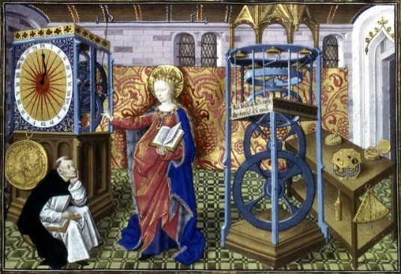**Invention or discovery: Mechanical Clock**

The English word "clock" replaced the Old English word daegmael meaning "day measure." The word "clock" comes from the French word cloche meaning bell. Until the High Middle Ages, there was no accurate and accessible way of measuring time. People had to rely on natural phenomenon, such as the movements of the Sun, or on contraptions such as the hour glass or calibrated candles. It was only in the 14th century that innovations in Church bell-ringing mechanism evolved to give birth to the earliest mechanical clocks. The mechanical clock, which derived from water clock, was born in medieval Europe which dates back from 1344 and being used in a cathedral in Padua.

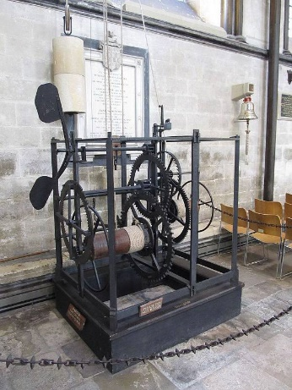The mechanical clock comprises an oscillating mechanism that marks the passing of time, and an escapement that counts its beats. By comparison with astronomical systems for measuring time, the mechanical clock is less accurate, hence, can be consulted at any time of day or night (even in adverse weather conditions). The first examples were truly huge devices and relied on the use of heavy-weights (made of iron) to drive the clock's hands. They were often built-in tall towers and were able to keep relatively good time for long periods. Most often only lost about 2 hours a day. Whilst that might sound very inaccurate today, they were cutting edge at the time.

**Antecedents of the Mechanical Clock:**

* **Wrist Watch:** In 1504, the first portable timepiece was invented in Nuremberg, Germany by Peter Henlein. It was not very accurate.
* **Minute Hand:** In 1577, Jost Burgi invented the minute hand. Burgi's invention was part of a clock made for Tycho Brahe, an astronomer who needed an accurate clock for stargazing.
* **Pendulum Clock:** In 1656, the pendulum clock was invented by Christian Huygens, making clocks more accurate.
* **Mechanical Alarm Clock:** The first mechanical alarm clock was invented by American Levi Hutchins of Concord, New Hampshire, in 1787. However, the ringing bell alarm on his clock could ring only at 4 a.m. In 1876, a mechanical wind-up alarm clock that could be set for any time was patented (No. 183,725) by Seth E. Thomas.
* **Standard Time:** Sir Sanford Fleming invented standard time in 1878. Standard time is the synchronization of clocks within a geographical area to a single time standard. It developed out of a need to aid weather forecasting and train travel. In the 20th century, the geographical areas were evenly spaced into time zones.
* **Big Ben:** In 1908, the Westclox Clock Company has issued a patent for the Big Ben alarm clock in London. The outstanding feature on this clock is the bell back, which completely envelops the inner case back and is an integral part of the case. The bell back provides a loud alarm.
* **Battery-Powered Clock:** The Warren Clock Company was formed in 1912 and produced a new type of clock run by batteries, prior to that, clocks were either wound or run by weights.
* **Self-Winding Watch:** Swiss inventor John Harwood developed the first self-winding watch in 1923.
* **Quartz Clock:** In 1927, Warren Marrison, a telecommunications engineer, was searching for reliable frequency standards at Bell Telephone Laboratories. He developed the first quartz clock, a highly accurate clock based on the regular vibrations of a quartz crystal in an electrical circuit.
* **Atomic Clock:** Atomic clocks are far more accurate than any previous timekeeping device, and are used to calibrate other clocks and to calculate the International Atomic Time; a standardized civil system, Coordinated Universal Time, is based on atomic time.

**References:**

* https://i.pinimg.com/originals/95/aa/23/95aa236c5c5ae6204d2ebc7d85d6d5d7.jpg
* <https://images.interestingengineering.com/images/APRIL/Mechanical_engineering_clock.jpg>
* https://www.medievalists.net/2014/08/ten-medieval-inventions-changed-world/
* https://mfgsc-vic.libguides.com/c.php?g=916765&p=6610145#:~:text=A%20number%20of%20very%20important,Mills%2C%20Gunpowder%20and%20Printing%20Press.
* https://brunelleschi.imss.fi.it/itineraries/multimedia/MechanicalClocks.html
* https://www.thoughtco.com/clock-and-calendar-history-1991475
* https://interestingengineering.com/science/the-very-long-and-fascinating-history-of-clocks
* https://localhistories.org/a-history-of-clocks/