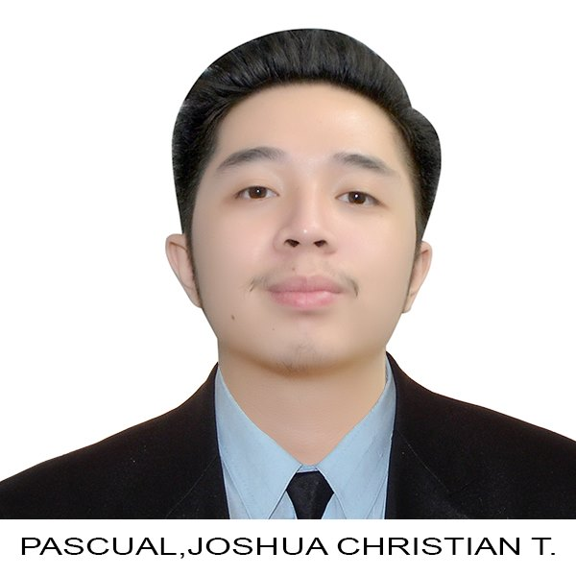

JOSHUA CHRISTIAN T. PASCUAL

Address: 313 Libis Talisay Dagat-Dagatan, Caloocan City   
Contact no.:09560261502

E-mail address: jcpascual13@gmail.com

**PERSONAL INFORMATION:**

**NICKNAME:** JC

**GENDER:** Male

**BIRTHDAY:** December 16, 2001

**AGE:** 21

**NATIONALITY:** Filipino

**RELIGION:** Roman Catholic

**CIVIL STATUS:** Single

**MOTHER:** Ma. Amor Pascual  
` **FATHER:**  Rossano C. Pascual

**EDUCATIONAL BACKGROUND:**

**ELEMENTARY EDUCATION:**

LA CONSOLACION COLLEGE CALOOCAN 496 A. Mabini St. Caloocan City 2008 – 2014

**SECONDARY EDUCATION:**

LA CONSOLACION COLLEGE CALOOCAN Strand: Information Communication Technology 496 A. Mabini St. Caloocan City 2014 – 2020

**COLLEGE:**

UNIVERSITY OF THE EAST CALOOCAN

Course: Bachelor of Science in Information Technology

105 Samson Rd, Caloocan, Metro Manila

2020-2024