Freight Rate Prediction
Validation approach, model selection and December forecast
Spotter Labs - Machine Learning Engineer assessment
October 31, 2026
Submitted by: Muhammad Ishtiaq Hussain

1. Summary
The task is to predict posted_rate for 12,000 loads from November-December 2025, based on 48,000 labelled loads from Jan-Oct 2025. The entire exercise in this project is based on the principle of how well a model developed during the past will be able to predict the rates one to two months down the road, so that every validation decision is framed in terms of a single question.
- Split: rolling-origin, time-based validation with two-month test windows that mirror the Nov-Dec horizon; the most recent window (Sep-Oct) is held back as a one-time final check. A simulated unseen-city test covers the 8 validation cities absent from training.
- Model: a 70/30 blend of gradient boosting and a spline Ridge model, both predicting log(rate) from distance, equipment, weight, market_index and coordinates, with recent loads weighted more heavily and corrupted labels removed from training. quote_signal is deliberately excluded: its link to price flips sign by month and is absent in Nov-Dec.
- Result: on the Sep-Oct holdout the selected model reaches MAE $65.20 (2.7% MAPE) on clean labels versus $79.26 (3.7%) for the strongest naive baseline.
- Deliverables: validation_predictions.csv (12,000 rows) and the completed December file are accepted by the unmodified score.py; the December chart is in Section 6.

2. Data findings and data quality
Distance dominates price (correlation 0.91); rate per mile falls with distance and each equipment type shifts the whole curve (Reefer > Flatbed > Dry Van). market_index is a market-wide daily value: it barely varies within a day but moves strongly across the year, and it is the strongest signal after distance. Prices also drift up over the year by about 6% beyond what market_index explains, which makes the most recent months the best guide to November-December.
Table 1. Data-quality issues and how they were handled.
Issue | Evidence | Treatment
Corrupted labels | 677 rows (1.4%) priced at 0.17-0.47x or 2.1-5.2x comparable loads; no load lies between these clusters and the clean band (0.81-1.28x) | Removed from training in every fold; kept and reported in evaluation
Negative weights | 292 train / 145 validation; absolute values match the normal distribution and are priced normally | Absolute value (sign error)
Missing weight | 300 train / 165 validation; unrelated to price | Training-window median
Missing market_index | 374 train / 249 validation; unrelated to price | Mean of the same day's loads (daily market value)
Unseen cities | 8 validation cities (1,447 loads, 12%) never appear in training | No city-name features; coordinates + distance; tested explicitly
Distance vs coordinates | Short hauls up to 2.1x the great-circle distance; prices follow the stated distance | Keep stated distance
quote_signal regimes | Within each month it encodes the true rate per mile almost exactly (R2 ~0.99), but the sign flips by month and there is no relationship in Aug 2-31 or Nov-Dec (Section 2.1) | Not used by the final model
load_id | Assigned in date order (a time proxy) | Never used as a feature

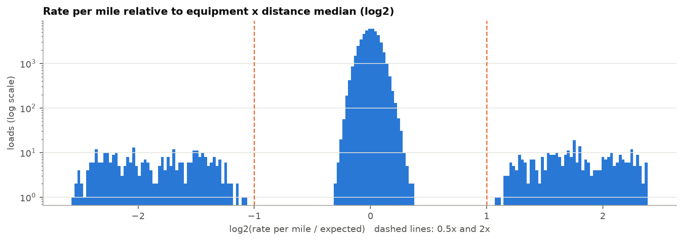
Figure 1. Rate per mile relative to comparable loads. Clean loads form one tight band; corrupted labels form two separate clusters, which justifies treating them as label errors rather than market moves.

2.1 quote_signal: a relationship that flips by month
Pooled over the year, quote_signal correlates only 0.07 with relative price, so it first looked like a weak feature, and the first draft of the model used it. Checked month by month (prompted by review), it turns out to be an almost exact linear encoding of the true rate per mile (R2 about 0.99): rate per mile is approximately quote_signal in Jan, Feb, Mar, Jun, Sep, and approximately 4.13 - quote_signal in Apr, May, Jul, Oct. From 2 August onwards there is no relationship at all. It even encodes the true price on rows whose label is corrupted.
The regime of any period can be read without labels, by correlating quote_signal with the rate per mile expected from distance and equipment alone. This matches the labelled regime in every training month. For November and December, it is about 0 every day, and validation quote_signal has August's distribution exactly. So, quote_signal carries no price information in the period to be predicted, and flipping its sign cannot help there is no regime to flip to.
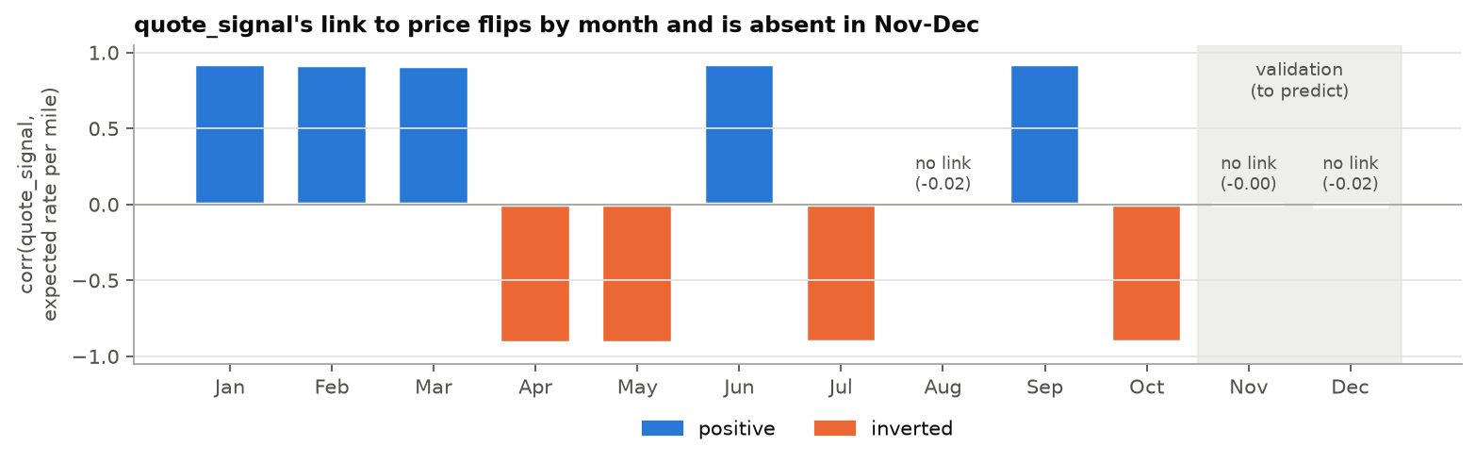
Figure 2. Label-free regime checks per month: correlation of quote_signal with the rate per mile expected from distance and equipment. Training months show a strong positive or inverted link; August and both validation months show none.

3. Train/test split and validation approach

3.1 Why a time-based split
In deployment the model is fitted on January-October and predicts November-December. A random K-fold split would mix future loads into training and test the model on periods it has already seen, overstating accuracy for a forward forecast. Prices drift over time beyond what market_index explains, so the validation must measure forecasting forward in time.

3.2 Rolling-origin folds
Table 2. Validation folds. Training windows expand; every test window is two months long.
Fold | Role | Train | Test | Train rows | Test rows
fold_1 | Model selection | Jan 1 - Apr 30 | May 01 - Jun 30 | 19,110 | 9,696
fold_2 | Model selection | Jan 1 - Jun 30 | Jul 01 - Aug 31 | 28,806 | 9,671
holdout | Final check | Jan 1 - Aug 31 | Sep 01 - Oct 31 | 38,477 | 9,523

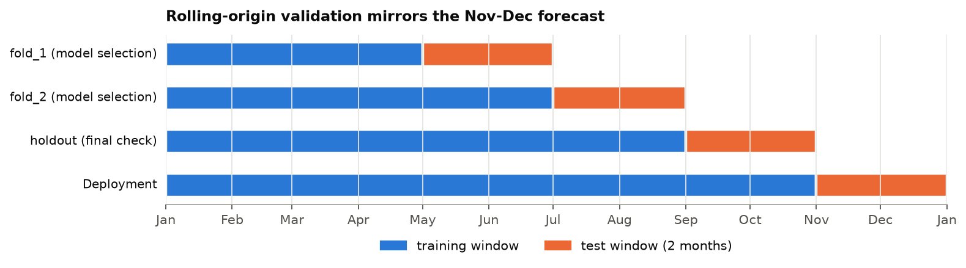
Figure 3. Each fold trains on all data before its test window and tests on the next two months, the same shape as the real task (bottom row).
- Two-month test windows match the Nov-Dec horizon; metrics are also reported separately for the first and second month, because accuracy decays with horizon.
- Different market regimes: fold_1 tests on the May-June peak, fold_2 on the July-August decline, so a model must work in both.
- Final holdout kept separate: Sep-Oct is the closest analogue to Nov-Dec. It was excluded from all model comparison (enforced in code and by a test) and only evaluated after the model was chosen (see the disclosure in Section 5).
- Final model: refitted on all January-October data with the identical pipeline.

3.3 Unseen-city check
12% of validation loads touch a city that never appears in training (always exactly one endpoint). To measure this risk, each selection fold is repeated three times with 8 random training cities hidden: every training load touching them is removed, and the model is scored on test loads with exactly one hidden endpoint. The same loads are also scored by the model that did see those cities; the difference is the cost of a new city.

3.4 Preventing leakage
- All learned preprocessing (weight median, anomaly reference, model) is fitted on the training window only; the cleaning step never drops rows, so every load receives a prediction.
- Corrupted labels are removed from training only. Test loads are never dropped; the anomaly flag only splits the reported metrics into 'all rows' and 'clean rows'.
- The model never sees the target or load_id; features are row-independent and identical in cross-validation, final training and inference (no train/serve skew).
- Each of these is enforced by an automated test in tests/.

3.5 Metrics
The official metric is not disclosed, so MAE in dollars is the primary metric (interpretable and robust to the corrupted labels), reported on clean rows and on all rows, with RMSE, MAPE (safe: every rate is positive) and bias as supporting metrics.

4. Model development and selection
All learned models predict log(rate) and are transformed back: errors scale with load size, so a log target makes them roughly proportional, and the back-transformed value estimates the median rate, which suits MAE. Experiments changed one thing at a time on the two selection folds.
- Drift: the main weakness was growing under-prediction in the second forecast month. Weighing recent loads more (30-day half-life) reduced clean MAE from $56.28 to $52.97; an explicit time trend made it worse ($77.19), because extrapolating the trend misjudges the next months.
- Ablations: removing market_index (+18), weight (+15), or coordinates (+8) all hurt; missing-value flags and day-of-week added nothing and were left out.
- quote_signal: on the selection folds, removing it looked harmful (+4), but only because those test windows had an active regime. Two checks that match the real forecast period reverse this. (1) Nov-Dec conditions: with quote_signal shuffled inside each test window, the first-draft blend falls to $65.44 while the same blend without quote_signal stays at $55.00. (2) A real lookalike: trained through July (ending in an inverted month, as October does) and tested on Aug 2-31 (no regime), clean MAE improves from $48.40 to $42.66 (-12%) without quote_signal. It was therefore removed.
- Label cleaning: training on the corrupted labels raised clean MAE from $52.97 to $80.91, confirming the decision to remove them.
- Tuning: gradient boosting settings all landed within $52.42-$54.52, i.e. within noise, so defaults were kept rather than fitted to two folds.
- Blend: Gradient boosting is strongest in the first month, Ridge (smoother) in the second; a 70/30 blend in log space was best overall. The weight was fixed once, not tuned.
Table 3. Finalists on the selection folds (meaning fold_1 and fold_2). Nov-Dec conditions = quote_signal shuffled within each test window, since it carries no information in Nov-Dec. Selected model in bold.
Selection folds (USD) | Baseline | Blend with quote_signal | GB + recency | Ridge + recency | Selected
MAE clean, as observed | 115.9 | 51.3 | 56.8 | 63.3 | 55.0
MAE clean, Nov-Dec conditions | 115.9 | 65.4 | 56.8 | 63.3 | 55.0
MAE all rows, Nov-Dec cond. | 168.0 | 118.1 | 109.6 | 116.0 | 107.8
Month 1 / 2, Nov-Dec cond. | 107 / 125 | 54 / 77 | 41 / 73 | 55 / 72 | 41 / 69
Unseen-city cost | +0.1% | +4.2% | +3.8% | +4.9% | +3.9%
Seconds per fit | 0.08 | 1.71 | 1.43 | 0.17 | 1.52
Baseline = median rate per mile by equipment and distance decile x distance. GB = gradient boosting. Blend with quote_signal = the first-draft model (70/30 blend that used quote_signal). Selected = the same 70/30 blend of GB + recency and Ridge + recency, without quote_signal.
The selected model reduces clean MAE from $115.87 to $55.00 versus the equipment x distance baseline. Errors are proportional (about 2-2.5% at every distance, weight and equipment band, no problem lanes), and a new city costs only 4%, so city identity is not needed.

5. Final holdout result (Sep-Oct)
Table 4. Train January-August, test September-October.
Sep-Oct holdout (USD) | Baseline | Blend with quote_signal | GB + recency | Ridge + recency | Selected
MAE, clean rows | 79.3 | 65.1 | 63.8 | 76.3 | 65.2
MAE, all rows | 134.9 | 120.8 | 119.5 | 131.9 | 120.9
MAPE %, clean | 3.68 | 2.66 | 2.67 | 3.13 | 2.70
Bias, clean | -$16 | -$59 | -$57 | -$62 | -$58
Unseen-city cost | +0.7% | +3.2% | +4.6% | +2.2% | +3.9%
Baseline = median rate per mile by equipment and distance decile x distance. GB = gradient boosting. Blend with quote_signal = the first-draft model (70/30 blend that used quote_signal). Selected = the same 70/30 blend of GB + recency and Ridge + recency, without quote_signal.
- The selected model beats the strongest naive baseline: clean MAE $65.20 vs $79.26, all-row MAE $120.93 vs $134.91.
- Recency weighting is essential: without it, gradient boosting scores $86.78, worse than the baseline on this period.
- Removing quote_signal leaves the holdout essentially unchanged ($65.09 with it, $65.20 without). The holdout cannot show the benefit: that model's recency weighting falls mostly in August, when quote_signal had no regime, so it had already learned to ignore it. The final model weights October (inverted regime) most, which is where quote_signal would do harm.
- Gradient boosting alone scored slightly better here ($63.80), the reverse of the selection folds; the blend chosen on the selection folds was kept.
- Disclosure: the holdout was evaluated once for the first-draft model and a second time for the revised model after the quote_signal finding. That change was driven by the regime analysis, not by holdout scores, which barely moved.
- The all-row MAE is roughly $55 higher than the clean-row MAE for every model: the unavoidable cost of the ~1.5% corrupted labels, which validation data almost certainly contains as well.

6. Final predictions and the December chart
The final model was refitted on all January-October data. Validation predictions range from $211.40 to $6,458 (median $2,038); predicted rate per mile is $2.15 in November and $2.15 in December, in line with the September-October actuals.
The December chart file contains only lane, distance, equipment, weight and date. Each date receives the mean market_index of that day's loads in validation.csv (input features, not labels; at least 163 loads per day), coordinates come from the training data, and the identical pipeline produces the predictions.
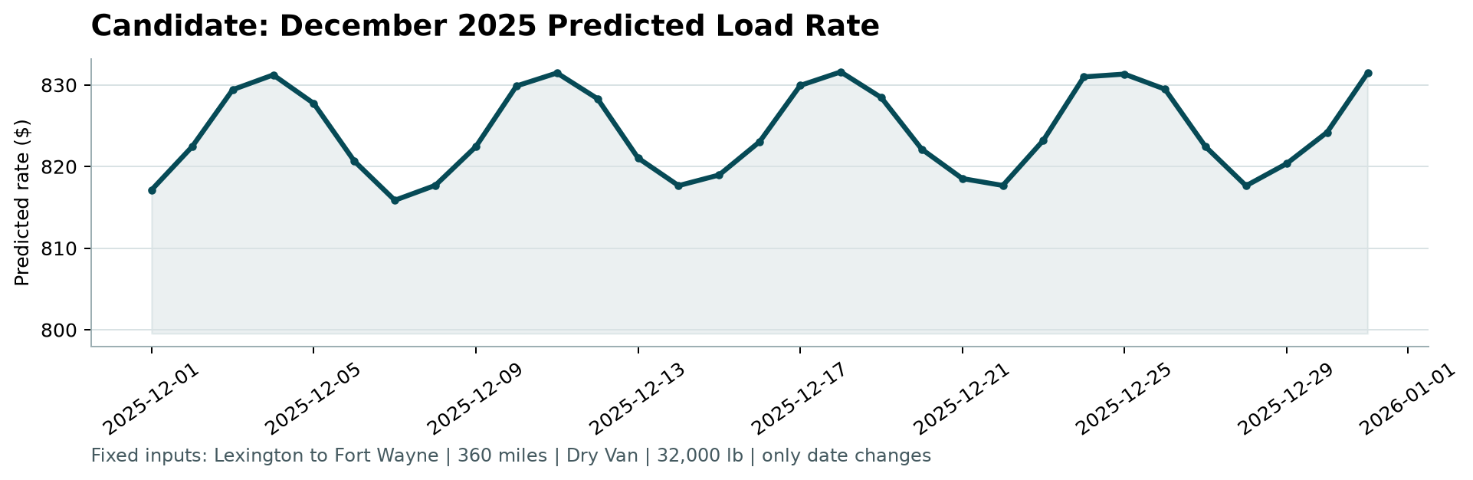
Figure 4. December chart produced by the provided score.py from the completed data/december_chart_inputs.csv.
Predictions stay between $815.87 and $831.59, consistent with recent Lexington-Fort Wayne Dry Van loads ($790-841 scaled to 360 miles, Aug-Oct). The weekly shape is real: the daily market_index peaks on Thursdays and dips on Sundays, in training and in December, and prices follow it by about +/-1%. The model has no day-of-week feature, so the pattern comes entirely from the market data. No trend is imposed across the month.

7. Limitations and next steps
- Forward drift: every model under-predicts increasingly with horizon (about -$59 on the Sep-Oct holdout); prices appear to follow market_index with a delay. Recently weighing anchors, the final model on the most recent months, but some under-prediction in late December is likely.
- Seasonality: one year of history cannot reveal December holiday effects; they are not modelled.
- Small number of folds: two selection folds make small differences (about $1-2 MAE) indistinguishable from noise, which is why tuning and blend weights were not optimised further.
- Next steps: with more history, a model of the lagged market response (tested here, not yet beneficial), seasonal terms, and monitoring of bias on newly labelled loads to recalibrate.

Appendix: reproducing the results
python -m freight_rate.pipelines.train
python -m freight_rate.pipelines.predict
python score.py --predictions validation_predictions.csv --december-predictions data/december_chart_inputs.csv
python -m pytest
Experiments: configs/experiments/phase4.yaml with python -m freight_rate.pipelines.experiment; results in reports/experiments/. Exploratory analysis: notebooks/01_eda.ipynb. Detailed write-ups for each phase: docs/.

