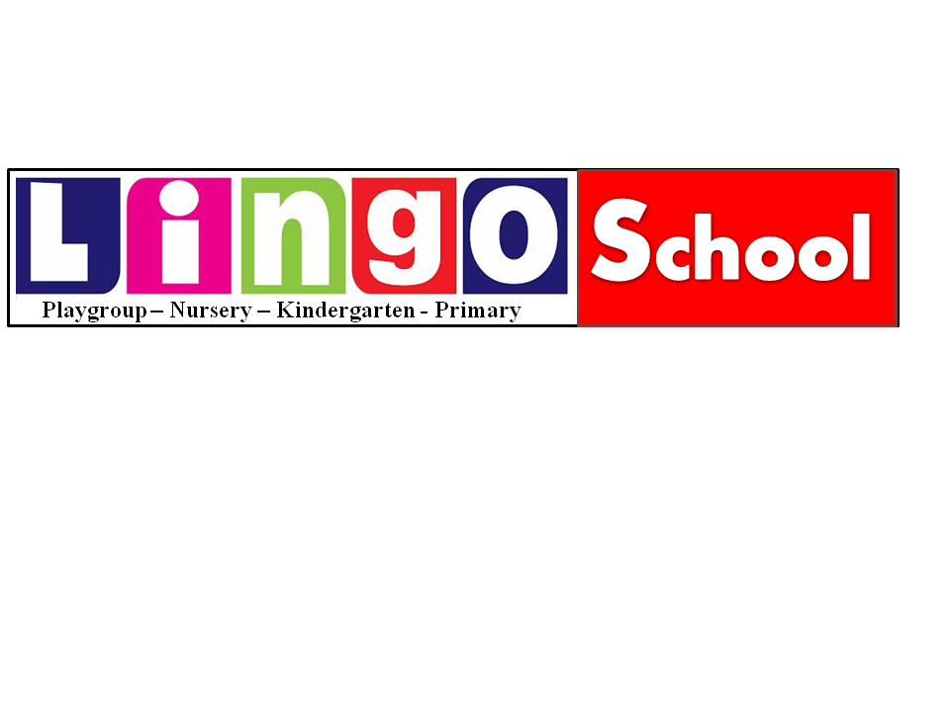

Photo

ADMISSION FORM
Student Information
Full Name: |  | Gender: M/F
Date of Birth : | Place of Birth: |  | Religion:
Residence Tel : | Emergency No :
Class :__________________________ | Does the student have any physical impairment? If yes, then please give detail:
Previous Academic Record:
Sr.# | Name of School | From | To | Up to class | Reason for leaving
Parents Information
Father’s Name: | Mother’s Name:
Mobile No.: | Mobile No.:
CNIC# | CNIC#
Address: | Address:
Occupation: | Occupation:
Qualification: | Qualification:
Office Address: | Office Address:
Nationality/Religion: | Nationality/Religion:
Guardian Information (If appropriate)
Guardian’s Name: | Occupation:
CNIC# | Address of Workplace:
Address: | Qualification:
Religion: | Telephone:
Relationship with student:
Details of other Children studying in Lingo School
Sr.# | Name of Student | Student ID | Class

FOR OFFICE USE ONLY

Admission Test Result: Pass / Fail
Interviewer Notes: _____________________________________________________________________
Admission No | Date Of Admission | Class | Section | Student ID | Tuition Fees | Admission Fees | Registration Fees
School Head Remarks: Admitted / Not Admitted

Admission Officer:_________________ Principal:_________________

