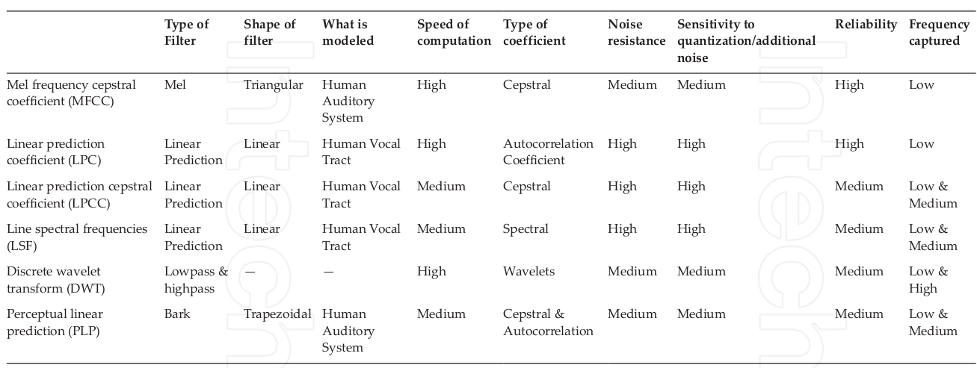
1) The feature space of a MFCC obtained using DCT is not directly dependent on speech data, the observed signal with noise does not show good performance without utilizing noise suppression methods

2) ICA, applied to speech data in the time or time-frequency domain, it gives good performance in phoneme recognition tasks

3) LDA, applied to speech data in the timefrequency domain shows better performance than combined linear discriminants in the temporal and spectral domain in continuous digit recognition task.

4) MEL analysis and PLP analysis of speech, are similar where the short term spectrum is modified based on psychophysically based spectral transformations.

5) In MEL the spectrum is warped according to the MEL Scale.

6) In PLP the spectrum is warped according to the Bark Scale.

7) The PLP model uses an all-pole model to smooth the modified power spectrum. The output cepstral coefficients are then computed

8) Mel scale cepstral analysis uses cepstral smoothing to smooth the modified power spectrum. This is done by direct transformation of the log power spectrum to the cepstral domain using an inverse DFT.

9) In LPC reduced word error rates is found in difficult conditions as compared to PLP.

10) FFT-based approach is good for its linearity in the frequency domain and its computational speed.

11) FFT does not discard or distort information in any anticipatory manner.

12) In FFT the representation of the signal remains easily perceivable for further analysis and post-processing.

13) The effects of noise in the FFT spectrum can also be easily comprehended.

14) The PLP features outperform MFCC in specific conditions.

15) The MFCC reduces the frequency information of the speech signal into a small number of coefficients.

16) In MFCC, the logarithmic operation attempts to model loudness perception in the human auditory system.

17) MFCC is a very simplified model of auditory processing; it is easy and relatively fast to compute.

18) The PLP functions provides limited capability of dealing with these distortion by employing a RASTA filter which makes PLP analysis more robust to linear spectral distortions

