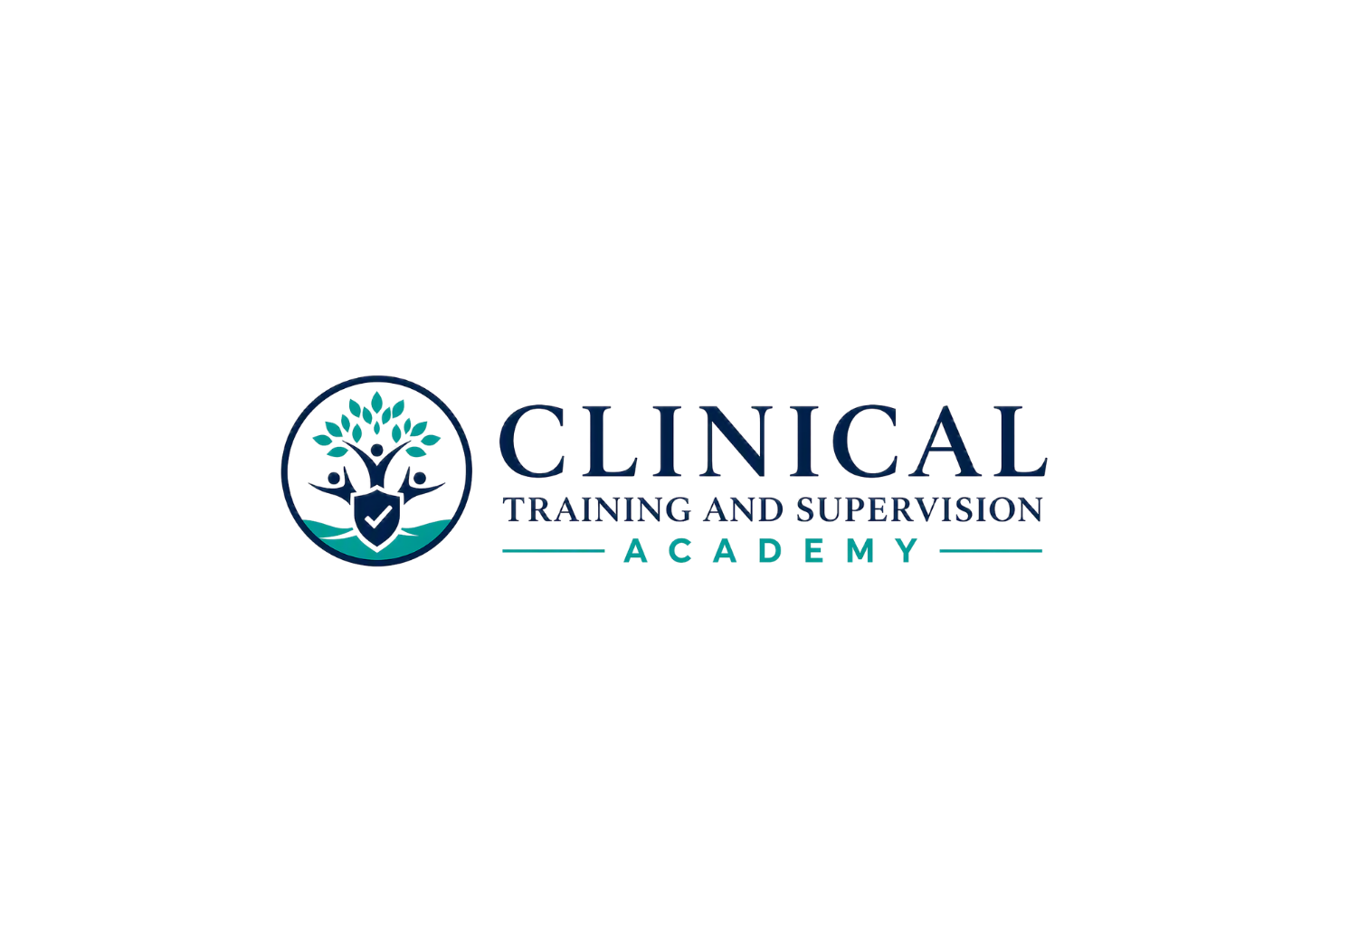

STAGE 5D | FINAL CURRENTNESS, CONSISTENCY, INVENTORY & PRIVATE HANDOFF
CTA LCSW California Law & Ethics Exam Preparation Program
CTA-EP-002 | Version 1.0 | August 7, 2026
PRIVATE IMPLEMENTATION HANDOFF READY | PUBLIC ACTIVATION REMAINS BLOCKED
Teaching Clinicians How to Think.

1. Stage 5D Exit Finding
Control | Stage 5D finding
Formal program | CTA LCSW California Law & Ethics Exam Preparation Program
Public title | LCSW California Law & Ethics Exam Preparation
Program code | CTA-EP-002
Offer | $199 launch/current price | Six months of access | Exam preparation only | No CE credit/certificate
Production status | Nine workbook systems complete; license-specific module complete; cumulative Practice A, Practice B, and 100-question Final complete; 833-card Study Center complete; six learner toolkits complete.
Stage 5D decision | READY FOR PRIVATE IMPLEMENTATION/STAGING. Public activation is NOT authorized by this register.
Next gate | Stage 5E: private LMS/website/checkout build, learner-view testing, defect closure, backup/rollback verification, and written owner public-release approval.

2. Final Currentness Regression — August 7, 2026
Official-source regression found no new release-blocking change to the program’s substantive California LCSW/ASW law-and-ethics controls between the most recent workbook/toolkit reviews and this Stage 5D freeze. The following high-change controls were refreshed and are the baseline for private staging:
Source family | Stage 5D result
California BBS Laws & Regulations | 2026 annual compilation remains current baseline; current BBS Law Changes/Updates pages remain required for changes after publication.
LCSW California Law & Ethics Exam | Pearson/BBS current administration remains 50 scored + 25 pretest questions, 90 minutes total exam time; current LCSW outline remains effective January 2024 with Law 44% / Ethics 56%.
ASW/LCSW pathway | BBS current guidance continues annual Law & Ethics exam participation until passage for renewal; subsequent ASW registration requires passage and may not be used in private practice/professional corporation settings.
Advertising | 16 CCR §1811 advertising changes remain operative April 1, 2026; current BBS examples/fact sheet remain the controlling implementation guidance.
Telehealth | 16 CCR §1815.5 amendments remain effective January 1, 2026.
Fee reduction | BBS temporary 50% fee reductions remain effective July 1, 2026 through June 30, 2030; LCSW California Law & Ethics exam fee is $75 during that period. No CTA learner file was found to state the superseded $150 exam fee as a current fact.
NASW ethics | NASW continues to publish the Code of Ethics with 2021 revisions as the current national ethics code used in the program.
Federal nondiscrimination/access overlays | HHS June 1, 2026 partial-vacatur notice remains current; unaffected Section 1557 protections continue. HHS also extended certain web/mobile accessibility compliance dates in May 2026; the program does not state superseded compliance dates.

3. Consistency & Version-Control Corrections
- License-specific module and 25-question assessment system advanced to v1.1 implementation copies; Stage 3 internal-review labels were removed and currentness/status language was normalized to Stage 5D private-staging status.
- Practice A candidate and rationale files advanced to v1.2; Practice B candidate and rationale files advanced to v1.3; Comprehensive Final candidate and rationale files advanced to v1.3. Question stems, options, keyed answers, domain distribution, and difficulty distribution were not changed by Stage 5D.
- Cumulative candidate covers were corrected from the inaccurate “POST-ATTEMPT LEARNER TOOL” label to “ANSWER-HIDDEN CANDIDATE FORM.”
- Practice B and Comprehensive Final header/footer version carry-forwards were normalized to the controlling Stage 5D versions.
- The LMS implementation package advanced to v1.1 and now records Stage 5D private-handoff readiness. The website/catalog/checkout copy package advanced to v1.1 and now carries only the Stage 5E public-activation hold.
- Master Course Catalog advanced to v2.6 with CTA-EP-002 changed from “In development - Stage 1” to “Completed for implementation,” and the LCSW description rewritten in completed/present tense. Pricing Catalog v3.5 was verified unchanged at $199 and six-month access.
Final layout/accessibility regression passed across all 13 Stage 5D modified or newly issued DOCX outputs at 0 high / 0 medium / 0 low findings. The unnecessary blank spill page in the Practice Examination B candidate booklet was removed during final render QA.

4. Superseding No-Lock Implementation Rule
This rule supersedes any older embedded “release only after attempt,” “submission gate,” or similar production wording that remains inside legacy workbook rationale files. Those phrases are pedagogical study-sequence cues only and MUST NOT be implemented as LMS access restrictions.
Resource class | Controlling Stage 5D access rule
All learner-facing files | Open from enrollment for the full six-month access term; downloadable/printable for personal study.
Candidate assessments and practice forms | Open from enrollment; unlimited attempts; recommended sequence only.
Printable detailed rationales | Open from enrollment. Recommend reviewing after the first recorded attempt; no prerequisite, completion, or score lock.
Online quiz feedback/rationales | May display after quiz submission as normal quiz behavior, but that behavior may not gate printable files or other study resources.
Flashcards and toolkits | Open from enrollment; no completion dependency.
CE workflow | Do not apply CE progress locks, CE evaluation, CE certificate, or CE completion logic to CTA-EP-002.

5. David Handoff Boundary
- This ZIP authorizes private implementation and staging only.
- Do not publish the website product page, enable public checkout, activate learner enrollment, or advertise the program as live until Stage 5E is closed and Candice Fuimaono gives written public-release approval.
- Do not expose reserve-bank items or internal replacement sets. Reserve files are intentionally excluded from the David handoff ZIP.
- The master question-bank control register and Stage 5B/5C production closeout files remain CTA internal controls and are not needed for routine LMS build.

6. Package Inventory Summary
- 01_Learner_Facing_Core: 27 files
- 02_Learner_Rationales_Open_Access: 13 files
- 03_Flashcards_and_Toolkits: 12 files
- 04_Admin_Implementation: 4 files
- 05_Catalog_Controls: 2 files
A full SHA-256 list is provided separately as SHA256SUMS.txt. The checksum list is the controlling package-integrity record for the frozen Stage 5D handoff.

7. Stage 5E Test Requirements
- Confirm title, CTA-EP-002, $199 price, six-month expiration, and no-CE classification in learner view.
- Confirm every learner-facing unit and download opens immediately after enrollment with no prerequisite icon or lock.
- Confirm online quiz submissions show intended scores/rationales without controlling access to printable resources.
- Confirm controlled rationales are placed as learner study resources with post-attempt recommendation language but no technical lock.
- Confirm reserve/internal content is absent from learner view.
- Confirm download integrity, mobile/desktop readability, keyboard accessibility, and no broken links.
- Confirm checkout/receipt copy and public product copy match the frozen Stage 5D controls.
- Verify backup and rollback, capture evidence, close all release-blocking defects, then obtain written owner public-release approval.

8. Owner Decision Boundary
Stage 5D production is complete. The package is ready to be sent to David for PRIVATE IMPLEMENTATION/STAGING. This document is not a public-release authorization. Final public release remains a separate Stage 5E decision after staging evidence and defect closure.

