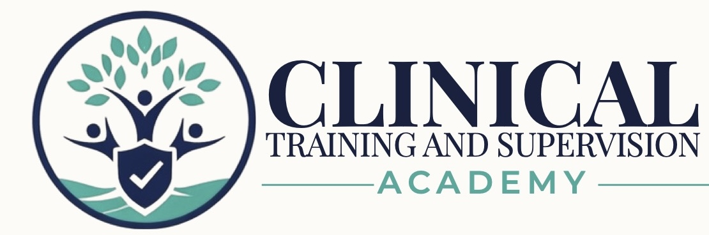
LCSW ASWB CLINICAL EXAM PREPARATION PROGRAM

August 2026 Source Verification and Release Control
  - Internal confirmation for the initial David LMS and website package
INTERNAL ADMINISTRATIVE RESOURCE • NOT STUDENT-FACING
Version 1.0 • August 2026 • Exam Preparation Only — No CE Credit

1. Controlling Determination
Decision: The August 2026 ASWB Examination Guidebook confirms the examination architecture used in the CTA LCSW program. No curriculum rebuild is required. The initial release package requires only candidate-logistics, source-control, and media-status clarification.
Control | Verified Result
Source edition | ASWB Examination Guidebook, August 2026
Effective testing date | August 3, 2026
Exam structure | 122 total; 110 scored; 12 unscored; two 61-question sections; four hours
Break structure | Optional scheduled break up to 10 minutes after Section 1; unscheduled breaks use exam time
Option structure | Mixed three- and four-option multiple-choice questions
Clinical blueprint | Values and Ethics 36%; Assessment and Planning 32%; Intervention and Practice 32%
CTA curriculum decision | Retain 12 workbooks, 12 paired 17-question banks, Workbook 12 mini-mock, and Forms A/B
Media status | No recorded audio or video at initial launch; scripts/decks are future production assets only

2. Release Files Updated for Initial Package
File | Initial-Release Action | Status
Student FAQ and Self-Service Support Guide | Removed media promises; added August source and support language. | Complete
Student Roadmap and Study Schedules | Replaced media requirements with written preview actions. | Complete
Readiness Self-Assessment and Progress Tracker | Removed media dependencies; aligned resource fields. | Complete
August 2026 Exam-Day and Simulation Guide | Created current exam-day and simulation guide. | Complete
David Website Release Package | Confirmed written resources, no recorded media, and complete-package controls. | Complete
Comprehensive Forms A and B | Reviewed; existing structure already matched the August guidebook. | No change required

3. Program Release Basis
The July 25, 2026 Master Program Index and Final Release Audit controls file-integrity status. It verifies 12 student workbooks, 12 paired 17-question banks, two 122-question comprehensive forms, controlled rationales, administrative item banks, and blueprint/QC reports, with zero blocking release defects.
The earlier July 23, 2026 master QC audit is retained as a historical remediation record. It does not override the later final audit after the required bank, simulation, accessibility, and release-control work was completed.

4. Media and Advertising Control
- Do not advertise or publish recorded video, recorded audio, MP3, or multimedia lessons at initial launch.
- Keep workbook companion scripts/decks, shared scripts/decks, LCSW multimedia scripts/decks, and audio-review scripts in the unrecorded future-production folder.
- The written learner system is complete without recorded media: workbooks, banks, rationales, flashcards, quick references, roadmap, tracker, FAQ, exam-day guide, and Forms A/B.
- Before any future recording release, synchronize the scripts/decks with the then-current ASWB guidebook and verify the actual playback files in the LMS.

5. Maintenance Triggers
- Recheck ASWB candidate guidance before every major republication and after any exam-format announcement.
- Check for a newer guidebook at least quarterly because ASWB may revise candidate procedures during the year.
- Update candidate logistics immediately if identification, test-center security, break, scheduling, or accommodation procedures change.
- Do not state an official passing score or guarantee. Preserve the distinction between CTA internal simulation controls and official ASWB psychometrics.

6. Initial Release Sign-Off
Field | Entry
Program | CTA LCSW ASWB Clinical Exam Preparation Program
Package classification | Initial complete LMS and website release v1.0
Source review date | August 3, 2026
Prepared for | David — website and LMS implementation
Recorded media | None included or advertised at launch
Administrator approval | ____________________________________________
Approval date | ____________________________________________

