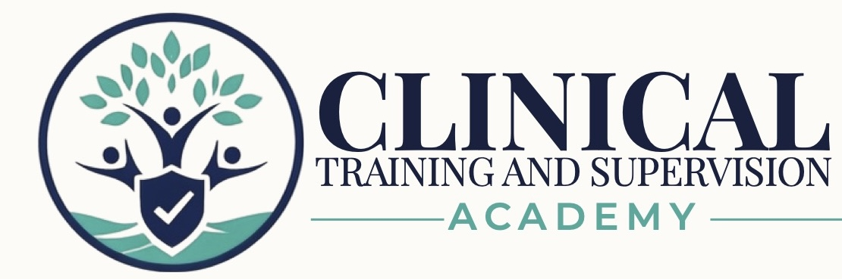
LPCC NCMHCE EXAM PREPARATION PROGRAM
Final Publication Readiness Audit & Approval Record
Version 1.0 | July 2026 | Exam Preparation Program | No CE Credit
AUDIT DETERMINATION
The LPCC NCMHCE curriculum, twelve workbook-bank pairs, three cumulative checkpoints, Form A, Form A remediation, Form B, study tools, and student-administration guides are complete and reconciled into one controlled release package. The package is approved for David to build and test in the LMS and website. Public sale remains pending live-system testing and final owner approval.

Current status: RELEASE PACKAGE RECONCILED - APPROVED FOR LMS BUILD
Public release status: PENDING DAVID IMPLEMENTATION TESTING AND FINAL OWNER APPROVAL
Teaching Clinicians How to Think.

1. Program Identity and Release Classification
Field | Controlling Entry
Program title | CTA LPCC NCMHCE Exam Preparation Program
Primary learner | APCCs and other eligible candidates preparing for the NCMHCE
Program type | Self-paced, asynchronous licensure examination preparation
Credit status | No continuing-education credit
Curriculum status | Complete
Implementation status | Release package reconciled; approved for LMS build and testing
Public release status | Pending David implementation testing and final owner approval
Current-format control | Review and update before use for examinations administered on or after July 1, 2027

2. Corrections and Administrative Gaps Resolved
Previously Open Item | Resolution | Status
Workbook 12 running header | Corrected from the Workbook 10 header to “CTA LPCC Workbook 12 - California Legal, Ethical & Professional Practice” on all interior pages; the 20-page workbook was rerendered and visually reviewed. | Resolved
Student Start Here roadmap | Completed with the WB1-WB12 sequence, checkpoint gates, Form A remediation, Form B release sequence, final-week guidance, and 10-, 14-, and 18-week routes. | Complete
Student FAQ and support guide | Completed with navigation, scoring, rationale release, troubleshooting, official-source reminders, and support boundaries. | Complete
LMS implementation guide | Completed with lesson order, release controls, lock rules, controlled-answer sequencing, archive expectations, and implementation checks. | Complete
Form B candidate/rationale synchronization | Automated audit completed against the controlling candidate and rationale files. | Verified
Workbook 11 rationale form | Located, added to the controlled sequence, and synchronized to the 17-question candidate form. | Verified
Complete directory reconciliation | All 12 workbooks, 12 candidate banks, 12 rationale forms, three checkpoint pairs, Form A pair, remediation workbook, Form B pair, flashcards, quick references, tracker, roadmap, FAQ, and administration files were mapped to one package. | Complete
Duplicate and archive control | One controlling copy of each active asset is in the release path; prepublication reports and obsolete drafts are isolated in the nonpublishing archive. | Complete
Recorded-media status | No playable media exists at launch. The audio-review file is classified as an unrecorded script-only production asset and excluded from learner view. | Controlled
July 2027 update register | A controlled replacement schedule and asset-impact register was created for the NCMHCE specifications effective July 1, 2027. | Complete

3. Assessment Synchronization Audit
CONTROLLED ASSESSMENT SET
All 12 workbook candidate/rationale pairs, all three checkpoint pairs, Form A, and Form B were audited. Question counts, identifiers or numbering, stems, options, keys, and candidate/rationale synchronization passed for all available pairs.

Audit Test | Result | Status
Workbook bank pairs | 12 of 12 candidate/rationale pairs contain 17 synchronized questions. | Verified
Checkpoint pairs | Checkpoint 1 (39), Checkpoint 2 (52), and Checkpoint 3 (65) are synchronized. | Verified
Form A pair | 143 candidate items and 143 rationale entries are synchronized. | Verified
Form B pair | 143 candidate items and 143 rationale entries are synchronized. | Verified
Candidate answer exposure | No candidate file exposes correct-answer or rationale content. | Verified
Package integrity | All controlling Word files open as valid Office packages with no reviewer comments or tracked changes. | Verified
Answer distribution controls | Workbook banks and checkpoints are balanced; simulation keys are distributed without a dominant position pattern. | Verified
No recorded media claim | Student-facing and website materials state that recorded audio/video are not included at launch. | Verified

4. Publication Package Readiness Matrix
Package Area | Audit Determination | Status
Twelve student workbooks | All 12 controlling learner workbooks mapped; corrected WB12 used. | Complete
Twelve practice-bank candidate forms | All 12 controlling candidate forms mapped. | Complete
Twelve controlled rationale forms | All 12 controlling rationale forms mapped, including WB11. | Complete
Three cumulative checkpoints | All three candidate/rationale pairs mapped and synchronized. | Complete
Form A candidate and rationales | Controlling 143-item pair mapped and synchronized. | Verified
Form A remediation workbook | Present and required before Form B. | Complete
Form B candidate and rationales | Controlling 143-item pair mapped and synchronized. | Verified
Readiness tracker and study routes | Updated for launch without recorded-media requirements. | Complete
Flashcards | 132-card collection included. | Complete
Quick-reference/rapid-review library | Included and updated to distinguish 225 examination minutes from 255 total session minutes. | Complete
Student Start Here roadmap | Updated; 10-, 14-, and 18-week routes included. | Complete
Student FAQ and support guide | Updated; no recorded media promised at launch. | Complete
LMS implementation and release-control guide | Updated with $249 price, six-month access, and launch controls. | Complete
2027 update register | Created and placed in restricted source-control records. | Complete
Website/LMS handoff package | Public copy, product configuration, implementation instructions, branding, manifests, and restricted controls assembled. | Ready for David

5. Remaining Conditions Before Public Release
No. | Condition | Completion Standard | Status
1 | LMS build and student-role testing | Upload the approved files and test lesson order, locks, rationale release, Form A remediation gate, Form B access, downloads, responsive views, access expiration, and support links. | David / owner
2 | Public-system synchronization | Activate the website, LMS product, checkout, price, six-month access, terms, and support configuration using the approved package. | David / owner
3 | Final approving-authority signoff | After live-system testing, the Founder/CEO or designee records the launch date and approves public learner release. | Owner

6. Approval Stages
Approval Stage | Determination | Status
Curriculum completeness | All required instructional and assessment content through Form B is present. | Approved
Assessment integrity | All 12 bank pairs, three checkpoints, Form A, and Form B passed synchronization review. | Approved
Student administration | Roadmap, FAQ, tracker, quick references, and LMS guide are complete. | Approved
Release-folder reconciliation | One controlled release package and archive structure has been created. | Approved
LMS build authorization | The complete package may proceed to David for implementation and testing. | Approved for LMS Build
Public learner release | Requires completion of live-system testing and final owner signoff. | Pending

BOTTOM LINE
The LPCC NCMHCE exam-preparation curriculum and complete release package are ready for David to build and test. No additional core workbook, checkpoint, rationale set, or full simulation is required. Public launch should occur only after the live website/LMS implementation passes the final student-role review.

7. Final Approval Record
Field | Entry
Curriculum and assessment content complete | ☒ Yes ☐ No
Workbook 12 correction verified | ☒ Yes ☐ No
Form B synchronization audit passed | ☒ Yes ☐ No
Student Start Here guide complete | ☒ Yes ☐ No
Student FAQ complete | ☒ Yes ☐ No
LMS implementation guide complete | ☒ Yes ☐ No
Exact release-folder inventory reconciled | ☒ Yes ☐ No
Duplicate/superseded files archived | ☒ Yes ☐ No
LMS and download testing completed | ☐ Yes ☒ No - David implementation pending
Catalog, pricing, website, and LMS listing synchronized | ☐ Yes ☒ No - activate after testing
2027 update register created | ☒ Yes ☐ No
Current release classification | ☐ Draft ☐ Under Review ☒ Approved for LMS Build ☐ Approved for Publication ☐ Archived
Final approved by | ____________________________________________
Final approval date | ____________________________________________
Released version | Version 1.0 - initial release package
Final comments | Complete package sent to David for website and LMS implementation. Recorded audio/video are not included at launch.

8. Controlled Files and Evidence Used for This Audit
- CTA_LPCC_WB1-WB12 student workbooks (12 controlling copies)
- CTA_LPCC_WB1-WB12 17-question candidate forms and controlled rationales (12 pairs)
- CTA_LPCC_Checkpoint_1, Checkpoint_2, and Checkpoint_3 candidate/rationale pairs
- CTA_LPCC_Comprehensive_Simulation_Form_A_143_Question candidate/rationale pair
- CTA_LPCC_Form_A_Remediation_Workbook_v1.0.docx
- CTA_LPCC_Comprehensive_Simulation_Form_B_143_Question candidate/rationale pair
- CTA_LPCC_Readiness_Self_Assessment_and_Progress_Tracker_v1.0.docx
- CTA_LPCC_Clinical_Exam_Preparation_Flashcard_Collection_v1.0.docx
- CTA_LPCC_Quick_Reference_and_Rapid_Review_Library_v1.0.docx
- CTA_LPCC_Student_Start_Here_Roadmap_and_10_14_18_Week_Study_Schedules_v1.0.docx
- CTA_LPCC_Student_FAQ_and_Self_Service_Support_Guide_v1.0.docx
- CTA_LPCC_LMS_Implementation_and_Release_Control_Guide_v1.0.docx
- CTA_LPCC_NCMHCE_2027_Update_Register_v1.0.docx
- Official NBCC current handbook, 2027 specifications, and California BBS 2026 source references

