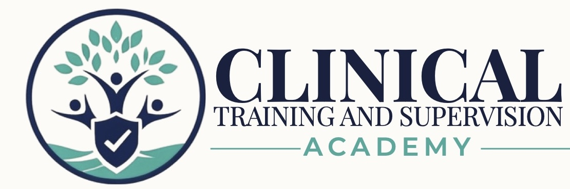
LPCC NCMHCE EXAM PREPARATION PROGRAM
Final Publication Readiness Audit & Approval Record
Version 1.0 | July 2026 | Exam Preparation Program | No CE Credit
AUDIT DETERMINATION
The LPCC NCMHCE curriculum, assessment sequence, final Form B simulation, and core student-administration guides are complete. The package is approved to move into LMS build and testing. It is not yet approved for public sale or learner release until the exact course folder is reconciled, duplicate files are archived, the LMS workflow is tested, public systems are synchronized, and the final approver signs this record.

Current status: CURRICULUM COMPLETE - APPROVED FOR LMS BUILD
Public release status: PENDING FINAL IMPLEMENTATION APPROVAL
Teaching Clinicians How to Think.

1. Program Identity and Release Classification
Field | Controlling Entry
Program title | CTA LPCC NCMHCE Exam Preparation Program
Primary learner | APCCs and other eligible candidates preparing for the NCMHCE
Program type | Self-paced, asynchronous licensure examination preparation
Credit status | No continuing-education credit
Curriculum status | Complete
Implementation status | Approved for LMS build and testing
Public release status | Pending final implementation approval
Current-format control | Review and update before use for examinations administered on or after July 1, 2027

2. Corrections and Administrative Gaps Resolved
Previously Open Item | Resolution | Status
Workbook 12 running header | Corrected from the Workbook 10 header to “CTA LPCC Workbook 12 - California Legal, Ethical & Professional Practice” on all interior pages; the 20-page workbook was rerendered and visually reviewed. | Resolved
Student Start Here roadmap | Completed with the WB1-WB12 sequence, checkpoint gates, Form A remediation, Form B release sequence, final-week guidance, and 10-, 14-, and 18-week routes. | Complete
Student FAQ and support guide | Completed with navigation, scoring, rationale release, troubleshooting, official-source reminders, and support boundaries. | Complete
LMS implementation guide | Completed with lesson order, release controls, lock rules, controlled-answer sequencing, archive expectations, and implementation checks. | Complete
Form B candidate/rationale synchronization | Automated audit completed against the controlling candidate and rationale files. | Verified

3. Form B Synchronization Audit
CONTROLLED FORM B PAIR
The July 28, 2026, 04:46 upload pair is the working controlling candidate/rationale set. Earlier identical-name copies should be archived or labeled as duplicates during course-folder reconciliation.

Audit Test | Result | Status
Candidate question sequence | Questions 1-143 are present with no missing or duplicate numbers. | Verified
Candidate options | Every question contains options A, B, C, and D. | Verified
Detailed rationale sequence | Rationale entries 1-143 are present. | Verified
Correct-answer fields | All 143 rationale entries contain one correct-answer letter. | Verified
Compact answer key | The compact key contains all 143 answers. | Verified
Key-to-rationale agreement | All 143 compact-key letters match the detailed-rationale answer letters. | Verified
Question-stem agreement | All 143 rationale question stems match the candidate examination stems. | Verified
Correct-option text agreement | For every item, the rationale’s correct-answer text matches the corresponding candidate option. | Verified

4. Publication Package Readiness Matrix
Package Area | Audit Determination | Status
Twelve student workbooks | Program sequence and titles established; corrected WB12 is directly verified. Exact current filename/version for WB1-WB11 must be confirmed in the release folder. | Directory confirmation required
Twelve practice-bank candidate forms | Program architecture established; exact current copies must be mapped to the release folder. | Directory confirmation required
Twelve controlled rationale forms | Program architecture established; exact current copies must be mapped to the controlled folder. | Directory confirmation required
Three cumulative checkpoints | Sequence established after WB4, WB8, and WB12; candidate/rationale pairs must be confirmed in the release folder. | Directory confirmation required
Form A candidate and rationales | Form A sequence is established; final controlling pair must be confirmed in the release folder. | Directory confirmation required
Form A remediation workbook | Present in the established program sequence and required before Form B. | Complete
Form B candidate and rationales | Controlling pair identified and fully synchronized. | Verified
Readiness tracker and study routes | Present and incorporated into the Start Here roadmap. | Complete
Flashcards and audio review | Established as program reinforcement assets; exact release-folder copies must be confirmed. | Directory confirmation required
Quick-reference/rapid-review library | Established in the program sequence; exact release-folder files must be confirmed. | Directory confirmation required
Student Start Here roadmap | Completed. | Complete
Student FAQ and support guide | Completed. | Complete
LMS implementation and release-control guide | Completed. | Complete
Master Course Catalog and pricing catalog | Still show the LPCC program as in development/activating upon release; update after LMS testing and final approval. | Pending

5. Remaining Conditions Before Public Release
No. | Condition | Completion Standard | Status
1 | Release-folder reconciliation | Create one exact inventory showing the current filename, version, learner/controlled classification, and location of every workbook, bank, checkpoint, simulation, review resource, media asset, and administration document. | Required
2 | Duplicate and archive control | Retain one controlling copy of each asset. Move all earlier, duplicate, draft, or superseded files into a clearly labeled archive. | Required
3 | LMS build and testing | Upload the approved files and test lesson order, progression locks, rationale release, Form A remediation gate, Form B access, downloads, mobile view, access period, and support links. | Required
4 | Public-system synchronization | After LMS testing, update the Master Course Catalog, pricing catalog, website, LMS product listing, product image, title, launch price, access period, and support/update terms. | Required
5 | 2027 update register | Create a controlled review schedule for all workbooks, banks, checkpoints, simulations, scoring sheets, official-source reminders, and public claims affected by the July 1, 2027 NCMHCE specifications. | Required
6 | Final approving-authority signoff | The Founder/CEO or designated final approver confirms that all conditions are satisfied and changes the release classification to Approved for Publication. | Required

6. Approval Stages
Approval Stage | Determination | Status
Curriculum completeness | All required instructional and assessment content through Form B is present; no additional core workbook or required simulation is indicated. | Approved
Assessment integrity | Form B question, option, key, and rationale synchronization passed. | Approved
Student administration | Start Here, FAQ, and LMS implementation guides are complete. | Approved
LMS build authorization | The reconciled package may proceed into LMS implementation and testing. | Approved for LMS Build
Public learner release | Requires completion of the six conditions in Section 5 and final approver signature. | Pending

BOTTOM LINE
The LPCC NCMHCE exam-preparation curriculum is complete. The remaining work is implementation control—not additional educational content. The program should now move into release-folder reconciliation and LMS build/testing.

7. Final Approval Record
Field | Entry
Curriculum and assessment content complete | ☒ Yes ☐ No
Workbook 12 correction verified | ☒ Yes ☐ No
Form B synchronization audit passed | ☒ Yes ☐ No
Student Start Here guide complete | ☒ Yes ☐ No
Student FAQ complete | ☒ Yes ☐ No
LMS implementation guide complete | ☒ Yes ☐ No
Exact release-folder inventory reconciled | ☐ Yes ☒ No
Duplicate/superseded files archived | ☐ Yes ☒ No
LMS and download testing completed | ☐ Yes ☒ No
Catalog, pricing, website, and LMS listing synchronized | ☐ Yes ☒ No
2027 update register created | ☐ Yes ☒ No
Current release classification | ☐ Draft ☐ Under Review ☒ Approved for LMS Build ☐ Approved for Publication ☐ Archived
Final approved by | ____________________________________________
Final approval date | ____________________________________________
Released version | ____________________________________________
Final comments | ________________________________________________________________________________  ________________________________________________________________________________

8. Controlled Files Used for This Audit
- CTA_LPCC_Comprehensive_Simulation_Form_B_143_Question_Candidate_Exam_v1.0.docx
- CTA_LPCC_Comprehensive_Simulation_Form_B_143_Question_Answer_Rationales_v1.0.docx
- CTA_LPCC_WB12_California_Legal_Ethical_Documentation_Technology_and_Professional_Practice_Student_Workbook_v1.0.docx (corrected)
- CTA_LPCC_Student_Start_Here_Roadmap_and_10_14_18_Week_Study_Schedules_v1.0.docx
- CTA_LPCC_Student_FAQ_and_Self_Service_Support_Guide_v1.0.docx
- CTA_LPCC_LMS_Implementation_and_Release_Control_Guide_v1.0.docx
- CTA_LPCC_NCMHCE_Prepublication_Master_Index_and_Gap_Report_v1.0.docx
- CTA_Master_Course_Catalog_v2.0.docx
- CTA_Master_Pricing_Subscription_and_Bundle_Catalog_v3.0.docx

