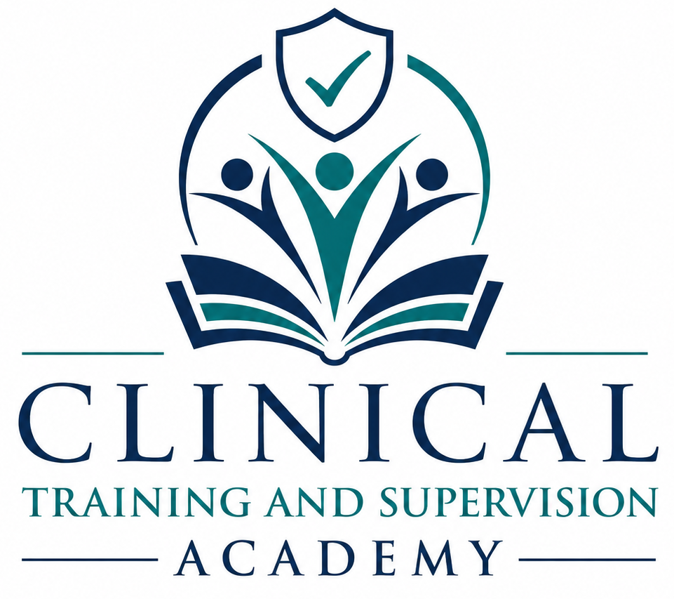

CLINICAL TRAINING AND SUPERVISION ACADEMY
Master Course Catalog

Table of Contents
About Clinical Training & Supervision Academy 3
Course Classification System 4
I. Continuing Education Courses 5
Course 1: California Law & Ethics for Mental Health Professionals: Navigating the Evolving Clinical Landscape 5
Course 2: Clinical and Ethical Excellence in Telehealth: The Essential California Framework 6
Course 3: Advanced Suicide Risk Assessment: Evidence-Based Intervention and Ethical Documentation 7
Course 4: Alcoholism & Other Chemical Substance Dependency: Assessment, Treatment, Recovery, & Clinical Practice 8
Course 5: Child Abuse Assessment & Mandated Reporting 9
Course 6: HIV/AIDS and Mental Health: Clinical Implications, Stigma, and Ethical Practice 10
Course 7: Human Sexuality & Clinical Practice 11
Course 8: The Fundamentals of Clinical Supervision: Legal Frameworks and Developmental Models 12
II. Exam Preparation Programs 13
California Law & Ethics Exam Preparation Program 13
LMFT California Clinical Exam Preparation Program 14
LCSW California Clinical Exam Preparation Program 15
LPCC California Clinical Exam Preparation Program 16

About Clinical Training & Supervision Academy
Clinical Training & Supervision Academy (CTA) is a California-based continuing education and professional development organization dedicated to supporting the growth, competence, and success of mental health professionals throughout their careers.
CTA provides evidence-based continuing education, clinical supervision, exam preparation, and professional development resources designed to strengthen clinical skills, promote ethical practice, and support compliance with evolving legal and regulatory requirements. Our programs are developed to provide practical, real-world application that clinicians can immediately integrate into their professional practice.
CTA serves Licensed Marriage and Family Therapists (LMFTs), Licensed Clinical Social Workers (LCSWs), Licensed Professional Clinical Counselors (LPCCs), Licensed Educational Psychologists (LEPs), registered associates, trainees, supervisors, and other behavioral health professionals seeking high-quality continuing education and clinical training.
Founded by Candice Fuimaono, MS, LMFT, CTA reflects a commitment to excellence in behavioral health education, clinical supervision, and professional development. Candice brings experience across community mental health, crisis residential treatment, telehealth, private practice, clinical supervision, compliance management, program administration, records oversight, and workforce training.

Educational Philosophy
CTA is committed to providing continuing education that is practical, accessible, evidence-based, and clinically relevant. Our educational programs are designed to help mental health professionals strengthen clinical competence, enhance ethical decision-making, maintain regulatory compliance, and deliver high-quality services to the individuals, families, and communities they serve.
Our mission is simple: to provide training, supervision, and professional development resources that support lifelong learning and promote excellence in behavioral health practice.

Course Classification System
Clinical Training & Supervision Academy (CTA) organizes its educational offerings into course classifications to assist learners in identifying training opportunities that align with their professional roles, continuing education requirements, and career development goals.

Core Tier Courses
Core Tier Courses provide foundational and advanced clinical training in areas commonly encountered within mental health practice. These courses are designed to strengthen clinical competence, enhance ethical decision-making, improve risk management, and support evidence-based treatment across diverse client populations and practice settings.
Core Tier Courses may include topics such as:
- Law and Ethics
- Telehealth Practice
- Suicide Risk Assessment
- Substance Use Disorders
- Child Abuse Assessment and Mandated Reporting
- HIV/AIDS and Mental Health
- Human Sexuality
- Clinical Supervision

Exam Preparation Programs
Exam Preparation Programs are fully self-paced, asynchronous systems for candidates preparing for California licensure examinations. They combine profession-specific review, applied reasoning, exam strategy, original practice, detailed rationales, multimedia support, and readiness simulations. They do not provide continuing education credit.
Exam preparation offerings may include:
- California Law & Ethics Exam Preparation
- LMFT California Clinical Exam Preparation
- LCSW California Clinical Exam Preparation
- LPCC California Clinical Exam Preparation

Educational Standards
All CTA courses are developed using evidence-based and practice-oriented educational principles. Course content is designed to promote clinical competence, professional growth, ethical practice, and compliance with applicable California laws, regulations, and professional standards.
Programs include defined objectives, instruction, assessment, and practical learning resources.

I. Continuing Education Courses

Course 1: California Law & Ethics for Mental Health Professionals: Navigating the Evolving Clinical Landscape
CE Credits: 6.0 CE Hours
Instructional Method: Asynchronous Distance Learning
Target Audience: LMFTs, LCSWs, LPCCs, LEPs, and Registered Associates

Course Description
This course provides mental health professionals with a comprehensive review of California legal and ethical requirements impacting clinical practice. Participants will examine recent regulatory developments, informed consent requirements, confidentiality and privilege laws, minor consent treatment regulations, crisis management responsibilities, record-keeping standards, and professional liability considerations.
Through practical case examples and applied legal analysis, participants will strengthen their ability to navigate complex ethical dilemmas, maintain compliance with California law, protect client welfare, and reduce professional risk in both private and institutional practice settings.

Key Topics Covered
- California regulatory updates and BBS requirements
- Scope of competence and ethical practice
- Informed consent and telehealth compliance
- Digital boundaries and social media ethics
- Confidentiality, privilege, and mandated reporting
- Minor consent treatment and parental rights
- Tarasoff duties and crisis management
- Record keeping and documentation standards
- Professional wills and practice closure planning
- Risk management and professional liability

Course Classification
Core Tier Course

Course 2: Clinical and Ethical Excellence in Telehealth: The Essential California Framework
Course Code: CTA-CE-002
CE Credits: 3.0 CE Hours
Instructional Method: Asynchronous Distance Learning
Target Audience: LMFTs, LCSWs, LPCCs, and Registered Associates

Course Description
This course provides mental health professionals with a comprehensive framework for delivering legally informed, ethically sound, and clinically effective telehealth services within California. Participants will examine current telehealth regulations, jurisdictional and interstate-practice considerations, informed consent, identity and present-location procedures, telehealth appropriateness, crisis-response planning, privacy and security safeguards, digital communication, and continuity of care.
Through realistic scenarios, structured decision-making, knowledge checks, and practical risk-management tools, participants will strengthen their ability to provide secure, professional, and client-centered virtual care while documenting clinical reasoning and responding appropriately when client location, risk, privacy, or technology conditions change.

Key Topics Covered
- California telehealth laws and regulations
- Jurisdictional and interstate practice considerations
- Telehealth informed consent requirements
- Client identity and location verification procedures
- Telehealth intake and assessment protocols
- Crisis intervention and emergency response planning
- Privacy, security, and HIPAA Security standards
- Technology and vendor safeguards, including BAAs when applicable
- Digital privacy and electronic communications
- Technology failure planning and continuity of care
- Professional boundaries in virtual treatment environments

Course Classification
Foundational CE Course

Course 3: Advanced Suicide Risk Assessment: Evidence-Based Intervention and Ethical Documentation
CE Credits: 6.0 CE Hours
Instructional Method: Asynchronous Distance Learning
Target Audience: LMFTs, LCSWs, LPCCs, and Registered Associates

Course Description
This course provides mental health professionals with advanced training in the assessment, management, and documentation of suicide risk across diverse clinical settings. Participants will learn evidence-based approaches to identifying risk factors, conducting standardized suicide assessments, implementing collaborative safety planning interventions, and responding appropriately to psychiatric emergencies.
Emphasis is placed on clinical decision-making, ethical responsibilities, legal considerations, and documentation practices that support client safety while meeting professional standards of care. Participants will gain practical tools for risk stratification, crisis intervention, involuntary hospitalization decision-making, and postvention planning for both clients and clinicians.

Key Topics Covered
- Epidemiology and risk factors associated with suicide
- Warning signs, risk factors, and protective factors
- Differentiating suicidal ideation, suicide intent, and non-suicidal self-injury (NSSI)
- Columbia-Suicide Severity Rating Scale (C-SSRS)
- SAFE-T suicide assessment framework
- Suicide risk stratification and clinical decision-making
- Stanley-Brown Safety Planning Intervention (SPI)
- Moving beyond no-harm contracts
- California 5150 criteria and involuntary hospitalization
- Crisis intervention and emergency response procedures
- Suicide-related documentation and liability management
- Risk management and professional standards of care
- Postvention planning following client suicide attempts or death
- Clinician self-care, burnout prevention, and secondary traumatic stress

Course Classification
Core Tier Course

Course 4: Alcoholism & Other Chemical Substance Dependency: Assessment, Treatment, Recovery, & Clinical Practice
CE Credits: 15.0 CE Hours
Instructional Method: Asynchronous Distance Learning
Target Audience: LMFTs, LCSWs, LPCCs, LEPs, and Registered Associates

Course Description
This course provides mental health professionals with a comprehensive examination of Alcoholism and Other Chemical Substance Dependency across the continuum of assessment, treatment, recovery, and professional practice. Participants will explore the neurobiology of addiction, substance-specific disorders, evidence-based screening and assessment methods, treatment planning, relapse prevention strategies, and co-occurring mental health conditions.
The course also examines professional impairment, therapist substance use concerns, ethical decision-making, risk management, and California-specific practice considerations. Emphasis is placed on developing practical clinical skills that support effective, ethical, and recovery-oriented care for individuals affected by substance use disorders.

Key Topics Covered
- Foundations of addiction science
- Neurobiology of addiction and recovery
- Alcohol Use Disorder assessment and treatment
- Opioid Use Disorders and Medication for Opioid Use Disorder (MOUD)
- Stimulants, polysubstance use, and emerging drug trends
- DSM-5-TR Substance Use Disorder diagnosis
- Screening and assessment tools (AUDIT, AUDIT-C, DAST-10, CAGE-AID)
- Screening, Brief Intervention, and Referral to Treatment (SBIRT)
- Motivational Interviewing (MI)
- Cognitive Behavioral Therapy (CBT)
- Contingency Management and recovery-oriented care
- Relapse prevention planning
- Co-occurring mental health and substance use disorders
- Professional impairment and therapist substance use concerns
- Ethics, documentation, and risk management
- California disciplinary case analysis and professional accountability

Course Classification
Core Tier Course

Course 5: Child Abuse Assessment & Mandated Reporting
CE Credits: 7.0 CE Hours
Instructional Method: Asynchronous Distance Learning
Target Audience: LMFTs, LCSWs, LPCCs, LEPs, and Registered Associates

Course Description
This course provides mental health professionals with comprehensive training in the recognition, assessment, documentation, and reporting of suspected child abuse and neglect within California clinical practice. Participants will examine evidence-based assessment strategies, trauma-informed interviewing practices, documentation standards, mandated reporting requirements, and ethical decision-making frameworks that support child safety and professional compliance.
The course emphasizes practical application of California’s Child Abuse and Neglect Reporting Act (CANRA), objective clinical documentation, management of complex reporting situations, and therapeutic interventions following a report. Participants will develop the knowledge and skills necessary to confidently navigate child protection concerns while maintaining ethical, legal, and professional standards of care.

Key Topics Covered
- Foundations of child abuse and neglect assessment
- Prevalence, risk factors, and developmental impacts of maltreatment
- Trauma-informed assessment principles
- Physical, behavioral, emotional, and developmental indicators of abuse
- Child disclosures and clinical interviewing considerations
- Objective documentation and record-keeping practices
- California Child Abuse and Neglect Reporting Act (CANRA)
- Mandated reporter responsibilities and legal requirements
- Reasonable suspicion standards and reporting thresholds
- Verbal and written reporting procedures
- Ethical dilemmas and difficult reporting decisions
- Confidentiality and professional boundary considerations
- Cultural factors in child protection work
- Supporting children and families after a report
- Collaboration with Child Protective Services and investigative agencies
- Risk management, consultation, and clinician self-care

Course Classification
Core Tier Course

Course 6: HIV/AIDS and Mental Health: Clinical Implications, Stigma, and Ethical Practice
CE Credits: 7.0 CE Hours
Instructional Method: Asynchronous Distance Learning
Target Audience: LMFTs, LCSWs, LPCCs, LEPs, associates, trainees, supervisors, and other behavioral health professionals seeking continuing education related to HIV/AIDS.

Course Description
This course provides mental health professionals with a comprehensive overview of HIV/AIDS and its impact on behavioral health treatment. Participants will examine HIV transmission, prevention strategies, current medical treatment approaches, and the psychological challenges commonly experienced by individuals living with HIV/AIDS.
The course explores stigma, minority stress, cultural considerations, co-occurring mental health concerns, evidence-based interventions, California confidentiality requirements, and ethical decision-making. Emphasis is placed on promoting resilience, wellness, multidisciplinary collaboration, and recovery-oriented care while supporting individuals affected by HIV/AIDS across diverse clinical settings.

Key Topics Covered
- HIV epidemiology and transmission pathways
- HIV prevention strategies, including PrEP, PEP, and U=U
- Current medical treatment and management approaches
- Psychological responses to HIV diagnosis and chronic illness
- Depression, anxiety, trauma, grief, and adjustment concerns
- HIV-Associated Neurocognitive Disorders (HAND)
- Substance use and co-occurring behavioral health conditions
- HIV stigma and Minority Stress Theory
- LGBTQ+ populations and cultural considerations
- Healthcare disparities and social determinants of health
- Evidence-based assessment and intervention strategies
- Cognitive Behavioral Therapy (CBT) and Acceptance and Commitment Therapy (ACT)
- California confidentiality laws and privacy protections
- Ethical decision-making and risk management
- Disclosure, partner notification, and clinical consultation
- Resilience, wellness, self-advocacy, and multidisciplinary care

Course Classification
Core Tier Course

Course 7: Human Sexuality & Clinical Practice
CE Credits: 10.0 CE Hours
Instructional Method: Asynchronous Distance Learning
Target Audience: LMFTs, LCSWs, LPCCs, and Registered Associates

Course Description
This course provides mental health professionals with a comprehensive examination of human sexuality from biological, psychological, relational, developmental, and cultural perspectives. Participants will explore the human sexual response cycle, psychosexual development, sexual health assessment, sexual dysfunctions, identity development, relationship diversity, and evidence-based treatment approaches for common sexual concerns.
The course emphasizes culturally responsive, affirming, and trauma-informed clinical practice while addressing the influence of stigma, minority stress, developmental experiences, and relationship dynamics on sexual well-being. Participants will also examine professional ethics, boundary management, and legal considerations related to sexuality within psychotherapy practice.

Key Topics Covered
- Human sexual response cycle and sexual functioning
- Neurobiology and hormonal influences on sexuality
- Psychosexual development across the lifespan
- Sexual health and aging
- Impact of chronic illness and medications on sexual functioning
- Sexual history assessment and intake procedures
- DSM-5-TR sexual dysfunction diagnoses
- Gender identity and sexual orientation considerations
- Consensual non-monogamy (CNM), kink, and BDSM-informed practice
- Trauma and its impact on sexual functioning
- Body image and sexual self-concept
- Cognitive Behavioral Therapy (CBT) for sexual concerns
- Sensate Focus interventions
- Relationship and intimacy concerns
- Minority stress and sexual health disparities
- Erotic transference and countertransference
- Professional ethics, boundaries, and dual relationships

Course Classification
Core Tier Course

Course 8: The Fundamentals of Clinical Supervision: Legal Frameworks and Developmental Models
CE Credits: 15.0 CE Hours
Instructional Method: Asynchronous Distance Learning
Target Audience: Licensed LMFTs, LCSWs, and LPCCs seeking supervisor status

Course Description
This course provides licensed mental health professionals with foundational knowledge and practical skills necessary to provide effective, ethical, and legally compliant clinical supervision within California behavioral health settings. Participants will examine Board of Behavioral Sciences (BBS) supervision requirements, supervision agreements, developmental supervision models, risk management strategies, evaluation processes, and gatekeeping responsibilities.
The course emphasizes the supervisor’s role in fostering professional growth, protecting client welfare, supporting associate development, and maintaining compliance with California laws and ethical standards. Participants will also explore cultural humility, diversity considerations, and supervisory practices that promote competence, accountability, and professional excellence.

Key Topics Covered
- California BBS supervision laws and regulations
- Supervisor qualifications and training requirements
- Supervision agreements and disclosure requirements
- Administrative onboarding procedures
- Integrated Developmental Model (IDM)
- Developmental stages of supervisee growth
- Clinical teaching, consultation, and mentoring strategies
- Direct and vicarious liability
- Risk management and legal responsibilities
- Documentation and oversight requirements
- Child abuse, elder abuse, and Tarasoff supervision considerations
- Associate evaluation and performance monitoring
- Remediation planning and gatekeeping responsibilities
- Ethical decision-making in supervision
- Cultural humility and diversity in supervision
- Power dynamics, privilege, and parallel process
- Feedback and professional development strategies

Course Classification
Core Tier Course

II. Exam Preparation Programs

California Law & Ethics Exam Preparation Program

Program Description
The California Law & Ethics Exam Preparation Program is designed for Associate Marriage and Family Therapists (AMFTs), Associate Clinical Social Workers (ASWs), Associate Professional Clinical Counselors (APCCs), and other eligible candidates preparing for the profession-specific California Law and Ethics Examination administered through Pearson VUE.
This fully self-paced program is available as a standalone launch offer and as the foundation of each profession-specific Complete Licensure Success Package. It combines California-specific review, original practice questions, detailed rationales, examination strategy, quick-reference tools, flashcards, progress tracking, remediation guidance, and full-length simulations.

Program Components and Core Coverage
- Profession-specific California Law and Ethics examination strategy
- Confidentiality, privilege, and legally permitted disclosures
- Informed consent, fees, policies, and client rights
- Minor consent treatment and parental involvement
- Child, elder, dependent-adult, and other mandated reporting duties
- Duty to protect, crisis response, and emergency decision-making
- Professional boundaries, dual relationships, and conflicts of interest
- Documentation, records, access, release, and retention
- Telehealth, technology, social media, privacy, and jurisdiction
- Scope of competence, supervision, consultation, and referral
- BBS statutes, regulations, and professional accountability
- Ethical decision-making, common exam traps, and answer selection
- Practice simulations, error analysis, remediation, and test-day planning

Program Status and Classification
Launch Program | Exam Preparation Program | No CE Credit

LMFT California Clinical Exam Preparation Program

Program Description
The LMFT California Clinical Exam Preparation Program is designed for Associate Marriage and Family Therapists (AMFTs) and eligible candidates preparing for the California LMFT Clinical Examination after Board of Behavioral Sciences eligibility approval. The program teaches profession-specific relational, systemic, diagnostic, legal, ethical, and clinical decision-making.
The completed self-paced system includes 12 editable and print-optimized workbooks, one 17-question bank per workbook, complete rationales, multimedia instruction, quick-reference resources, flashcards, audio review, progress tracking, and controlled Form A and Form B simulations. It is offered independently and within the CTA LMFT Complete Licensure Success Package.

Program Components and Core Coverage
- Twelve profession-specific student workbooks
- Twelve 17-question workbook banks with complete option-by-option rationales
- Exam strategy, task analysis, sequencing, and applied clinical reasoning
- Engagement, intake, mental status, development, diversity, and psychosocial assessment
- Relational, family-system, trauma, strengths, and treatment-unit assessment
- Diagnosis, differential diagnosis, crisis, abuse, and safety
- Treatment planning, progress evaluation, documentation, and termination
- Family, couple, attachment, relational, trauma-informed, behavioral, and contextual interventions
- Theory, groups, referral, interdisciplinary collaboration, and California professional practice
- Quick-reference sheets, flashcards, audio review, study pathways, progress tools, Form A, and Form B

Program Status and Classification
Completed Program | Exam Preparation Program | No CE Credit

LCSW California Clinical Exam Preparation Program

Program Description
The LCSW California Clinical Exam Preparation Program is designed for Associate Clinical Social Workers (ASWs) and eligible candidates preparing for the Association of Social Work Boards (ASWB) Clinical Examination after Board of Behavioral Sciences eligibility approval. The program teaches profession-specific social work reasoning, person-in-environment assessment, values, ethics, intervention, advocacy, and collaboration.
The completed self-paced system includes 12 editable and print-optimized workbooks, one 17-question bank per workbook, complete rationales, multimedia instruction, quick-reference resources, flashcards, audio review, progress tracking, and controlled Form A and Form B simulations. It is offered independently and within the CTA LCSW Complete Licensure Success Package.

Program Components and Core Coverage
- Twelve profession-specific student workbooks
- Twelve 17-question workbook banks with complete option-by-option rationales
- ASWB strategy, qualifier analysis, sequencing, and applied social work reasoning
- Values, ethics, self-determination, social justice, diversity, and person-in-environment
- Clinical assessment, interviewing, mental status, diagnosis, medical factors, and psychopharmacology
- Crisis, abuse, neglect, safety assessment, and level-of-care decisions
- Treatment and service planning, progress evaluation, and termination
- Clinical, trauma-informed, family, couple, group, parenting, and motivational interventions
- Case management, advocacy, resources, referral, interdisciplinary collaboration, supervision, and research
- Quick-reference sheets, flashcards, audio review, study pathways, progress tools, Form A, and Form B

Program Status and Classification
Completed Program | Exam Preparation Program | No CE Credit

LPCC California Clinical Exam Preparation Program

Program Description
The LPCC California Clinical Exam Preparation Program is being developed for Associate Professional Clinical Counselors (APCCs) and eligible candidates preparing for the National Clinical Mental Health Counseling Examination (NCMHCE), the clinical examination used for California LPCC licensure after Board of Behavioral Sciences approval. The NCMHCE is administered by the National Board for Certified Counselors (NBCC).
The planned self-paced system contains 12 profession-specific workbooks, one 17-question bank per workbook with an NCMHCE-style three-part mini case, detailed rationales, multimedia instruction, quick-reference resources, flashcards, audio review, progress tracking, and comprehensive Form A and Form B simulations. Development is aligned to the current NCMHCE and includes controlled transition planning for the July 2027 specifications.

Planned Program Components and Core Coverage
- NCMHCE case-study navigation, pacing, section review, and applied counselor reasoning
- LPCC professional identity, scope of practice, ethics, boundaries, documentation, and self-care
- Therapeutic alliance, counselor attributes, foundational helping skills, and client engagement
- Intake, biopsychosocial and cultural assessment, mental status, trauma, substance use, and risk screening
- Diagnosis, differential diagnosis, co-occurring conditions, level of care, and assessment instruments
- Collaborative treatment planning, measurable goals, progress monitoring, discharge, and follow-up
- Counseling theories, case conceptualization, and theory-consistent intervention selection
- Evidence-based individual, group, trauma, substance-use, career, and recovery-oriented interventions
- Crisis intervention, safety planning, referral, consultation, and interdisciplinary collaboration
- Twelve banks, three-part mini cases, quick references, flashcards, audio, progress tools, Form A, and Form B

Program Status and Classification
In Development | Exam Preparation Program | No CE Credit
Important Notice: CTA exam-preparation programs are educational review resources intended to support readiness. They do not guarantee passage, determine examination eligibility, replace current official candidate materials, or imply affiliation with or endorsement by BBS, Pearson VUE, ASWB, NBCC, or CCE.

