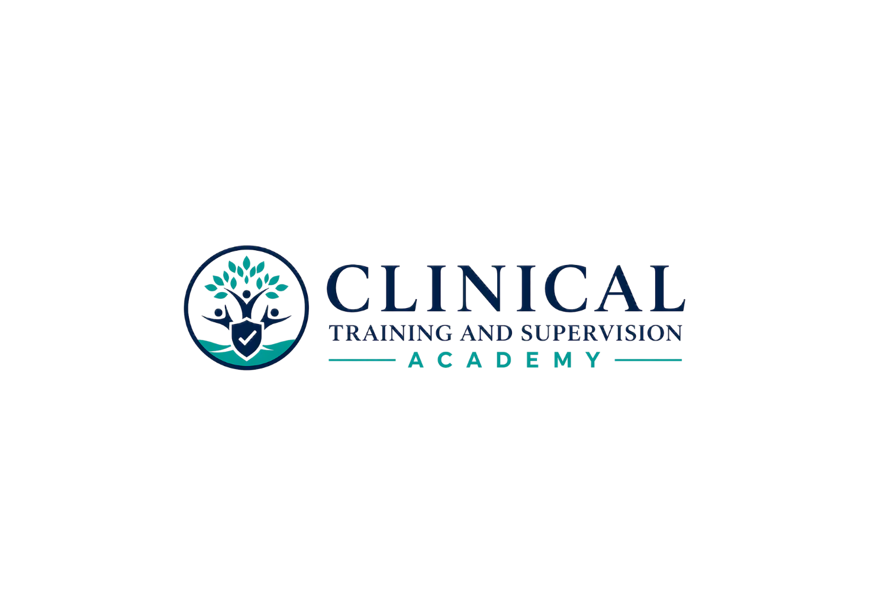
LEARNER FINAL READINESS

LPCC California Law & Ethics Exam Preparation
Program Close & Final Readiness Guide
SELF-PACED STUDY | NO CE CREDIT | FINAL PLANNING RESOURCE
CTA-EP-003 | Version 1.1 | August 7, 2026
Teaching Clinicians How to Think.
PURPOSE
Use this final learner resource after your main study cycle to convert performance data into a focused test-day plan. It does not predict passage, determine eligibility, or replace current official examination instructions.

1. Final Readiness Review
- Revisit the final remediation plan from the 100-question Comprehensive Final.
- Prioritize recurring reasoning errors, low-confidence correct answers, and chapters with weak transfer across different scenarios.
- Use the 807-card Study Center and high-yield toolkits for targeted retrieval rather than trying to reread the entire program indiscriminately.
- Complete one final review of numbers, timelines, trigger words, legal decision sequences, ethics decision guides, and recurring exam traps.
- Stop adding new study systems in the final days unless a specific identified gap requires them.

2. Current Official-Material Check
- Review the current California BBS LPCC Law and Ethics Examination page.
- Review the current examination candidate handbook and administrator instructions.
- Confirm current identification, scheduling, rescheduling, security, accommodation, and test-center procedures.
- Confirm any current BBS applicant or eligibility instructions that apply to your own status.
- Treat CTA date-bound legal or ethical statements as educational summaries and use current official sources when a later change conflicts.
CTA CURRENTNESS AND UPDATE CONTROL
This program was released using the current official California and examination sources available on August 7, 2026 and the currently operative 2014 ACA Code of Ethics. CTA will update affected materials when material official sources or ethics standards change. Learners should also review current official materials near their actual examination date.

3. How to Interpret Your CTA Scores
Field | Controlling entry
80% CTA benchmark | A study-readiness benchmark only; not an official passing score and not a guarantee.
70% chapter-test threshold | A technical internal chapter-test completion/scoring setting where implemented; it does not gate access to other study materials and is not an official examination standard.
Correct + low confidence | Treat as a study signal; verify the rule and why the strongest distractor fails.
Incorrect + high confidence | High-priority remediation because the reasoning model may be stable but wrong.
Repeated error category | Route back to the exact workbook/chapter, source concept, decision guide, and related flashcards.

4. Final 7-Day Planning Template
Day | Primary target | Evidence of mastery | Stop rule
7 | ____________________ | ____________________ | ____________________
6 | ____________________ | ____________________ | ____________________
5 | ____________________ | ____________________ | ____________________
4 | ____________________ | ____________________ | ____________________
3 | ____________________ | ____________________ | ____________________
2 | ____________________ | ____________________ | ____________________
1 | ____________________ | ____________________ | ____________________

5. Test-Day Decision Rules
- Read the entire stem and identify the decision point before comparing options.
- Classify the question: legal mandate, ethical responsibility, scope/authority, safety, client welfare, professional role, or sequencing.
- Prioritize immediate safety and controlling law before later administrative or idealized actions.
- Do not let a broad good idea defeat a narrower action that is required FIRST, NEXT, BEST, MOST, INITIAL, or PRIMARY.
- When two options look plausible, identify what fact makes one premature, excessive, unsupported, outside scope, or improperly sequenced.

6. Separate NCMHCE Pathway
SEPARATE PRODUCT BOUNDARY
The NCMHCE is not part of this California Law & Ethics Exam Preparation Program. CTA NCMHCE preparation, when available, is a separate profession-specific product with different content, assessment architecture, and study materials.

7. Access, Downloads, and Support Before Expiration
- Your program access lasts six months from enrollment.
- Download the learner-facing workbooks, performance tools, Study Center print formats, and toolkits you want to retain for permitted personal study before access ends.
- Keep controlled answer materials and all CTA files private and for your personal study use only.
- Contact CTA support before expiration if you have a technical access problem. Extensions or account exceptions are controlled by current CTA policy and checkout terms, not promised by this guide.

8. My Final Test-Day Plan
My three highest-priority review topics:
________________________________________________________________________________
My most common reasoning error:
________________________________________________________________________________
My plan if I am stuck between two answers:
________________________________________________________________________________
What I will review the evening before:
________________________________________________________________________________
What I will not study at the last minute:
________________________________________________________________________________
My scheduling / ID / arrival checklist:
________________________________________________________________________________
FINAL REMINDER
CTA supports preparation and reasoning practice. It does not determine eligibility, reproduce official examination content, or guarantee passage. Use current official BBS and examination-administrator materials for official rules and procedures.

