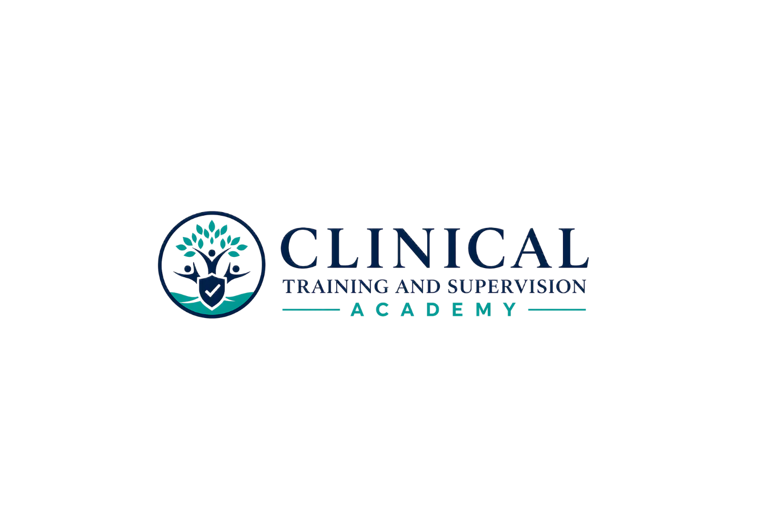
PUBLIC COPY CONTROL

LPCC California Law & Ethics Exam Preparation
Website, Catalog, Checkout, FAQ & LMS Copy Package
APPROVED PUBLIC AND LMS MASTER COPY
CTA-EP-003 | Version 1.1 | August 7, 2026
Teaching Clinicians How to Think.
PUBLICATION AUTHORIZATION
Approved by the program owner for public posting and LMS implementation under CTA-EP-003. Use the exact title, price, access period, no-CE classification, and access rules contained in this document.

1. Canonical Identity
Field | Controlling entry
Formal/internal name | CTA LPCC California Law & Ethics Exam Preparation Program
Public display title | LPCC California Law & Ethics Exam Preparation
Program code / SKU | CTA-EP-003
Slug | lpcc-california-law-ethics-exam-preparation
Price | $199
Access | Six months
Classification | Exam Preparation Program | No CE Credit
Audience | California APCCs and other eligible LPCC applicants
Examination | California LPCC Law and Ethics Examination

2. Website Course Card
Title: LPCC California Law & Ethics Exam Preparation
Card subtitle: Profession-specific California law and ethics preparation for APCCs and eligible LPCC applicants.
APPROVED PUBLIC COPY
Prepare for the California LPCC Law and Ethics Examination with LPCC/APCC-specific instruction, nine structured workbooks, original practice examinations, detailed rationales, an 807-card Study Center, printable study tools, and targeted remediation. Self-paced access for six months. No CE credit.

3. Full Product Description
LPCC California Law & Ethics Exam Preparation is a separate, profession-specific study program for California APCCs and other eligible LPCC applicants. The program combines current California legal requirements, counseling ethical standards, LPCC/APCC professional identity, applied decision-making, and original examination practice.
The completed program is designed to include a required LPCC/APCC license-specific module, nine learner workbooks covering 45 law-and-ethics chapters, answer-hidden assessments, detailed option-by-option rationales, two distinct 50-question practice examinations, one 100-question comprehensive final examination, performance and remediation tools, an interactive and printable 807-card flashcard system, and six high-yield printable study toolkits.
Learners may access and download approved study materials from the beginning of enrollment and study offline. The recommended order is guidance only; the program does not use continuing-education completion locks, a CE evaluation, or a certificate.

4. What the Completed Program Includes
- LPCC Practice Act, APCC professional identity, clinical-assessment boundaries, counseling ethics, and California examination-distinction module
- Nine LPCC Candidate Edition workbooks with 45 law-and-ethics chapters
- Answer-hidden chapter assessments with detailed teaching rationales and remediation
- Practice Examination A: 50 original questions
- Practice Examination B: 50 distinct original questions
- Comprehensive Final Examination: 100 original questions
- Performance, confidence-calibration, error-log, and targeted-remediation tools
- 807-card LPCC/APCC Study Center plus single-sided and duplex printable flashcards
- Six printable high-yield toolkits, rapid review, readiness map, schedules, and error log
- Six months of self-paced access and personal-study downloads

5. Core Coverage
- LPCC and APCC professional identity, statutory scope, competence, status, setting, title, and assessment boundaries
- APCC registration, supervision, employment/volunteer settings, payment limits, advertising, and client disclosures
- Counseling ethics, professional integrity, cultural humility, client welfare, boundaries, and professional responsibility
- Informed consent, fees, policies, minors, families, groups, and required notices
- Confidentiality, privilege, authorization, subpoenas, court requests, privacy, and information sharing
- Child, elder, dependent-adult, danger, crisis, and other reporting or safety responsibilities
- Telehealth, technology, social media, privacy, security, location, jurisdiction, and continuity
- Competence, consultation, supervision, impairment, referral, termination, and accountability
- Boundaries, multiple relationships, conflicts, gifts, fees, exploitation, and sexual misconduct
- Documentation, client access, amendments, retention, security, corrections, technology, and continuity

6. Who This Program Is For
Appropriate for | Not designed for
California APCCs preparing for the LPCC Law and Ethics Examination | Candidates preparing for a different license-specific Law and Ethics examination
Eligible LPCC applicants who need profession-specific California review | Candidates seeking NCMHCE preparation
Learners who want downloadable, printable, self-paced study materials | People seeking CE credit or a CE certificate
Learners who want original practice and detailed rationales | Anyone seeking an eligibility decision, legal advice, official questions, or a passage guarantee

7. Checkout Copy
Field | Controlling entry
Product | LPCC California Law & Ethics Exam Preparation
Price | $199
Access term | Six months beginning on the enrollment date
Delivery | Immediate online access after purchase
Downloads | Approved learner resources may be downloaded and printed for personal study
Attempts | Unlimited practice attempts; no minimum score controls access
Readiness benchmark | 80% may be displayed as a CTA study benchmark only
CE credit | None
Certificate | None
Refund / extension terms | Use the controlling CTA checkout terms and policy links; do not promise a separate or automatic exception here.

8. Frequently Asked Questions
Is this the NCMHCE exam-preparation program?
No. This product prepares for the California LPCC Law and Ethics Examination. NCMHCE preparation is a separate CTA program and a later licensure-pathway step.
Does the program provide continuing education credit?
No. It is exam preparation only and does not include CE hours, an evaluation, or a certificate.
How long do I have access?
Six months from enrollment.
Can I download and print the materials?
Yes. Approved learner-facing materials may be downloaded and printed for personal study during the access term.
Do I have to complete the modules in order?
No. The program displays a recommended sequence, but learner-facing resources are not locked. You may study in the order that works best for you.
When can I see rationales?
Online quiz feedback appears after submission. Separate downloadable rationale files are available as study resources; learners are strongly encouraged to complete a first attempt before opening them.
How many attempts do I receive?
Unlimited practice attempts during the access term.
Is 80% the official passing score?
No. It is only a CTA study benchmark. Official scoring and passing standards are controlled by the examination program.
Are these real or recalled examination questions?
No. CTA uses original educational questions and does not reproduce live or recalled examination content.
Does CTA guarantee I will pass or determine eligibility?
No. CTA does not determine eligibility or guarantee passage. Use current BBS and examination-administrator materials for official requirements and procedures.
Are recordings included?
No recordings or PowerPoint lessons are required for this program. The program is designed around workbooks, practice, rationales, flashcards, and printable study tools.

9. LMS Dashboard and Lesson Copy
00 | Start Here
Program identity, no-CE notice, source-currentness notice, access rules, and study instructions.
Access: Open from enrollment. Recommended sequence only; no prerequisite lock.
01 | LPCC/APCC License-Specific Module
Build the profession-specific foundation: LPCC scope, APCC status, assessment boundaries, advertising, supervision, professional conduct, counseling ethics, and examination distinctions.
Access: Open from enrollment. Recommended sequence only; no prerequisite lock.
02 | Workbook 1 - Informed Consent, Minors, and Family Involvement
Consent, client identity, fees, policies, minors, families, groups, and required disclosures.
Access: Open from enrollment. Recommended sequence only; no prerequisite lock.
03 | Workbook 2 - Telehealth Law and Ethics
Consent, identity/location, jurisdiction, privacy/security, crisis planning, technology, and digital professionalism.
Access: Open from enrollment. Recommended sequence only; no prerequisite lock.
04 | Workbook 3 - Professional Competence
Scope, competence, consultation, supervision, accountability, professional roles, and role clarification.
Access: Open from enrollment. Recommended sequence only; no prerequisite lock.
05 | Workbook 4 - Professional Impairment
Self-monitoring, colleague impairment, consultation, coverage, remediation, and client protection.
Access: Open from enrollment. Recommended sequence only; no prerequisite lock.
06 | Workbook 5 - Preventing Harm and Promoting Client Welfare
Mandated duties, safety, crisis response, nonmaleficence, beneficence, and documentation.
Access: Open from enrollment. Recommended sequence only; no prerequisite lock.
07 | Workbook 6 - Professional Boundaries
Multiple relationships, conflicts, gifts, fees, exploitation, sexual misconduct, and boundary repair.
Access: Open from enrollment. Recommended sequence only; no prerequisite lock.
08 | Workbook 7 - Cultural Humility and Diverse Populations
Dignity, self-determination, intersectionality, language and disability access, advocacy, and organizational barriers.
Access: Open from enrollment. Recommended sequence only; no prerequisite lock.
09 | Workbook 8 - Confidentiality and Information Sharing
Confidentiality, privilege, authorization, subpoenas, court requests, privacy, and multi-person services.
Access: Open from enrollment. Recommended sequence only; no prerequisite lock.
10 | Workbook 9 - Documentation and Records
Record creation, access, amendment, retention, security, technology, and continuity.
Access: Open from enrollment. Recommended sequence only; no prerequisite lock.
11 | Practice Examination A
Complete the 50-question diagnostic form, then use detailed rationales and the performance worksheet.
Access: Open from enrollment. Recommended sequence only; no prerequisite lock.
12 | Practice Examination B
Use the distinct transfer form after reviewing Practice A reasoning errors.
Access: Open from enrollment. Recommended sequence only; no prerequisite lock.
13 | Comprehensive Final Examination
Complete the 100-question cumulative readiness exercise and final remediation plan.
Access: Open from enrollment. Recommended sequence only; no prerequisite lock.
14 | Study Center
Use the 807-card Study Center, decision guides, numbers/timelines, exam traps, readiness checklist, rapid review, schedules, and error log.
Access: Open from enrollment. Recommended sequence only; no prerequisite lock.
15 | Program Close
Create the final test-day plan, review current official candidate materials, and distinguish the later NCMHCE pathway.
Access: Open from enrollment. Recommended sequence only; no prerequisite lock.

10. Enrollment / Receipt Copy
ENROLLMENT CONFIRMATION DRAFT
You are enrolled in the CTA LPCC California Law & Ethics Exam Preparation Program (CTA-EP-003). Your six-month access begins on [START DATE] and ends on [END DATE]. This is an exam-preparation program and provides no continuing education credit or certificate. Sign in to access and download your study materials. Use the recommended sequence as guidance; learner-facing resources are open from enrollment. Keep all materials for personal study and do not share or distribute them.

11. Required Disclaimer
INDEPENDENCE AND NO-GUARANTEE NOTICE
Clinical Training and Supervision Academy is an independent educational provider. CTA is not affiliated with or endorsed by the California Board of Behavioral Sciences, Pearson VUE, NBCC, CCE, ACA, or another licensing or examination organization. This program is not legal advice, does not determine examination or licensure eligibility, does not reproduce live or recalled examination questions, and does not guarantee passage. Requirements and procedures may change; learners should review current official materials.

12. Owner Publication Authorization and Implementation Status
Field | Controlling entry
Current package scope documented | ☒ Yes ☐ No — see Missing Earlier Binary Checklist
Catalog and public copy synchronized | ☒ Yes ☐ No
Checkout fields synchronized | ☒ Yes ☐ No
Implementation QA completed | ☐ Yes ☒ No — complete after upload and retain evidence
Known critical content defect at owner release | ☐ Yes ☒ No
Current-source release baseline documented | ☒ Yes ☐ No
Owner approved for public posting | ☒ Yes ☐ No
Approved by | Candice Fuimaono / CTA
Date | August 7, 2026

